封底 封面

Portable Power Station USER GUIDE

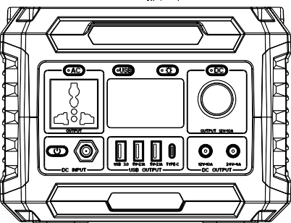

Made in China

Before using or storing,please read this manual carefully,and charge your A3B with the included charging adapter

封面内页
前言

Introduction
Thank you for purcharsing Portable Power Station.Before using or storing,please read this manual carefully,and charge your A3B with the included charging adapter.If you have any questions or issues,please contact our custoner services team for further assistance.

What’s In The Box
1x A3B Portable Power Station 1x AC charging Adapter
1x Car Charger Cable 1x User Guide

Button Definition
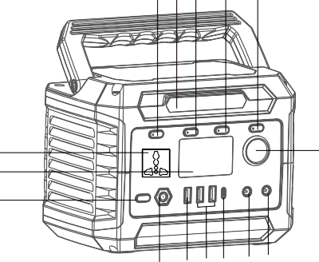
b c d e f
j
k l m n o

LED Display

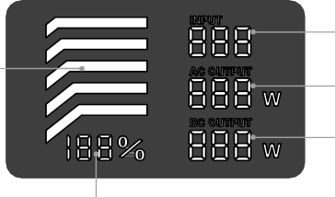
BATTERY LEVEL
W

BATTERY LEVEL

INPUT

AC OUTPUT DC OUTPUT

Shows the amount of power (watts) going into the A3B while charging.
INPUT
Shows the amount of power(watts) your AC devices are using while plugged into the A3B
AC OUTPUT

g i
DC OUTPUT
h
Shows the amount of power(watts) your DC devices are
using while plugged into the A3B

a

BATTERY LEVEL
Shows 6 segments, approximating 10%-20%-40%
60%-80%-100% capacity.
When charging your A3B you will notice
a battery segment blinking, this indicates the current charge status. Once fully charged, all battery segments will be lit and remain solid.
a. Power | b. AC switch | c. LED light
d. USB switch | e. LED switch | f. DC switch
g. AC output | h. LED display | i. DC output
j. DC input | k. USB3.0 output | l. USB output
m. Type-c output | n. 12V DC output | O. 24V DC output

01 02

DC OUTPUT
Using Your A3B
Press the main power button，the power station will be turned on.
Press POWER and Press the DC/USB/AC/LED button to turn on corresponding output port(when not using certain ports, make sure
to turn them off to conserve power)
You'll know the output port is turned on when the green LED light on the button is illuminated
Press the "POWER" button to turn on/off the LED display

- press the main power button, and then press the “DC” power button, the DC output will be turned on, the green LED light on the button is illuminated.
- Plug your devices into corresponding ports, you will see the amount of power(watts) your devices are using marks on the LED display
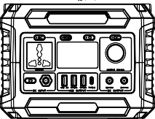
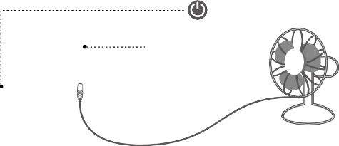
Main Power Button
DC DC Power Button

USB OUTPUT
Notice:
- Please use this power station to power your device at temperatures
ranging from -10℃~45℃
- Before using, please check whether the power of your device exceeds the output range of this unit. This power station will enter protection mode if the power of your device exceeds the output range
- Press the main power button, and then press the “USB” power button, USB output and Wireless charging will be turned on, the green LED light on the button is illuminated.
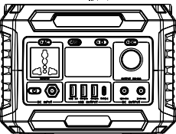
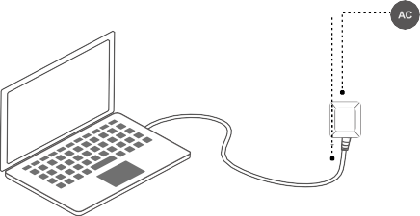
- Plug your devices into corresponding ports.

AC OUTPUT
- press the main power button, and then press the “AC” power button, the AC output will be turned on, the green LED light on the button is illuminated.
- Plug your devices into corresponding ports, you will see the amount of power(watts) your devices are using marks on the LED displa

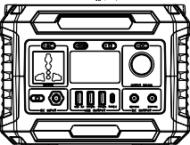
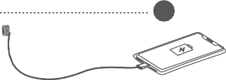
Main Power Button
Main Power Button
AC Power Button

USB USB Power Button

03 04

What it Powers

AC OUTPUT
 Television | 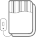  Electric blanket | Tablet
DC OUTPUT
Mini Fridge |  LED light | Fan
USB OUTPUT
Phone | USB fan |   GoPro
As the ambient temperature and battery usage times change, the using time of power station will change.
Please confirm the power of the device in the instruction manual or catalog of the device.
When the charging specification of the device exceeds the maximum value of this unit, this power station will enter automatic protection mode,the output will be turned off automatically.Before using, please ensure your electronic device is below 300W.
Charging Your A3B
Charging from Solar

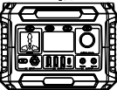
Charging from AC Adapter
① Place the solar panels in direct sunlight.
② Please connect the DC output terminal of the solar panel to the charging. port of the power station, and the LED display will show the charging status. (Please charge at the temperature range of 0
°C ~ 40 °).
③ Remove the charging device from the solar panel and power station after fully charged.
Sun
Solar panel
A3B


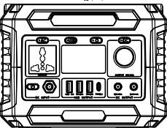

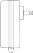
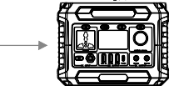
AC Wall Charger
① Insert the AC adapter into the socket, and then connect the other end to the DC input charging port of the power station. The LED display will show the charging status.
② Remove the charging adapter from power station after fully
charged.
AC socket
AC charging adapter
A3B
Solar Panel

Car Charger
Input

05 06

Charging from Car Charger(12V)
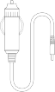
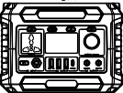
① Connect the included car charging cable into car port.
② Connect the other end of car charging cable into the charging port of the power station, and the LED display will show the charging status.
③ Remove the charging adapter from power station after fully
charged.
Car
Car Charger Cable
A3B

Charging Indication

The battery indicator shows the remaining battery capacity.

Technical Specifications



100% 80%
60% 40%
20%
Charge soon
10%
Capacity | 288Wh/ 78000mAh, Lithium-ion
Size | 210×146×157mm(LWH)
Weight | 3.2KG
Input | Adapter:DC15V/3A  Solar Panel Charging: DC13V~26V/3A
DC Output | 1x Cigarette Lighter Adapter  1x 5521 DC Output:12V/10A  1x 5525 DC Output:24V/4A
AC Output | 230V 50Hz / 300W
2 x USB Output | 5V/2A
USB-A QC Port | 5V~ 9V/2A, 18W Max
USB-C QC Port | 5V~9V/2A ,18W max
Cell Type | Lithium-ion Battery
Lifecycles | ≥ 1000 times
Working Temperature | Charge Temperature: 0℃-40℃  Discharge Temperature: -10℃-45℃
Safety Protection | Overheating Protection, Over Current Protection, Over Voltage Protection, Short Circuit Protection

High Low
The power marquee will be 10%-20%-40%-60%-80%-100%, displayed in 6 segments. When the battery capacity is below 10%, the power marquee could not show the specific remaining amount of capacity. At this time, please charge as soon as possible;
when the battery capacity is below 10%, the power marquee will flash.
In addition, if you do not use it for a long time, please charge the power supply every three months.

07 08

Frequently Asked Questions

Why this power station cannot supply power to other devices (no output)?
① Please check whether the power button and output ports of the power station are turned on (there’s no output if the ambient temperature is beyond -10 °C to 45 °C).
② Check if the device completely inserted into the output port of power station; Whether there is foreign matter at the port of device and power station.
③ Please refer to the marquee of the LED display to confirm the remaining battery capacity of the power station. If it’s less than 10%, the power station needs to be recharged.
④ Check if the voltage and current，power specifications of the
device exceed the range of power station.
⑤ Please confirm whether the power station is automatically turned on over current/ overload/ over temperature function due to other reasons.

How to release the automatic protection function after it is activated?
Follow these steps

① AC output overload and short circuit
AC output will enter the protection state, please remove the load of AC output, and restart to restore normal.

② DC overload
DC output will enter the protection state, please remove the load of DC output, and restart to restore normal;

③ USB output overload and short circuit
USB output will enter the protection state, please remove the load of USB output, USB will automatically return to normal.

④ Wireless charging
When the temperature of the wireless transmitter reaches 50 degrees, it will automatically turn off the wireless charging function. After the temperature drops, it will automatically return to normal. Please place the mobile phone in the middle of the wireless charging area.

"!"Troubleshooting
- When the battery temperature reaches 70 degrees, "!" will appear on the display, after the temperature dropping, restart to restore normal.
- When the DC output happens short-circuit issue, "!" will appear on the display, and the DC output will be automatically turned off. Please remove the abnormality and then restart to restore normal.

Why is the adapter hot while charging the power station?
Our accessories include a high temperature AC adapter. In addition, the adapter is UL / PSE certified. Please feel free to use it

What is overload protection?
Overload protection is that the power station will automatically turn off when the power of the device exceeds the rated output power. when the power system detects that the device being used is shorted or overloaded. Related functions will be turned off. Please confirm whether the device parameter specifications meet the scope of the power station before using it.

How do i know if my device will work with the A3B?
You will need to check the amount of power your device requires. This may require some research on your end. An online search or examining the user guide for your devices should suffice. To be compatible with the A3B you should use devices that require less than 300W.

How to know the working times for my device?
You will need to check the amount of power your device requires. This may require some research on your end. An online search or examining the user guide for your devices should suffice. To be compatible with the A3B you should use devices that require less than 300W.

09 10

SECURITY AND MAINTENANCE
- Do not short-circuit the unit. To avoid short-circuitng, keep the unit away from all metal objects (e.g. coins, hair-pins, keys, etc.).
- Do not heat the unit, or dispose of it in fire, water or other liquids. Keep away from high temperatures. Do not expose the unit to direct sunlight.
- Keep away from high humidity, dusty places.
- Do not disassemble or reassemble this unit.
- Do not drop, place heavy objects on, or allow strong impact to this unit.
- This appliance is not intended for use by persons (including children) with reduced hysical, sensory or mental capabilites, or lack of experience and knowledge, unless they have been given supervision or instruction concerning use of the appliance by a person responsible for their safety.

PRODUCT APPLICATION SKILLS
- This product is built in high quality original lithium ion battery, it has no memory effect but high-capacity, and it is durable. However, we still recommend you to apply in the range of 10
℃ ~30 ℃, so as to obtain the optimal charging capacity;
- When charging, in order to avoid interference, please stay away from TV, radio and other equipment
- If the device has not been used for a long time, please
disconnect the cable and store it
- Some portable devices may need to be set in charge mode to charge, see the corresponding equipment use manual for more information
- In order to extend the life of product (lithium battery), is better to charge within 3 months, and charge at least once within 6 months.

- Children should be supervised to ensure that they do not play
with the appliance.
- Do not cover the device with towels, clothing and other item.
- The unit may become hot when charging. This is normal. Use caution when handling.
- Use the unit properly to avoid electronic shock.
- Please deal with scrap products in accordance with the regulations, do not treatment the built-in battery as a household garbage, so as not to cause the explosion and pollution.
- The product is only used for emergency power station, it can not replace the standard DC or AC power of household appliances or digital products.

Battery information
Your device has and internal, non-removable, rechargeable battery. Do not attempt to remove the battery, as you may damage the device.
The battery can be charged and discharged over 1000 times, but it will eventually wear out.

Statement
All rights reserved. Reproduction in whole or in part without written permission is prohibited. All other trademarks are trademarks of their respective owners. Features and specifica- tions are subject to change without notice.
This manual is only used as guide unless otherwise agreed.All the statement, information and suggestion in this manual ,do not constititue as express or implied gurantee.

11 12

说明书
材质：100g书写纸
成品尺寸：88x140mm装订方式：骑马钉
装钉成本后，排版按照的顺序：封面，封面内页，前言， 01、02、03、04……12、封底
注：红色字和线条不做印刷 960401052836Y

