尺寸：42Qx28Smm



四折页(10Sx142.Smm)
材质：1089铜版纸，双面印刷
备注：图中－－ － －虚线为

折叠线不需要印刷

生产大货时，必须参照右边示意图折叠好！！！
艾
奂
文
羹

PORTABLE POWER SUPPLY

Thank you very much for applying our mul廿function portable solar generator. In case of power failure or you need to charge on a travel, you can temporarily charge your electrical or digital products with this unit.This unithas been builtin high quality lithium battery,supports for USB, DC and AC output.Before using this unit,please read the user manual carefully and properly keep for reference
ABOUT THE UNIT

DC Output

ACPower Power Indicator


lx Cigarette Lighter Adapter
折叠示意图：
上上
／

／
4x 5521 DC Output:9~12.6V/10A(12A Max total)
AC Continous Power Output:230V SOHZ, SOOW, LED Display
(LED Display)

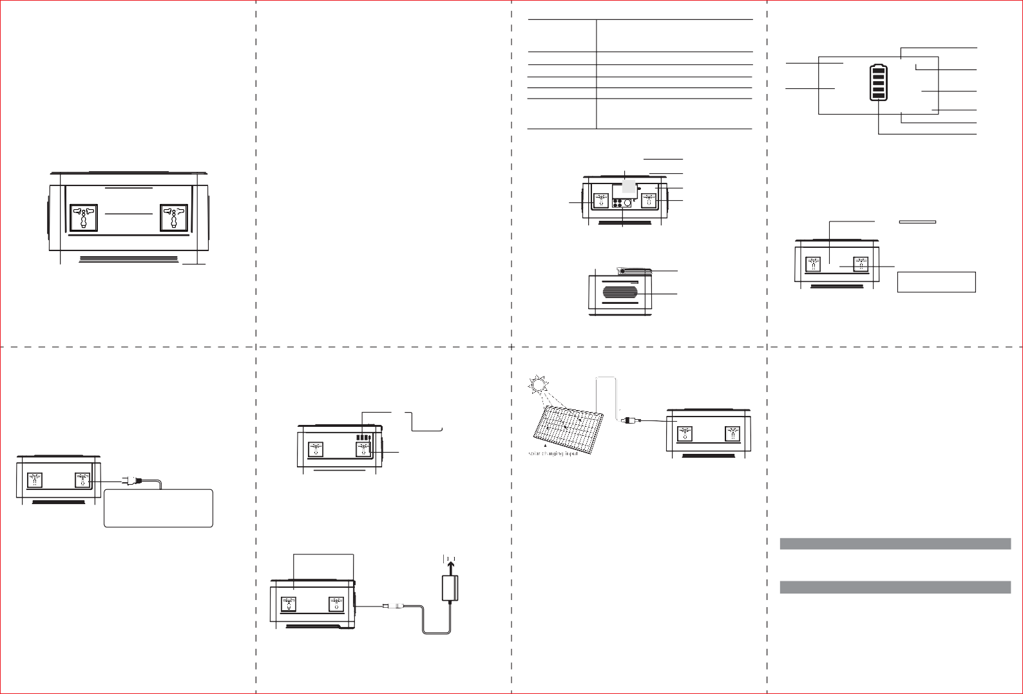
Input

INPUT

USB QC3. 0

USB Output

QC3.0 Output

Universal Instruction manual
｀俨

This manual is to help you use the productcorrectly;it does notrepresentany description on the hardware and software configuration ofthe product.Aboutthe productconfigura­ tion, please refer to the contractrelated to this product(if there is), or consultto the seller that sells the product.Pictures in this manual is for reference only,if there are individual pictures do notmatch the actual, please prevail in actual products
The unitprovides Sine Wave output
ATTENTION!
Operation temperature
Lifecycle Package include

-10"C-40'C
>1000 times

lx Portable Power Supply lx Power Adapter lx user manual

AC Output
BB已BB
上十OUTPUT 0 Type_c

DC Output

Type-c Output DC Output
【II) PRODUCT DESCRIPTION

_ J

尸
|

The unit is built-in inverter, AC output waveform of "Wave". It is a waveform that has characteristics same to the sine wave shape ofutility power. It can provide the cleanest, most stable AC voltage to your AC electric appliance. While traditional inverter output Modified Sine Wave output,which can cause unstab山ties to electrical devices,such as an electrical fan, It will even make the electric appliance arouse some noise.Appliances like refrigerators, microwaves, and compressors thatuse AC motors and some delicate medical
equipment will be better offwith a pure sine wave inverter. This productis only used for
来There may be some differences on differentspare parts.Please adhere to the actual productinstead

USB 5~9V/2A
ut
lnPRec
『
QuickCharge3.0
[
ay
IPS
D D LE
USB SV/3.lA USS C 5分V/2A
-- 8a
, 1 -3 0 0
.I `
- BB.
！、
已
！，
QuickCharge3.0
，
一
．
Capacity
【Ill】PRODUCT INSTRUCTION
- How to provide power for DC12V appliances(such as head lamp,fan)with this product? The 5.5mm 12V DCoutputis plug and play.Plug your appliances to the DC outputportto gain power. DCoutputrated power<120W,Max output<145W
Notices:Please confirm whether your DC 12V appliance supportcharging with 5.5mm DC

仁仁I O
飞，［甘
:: 0 �
1IIll Ill°

emergency,it cannot replace the normal alterna廿ng current,for long-term use.

Universal AC Outlet
(I) PRODUCT PARAMETERS

Universal AC Outlet
header interface(the diameter ofthe DC Portofthe Productis:5.Smm),otherwise itunable to connectwith the DC Output,you can consultthe electrical manufacturer,buythe corresponding adapter and connectwith it
—
5.5mm DC12V for Fan or LED
lights(power<l20W)

一一DC O一utput 、
J
夕
Capacity | 520Wh,11.1V(equivalent140400mAh,3.7V)
D,mensions(LWH) | 306x200xl76mm
Weight | about6.3Kg
Built-in Battery | High Quality Lithium ion Batteries
InputRecharging | Adapter:DC15V/6A  Solar Panel Charging:DC13V~22V/6A Max
FullyCharged Time | DC15V/6A: 8~10 hours
USB Output | 1 X USB SV~9V/2A Qualcomm QuickCharge 3.0  1 X Typ-c 5炉9V/2A Qualcomm QuickCharge 3.0  2 X USB SV/3.lA

(9~12.6V)/10A
[Front) c

［一 包

Handle

勹＂窖气i
such as Vacuum Cleaner.Inflation
－

亡_J

Coolingvents

［今 今飞
Pump.Electric wrench.fridge.etc

ATTENTION: Thisproductuser manualisunive飞alfor portable solar generator ACoutputrange between 230V/50Hz. Actual productspecification,actual AC outletswill bedifferent accordingto differentcountries, areas or customers. Please refer to the actual
P「oductbefo「eyou use the product
L
ACOutIest,AC outfutvoltage and frequency WIl1be dlfferentaccordmg to dlfferentcountnse or areas.Please refer to the-actual productbefore using
淡Note: The12V DC outputvoltage is range between 9V~12.6V, maximum outputcurrentis 12A. DC outputvoltage d「ops while batte「y capacity drops due to chemical characteristics of the battery.Ifyour appliance is notbuilt-in inputvoltage stabilizing function, it may shutdown when inputvoltage is too low, please unplug your device from the unitin time
And please charge the unitin time

Protection Mode:
short-ci「cuit/Overpower Protection:lfthe DC outputis short-circuited or overpowered(­ Load power>120W),the unitwill shutdown to protectitself.Please press the DC switch
again to resume use。
- How to provide power for AC appliances with this product?
Connectthe power cable plug ofthe electrical appliance to the AC outletofthe product, switch on the POWER-AC button and the unitwill startproviding power to your appliances WARNING! The AC outlets.AC voltage and frequency are differentaccording to different countrise;Please carefully check whether the productspeciftcations are consistentwith the appliance spec如ations before use,otherwise it can lead to dangerous situations
(Left)

门气。霄勹
忑
－
、
FastCharge 3.0 Technology:The power pack supports FastCharge 3.0 outputtechnology and SV-9V/2A max output,can be used for smartphones and pads which adopts Qualcomm FastCharge 3.0 technology.For exactcharging voltage and currentifthese devices, please contactthe manufacturer for more details
[Front)
已二
叩

尸。窖
L..., -

一、

DC13~22V,6A Max

c. Charge from your car with a 12V cigarette lighter.

尸窖＇气i

一、
－
－
- Please deal with scrap products in accordance with the regulations, do nottreatthe built-in battery as a household garbage, so as notto cause the explosion and pollution
- The productis only used for emergency situations, itcannotreplace the standard DC or AC
power ofhousehold appliances o「digital products
IV) PRODUCT APPLICATION SKILLS
- This productis builtin high quality original lithium ion battery,ithas no memoryeffectbut high-capacity,and itis durable. However, we still recommend you toapply in the range of10 C
~30 C, so as to obtain the optimal charging capacity
- When charging,in order to avoid interference, please stay awayfrom TV, radio and other equipment
- Ifthe device has notbeen used for a long time, please disconnectthe cable and store
- Some portable devices may need to be setin charge mode to charge, see the corresponding equipmentuse manual for more information
- In order to extend the life ofproduct(lithium battery),itis bestto charge within 3 months, and charge atleastonce within 6 months

iig
J r\
lt r
韵
血ited Appilance Wattage<SOOW,Lamp,Electric Fan,TV,etc. ACWIII shutdown when lt'sshort circuited or power overloaded.Removethe device andthe unitwill recover from short-circuitor
－ overpower protection in a few seconds. Repress
the AC outputbuttonto switch on ac outputagain

Warning:the plug standard and voltage differs according to countries, please make sure the socket standa「d matches you「appliance before using,in case ofany dange「ous situations
* Please turn offthe AC switch intime to save energyifyou don'tneed AC outputfunction
Protection Mode
Shortcircuit,over load protection: For AC outputShortcircuit or over load (more than 600W) situation, the AC outputfunction will be stopped, please remove the load and press the AC button for reactivation
*
Some electrical appliances, such asrefrigerators, ice machines, laser printers, etc., there will be a peak power during startor working,which lasts veryshorttime, butup to 1000W or above. The situation mayactivate the ove「load protection. Please remove the appliance, and pressthe AC button for reacllvallon

- How to use the power pack to supply the USB digital devices?
Connectthe digital device to the USB interface ofthe power pack, press "USB" button, then it works.
淡Note: For some smartdevices, such as the Bluetooth headset,LED lights, the charge currentisvery low, below lSOmA, which istoo low to be detected bythe power pack, these smartdevices can not getpower from the power pack
淡Note:When the productisin overloaded or short-circuitprotection, please remove the load and USB auto activation
5) How to charge the unit? a.Charge through AC Wall Charger
Usingthe included AC Wall Charger, plug the unitinto any wall outletto charge the unit.You will know the unitis cha「ging when the blue LEDbatte「y indicato『s are blinking.The unitis fully charged when all batteryindicators stop blinking and remain solid. After the unitisfully charged, please remove the AC wall charger in time
ASockCet
(Right)

尸窖气 Charging
一·

b.Charge from Solar panel
- Place your solar panel where it will getas much directsunlightas possible
- Plugthe outputofthe solar panel into the inputofthe unitto startcharging.You will know the unitis charging when the blue LED BatteryIndicator lights up and blinks. The unitis fully charged when all batteryindicators stop blinking and remain solid
Usingthe car charger, plug the unitinto a 12V cigarette lighter (car port)ofyour car
You will know the unitis charging when the blue LED Battery Indicator lights up and blinks. The unitis fully cha「ged when all batte「y indicators stop blinking and remain solid
Attention: To avoid car batterypower loss. Charging this unitthrough your car cigarette lighter is only available when your car engine is started.

[ IV】SECURITY AND MAINTENANCE
  - Do notshort-circuitthe unit.To avoid short-circu巾ng,keep the unitawayfrom all metal objects (e.g.coins, hair-pins, keys, etc.)
  - Do notheatthe unit,or dispose ofitin fire, water o「other liquids. Keep awayfrom high
temperatures. Do notexpose the unitto directsunlight
  - Keep away from high humidity,dusty places
  - Do notdisassemble or reassemble this unit
  - In order to extend the life ofp「oduct(lithium battery),itis bestto charge within 3 Do not drop,place heavy ob」ects on, or allow strong impactto this unit
  - This appliance is notintended for use by persons(including children) with reduced physical, sensory or mental capabilities, or lack ofexperience and knowledge, unless they have been given supervision or instruction conce「ning use ofthe appliance by a person responsible for thei「safety.
  - Child「en should be supervised to ensure thatthey do notplay with the appliance
  - Do notcover the device with towels, clothing and other item
  - The unitmay become hotwhen charging.This is normal.Use caution when handling
  - Do notcharge the unitover the「equired time
  - Disconnectthe unitwhen fully charged.
I) Use the unitproperly to avoid electronic shock

Cold Weather Usage
Cold temperatures (below freezing)can affectthe unit's batterycapacity due to chemical characteristics ofthe battery.Ifyou'll be living off-grid in sub-zero conditions, we recommend you keep your unitin an insulated cooler, and connected to a power source (solar panels). The natural heatgenerated bythe unitcontained in an insulated cooler will keep batterycapacity at its highest
Recycle
Always return your used electronic products, batteries, and packaging materials to dedicated collection points. This way you help preventuncontrolled waste disposal and promote the recycling ofmaterials
Batteryinformation
．．
Your device has and internal, non-removable, rechargeable battery.Do notattemptto remove
the battery,as you may damage the device
The battery can be charged and discharged over 1000 times, butit will eventually wear out
Statement
All rights reserved. Reproduction in whole or in partwithoutwritten permission is proh心ted All other trademarks are trademarks oftheir respective owners. Features and specifications are subjectto change withoutnotice
(E芘斗＠旦
MADE IN CHINA

