成品：A5装订成本，100G书写纸，骑马订

Portable power station User Manual

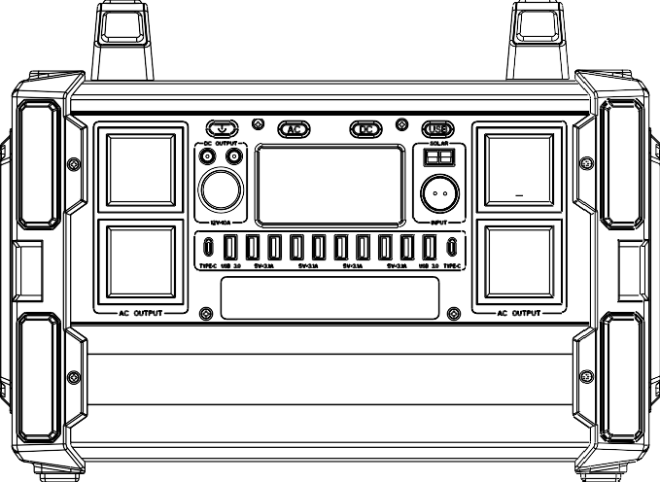

IMPORTANT! This product manual is a general version of 1200W porta- ble energy storage power supply. The actual specifications and parameters of the product, especially the specifications and voltage of AC output socket, will be customized according to different countries, regions and users. The product specification shall be subject to the actual product,

Please read this manual carefully before using this product.

About product
Thank you for using our multifunctional portable power station. You can use it to power your appliances or digital devices in the event of a power outage or when you are travelling. This product built-in high quality lithium-ion battery and supports DC, USB and AC power output. Before using it, please read this user manual carefully and keep it in a safe place for reference.

Please note!
This manual is intended to assist you in the proper use of this product and does not represent any description of the software or hardware configuration of this product. For information on the configuration of the product, please refer to the contract relating to the product (if any), or consult the dealer who sold it to you. The pictures in this manual are for reference only, if any of the pictures do not correspond to the actual product, please refer to the actual product.

This power station has a built-in inverter, which provides a pure sine wave output. This waveform is consistent with the mains waveform and characteris- tics, and can provide pure AC power to appliances. Traditional inverters with a modified waveform may cause instability in appliances and even cause certain appliances such as those with built-in motors (e.g. electric fans, printers with motors, etc.) to make a certain amount of operating noise. This product is for emergency use only and should not be used as a substitute for normal house- hold AC power.

Product Parameter

Battery capacity | 315000mAh,3.2V /1008Wh
Product size (LWH) | 394*213*287 mm
Net Weight | About 13.5kg
Battery type | LiFePO4
Power adapter | DC38V/6A

USB output | 8 X USB Port：5V/2A MAX  2 X USB QC 3.0: 5V~9V/2A MAX 18W  1 X Typ-c Port: 5V~9V/2A MAX 18W  1 X Typ-c Port: 5V~20V/3A PD 60W
DC output power (Max.) | 2 x DC5521 12V/7A  1 x Cigar socket 12V/7A
Charging time | DC 38V about 5 hours
AC output power | AC continuous output power 1200W
Battery level | LCD display
Operation temperature | -10℃-40℃
Life span | >2500 cycles
Packaging accessories | 1 x portable power station 1 x power adapter  1 x user manual
※ Note that accessories maybe different, please refer to the actual product.

Product Function Description
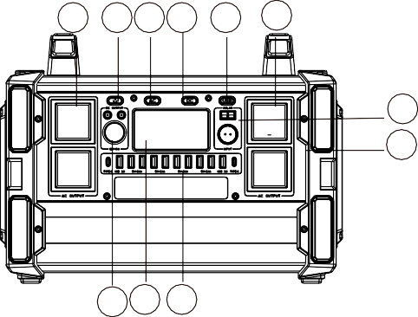
5 4 2 3 7 5
9
5
1 8 6

1.DC output | 2. AC button | 3. DC button | 4. Power button
5. AC output | 6. USB output | 7. USB button | 8. LCD display
9.Charging input


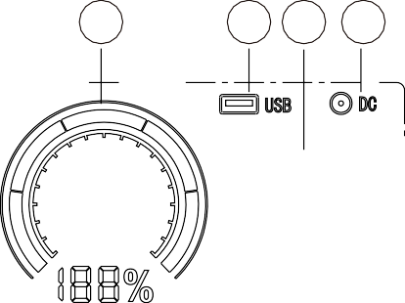



LCD display
6
5
4 3 2
7
1
8
1.Total output power 2. DC output display 3. AC output display
4. USB output display 5. Battery level display 6.Input display
7. Input power 8. Abnormal mark

DC output: Turn on the power switch first, Press the DC button for DC output and press the DC button again for DC off.
AC output: Turn on the power switch first, Press the AC button for AC output and press the AC button again for AC off.
USB output: Turn on the power switch first, Press the USB button for USB output and press the USB button again for USB off.
Charging : When the product is being charged, the INPUT icon is displayed and the battery level indicator bar will run. When the power station is fully charged, the battery level displays 100% and the bar stops rotating.
When the power station is fully charged, please remove the charger promptly.

Product instructions

1).How to use this product to power DC12V appliances (e.g. lights, ventila- tors)
Please confirm whether the interface of DC12V appliance or lighting equipment is the DC5.5 interface(The diameter of the DC Port of the Product is: 5.5mm)

otherwise it is unable to connect with the DC output, if so, you can consult the electrical manufacturer, buy the corresponding adapter and connect with it. Con- nect with vehicle mounted tool through cigar lighter. If your electrical appliance supports car charge, you can connect this product with your appliances through the standard cigarette lighter adapter to gain power.

Support DC12V Devices,such as Vacuum Cleaner,Inflation Pump, Electric wrench,fridge,etc.( power < 120W)


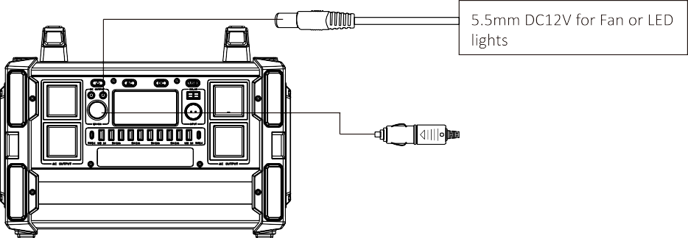
DC protection modes:
If short circuit occurs in the DC output or if the output is overpowered ( power
>120W), the unit will automatically cut off the output. After removing the load, please press the DC button to restart.

How to provide power for AC appliances with this product.
  - Connect the power cable plug of the electrical appliance to the AC interface of the product.
WARNING! The interface specifications and voltage standard of different coun- tries are different, please carefully check whether the product specifications are consistent with the appliance specifications before use, otherwise it may lead to dangerous situations.
  - Press the POWER button to start, press AC button to start the AC output.
At this point the LCD display shows the letters AC OUTPUT and the output power.
  - Single click POWER or directly press the AC power button to turn off AC output, the electrical appliances stop working.

Please turn on power switch before use, if the limited device wattage<1200W, like lamp, electric fan, game machine etc. If the AC output is short circuited or power over loaded above this unit, AC output wattage will trigger short circuit and over power protection, to eliminate the short circuit and remove the electri- cal appliance and restore the AC output

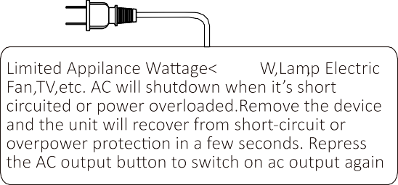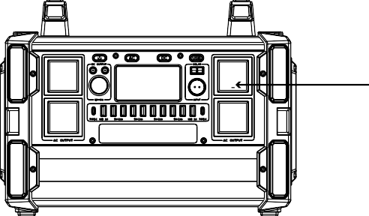
1200
Warning: Depending on the country, the interface specifications and voltage specifications maybe different. Please check carefully whether the product spec- ifications correspond to those of the machine, otherwise a dangerous situation may occur. When not using the AC outlet, please switch off it in time to save energy.
AC protection mode,
The unit will automatically switch off and protect the AC output when short circuit or overload (load over 1200W) occur. Please remove the load, press the AC button to restart.
Remarks：
Some appliances, refrigerators, ice machines, laser printer lights, etc. require high peak power to start. This time may be short, but this peak power may exceed , which will cause over-power protection of the unit. Please remove the load and press the AC button to recover again. Please consult the manufacturer of the unit for more information.

How to provide power for USB digital appliances with this product.
- Connect the standard USB cable of your digital device to the USB port of this product, then click on POWER and press the USB button to power up your digital devices.

This product supports Quick Charge 3.0 output technology. Smart USB devices such as mobile phones and tablets that also support Quick Charge 3.0 technolo- gy will continue to charge quickly. The actual charge voltage and current levels are related to the actual USB smart device. Please refer to the actual.

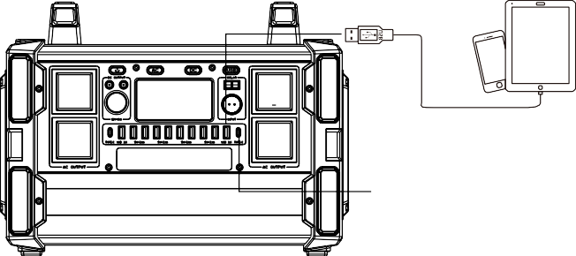

When overload and short-circuit protection for USB outputs occur, After remov- ing the load, please press the USB button to restart.

5). How to charge this unit
- Power adapter charging
Please connect one end of the power adapter to the DC input of the product, and then connect the other end of power adapter to the household AC outlet. And then the INPUT icon will light up and the charge level indicator bar will run. When the battery level is up to 100%, the bar will stop rotating.
Please remove the power adapter when it is fully charged.

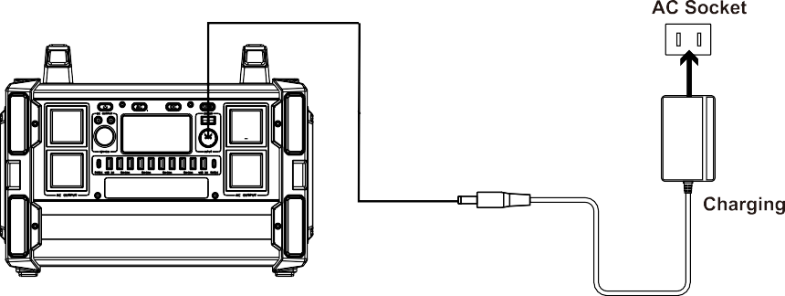

Solar input charging
  - Please try to place the solar panel in a right position with strong direct sunlight.
  - Please connect the output of the solar panel to the charging input of the prod- uct. At this point the INPUT icon will light up and the charging power indicator will run. When the battery level is displayed at 100% and the battery bar stops running, this means it is fully charged.
  - The charging time of the solar panel is related to the actual sunlight intensity (solar panel is not included）
  - only support 12~50V input

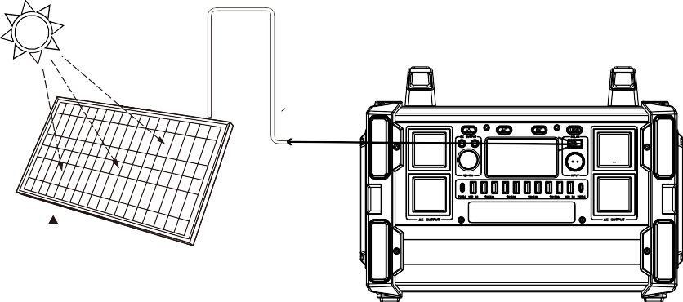
12~50V

Car Charging
car charger for this product to connect to the 12V cigarette lighter port in the car to charge. (Car charging line is not a standard accessory).
At this time, the INPUT icon will light up and the charging indicator will run. When the battery level is up to 100% and the battery level bar stops running, it means that product is fully charged.

Type-c port charging
The Type-c output port of this product also supports input charging, just need to connect the Type-c charger into Type-c port and the household AC outlet to charge this product. When the battery level is up to 100% and the bar will stop rotating. Once fully charged, please remove the charger promptly. (Type-c char- ger is not included)
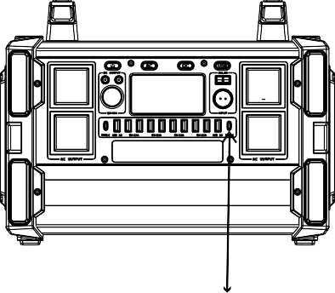
Unique Port Both ways charging

Security and maintenance
- Do not short-circuit the unit. To avoid short-circuiting, keep the unit away from all metal objects (e.g. coins, hair-pins, keys, etc.).
- Do not heat the unit, or dispose of it in fire, water or other liquids.
- Keep away from high temperatures.
- Do not expose the unit to direct sunlight.
- Keep away from high humidity, dusty places.
- Do not disassemble or reassemble this unit.
- Do not drop, place heavy objects on, or allow strong impact to this unit.
- This appliance is not intended for use by persons (including children) with reduced physical, sensory or mental capabilities, or lack of experience and knowledge, unless they have been given supervision or instruction concerning use of the appliance by a person responsible for their safety.
- Children should be supervised to ensure that they do not play with the appli- ance.
- Do not cover the device with towels, clothing and other item.
- The unit may become hot when charging,it is normal. Use caution when handling.
- Use the unit properly to avoid electronic shock.
- Please deal with scrap products in accordance with the regulations, do not treatment the built-in battery as a household garbage, so as not to cause the explosion and pollution.
- The product is only used for emergency power station, it can not replace the standard DC or AC power of household appliances or digital products.

Product application skills
- This product is built in high quality original lithium ion battery, it has no memory effect but high-capacity, and it is durable. However, we still recommend you to apply in the range of 10 ℃ ~30 ℃, so as to obtain the optimal charging capacity. B.When charging, in order to avoid interference, please stay away from TV, radio and other equipment.
C.If the device has not been used for a long time, please disconnect the cable and store it.
D.Some portable devices may need to be set in charging mode to charge, read the use manual of the corresponding equipment for more information
E.In order to extend the life of product (lithium battery), it is better to charge within 3 months, and charge at least once within 6 months.
F.After starting, if there is no any load, it displays to automatically shut down within 15s, so as to achieve better energy-saving effect.

Recycle
Always return your used electronic products, batteries, and packaging materials to dedicated collection points. This way you help prevent uncontrolled waste disposal and promote the recycling of materials.

Battery information
Your device has and internal, non-removable, rechargeable battery. Do not attempt to remove the battery, as you may damage the device.
The battery can be charged and discharged over 2500 times, but it will eventual- ly wear out.

Statement
All rights reserved. Reproduction in whole or in part without written permission is prohibited. All other trademarks are trademarks of their respective owners. Features and specifications are subject to change without notice. This manual is only used as guide unless otherwise agreed. All the statement, information and suggestion in this manual, do not constitute as express or implied guarantee.

