Portable Power Station USER GUIDE
What's In The Box
1x Portable Power Station 1 x AC charging Adapter

1x User Guide
LED Displa ＿
Using YourA3E |
Pressthe main power button, the power staition will be turned on

Press POWERand Pressthe DC/USB/AC/ILED buttonto tum on corresponding outputport(when notusing certain ports, make sure
y
INPUl

Button Definition

b d e f
，
,_

BATTERY LEVEL-
乞

BATTERYLEVEL
一INPUT

-—ACOUTPUT
I-lI-l·
13口亡IW
,7n I-r
m
/ICOUTPUT
0口CIW
OC OUTPUT
13 EI·
I斗UI-l W
—DCOUTPUT
口
c
to turn them offto conserve power)
You'll know the outputportisturned on when the green LED light onthe button isilluminated
Press the "POWER'buttonto turn on/offthe LED display
Notice:
- Please use thispower stationto poweryourdevice attemperatures ranging from -10°C~45°C
- Before using,please check whetherthe power ofyour deviceexceeds theoutputrangeofthisunit.This power station will enter prot的ion mode if the powerofyourdevice exceeds the outputrange

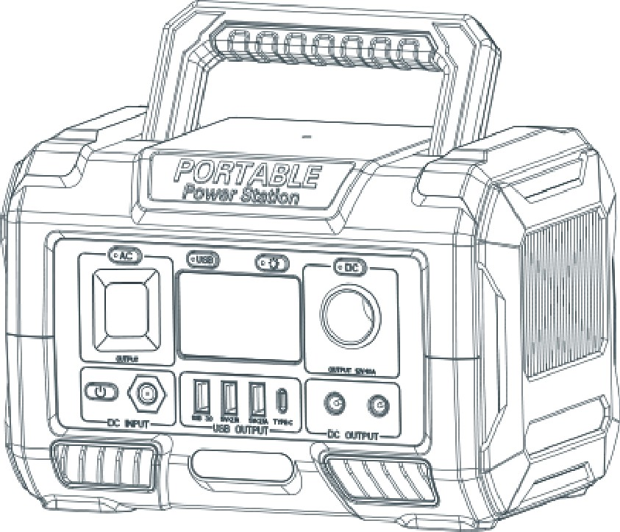
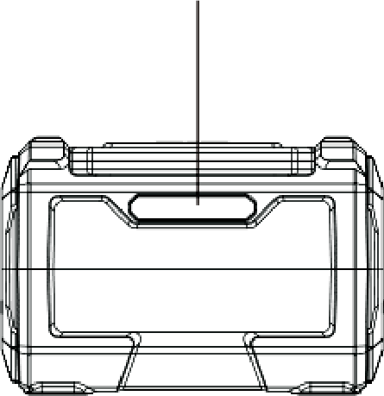
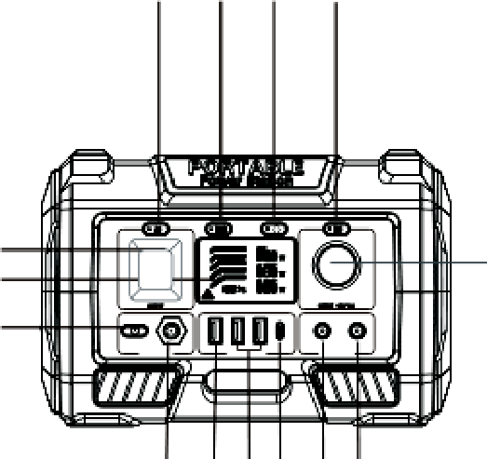

Shows the amountofpower (watts) going into the A3E while charging.

j k1mno
霆雪i二: i�ea;i:;;立霄；勺:s)your ACdevices are
g h a
- ::10忒5：＄芦芯�:(:::sy) our DCdev,ice5are

USBOUTPUT
- Press the main power button, and �hen pressthe "USB" power button,USBoutputand Wirelesscharging will be turned on,,the green LED lightonthe buttonisilluminated
- Plugyour devices into corresponding ports

Before using or storing.please read this manual carefully.and charge
your A3Ewith the included charging adapter

Power
d. USB switch g.AC output j.DCinput
m.Type-c output

- AC switch
e. LED郖itch
h. LED display
k. USB3.0 output n.12v-1Gv DC output

011

- LED light f.DC switch i..DC output
I. USBoutput
Q.12V-16VDC output

Shows 6 segments,approximating 10%-20'l/o-40% 60"/o-80%-100% capaiCity.

When charging your A3E you w,ill notice
a batterysegmentblinking,thisindicatesthe current chargestatus.Once fully cha「ged, all batterysegments will be litand remain solid

02
·---------···---------···---------·•• ®Main PowerButton

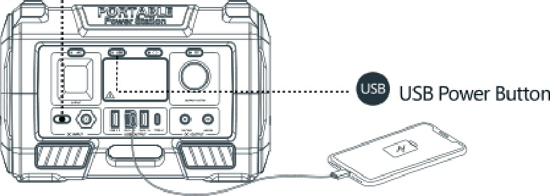
03

DC OUTPUT
- pressthe main power button, and then pres.sthe "DC" power button,the DC outputwill be turned on, the green LED lighton the button isilluminated.
- Plug your devicesinto corresponding ports,you will see the amountof power(watts)your devices are using marksonthe LED display
WhatitPowers

忑｝T如ision 巴Ele

I

ctri

cblanket

丘已Tablet
Charging from Solar

@ Placethesolar paneIs|n directsunIight.
@ Please connectthe DC outputterm,inal ofthe solar panel to the charging.portofthe power station, and the LEDdisplay will show
�he charging status.(Please charge atthe t.emperature range of0

·c~40 °).
@ Remove the charging devicefromthe solar panel and power
I Charging Indication|
The batteryindicator shows the remaining batterycapacity.
；＝；＝侈侈疹侈

痒尸芦户尸丿
0,oon

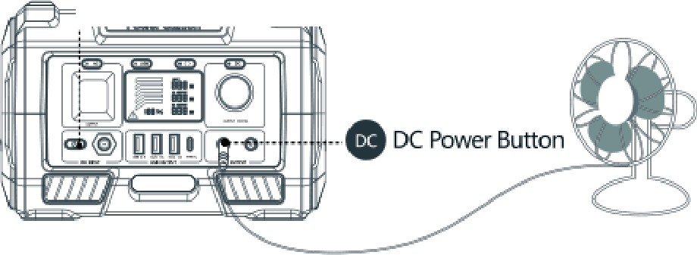
MiniFlidge � LED light燮Fan
点也乌一心－I尸仁飞 @Main Power Button
station after fully charged
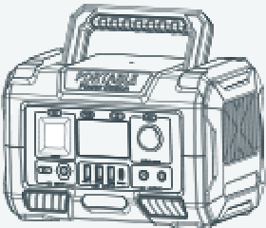
、l J
100%

High
80% 60% 叩笐， 2睬 10%

Low

AC OUTPUT
- pressthe main power button,and then pressthe "AC" power button,the AC outputwill be turned on,thegreen UED llighton the button isilluminated.
- Plug your devicesinto corresponding ports, you will see the amount
ofpowe『(watts)your devices are using marksonthe LED displa

Main Powe『Button@) i :-··-------• ACPower Button

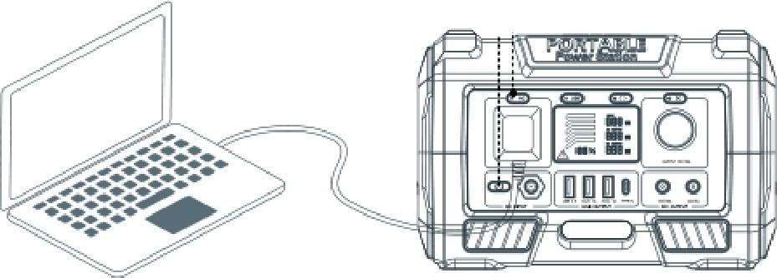
i
D Phone签USBfan琴GoPro

  - As the ambienttemperature and batteryusagetimeschange, the using time ofpowerstation will change.
  - Pleaseconfirm the powerofthe devicein theinstruction manual o『 catalog ofthe device.
  - When the charging specificationofthe deviceexceedsthe maximum value ofthis unit.this powerstation will enter automatic protection mode.the outputwill be turned offautomatically.Before using.please ensureyour electronicdeviceis below 300W.
Charging Your A3E

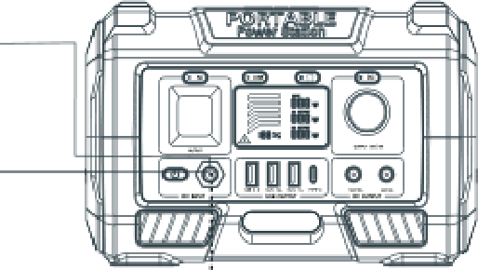
日兰－

ACWallCha屯e「
漫：目．一

So|arP.ne|

Input

;.:-1===1 -
，＇｀

Sun Solarpanel
ATTENTION! onlysupport18~28V input,Do notchargewithsolar panels thatexceed thevoltagerange

Charging from AC Adapter

© Insertthe AC adapter into the socket,and th,en connectthe other end to the DC inputcharging portofthe power station.The LED display will show the charging status
- Removethe charging adapter from power station after fully
charged.

B - [ - 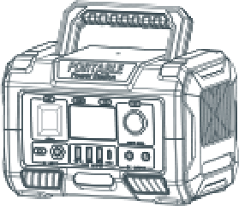
ACsocket ACchargingadapter
The power marquee will be 10%-20')/o-40%-60')/o-80%-100%. displayed in 6 segments. When the batterycapacityis below 1饶， the power marquee could notshow the specific remaining amount ofcapacity.Atthis time, please charge as soon as po达ible;
when the battery capacityis below 10%, the power marquee will
flash.
In addition, if you do notuse itfor a long time, please charge the power supply everythree months


Frequently Asked Questions
Why this power station cannotsupply power to other devices (no output)?
Capacity | 270Wh Lithium-ion
Size | 235x150x158mm (LWH)
Weight | 2.9 KG
Input | Adapter:DC 19V/2A  Solar Panel Charging:DC 18V-28V/2A
DC Output | 1x Cigarette Lighter Adapter  2x S521 DC Output:12V-16V/10A
AC Output | 11OV 60Hz / 300W
2 x USB Output | 5V/2.1A
USB-A QC Port | sv~9V/2A, 18W Max
U B-C QC Port | sv~9V/2A,18W max
Cell Type | Lithium-ion Battery
Lifecycles | � 1000 times
Working Temperature | Charge Temperature: O'C-40'C Discharge Temperature: -1O'C-45'C
SafetyProtection | Overheating Protection, Over CurrentProtection, Over Voltage Protection, ShortCircuitProtection

CD Please check whether the power button and outputports of the power station are turned on(there's no outputif the ambienttemperature is beyond -10 °C to 45 °C).
@ Check计the device completely inserted into the outputport ofpower station; Whether there is foreign matter atthe port ofdevice and power station.
® Please refer to the marquee ofthe LED display to confirm the remaining battery capacity ofthe power station. Ifit's less than 10%, the power station needs to be recharged.
® Check计the voltage and current, power specifications ofthe device exceed the range ofpower station.
� Please_ confirm whether_the pow�r station is automat)cally
turned on over current/overload/ over temperature function due to other reasons.
How to release the automatic protection function after it is activated?
Follow these steps
CD AC output overload and shortcircuit
AC outputwill enter the protection state, please remove the load ofAC output,and restartto restore normal.

@ DC overload
DC outputwill enter the protection state, please remove the load ofDC output,and restartto restore normal;
® USB output overload and shortcircuit
USB outputwill enter the protection state, please remove the load ofUSB output,USB will automatically return to normal.
"! "Troubleshooting
  - When the battery temperature reaches 70 degrees,"!" will appear on the display,after the temperature dropping,restartto restore normal.
  - When the DC outputhappens short-circuitissue,"!" will appear on the display,and the DC outputwill be automatically turned offP.lease remove the abnormality and then restartto restore normal.

Why is the adapter hotwhile charging the power station?
Our accessories include a high temperature AC adapter. In addition, the adapter is UL/ PSE ce「tified. Please feel free to use it

Whatis overload protection?
Overload protection is thatthe power station will automatically turn offwhen the power ofthe device exceeds the rated output power. when the power system detects thatthe device being used is sho「ted or overloaded. Related functions will be turned off.Please confirm whether the device parameter specifications meetthe scope ofthe power station before using it.

How do i know if my device will work with the A3E
You will need to check the amountofpower your device requires. This may require some resea「ch on your end. An online search or examining the user guide for your devices should suffice. To be compatible with the AP36E9you should use devices thatrequire less than 3

How to know the working times for my device?
You will need to check the amountofpower your device requires. This may require some research on your end. An online search or examining the user guide for your devices should suffice. To be compatible with the AK33E9 you should use devices thatrequire less than 300W.

- Do notshort-circuitthe unit.To avoid short-circuitng,keep the unitaway from all metal ob」ects (e.g.coins, hair-pins, keys, etc.).
- Do notheatthe unit,or dispose ofit in fire, water or other liquids. Keep away from high temperatures. Do notexpose the unitto directsunlight.
- Keep away from high humidity,dusty places
- Do notdisassemble or reassemble this unit.
- Do notdrop,place heavy objects on, or allow strong impactto this unit.
- This appliance is notintended for use by persons(including children) with reduced hysical, sensory or mental capab仆ites, or lack ofexperience and knowledge, unless they have been given supervision or instruction concerning use ofthe appliance by a person responsible for their safety.
- Children should be supervised to ensure thatthey do notplay with the appliance.
- Do not cover the device with towels, clothing and other item.
- The unitmay become hot when charging.This is normal.Use caution when handling.
- Use the unitproperly to avoid electronic shock.
- Please deal with scrap products in accordance with the regulations, do nottreatmentthe built-in battery as a household garbage, so as notto cause the explosion and
pollution.
  - The productis only used for emergency power station, it can notreplace the standard DC or AC power ofhousehold appliances or digital products

08 09 10 11

- This productis builtin high quality original lithium ion battery, it has no memory effectbuthigh-capacity,and it is durable However, we still recommend you to apply in the range of10 oc~30 °C, so as to obtain the optimal charging capacity;
- When charging,in order to avoid interference, please stay away from TV, radio and other equipment
- Ifthe device has notbeen used for a long time, please disconnectthe cable and store it
- Some portable devices may need to be setin charge mode to charge, see the corresponding equipmentuse manual for more information
- In order to extend the life ofproduct(lithium battery),is better to charge within 3 months, and charge atleastonce within 6 months.

Your device has and internal, non-removable, rechargeable battery.Do notattemptto remove the battery,as you may damage the device.
The battery can be charged and discharged over 1000 times, but it will eventually wear out.

All rights reserved. Reproduction in whole or in partwithout written permission is prohibited. All other trademarks are trademarks oftheir respective owners. Features and specifica­ tions are subjectto change withoutnotice.
This manual is only used as guide unless otherwise agreed.All the statement,information and suggestion in this manual,do notconstititue as express or implied gurantee.

