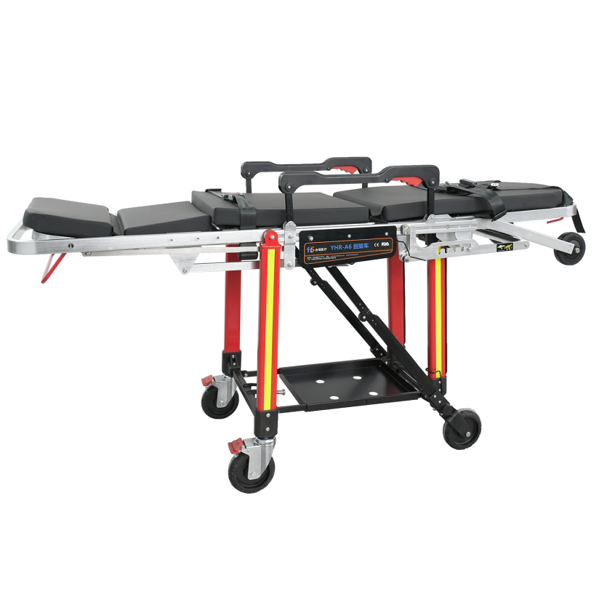

**HERUI**

**AMBULANCE STRETCHER**

**EMERGENCY TEAMS**

**AND PATIENTS DESERVE**

**A TRUE**

**AMBULANCE STRETCHER**

**STANDARD FEATURES**

|  |
| --- |
| **Can be folded into a transport chair** |
| **It has 5 types of angle position** |
| Length is adjustable pass small elevator |
| Waterproof PVC mattress |
| Aluminum backboard |
| Vest straps for chest,another for knee |
| Collapsible side rails |
| Vehicle Locking Device Included |
| Durable aluminum alloy |

**TECHNICAL PARAMETER**

|  |  |  |  |  |  |  |  |
| --- | --- | --- | --- | --- | --- | --- | --- |
| **MODEL** | **MATERIAL** | PRODUCT SIZE(L*W*H) | CARTON SIZE(L*W*H) | Backrest | Load bearing | N.W | G.W |
| YHR-A6 | Aluminium alloy | 192*57*82.5cm | 204*64*30cm | 75° | 325kg | 38.6 | 45 |

**TECHNICAL FEATURES**

|  |  |
| --- | --- |
| Technical features | ■ This stretcher can be quickly converted to a wheeled chair,and has 5 types of angle position,the wheeled chair position can meet the needs to operate in narrow space such as small lifts.The length is adjustable,length adjustment adopts bayonet type synchronous folding mechanism.  ■The legs of the stretcher can lock automatically when be unloaded from the ambulance.  ■Equip with nylon adjustable guardrails and vest type three-point safety belts.  ■The mattress is seamless double layers PU material,thickness 50mm.  ■Equipped with adjustable two-stage I.V pole,the max adjustable height is 100cm,and equipped with gas-spring support backrest,the patient can quickly transform from sitting to a half-lying or lying position,making it faster to do CPR or tracheal intubation.  ■ Paste fluorescent color warning sticker on legs,it can provide strong reflected light ray to perform the warning function.  ■Optional accessories:Oxygen bottle holder,Placing planes for defibrillator and ventilator etc.  ■Loading height:64cm,Wheel dia.:Φ150mm |

**OPTIONAL FEATURES**

|  |
| --- |
| Oxygen holder |
| Two-stage I.V. pole |
| Shelves for defibrilatorand ventilator |
| Color of reflective strips |