**Table Type Plan Labeling machine**

**About Us**

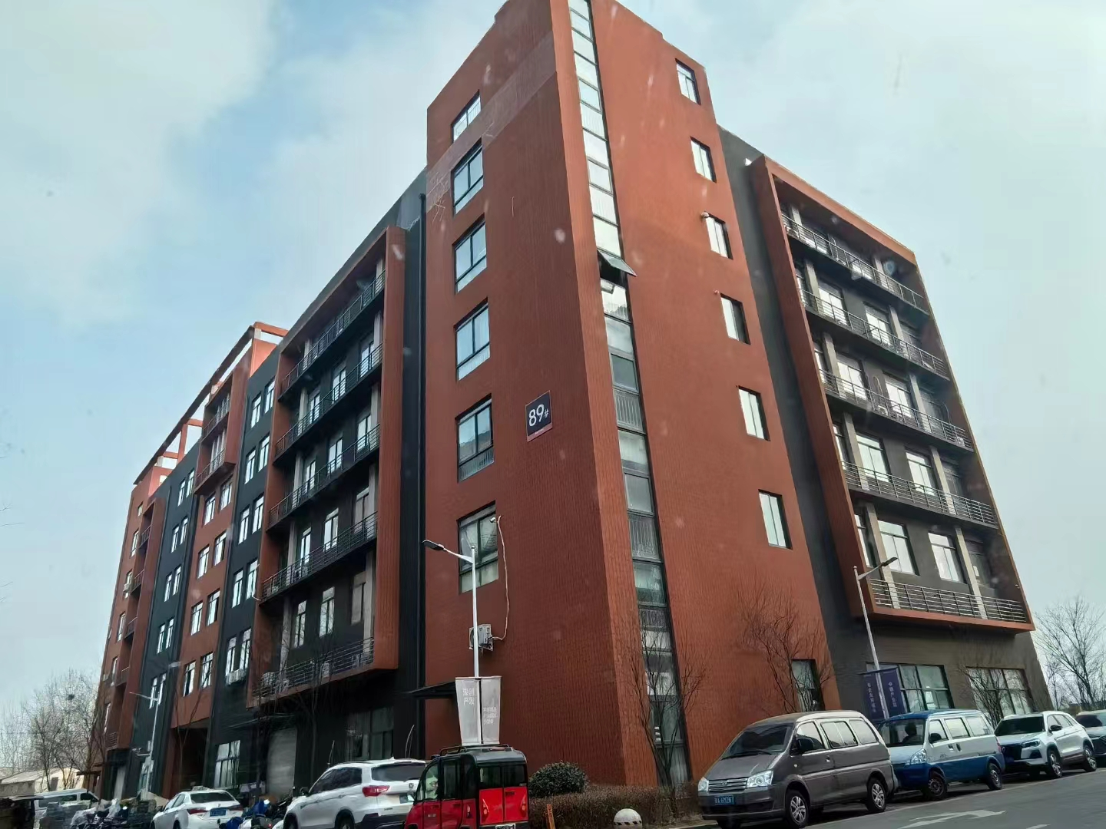

**Our company, located at Building 2-103, Zhongkai Enterprise City, National Economic and Technological Development Zone, Xinxiang City, Henan Province, is a regional branch of a leading labeling machinery manufacturer originally based in Dongguan. We specialize in designing and manufacturing advanced labeling machines, filling systems, and intelligent post-filling packaging equipment.**

**We deliver customized automation solutions for diverse industries, including food and beverage, pharmaceuticals, cosmetics, electronics, logistics, and tobacco. Our clients include globally recognized brands such as China Tobacco, Shuanghui, Muyuan, Sanquan, Antuo Biotech, White Elephant, Mixue, Tianbing Group, and others.**

**With a strong presence across China, we also serve international markets. We have established partnerships in Southeast Asia, the Middle East, Latin America, and Europe, supported by our independent import/export license to ensure seamless global operations.**

**Corner of the exhibition hall**

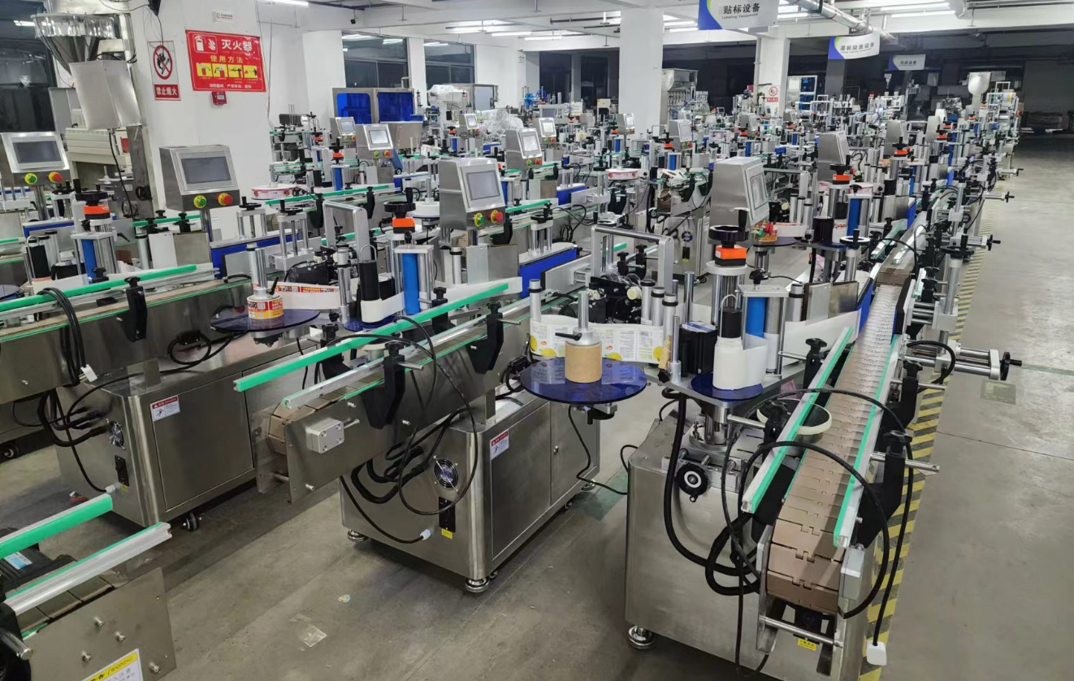

**Warehouse corner**

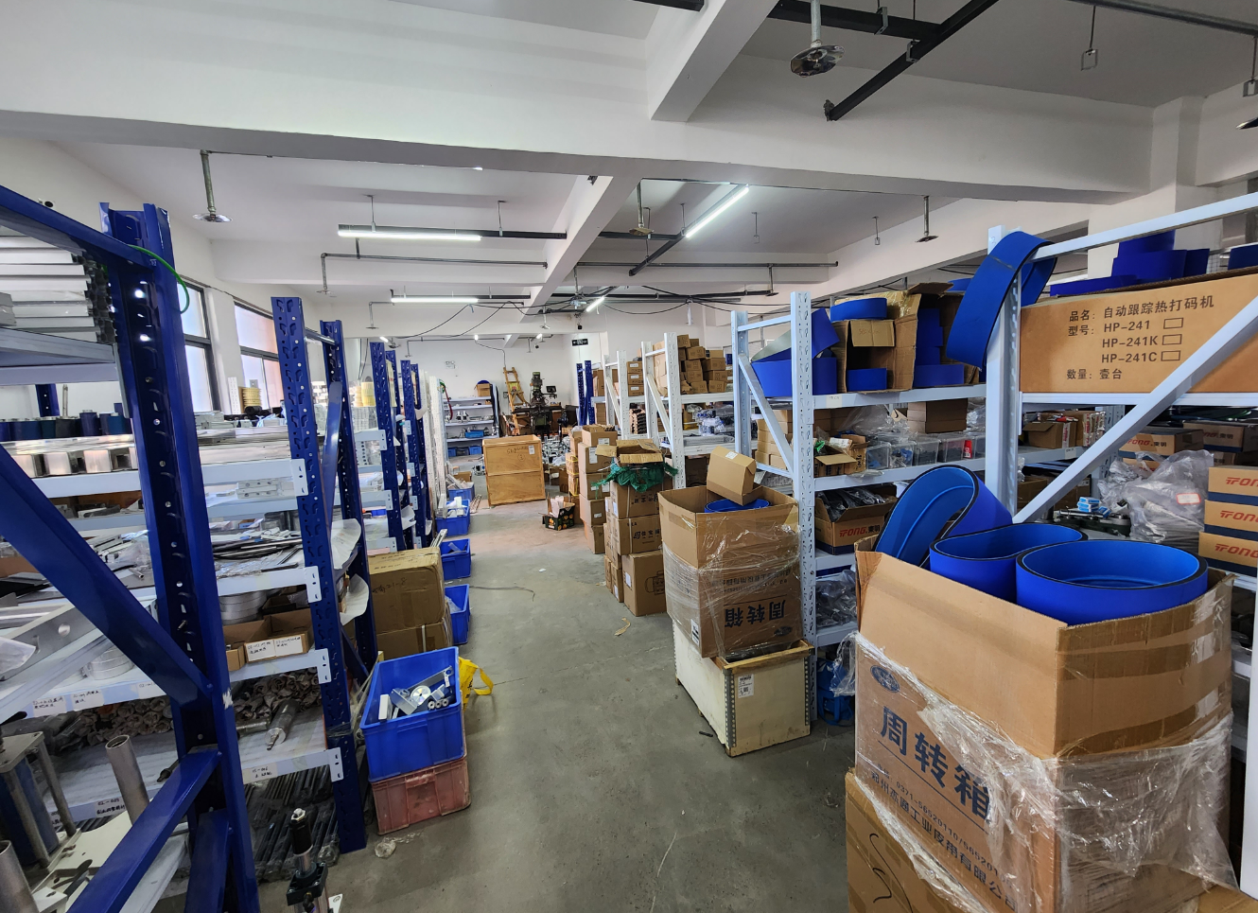

**Description of products**

**1.Basic Applications**

**Designed for applying labels or self-adhesive films to the top surfaces of various items, such as books, folders, boxes, cartons, or bags. Adaptable to uneven surfaces by replacing the label pressing mechanism. Widely used for flat labeling on large products and objects with significant dimensional variations.**

**Optional Configurations:**

**- Integrate a ribbon coder or inkjet printer into the labeling head to print production dates, batch numbers, or barcodes directly onto labels.**

**- Install an inkjet printer on the conveyor belt to mark production dates, batch numbers, or barcodes on products before or after labeling.**

**2.Scope of Application**

**Applicable Labels:Self-adhesive labels, self-adhesive films, electronic supervision codes, barcodes, etc.**

**Applicable Products: Products requiring label or film application on flat or slightly curved surfaces.**

**\*Industries: Widely used in printing, stationery, food, daily chemicals, electronics, pharmaceuticals, and related industries.**

**Examples: Labeling on books, folders, packaging boxes, flat boards, etc.**

**3.Working Process**

**Core Operating Principle: A sensor detects the passing product and sends a signal to the labeling control system. After processing by the PLC, the system dispenses and applies the label to the preset position at the precise moment. The product then moves through the label-pressing device to ensure secure adhesion, completing the labeling cycle.**

**Operational Steps:**

**Place products (compatible with production lines) -> Automated conveyance -> Product alignment (automated) -> Product detection (automated) -> Labeling (automated) -> Label pressing (automated) -> Collect labeled products.**

1. **picture**

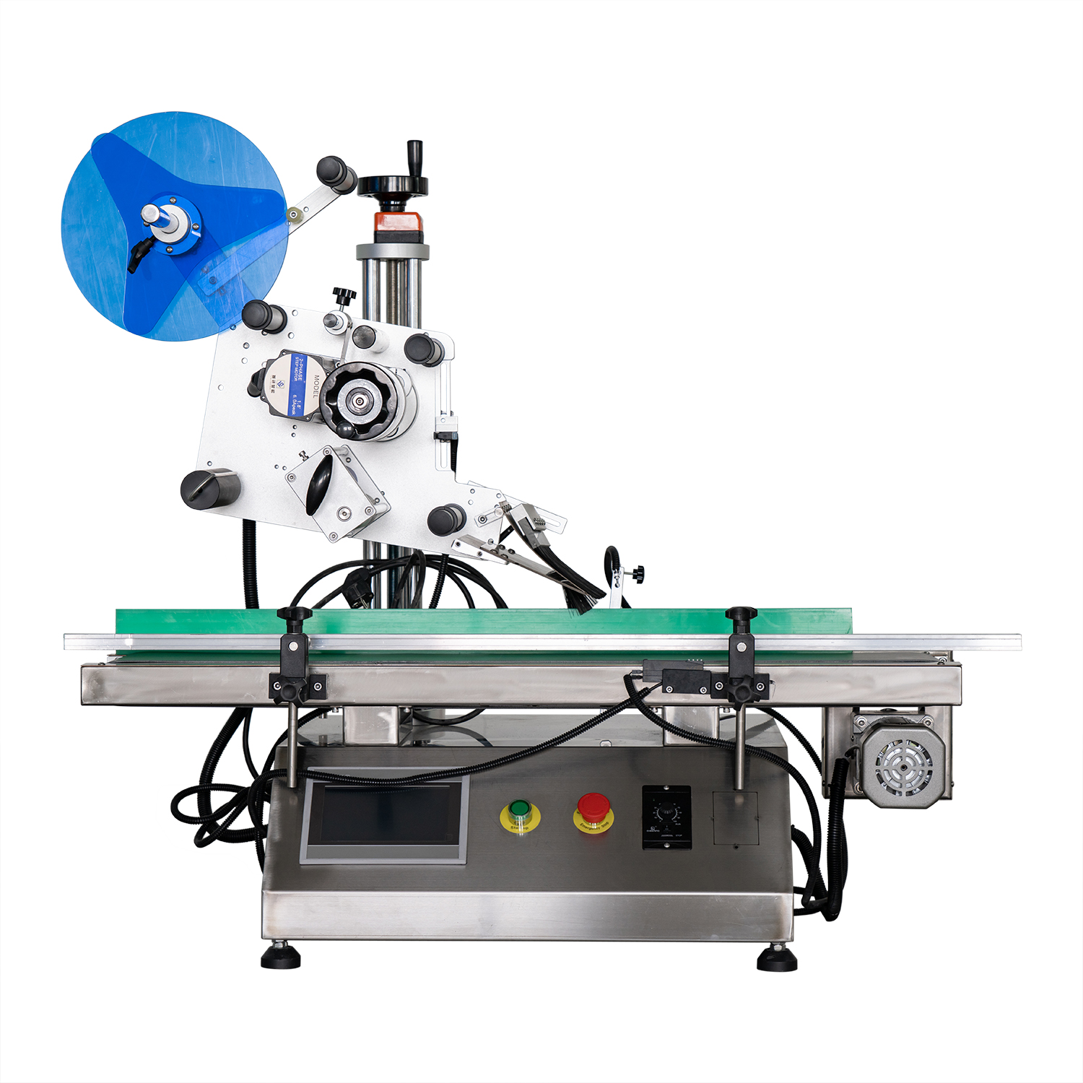

**5.Details   
 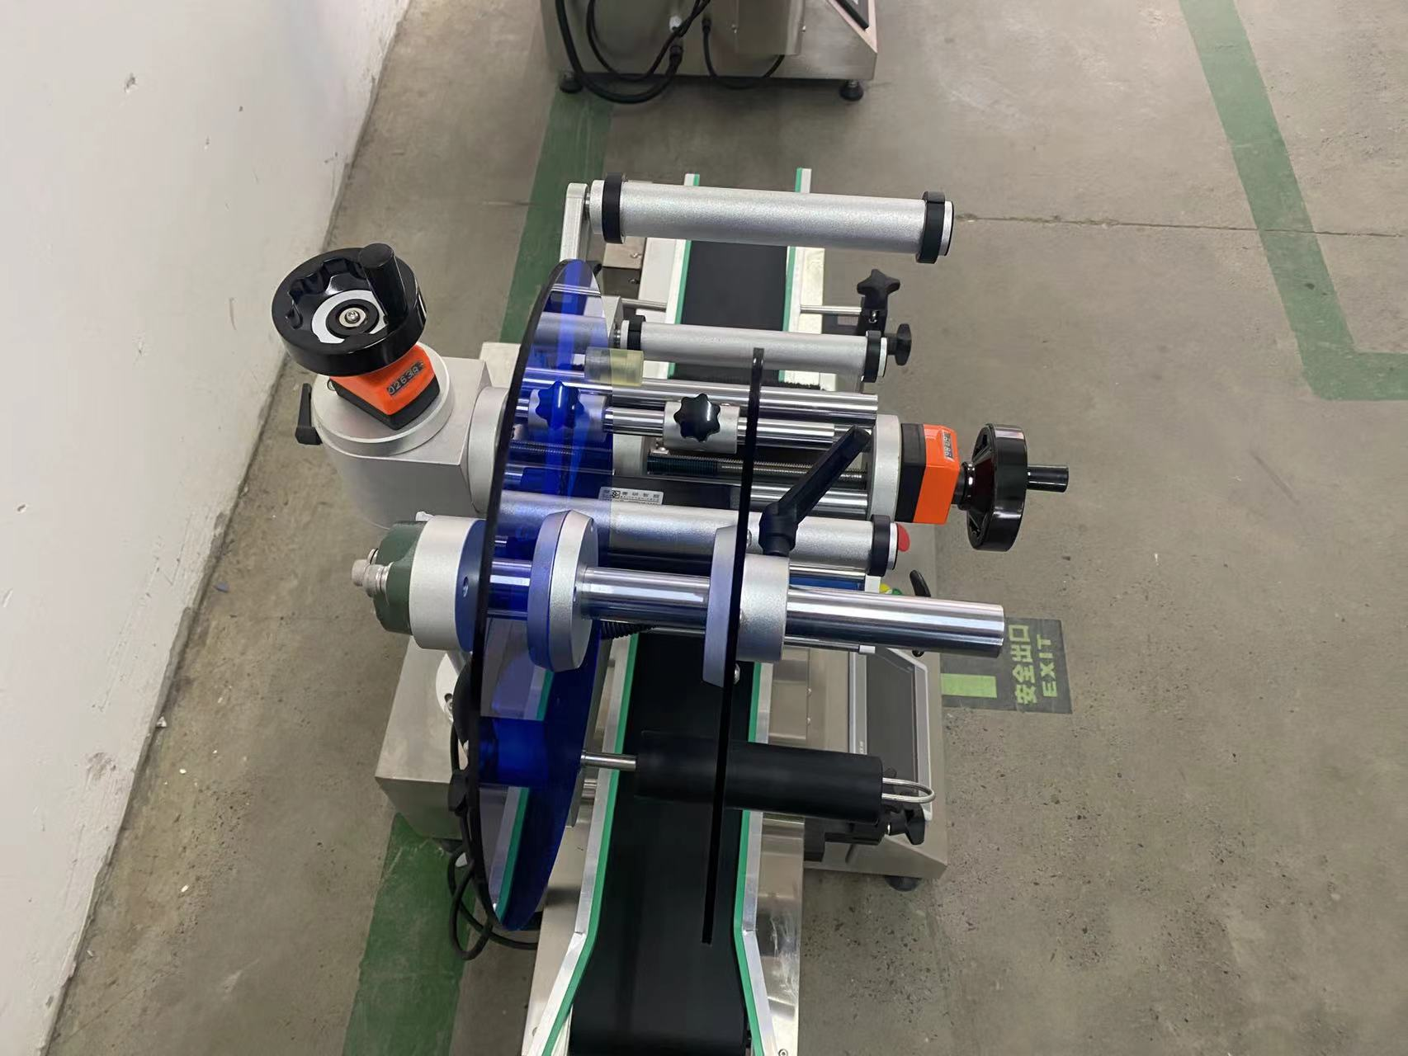**

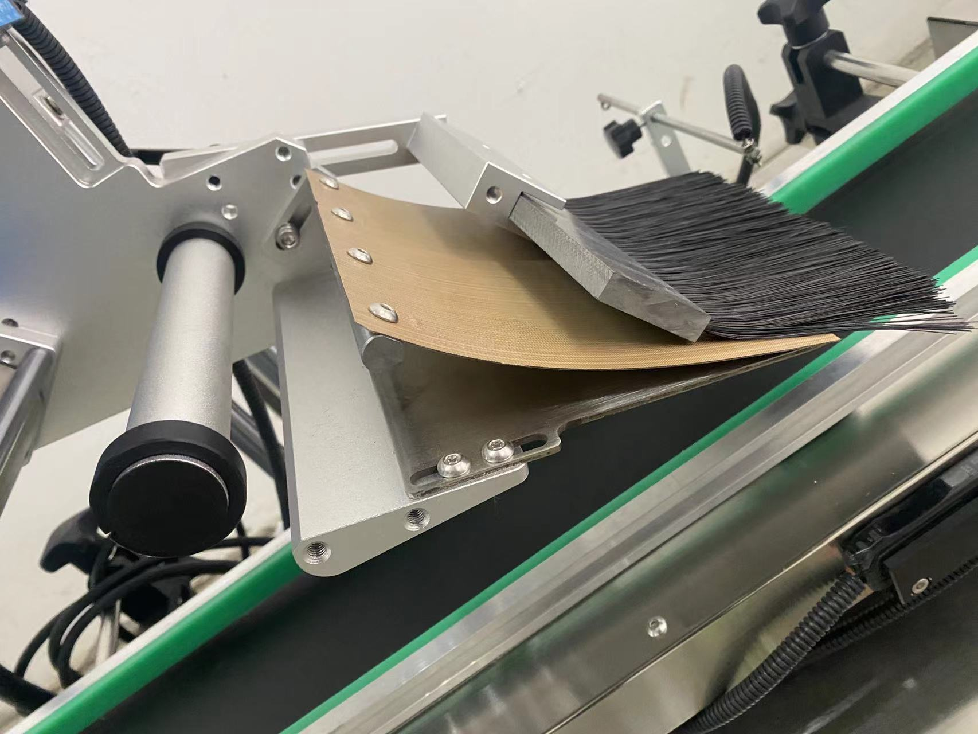

**technical specification**

|  |  |
| --- | --- |
| **适用产品尺寸**  **Applicadle product size** | **length：40mm～400mm**  **width：40mm～200mm**  **Height：5mm～150mm** |
| **适用标签尺寸**  **Applicadle label size** | **length：6mm～250mm**  **width（Bottom paper width）：20mm～160mm** |
| **贴标速度**  **Labeling speed** | **20～80Pieces/minute (depending on product and label size)）；** |
| **贴标精度**  **Labeling accuracy** | **±1mm (Does not include product or label errors)；** |
| **整机尺寸**  **Overall size** | **About1200mm×680mm×960mm（长×宽×高）；** |
| **适用电压**  **Adaptable voltage** | **220V/50HZ；** |
| **整机重量**  **Tatal weight** | **About 100Kg。** |

|  |  |
| --- | --- |
| **标准配置明细**  **Configuration list** | |
| **名称/Name** | **品牌/Brand** |
| **中间继电器**  **auxiliary relay** | **正泰**  **ZHENGTAI** |
| **侧标电眼**  **photosensor** | **西克/劳易测 /中芯**  **Sick/Leuze/zxcg** |
| **触摸屏**  **Touch screen** | **昆仑通态/台达**  **MCGS/Delta** |
| **PLC** | **松下/台达**  **Panasonic/Delta** |
| **测物电眼**  **Bottle sensor** | **松下/中芯**  **Panasonnic/zxcg** |
| **输送电机**  **Conveyor Drive Motor** | **东邦调速电机**  **DPG** |
| **牵引电机**  **servo motor** | **赛研步进电机**  **Research stepper motor** |
| **开关电源**  **Switching power supply** | **正泰**  **ZHENGTAI** |

Note: After-Sales Service:

1. Equipment Warranty Terms:

(1) One-year warranty on the entire machine. Repairs and replacements for quality-related defects are free of charge during the warranty period. Wear-and-tear parts are excluded from coverage.

(2) Lifetime maintenance support. Repairs outside the warranty period incur service and material costs. Lifetime spare parts supply and technical support are guaranteed.