**Automatic Horizontal Round Bottle Labeling**

**About Us**

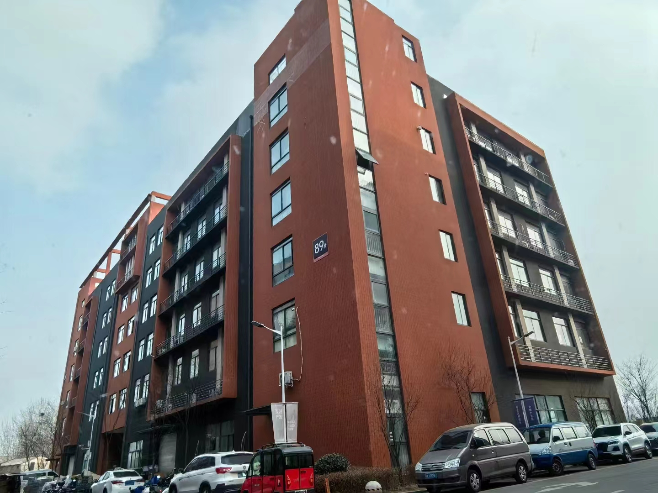

**Our company, located at Building 2-103, Zhongkai Enterprise City, National Economic and Technological Development Zone, Xinxiang City, Henan Province, is a regional branch of a leading labeling machinery manufacturer originally based in Dongguan. We specialize in designing and manufacturing advanced labeling machines, filling systems, and intelligent post-filling packaging equipment.**

**We deliver customized automation solutions for diverse industries, including food and beverage, pharmaceuticals, cosmetics, electronics, logistics, and tobacco. Our clients include globally recognized brands such as China Tobacco, Shuanghui, Muyuan, Sanquan, Antuo Biotech, White Elephant, Mixue, Tianbing Group, and others.**

**With a strong presence across China, we also serve international markets. We have established partnerships in Southeast Asia, the Middle East, Latin America, and Europe, supported by our independent import/expor**

**Corner of the exhibition hall**

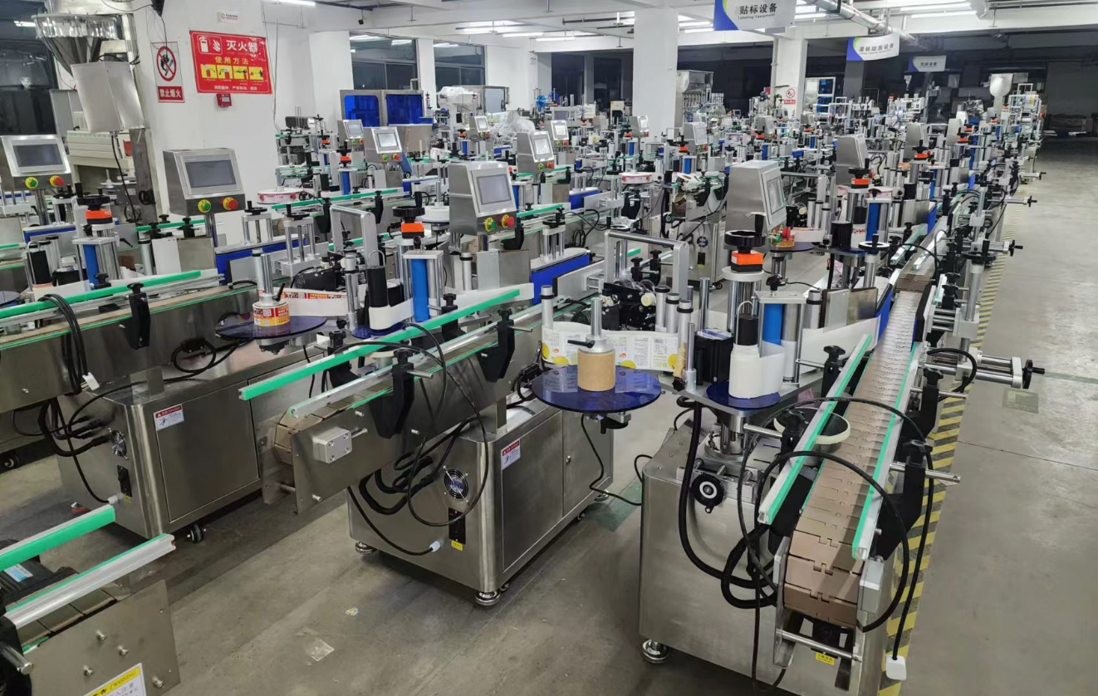

**Warehouse corner**

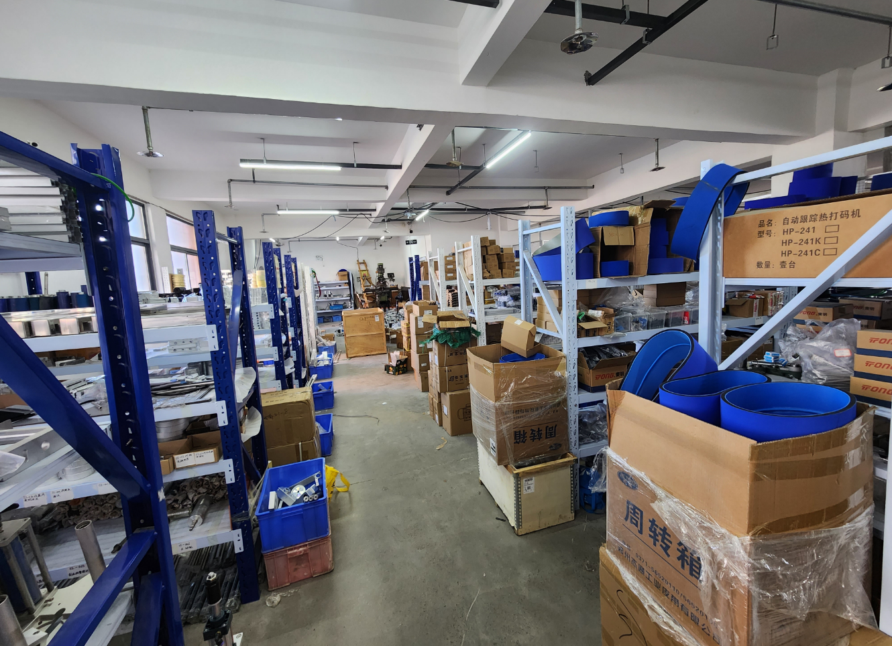

**Description of products**

**1.1. Basic Applications**

**Suitable for labeling the full or partial circumference of unstable cylindrical objects. Utilizes horizontal conveying and labeling, with pneumatic cylinder stopping mechanisms to enhance stability and labeling efficiency. Adding a bottle separating mechanism further reduces manual labor and increases throughput.**

**Optional Configurations:**

**- Integrate a coder or inkjet printer into the labeling head to print production dates, batch numbers, or barcodes directly onto labels.**

**- Install an inkjet printer on the conveyor belt to mark production dates, batch numbers, or barcodes on products pre-labeling or post-labeling.**

**2.Scope of Application**

**Applicable Products: Compact products requiring labeling or film application on cylindrical or small conical surfaces.**

**Applicable Labels: Self-adhesive labels, self-adhesive films, electronic supervision codes, barcodes, etc.**

**Industries: Widely used in pharmaceuticals, cosmetics, electronics, hardware, plastics, and related industries.**

**Examples: Labeling on solid glue sticks, oral liquid bottles, pen barrels, lipstick cases, etc.**

**3.Working Process**

**Core Operating Principle: The dividing wheel separates products and places them onto the conveyor. A sensor detects the passing product and sends a signal to the labeling control system. At the precise position, the system activates the corresponding motor to dispense and apply the label to the target area. The product then moves through the label-pressing device, where a pressing belt rotates the product to roll and secure the label, completing the application.**

**Operational Steps:**

**Load products (into the feed hopper) -> Separate and spread products onto conveyor rollers -> Conveyance -> Product detection -> Labeling -> Label pressing -> Collect labeled products.**

**4.Functional Features**

**High-Speed Performance: Utilizes a side-mounted roller conveyor mechanism with tilted chains for auto-centering bottles, ensuring stable labeling. Achieves speeds up to 400 bottles/minute, significantly reducing labor and operational costs.**

**Low Breakage Rate: Incorporates flexible bottle separation and gentle label pressing technology for smooth operation, with a bottle breakage rate below 1/100,000.**

**Premium Labeling Quality: Features label path correction technology for high head-to-tail alignment accuracy. Rolling-press adhesion ensures smooth, wrinkle-free, bubble-free labels, enhancing packaging aesthetics.**

**24/7 Operation Capability: Designed for continuous, uninterrupted production.**

**Smart Automation: Photoelectric tracking enables "no-labeling without detected products," auto-correction for missing labels, and label detection to prevent waste and missed applications.**

**\*\*Robust & Hygienic Design:** Constructed with stainless steel and high-grade aluminum alloy, GMP-compliant, featuring durable and sleek industrial-grade construction.**

**Advanced Management Functions:**

**- Fault alarm system**

**- Production counting**

**- Energy-saving mode**

**- Production quota alerts**

**- Parameter setting protection for streamlined operations.**

**Optional Upgrades:**

**① Hot stamping/inkjet printing integration.**

**② Automatic product collection (product-dependent).**

**③ Customized automatic feeding systems (client-specific configurations).**

**5.Machine pictures**

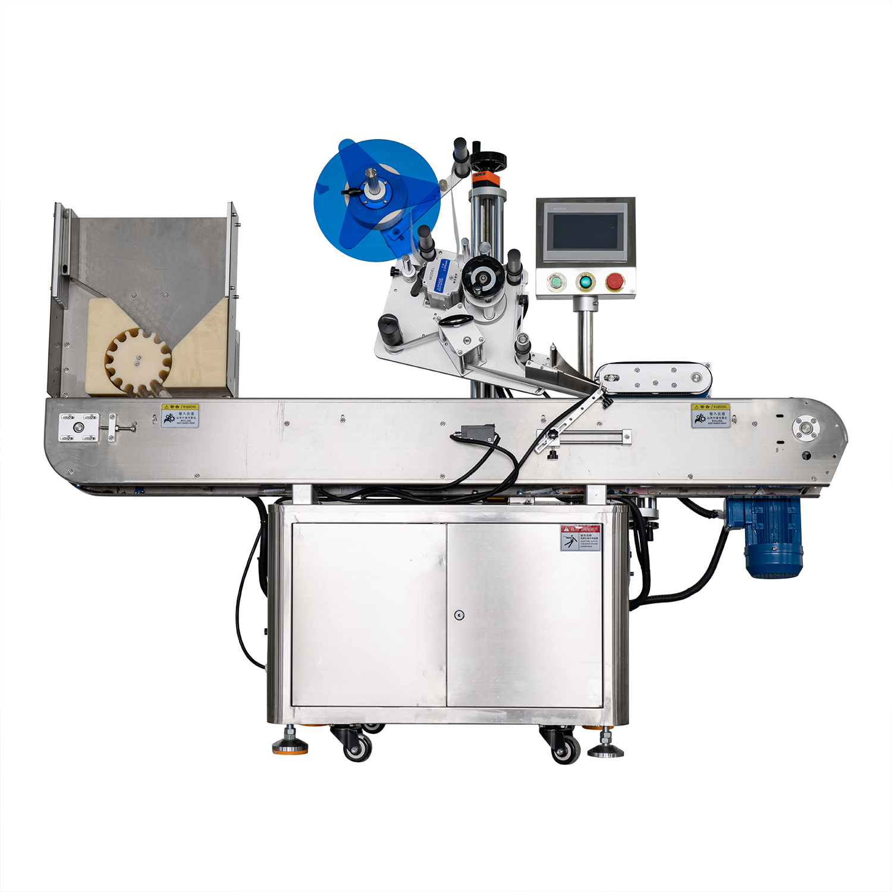

**6.Details**

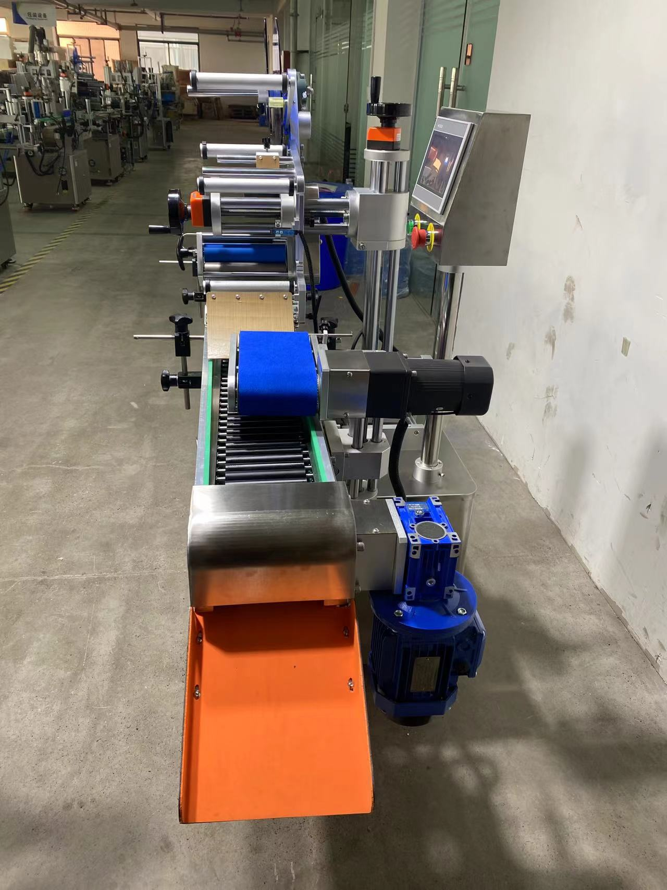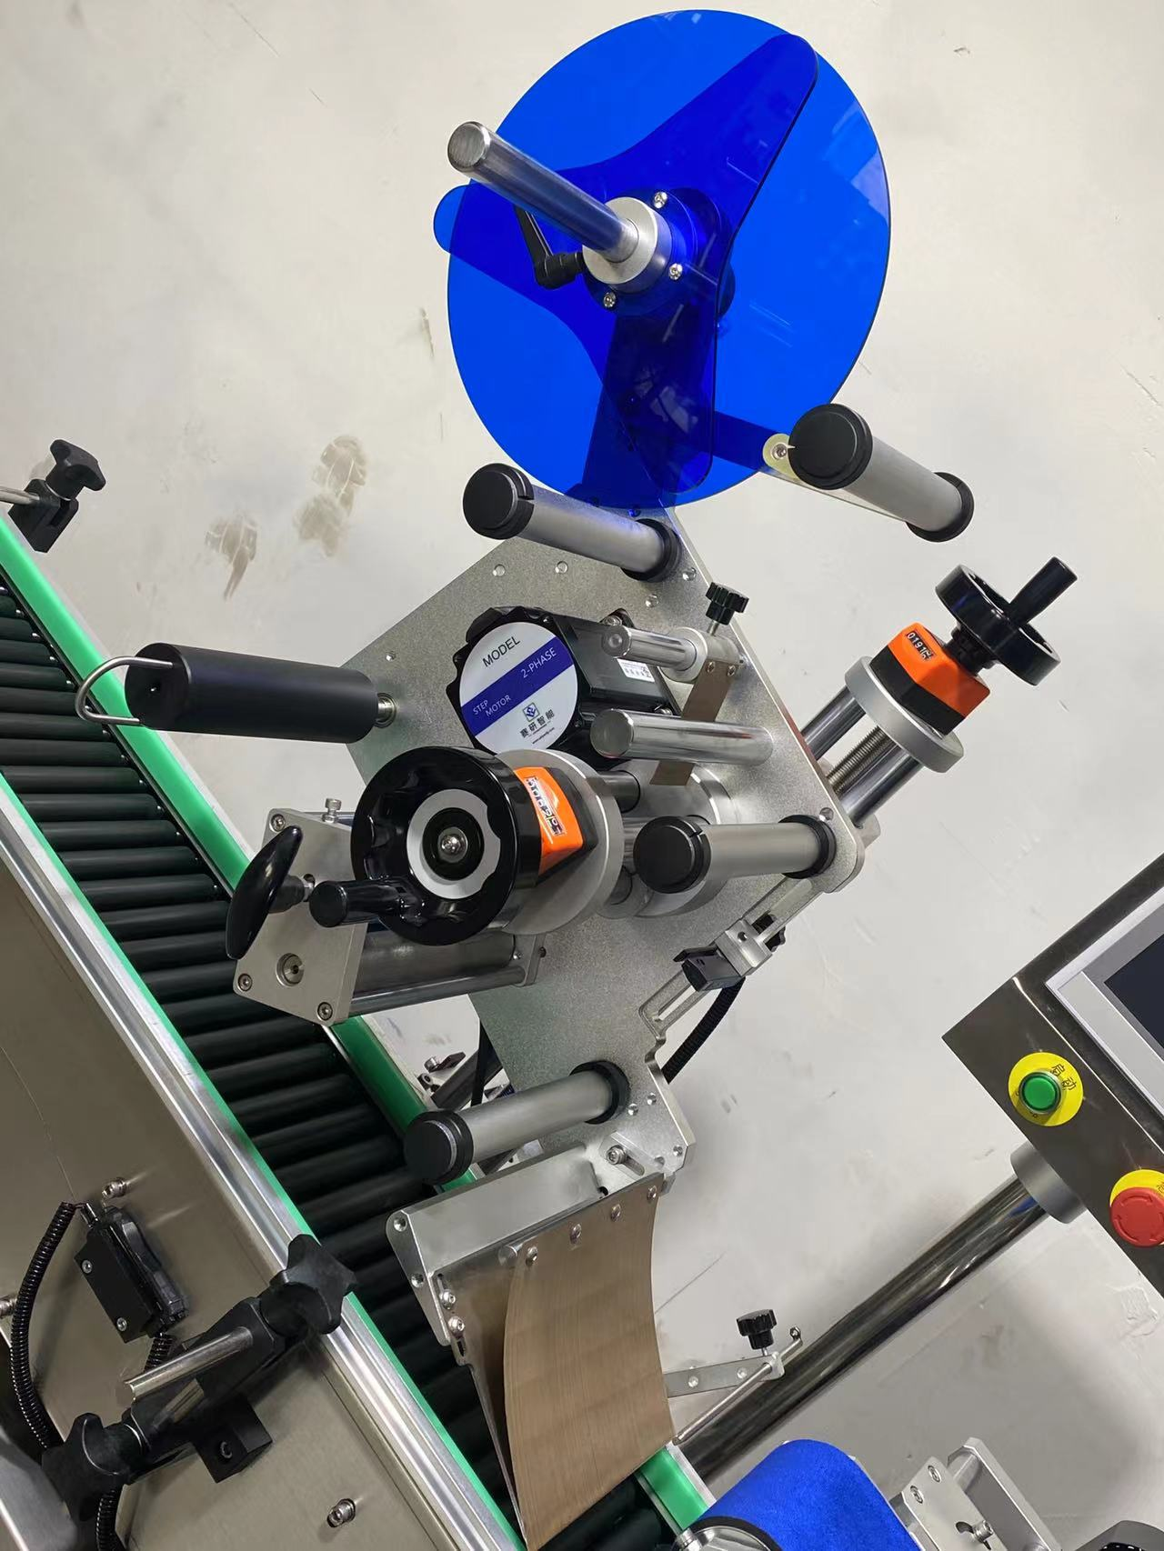

**technical specification**

|  |  |
| --- | --- |
| **适用产品尺寸**  **Applicadle product size** | **（For round bottles）：diameter：φ14mm～φ28mm(Note:(Standard configuration is compatible))** |
| **适用标签尺寸**  **Applicadle label size** | **length：15mm～100mm**  **width（Bottom paper width）：15mm～100mm** |
| **贴标速度**  **Labeling speed** | **100～300Pieces/minute（Related to product and label size）；** |
| **贴标精度**  **Labeling accuracy** | **±1mm (Does not include product or label errors)；** |
| **整机尺寸**  **Overall size** | **约2750mm×680mm×1450mm（Length × Width × Height）；** |
| **适用电压**  **Adaptable voltage** | **220V/50HZ；** |
| **整机重量**  **Tatal weight** | **About 200Kg。** |

|  |  |
| --- | --- |
| **标准配置明细**  **Configuration list** | |
| **名称/Name** | **品牌/Brand** |
| **中间继电器**  **auxiliary relay** | **正泰**  **ZHENGTAI** |
| **开关电源**  **Switching power suppl** | **正泰**  **ZHENGTAI** |
| **侧标电眼**  **photosensor** | **西克/劳易测 /中芯**  **Sick/Leuze/zxcg** |
| **触摸屏**  **Touch screen** | **昆仑通态/台达**  **MCGS/Delta** |
| **PLC** | **松下/台达**  **Panasonic/Delta** |
| **测物电眼**  **Bottle sensor** | **松下/中芯**  **Panasonnic/zxcg** |
| **输送电机**  **Conveyor Drive Motor** | **东邦调速电机**  **DPG** |
| **牵引电机**  **servo motor** | **赛研步进电机**  **Research stepper motor** |
| **覆标电机**  **Lead Screw/Guide** | **东邦调速电机**  **DPG** |

**Note: After-Sales Service:**

**1.Equipment Warranty Terms:**

**(1) One-year warranty on the entire machine. Repairs and replacements for quality-related defects are free of charge during the warranty period. Wear-and-tear parts are excluded from coverage.**

**(2) Lifetime maintenance support. Repairs outside the warranty period incur service and material costs. Lifetime spare parts supply and technical support are guaranteed.**