**Table Type Round bottle labeling machine**

**About Us**

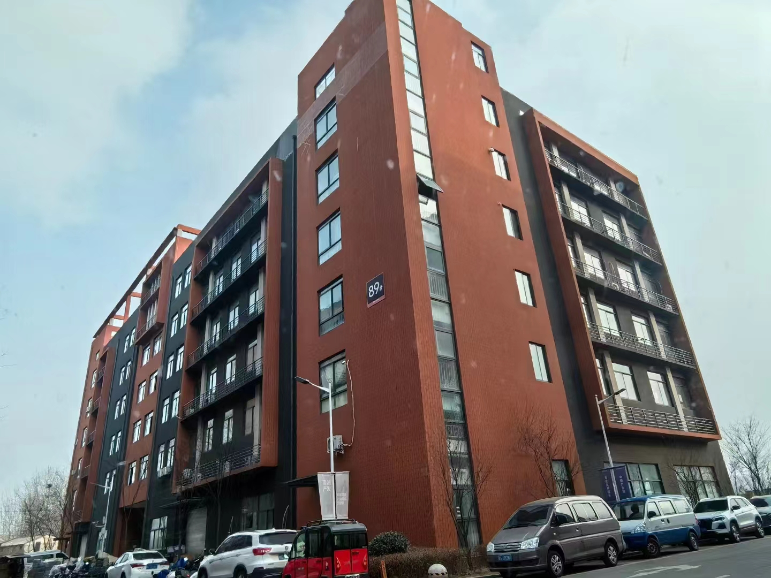

**Our company, located at Building 2-103, Zhongkai Enterprise City, National Economic and Technological Development Zone, Xinxiang City, Henan Province, is a regional branch of a leading labeling machinery manufacturer originally based in Dongguan. We specialize in designing and manufacturing advanced labeling machines, filling systems, and intelligent post-filling packaging equipment.**

**We deliver customized automation solutions for diverse industries, including food and beverage, pharmaceuticals, cosmetics, electronics, logistics, and tobacco. Our clients include globally recognized brands such as China Tobacco, Shuanghui, Muyuan, Sanquan, Antuo Biotech, White Elephant, Mixue, Tianbing Group, and others.**

**With a strong presence across China, we also serve international markets. We have established partnerships in Southeast Asia, the Middle East, Latin America, and Europe, supported by our independent import/export license to ensure seamless global operations.**

**Corner of the exhibition hall**

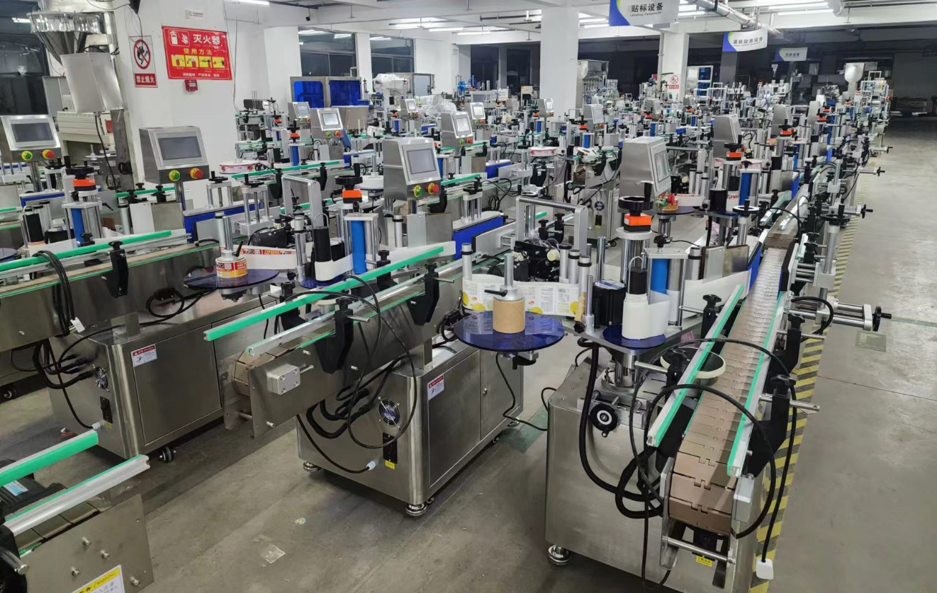

**Warehouse corner**

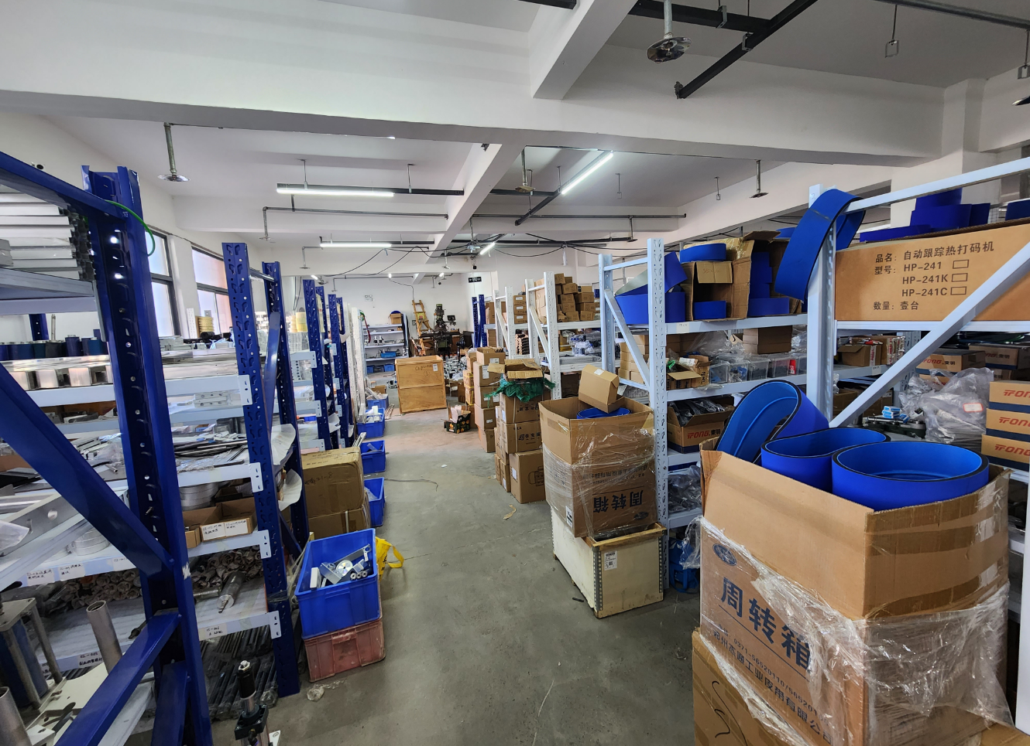

**Description of products**

**1.Basic Applications**

**Designed for full-circumference or semi-circumference labeling on round bottles in pharmaceutical, food, daily chemical, and related industries.**

**Optional Configurations:**

**- Integrate an automatic rotary bottle sorting system to connect with upstream production lines, enabling automated bottle feeding for increased efficiency.**

**- Add a ribbon coder labeling module for on-site printing of production dates and batch numbers, streamlining packaging processes and enhancing production efficiency.**

**2.Scope of Application**

**Applicable Labels: Self-adhesive labels, self-adhesive films, electronic supervision codes, barcodes, etc.**

**Applicable Products: Products requiring label or film application on cylindrical surfaces.**

**Industries: Widely used in food, pharmaceuticals, cosmetics, daily chemicals, electronics, hardware, plastics, and related industries.**

**\*\*Examples:** Labeling on PET round bottles, plastic bottles, food cans, etc.**

**3.Working Process**

**Core Operating Principle: After placing the product on the conveyor chain, a sensor detects its passage and sends a signal to the labeling control system. At the precise position, the system activates the motor to dispense and apply the label to the target area. As the product moves through the label-pressing device, a pressing belt rotates the product to roll and secure the label, completing the application.**

**Operational Steps:**

**Place products (compatible with production lines) -> Automated conveyance -> Product detection -> Labeling -> Label pressing -> Collect labeled products.**

**4.Machine pictures**

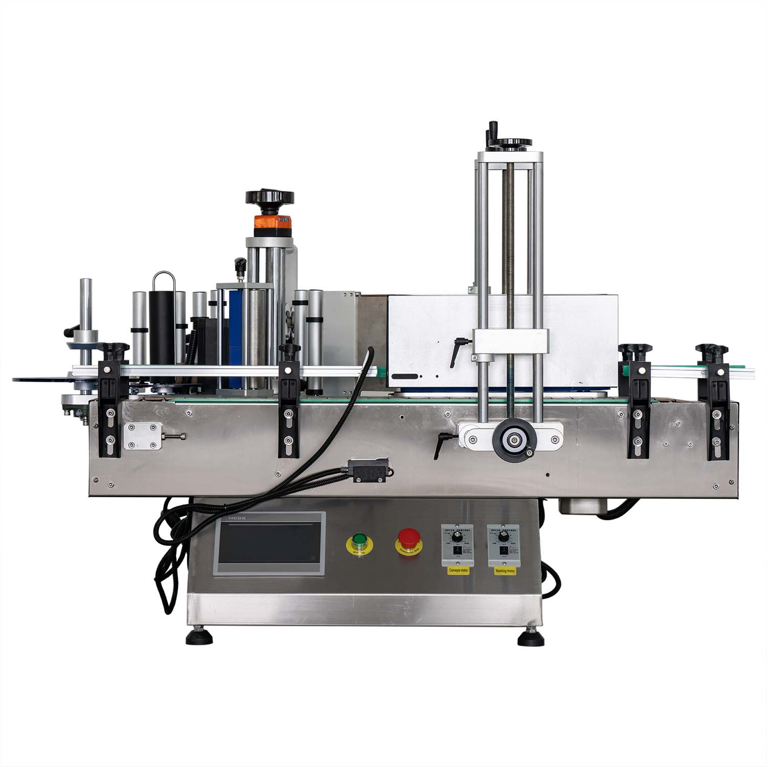

1. **Details**

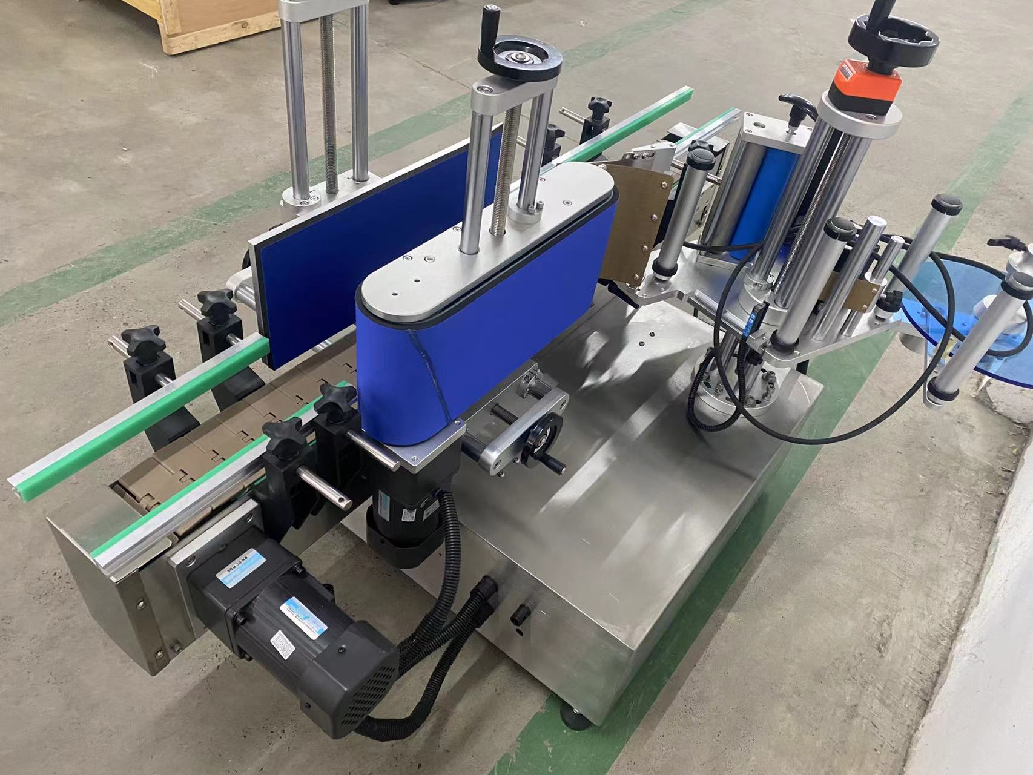

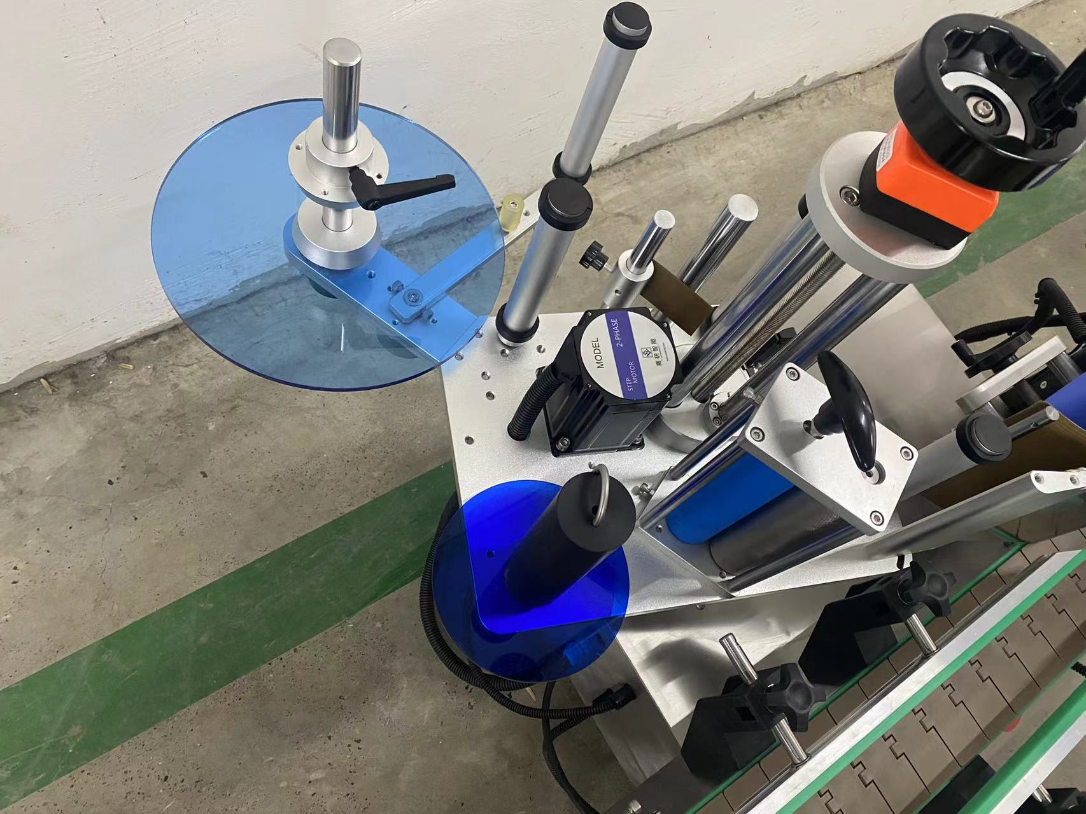

**technical specification**

|  |  |
| --- | --- |
| **适用产品尺寸**  **Applicadle product size** | **（For round bottles) and height: diameter：φ25mm～φ100mm**  **high：25mm～230mm（Related to the size and shape ratio of the product）** |
| **适用标签尺寸**  **Applicadle label size** | **length：20mm～285mm**  **Width (base paper width）：15mm～175mm** |
| **贴标速度**  **Labeling speed** | **30～60Pieces/minute (depending on product and label size)）；** |
| **贴标精度**  **Labeling accuracy** | **±1mm (Does not include product or label errors)；** |
| **整机尺寸**  **Overall size** | **约1260mm×1080mm×931mm（Length × Width × Height）；** |
| **适用电压**  **Adaptable voltage** | **220V/50HZ；** |
| **整机重量**  **Tatal weight** | **About 100Kg。** |

|  |  |
| --- | --- |
| **标准配置明细**  **Configuration list** | |
| **名称/Name** | **品牌/Brand** |
| **中间继电器**  **auxiliary relay** | **正泰**  **ZHENGTAI** |
| **侧标电眼**  **photosensor** | **西克/劳易测 /中芯**  **Sick/Leuze/zxcg** |
| **触摸屏**  **Touch screen** | **昆仑通态/台达**  **MCGS/Delta** |
| **PLC** | **松下/台达**  **Panasonic/Delta** |
| **测物电眼**  **Bottle sensor** | **松下/中芯**  **Panasonnic/zxcg** |
| **输送电机**  **Conveyor Drive Motor** | **东邦调速电机**  **DPG** |
| **牵引电机**  **servo motor** | **赛研步进电机**  **Research stepper motor** |
| **覆标电机**  **Lead Screw/Guide** | **东邦调速电机**  **DPG** |
| **开关电源**  **Switching power supply** | **正泰**  **ZHENGTAI** |

**Note: After-Sales Service:**

**1. Equipment Warranty Terms:**

**(1) One-year warranty on the entire machine. Repairs and replacements for quality-related defects are free of charge during the warranty period. Wear-and-tear parts are excluded from coverage.**

**(2) Lifetime maintenance support. Repairs outside the warranty period incur service and material costs. Lifetime spare parts supply and technical support are guaranteed.**