**Positioning round bottle labeling machine**

**About Us**

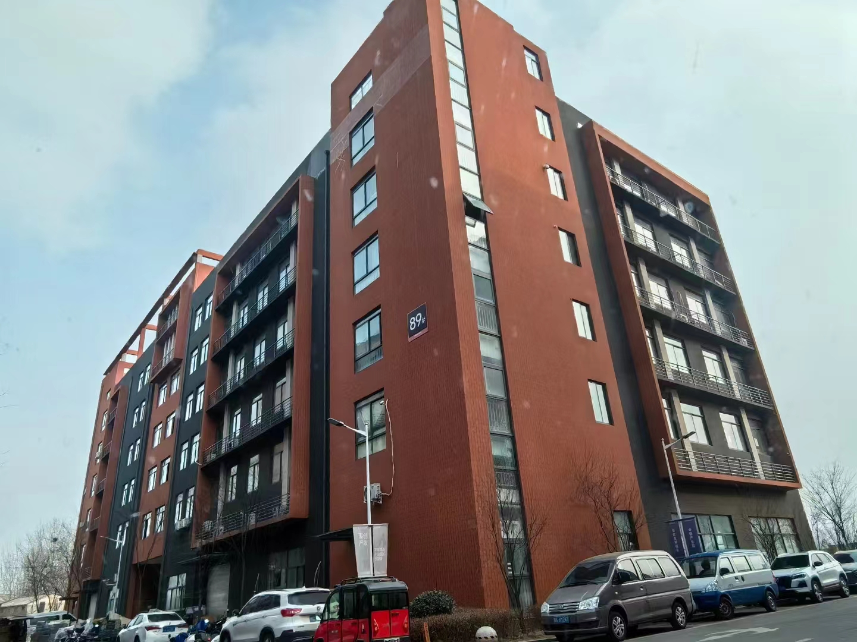

**Our company, located at Building 2-103, Zhongkai Enterprise City, National Economic and Technological Development Zone, Xinxiang City, Henan Province, is a regional branch of a leading labeling machinery manufacturer originally based in Dongguan. We specialize in designing and manufacturing advanced labeling machines, filling systems, and intelligent post-filling packaging equipment.**

**We deliver customized automation solutions for diverse industries, including food and beverage, pharmaceuticals, cosmetics, electronics, logistics, and tobacco. Our clients include globally recognized brands such as China Tobacco, Shuanghui, Muyuan, Sanquan, Antuo Biotech, White Elephant, Mixue, Tianbing Group, and others.**

**With a strong presence across China, we also serve international markets. We have established partnerships in Southeast Asia, the Middle East, Latin America, and Europe, supported by our independent import/export license to ensure seamless global operations.**

**Corner of the exhibition hall**

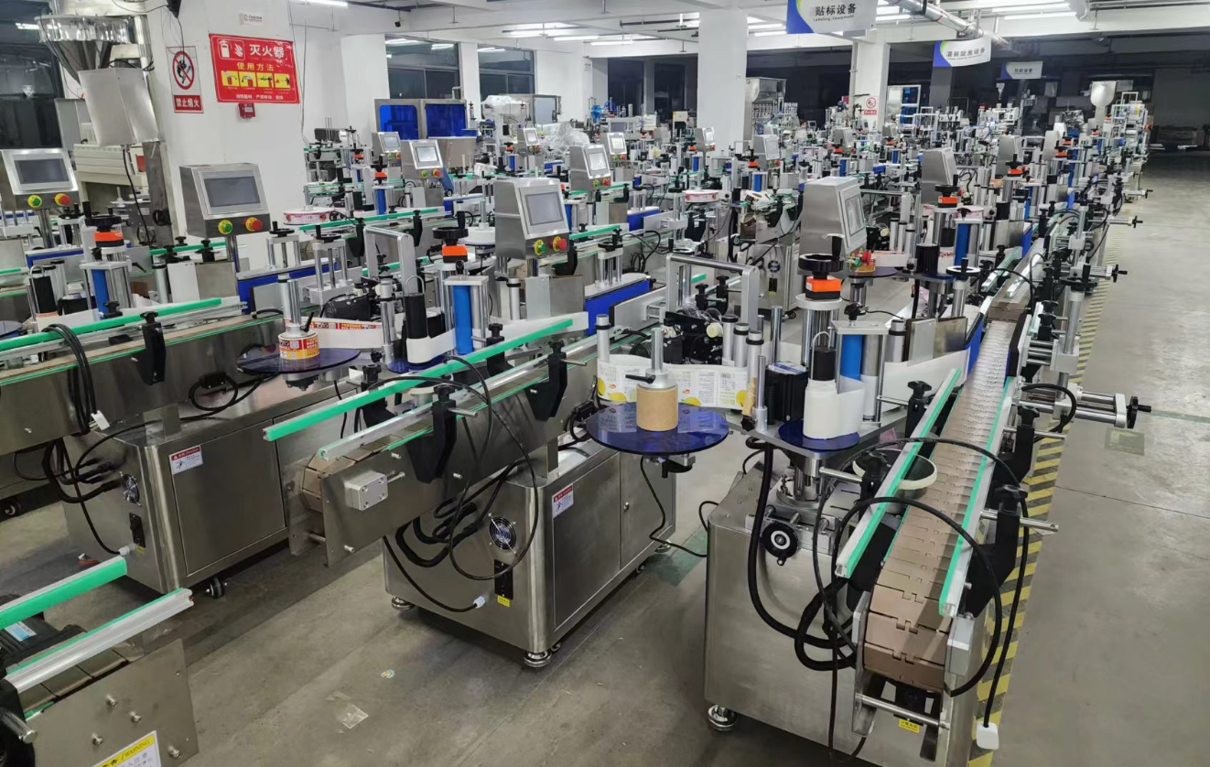

**Warehouse corner**

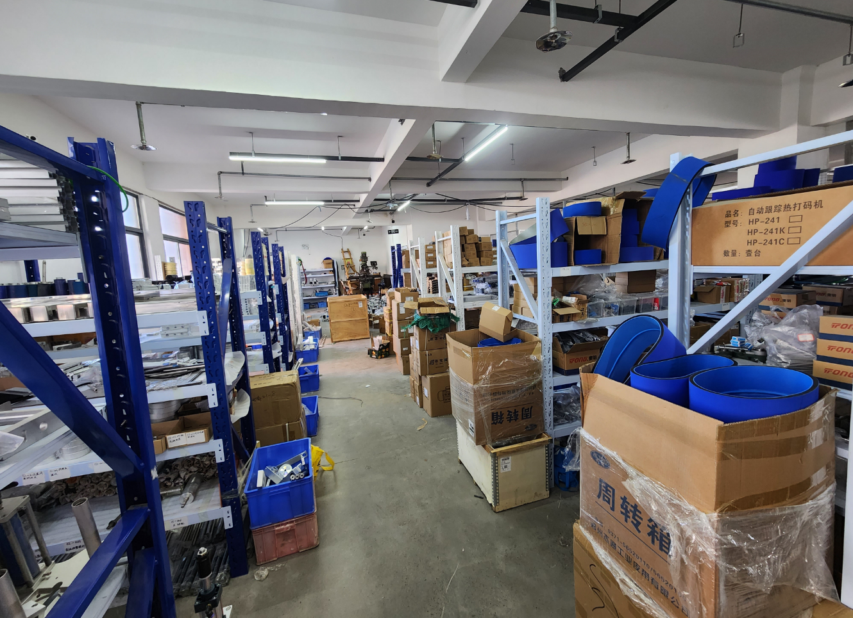

**Description of products**

**1.Primary Applications**

**Suitable for single or dual-label application on cylindrical surfaces of round bottles (e.g., hair gel bottles, food cans) with adjustable spacing between front/back labels. Applicable to industries such as cosmetics, food, pharmaceuticals, and disinfectants.**

**Optional Upgrades:**

**Circumferential positioning system for precise label placement on designated areas of curved surfaces.**

**-Ribbon coders or inkjet printers to imprint production dates and batch codes directly onto labels, enabling integrated labeling and coding processes.**

**2.Scope of Application**

**Compatible Labels: Self-adhesive labels, adhesive films, electronic regulatory codes, barcodes, etc.**

**Applicable Products: Cylindrical bottles with diameters ranging from 25mm to 100mm.**

**Industries: Pharmaceuticals, food, toys, personal care.**

**Examples: Disinfectant bottle labeling, dual-label application on hair gel bottles, precision front-label placement on wine bottles.**

**3.Working Process**

**Core Mechanism:**

**Products are placed onto the conveyor belt and guided through a bottle separation mechanism. Sensors detect the product’s position and trigger the labeling control system, which activates motors to dispense and apply labels at the precise location. Simultaneous label smoothing ensures seamless adhesion, completing the cycle.**

**Operational Steps:**

**Load product (inline conveyor compatible) → Automated conveying → Product spacing → Product detection → Product positioning →**

**Label application & smoothing → Collect labeled product.**

。

**4.Functional Features**

**Versatile Labeling: Single-label or dual-label application on cylindrical objects with adjustable spacing. Optional circumferential positioning system for curved surface labeling.**

**High-Precision Label Alignment Top stabilization mechanism + 3-axis positioning system eliminates vertical bottle fluctuations.**

**Stable Bottle Separation:Spring-loaded separation mechanism compensates for dimensional variations, ensuring smooth operation.**

**User-Friendly Touchscreen: Guided setup tutorials and intuitive parameter adjustment for quick mode switching.**

**Smart Automation: Photoelectric tracking with "no product, no labeling" logic, auto-calibration for missing labels, and real-time label detection to prevent waste.**

**24/7 Operation Capability: Engineered for continuous industrial workflows.**

**Hygienic & Durable:GMP-compliant stainless steel and high-grade aluminum alloy construction.**

**Advanced Management Tools:**

**- Auto-shutdown**

**- Production counting**

**- Energy-saving standby mode (activates during idle periods)**

**- Production quota alerts**

**- Role-based parameter access control.**

**Optional Upgrades:**

**① Heat coding/inkjet printing**

**② Vertical bottle feeding system**

**③ Automated product collection (product-specific)**

**④ Additional labeling units**

**⑤ Unlabeled bottle rejection system (customizable).**

**5.Machine pictures**

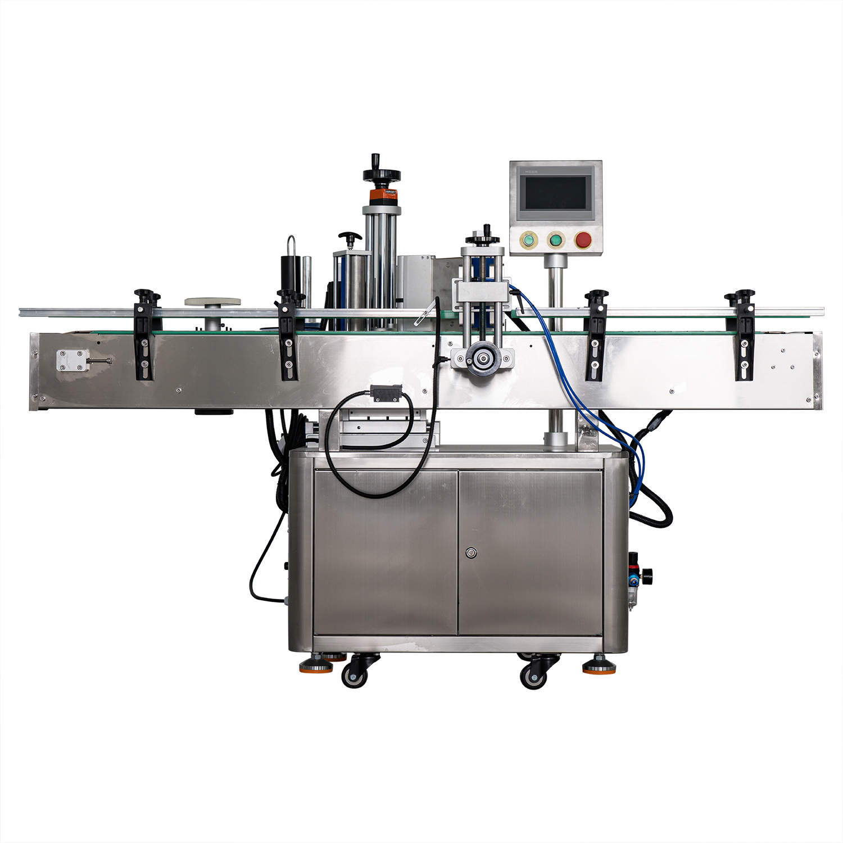

**6.Details**

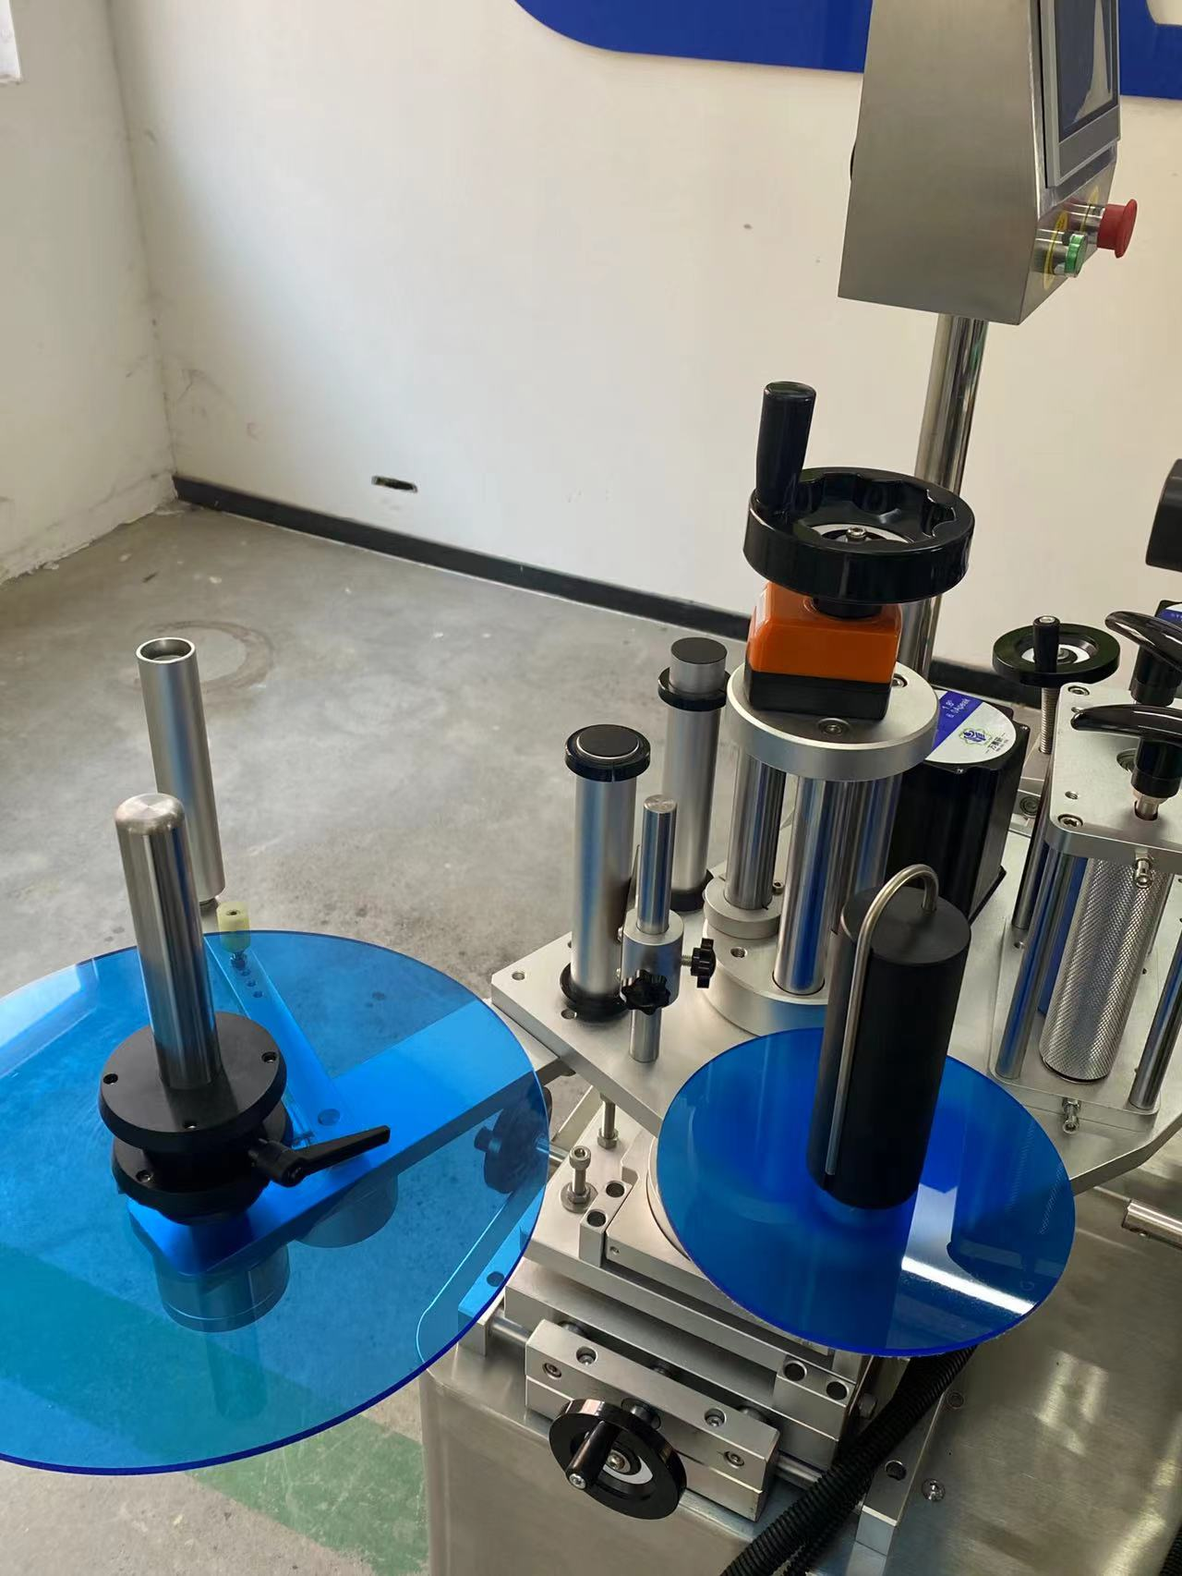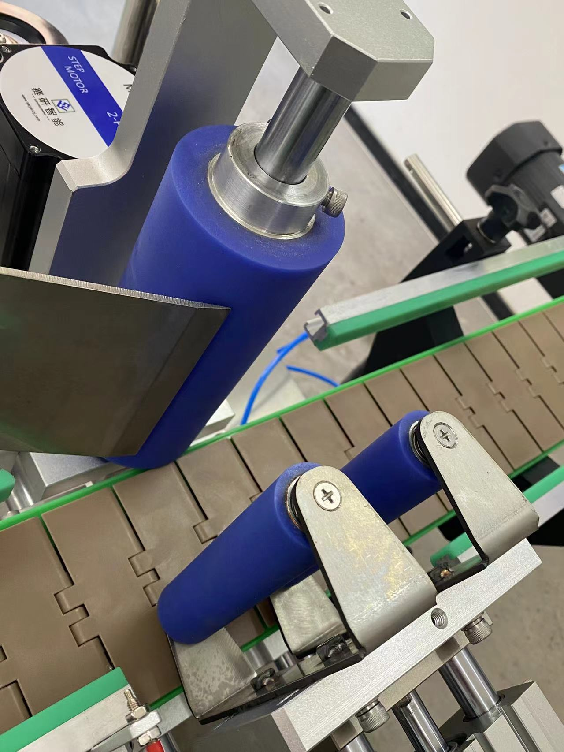

**technical specification**

|  |  |
| --- | --- |
| **适用产品尺寸**  **Applicadle product size** | **（For round bottles) and height: Diameter:：φ25mm～φ100mm**  **high：25mm～300mm（Related to the size and shape ratio of the product）** |
| **适用标签尺寸**  **Applicadle label size** | **length：20mm～320mm**  **Width (base paper width）：15mm～160mm** |
| **贴标速度**  **Labeling speed** | **15～45Pieces/minute (related to product and label size)；** |
| **贴标精度**  **Labeling accuracy** | **±1mm (Does not include product or label errors)；** |
| **整机尺寸**  **Overall size** | **About1900mm×1200mm×1530mm（Length × Width × Height）**； |
| **适用电压**  **Adaptable voltage** | **220V/50HZ；** |
| **整机重量**  **Tatal weight** | **About 150Kg。** |

|  |  |
| --- | --- |
| **标准配置明细**  **Configuration list** | |
| **名称/Name** | **品牌/Brand** |
| **中间继电器**  **auxiliary relay** | **正泰**  **ZHENGTAI** |
| **气缸**  **Air cylinder** | **亚德客/星辰**  **AirTac/Stars** |
| **侧标电眼**  **photosensor** | **西克/劳易测 /中芯**  **Sick/Leuze/zxcg** |
| **触摸屏**  **Touch screen** | **昆仑通态/台达**  **MCGS/Delta** |
| **PLC** | **松下/台达**  **Panasonic/Delta** |
| **测物电眼**  **Bottle sensor** | **松下/中芯**  **Panasonnic/zxcg** |
| **输送电机**  **Conveyor Drive Motor** | **东邦调速电机**  **DPG** |
| **牵引电机**  **servo motor** | **赛研步进电机**  **Research stepper motor** |
| **覆标电机**  **Lead Screw/Guide** | **赛研步进电机**  **Research stepper motor** |
| **分瓶电机**  **Straight slide track** | **东邦调速电机**  **DPG** |

**After-Sales Service:**

**1. Warranty Terms:**

**- (1) Full machine warranty for 1 year. Components confirmed as quality defects will be replaced free of charge (excludes wear-and-tear parts).**

**- (2) Lifetime maintenance support. Post-warranty repairs incur cost-based fees. Lifetime spare parts supply and technical assistance guaranteed.**