Round bottle labeling machine

About Us

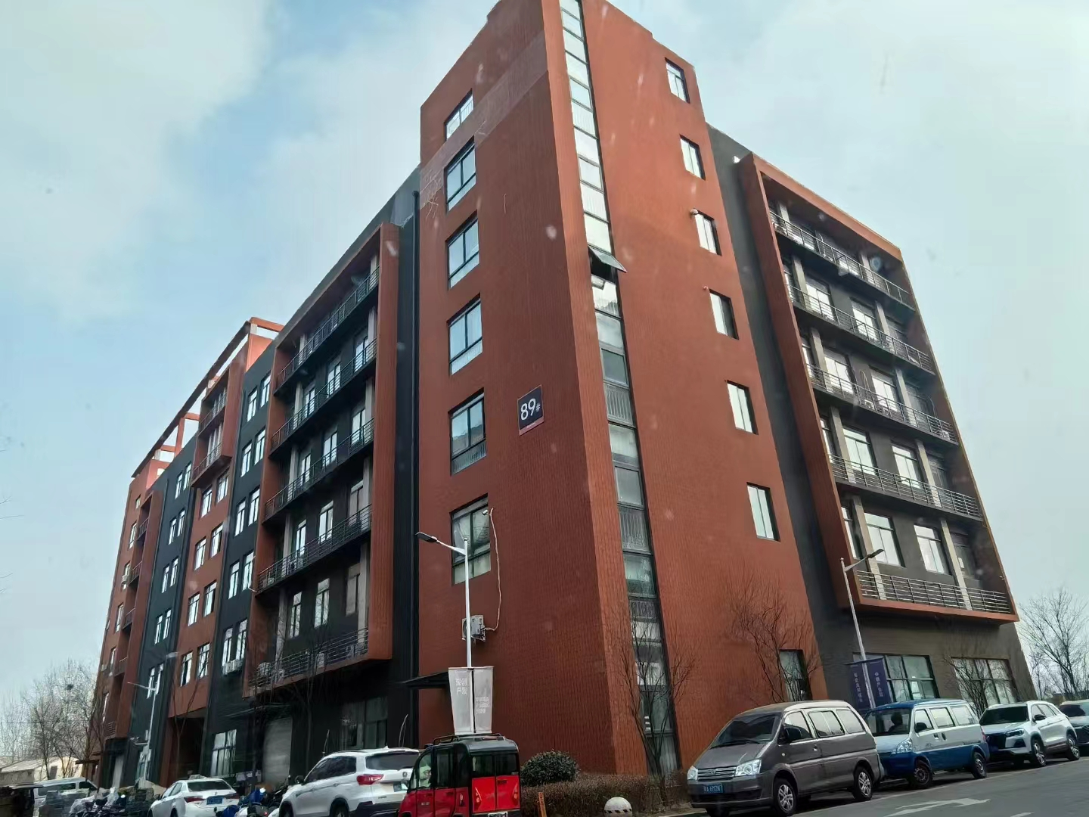

Our company, located at Building 2-103, Zhongkai Enterprise City, National Economic and Technological Development Zone, Xinxiang City, Henan Province, is a regional branch of a leading labeling machinery manufacturer originally based in Dongguan. We specialize in designing and manufacturing advanced labeling machines, filling systems, and intelligent post-filling packaging equipment.
We deliver customized automation solutions for diverse industries, including food and beverage, pharmaceuticals, cosmetics, electronics, logistics, and tobacco. Our clients include globally recognized brands such as China Tobacco, Shuanghui, Muyuan, Sanquan, Antuo Biotech, White Elephant, Mixue, Tianbing Group, and others.
With a strong presence across China, we also serve international markets. We have established partnerships in Southeast Asia, the Middle East, Latin America, and Europe, supported by our independent import/export license to ensure seamless global operations.

Corner of the exhibition hall
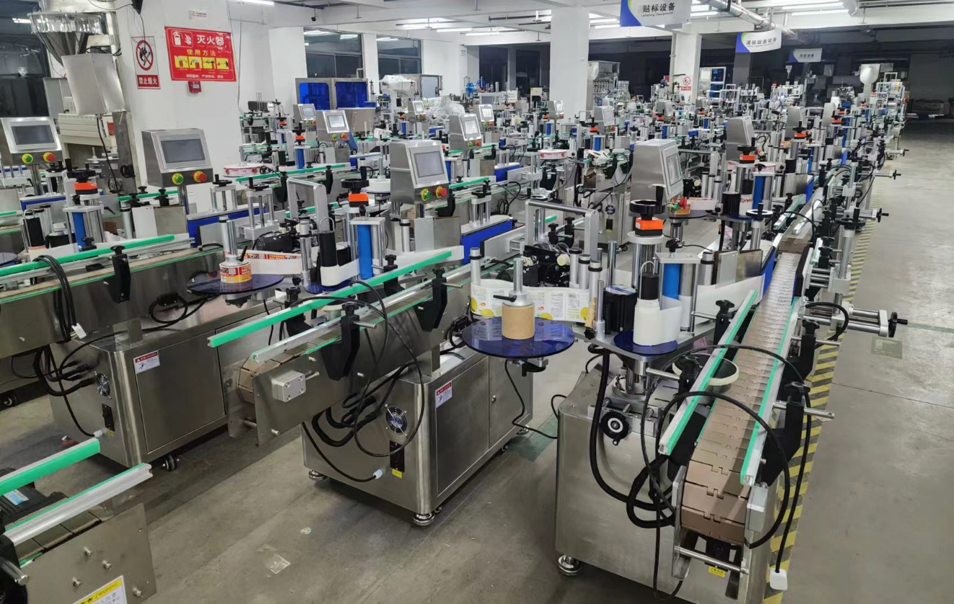

Warehouse corner
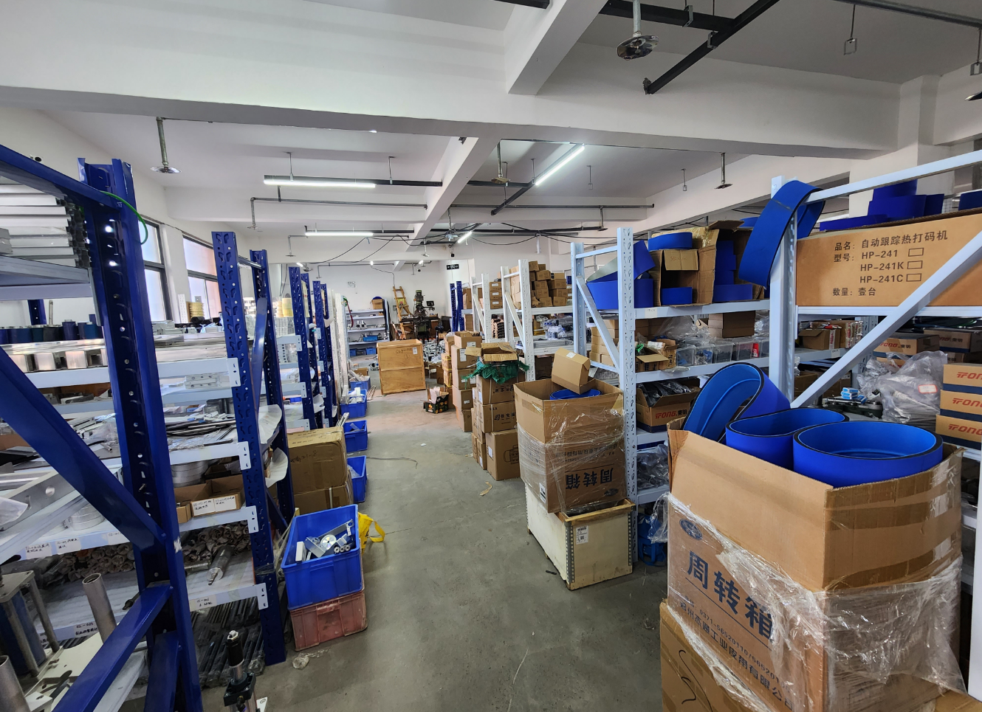

Description of products

1.Primary Applications
Suitable for full-wrap or half-wrap labeling on round bottles in pharmaceuticals, food, and personal care industries.

Optional Configurations:
Automatic rotary bottle sorting system** for direct integration with upstream production lines, enabling automated bottle feeding to boost efficiency.
Ribbon coder labeler for on-line printing of production dates and batch codes, reduces packaging steps and enhances production efficiency.

2.Scope of Application
Compatible Labels:Self-adhesive labels, adhesive films, electronic regulatory codes, barcodes, etc.
Applicable Products: Items requiring label or film application on cylindrical surfaces.
Industries: Food, pharmaceuticals, cosmetics, personal care, electronics, hardware, plastics.
Application Examples: PET round bottle labeling, plastic bottle labeling, food cans, etc

3.Working Process
Core Mechanism:
The product separation mechanism aligns items. Sensors detect the product’s presence and trigger the labeling control system. The system activates the motor to dispense and apply the label at the precise position. The product then passes through a label-smoothing mechanism, where rotation ensures seamless adhesion, completing the labeling cycle.

Operational Steps:
Place product (inline compatible) → .Automated conveying→ Product spacing → Product detection → Label application → Label smoothing → Collect labeled product.

4.Functional Features
Broad Compatibility: Supports full-wrap or half-wrap labeling on round bottles. Quick switching between bottle types with easy adjustments.
High-Precision Label Alignment: Self-correcting label path mechanism prevents misalignment.
Premium Adhesion Quality: Elastic pressure smoothing belt ensures wrinkle-free, bubble-free label application.
Flexible Integration: Vertical labeling with automatic bottle separation. Operates standalone or integrates into production lines.
Smart Automation:Photoelectric tracking enables "no product, no labeling logic. Auto-calibration and label detection prevent waste.
24/7 Operation Capability: Designed for continuous industrial use.
Intuitive Adjustment: Stepless speed control for labeling, conveying, and spacing.
Robust Construction: Triple-arm adjustment mechanism ensures stability. GMP-compliant stainless steel and high-grade aluminum alloy build.

Optional Upgrades:
① Heat coding/online coding/inkjet printing
② Automated feeding system (product-specific)
③ Automated collection system (product-specific)
④ Additional labeling units
⑤ Circumferential positioning labeling
⑥ Customized solutions (client-defined).

5.Machine pictures
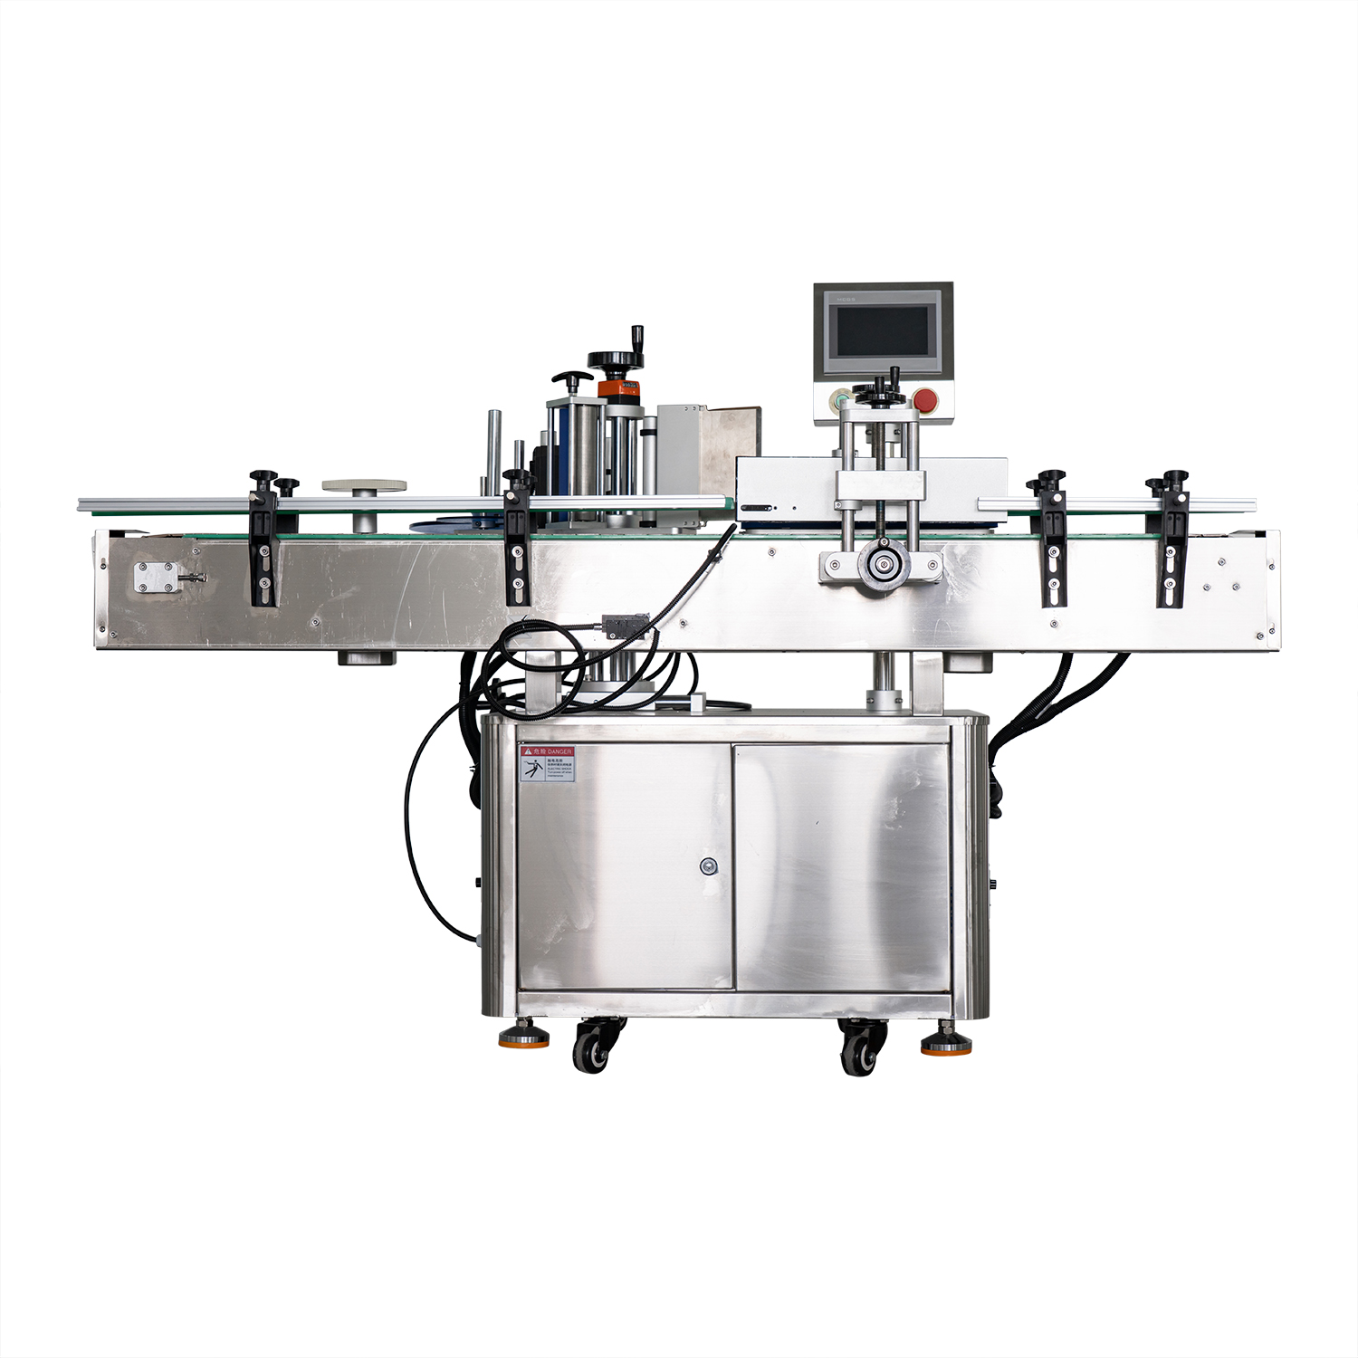

6.Details
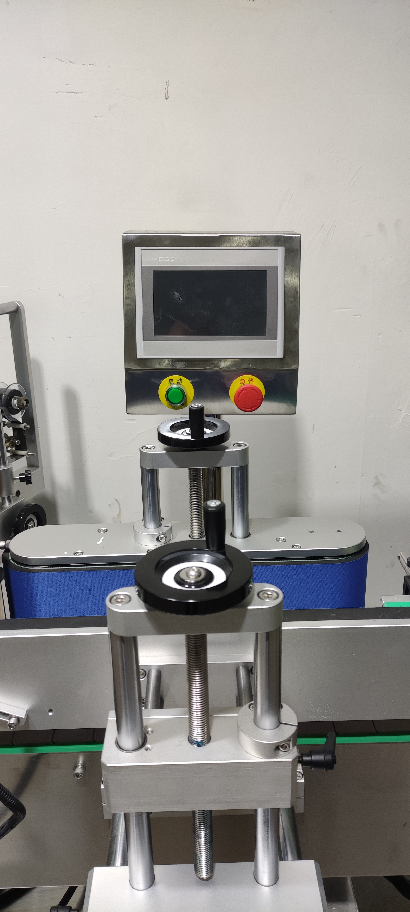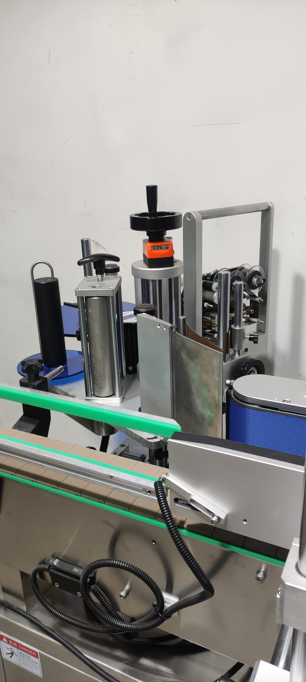

technical specification
适用产品尺寸  Applicadle product size | （For round bottles) and height: diameter：φ25mm～φ100mm  high：25mm～230mm（Related to the size and shape ratio of the product）
适用标签尺寸  Applicadle label size | length：20mm～285mm  Width (base paper width）：15mm～160mm
贴标速度  Labeling speed | 30～80Pieces/minute (depending on product and label size)）；
贴标精度  Labeling accuracy | ±1mm (Does not include product or label errors)；
整机尺寸  Overall size | about1950mm×1120mm×1340mm（Length × Width × Height）；
适用电压  Adaptable voltage | 220V/50HZ；
整机重量  Tatal weight | About 150Kg。

标准配置明细

Configuration list
名称/Name | 品牌/Brand
中间继电器  auxiliary relay | 正泰  ZHENGTAI
侧标电眼  photosensor | 西克/劳易测 /中芯  Sick/Leuze/zxcg
触摸屏  Touch screen | 昆仑通态/台达  MCGS/Delta
PLC | 松下/台达  Panasonic/Delta
测物电眼  Bottle sensor | 松下、中兴传感  Panasonnic/zxcg
输送电机  Conveyor Drive Motor | 东邦调速电机  DPG
牵引电机  servo motor | 万研步进电机  Research stepper motor
覆标电机  Lead Screw/Guide | 东邦调速电机  DPG
分瓶电机  Straight slide track | 东邦调速电机  DPG

After-Sales Service:
1. Warranty Terms:
(1) Full machine warranty for 1 year. Quality-defect components verified by inspection will be replaced free of charge (excludes wear-and-tear parts).
(2) Lifetime maintenance support. Post-warranty repairs incur cost-based fees. Lifetime spare parts supply and technical assistance guaranteed.

