**Semi-automatic round bottle machine**

**About Us**

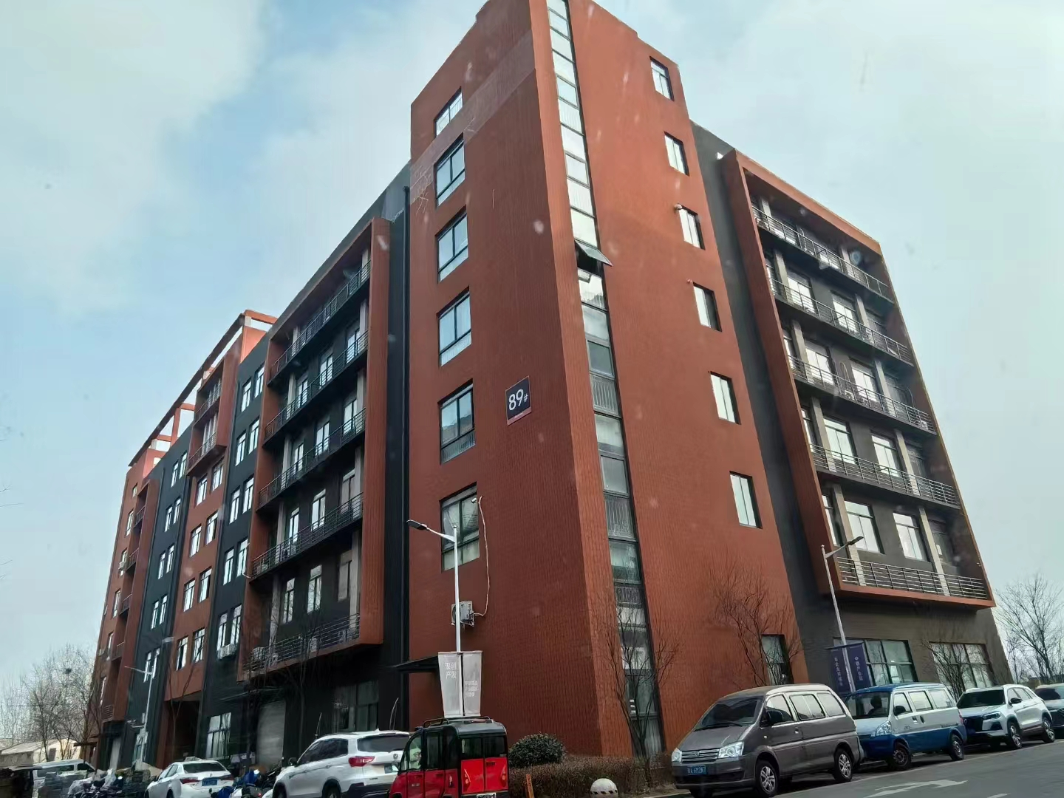

**Our company, located at Building 2-103, Zhongkai Enterprise City, National Economic and Technological Development Zone, Xinxiang City, Henan Province, is a regional branch of a leading labeling machinery manufacturer originally based in Dongguan. We specialize in designing and manufacturing advanced labeling machines, filling systems, and intelligent post-filling packaging equipment.**

**We deliver customized automation solutions for diverse industries, including food and beverage, pharmaceuticals, cosmetics, electronics, logistics, and tobacco. Our clients include globally recognized brands such as China Tobacco, Shuanghui, Muyuan, Sanquan, Antuo Biotech, White Elephant, Mixue, Tianbing Group, and others.**

**With a strong presence across China, we also serve international markets. We have established partnerships in Southeast Asia, the Middle East, Latin America, and Europe, supported by our independent import/export license to ensure seamless global operations.**

**Corner of the exhibition hall**

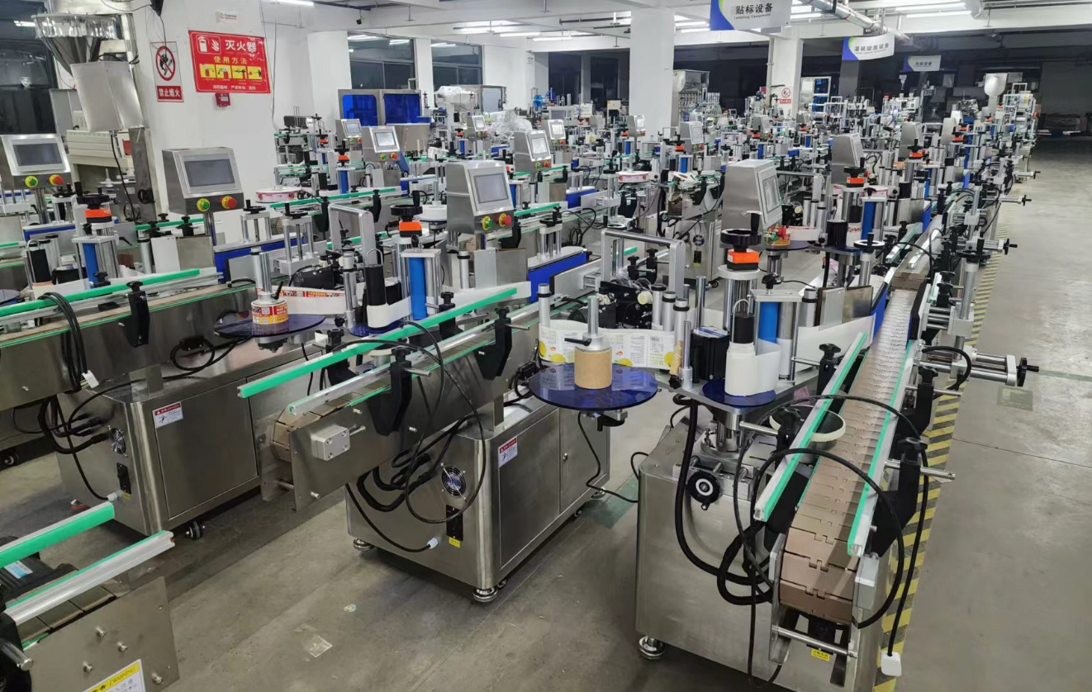

**Warehouse corner**

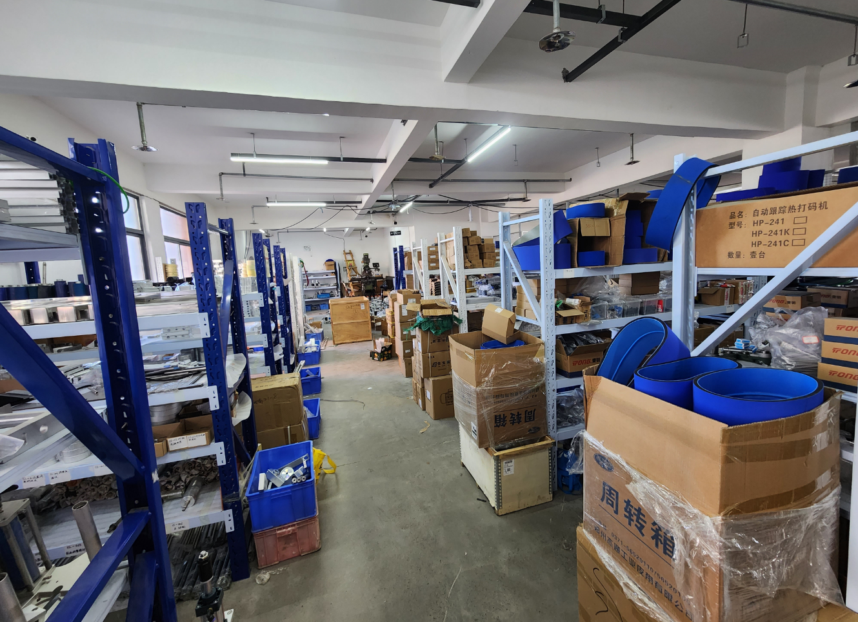

**Description of products**

**1.Basic Application**

**Designed for cylindrical and slightly tapered containers, including xylitol bottles, cosmetic containers, wine bottles, and similar shapes. Supports full-wrap/half-wrap labeling and front/back circumferential labeling, with freely adjustable spacing between front and back labels. Ideal for industries such as food, cosmetics, chemicals, and pharmaceuticals.**

**-Intuitive Touchscreen Control Adjust label spacing parameters (front/back) directly via the built-in user interface for rapid, error-free setup.**

**Ensures precise circumferential alignment during labeling.**

**Pair with ribbon codersor inkjet printersto imprint batch numbers, dates, or logos directly during labeling, streamlining packaging processes and boosting productivity.**

**2.Scope of application**

**Compatible Labels:Self-adhesive labels, adhesive films, electronic regulatory codes, barcodes, etc.**

**Applicable Products: Products requiring labeling on cylindrical or conical surfaces. Supports single or dual-label application. Industries:Food, pharmaceuticals, personal care, electronics, hardware, plastics.**

**Application Examples: Labeling for oral liquid round bottles Serum bottle labeling Xylitol container labeling Shampoo bottle labeling Dual-label application on wine bottles**

**Precision front-label placement on wine bottles**

**3.Working Process**

**Core Mechanisms: Single/Dual-label switching functionality, circumferential positioning labeling technology. Contact manufacturer for details.**

**Operational Steps: Place product → Automated labeling → Retrieve labeled product.**

**4.**

**Functional Features**

**High-Performance Labeling: Seamless switching between single/double labels with adjustable spacing between front/back labels. Optional circumferential positioning for precise label placement on curved surfaces.**

**Tapered Bottle Compatibility: Integrated taper adjustment knob for quick adaptation to conical containers.**

**Premium Labeling Quality: Dual positioning systems (product alignment + label correction) ensure wrinkle-free, bubble-free application with high-precision edge alignment.**

**Rapid Configuration: One-touch mode switching for fast adaptation to different products or label types, enhancing operational efficiency.**

**Hygienic & Durable Design: Complies with GMP standards. Constructed with stainless steel and aerospace-grade aluminum alloys.**

**Industrial-Grade Reliability: PLC and fiber-optic sensor control system ensures stable performance during extended operation.**

**Smart Production Management:Includes label counting, energy-saving mode, and photoelectric label tracking for streamlined workflows.**

**Optional Upgrades:**

**① Heat coding capability**

**② Circumferential positioning system**

**③ Customized solutions (client-specific requirements).**

**5.Machine pictures**

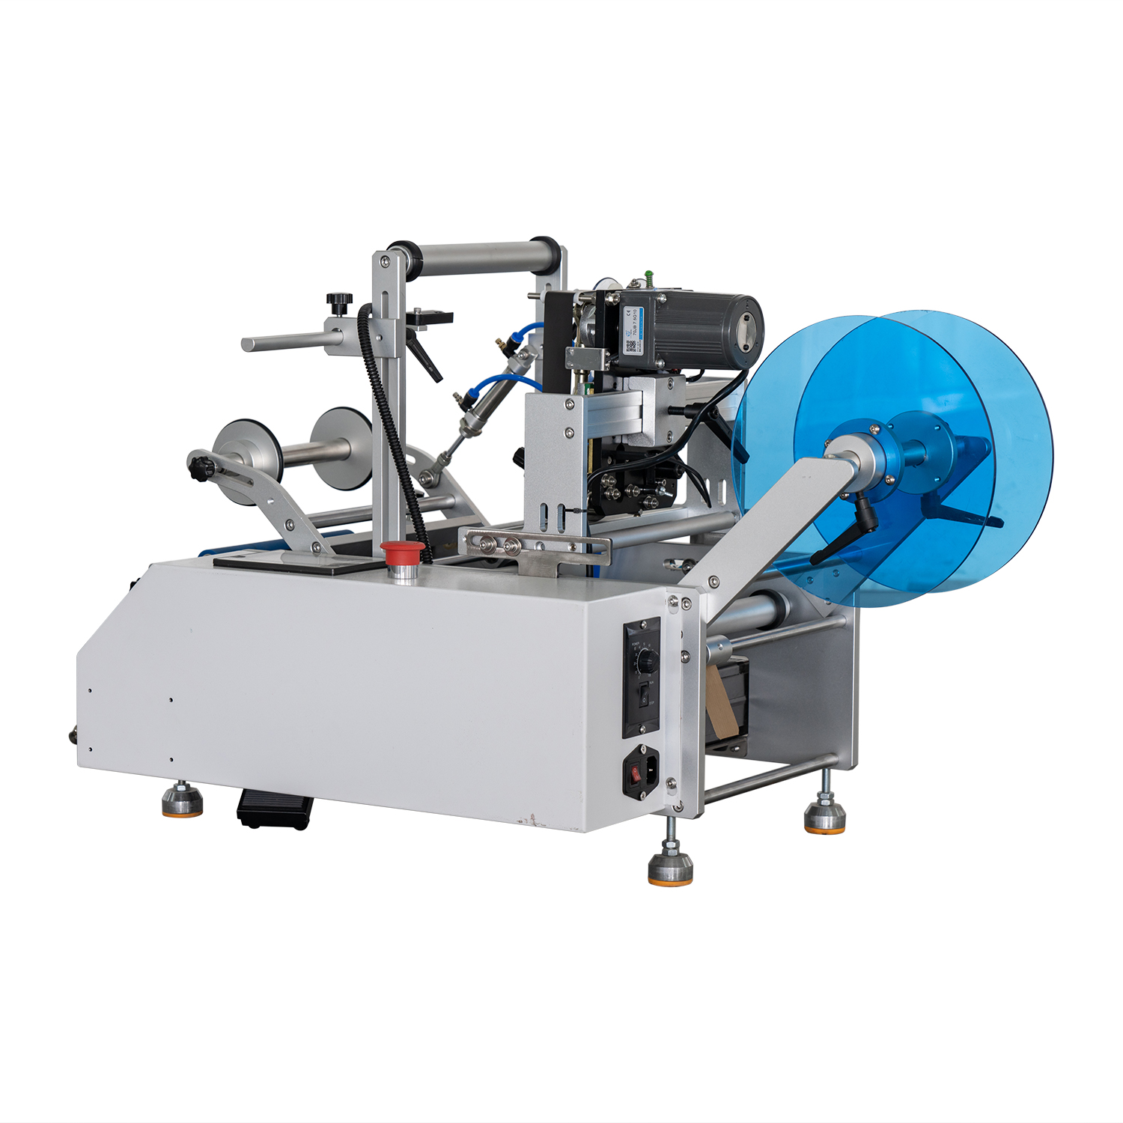

**technical specification**

|  |  |
| --- | --- |
| **适用产品尺寸**  **Applicadle product size** | **（For round bottles): Diameter：φ15mm～φ120mm** |
| **适用标签尺寸**  **Applicadle label size** | **length：15mm～376mm**  **Width (base paper width)：10mm～160mm** |
| **贴标速度**  **Labeling speed** | **15～30Pieces/minute (related to the speed of the staff)；** |
| **贴标精度**  **Labeling accuracy** | **±1mm (Does not include product or label errors)；** |
| **整机尺寸**  **Overall size** | **约920mm×450mm×500mm（Length × Width × Height）；** |
| **适用电压**  **Adaptable voltage** | **220V/50HZ；** |
| **整机重量**  **Tatal weight** | **About 35KG。** |

|  |  |
| --- | --- |
| **标准配置明细**  **Configuration list** | |
| **名称/Name** | **品牌/Brand** |
| **中间继电器**  **auxiliary relay** | **正泰**  **ZHENGTAI** |
| **气缸**  **Air cylinder** | **SNS** |
| **侧标电眼**  **photosensor** | **西克/劳易测 /中芯**  **Sick/Leuze/zxcg** |
| **PLC触摸屏一体机** | **金龚**  **MCGS** |
| **测物电眼**  **Bottle sensor** | **松下**  **Panasonnic** |
| **牵引电机**  **servo motor** | **东邦调速电机**  **DPG** |
| **开关电源**  **Switching power supply** | **明纬**  **Ming wei** |

**After-Sales Service:**

**1. Warranty Terms:**

**① One-year full machine warranty. Quality-defect components verified by inspection will be replaced free of charge (excludes wear-and-tear parts).**

**② Lifetime maintenance support. Post-warranty repairs incur cost-based fees. Lifetime spare parts supply and technical assistance guaranteed.**