**Automatic Suction page Labeling machine**

**About Us**

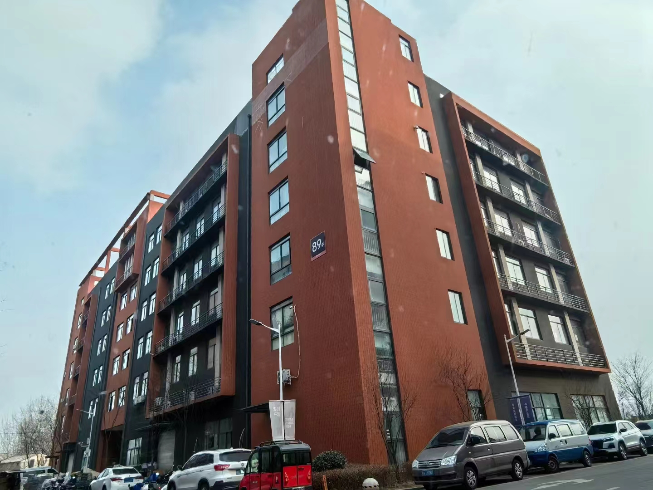

**Our company, located at Building 2-103, Zhongkai Enterprise City, National Economic and Technological Development Zone, Xinxiang City, Henan Province, is a regional branch of a leading labeling machinery manufacturer originally based in Dongguan. We specialize in designing and manufacturing advanced labeling machines, filling systems, and intelligent post-filling packaging equipment.**

**We deliver customized automation solutions for diverse industries, including food and beverage, pharmaceuticals, cosmetics, electronics, logistics, and tobacco. Our clients include globally recognized brands such as China Tobacco, Shuanghui, Muyuan, Sanquan, Antuo Biotech, White Elephant, Mixue, Tianbing Group, and others.**

**With a strong presence across China, we also serve international markets. We have established partnerships in Southeast Asia, the Middle East, Latin America, and Europe, supported by our independent import/export license to ensure seamless global operations.**

**Corner of the exhibition hall**

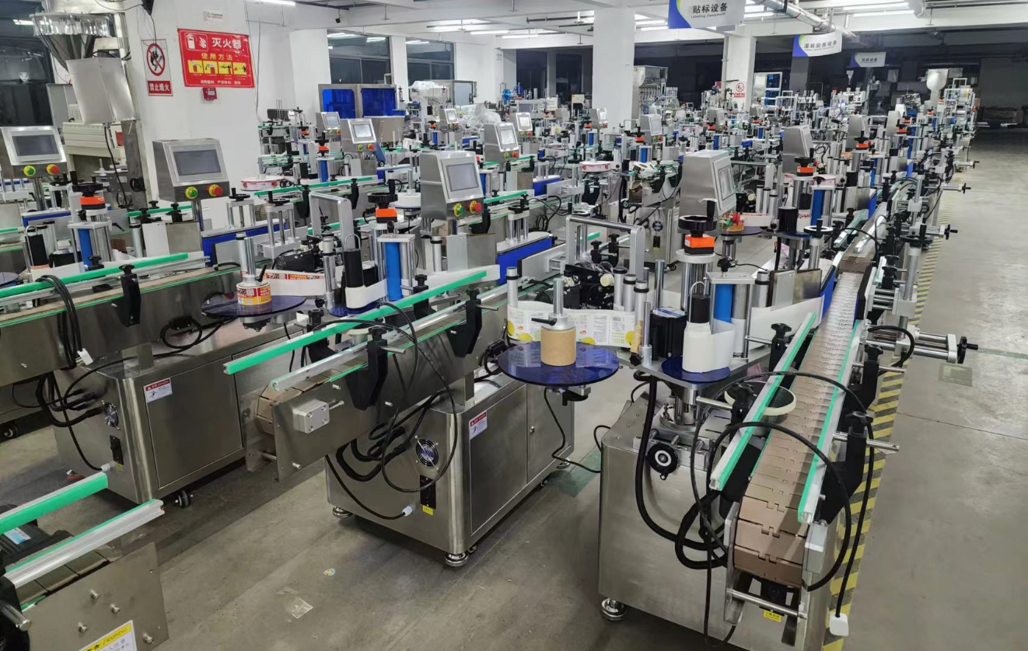

**Warehouse corner**

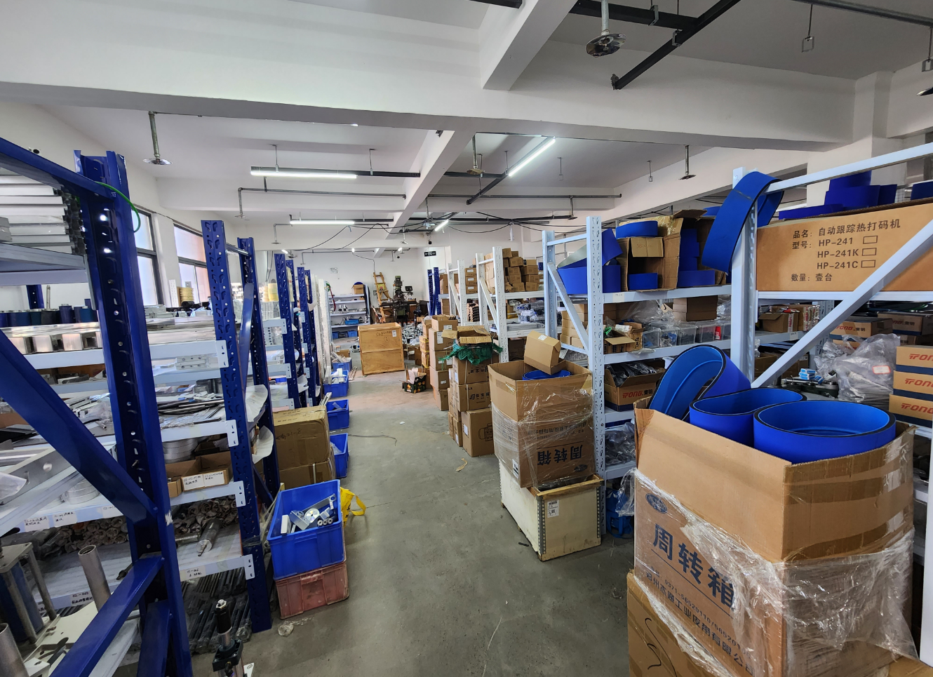

**Description of products**

**1.Basic Applications**

**Specifically designed for high-precision application of a single label on the upper surface of card-type products, such as color boxes, paper cards, scratch cards, PE bags, food-grade PP bags, and promotional sheets. Enables fully automated card separation, conveyance, and labeling, achieving unmanned operation for enhanced production efficiency.**

**2.Scope of Application**

**Applicable Labels: Self-adhesive labels, self-adhesive films, electronic supervision codes, barcodes, etc.**

**Applicable Products: Products requiring label or film application on flat or large-curvature surfaces.**

**Industries:** Widely used in electronics, hardware, plastics, chemical, and related industries.**

**Examples:** Scratch cards, flattened color boxes, promotional sheets, greeting cards, etc.**

**3.Working Process**

**Core Operating Principle: A sensor detects the passing product and sends a signal to the labeling control system. At the precise position, the system activates the motor to dispense and apply the label to the target area. As the product moves through the label pressing rollers, the label is rolled and pressed securely, completing the application.**

**Operational Steps:**

**Place products -> Automated separation and conveyance -> Labeling (automated) -> Collection of labeled products (automated) -> Remove finished products.**

**4.Functional Features**

**Stable Card Separation: Incorporates a sorting-reverse dial wheel mechanism for card separation, achieving significantly higher accuracy and efficiency compared to standard systems.**

**High-Speed Labeling: Designed for regulatory code labeling on items like medicine boxes, with stable speeds exceeding 200 units/minute.**

**Broad Compatibility: Suitable for labeling various cards, paper sheets, and unfolded cartons.**

**Precision Labeling: Utilizes top-pressing rollers to ensure smooth, flat adhesion without edge lifting, guaranteeing consistent accuracy.**

**Adaptable Design: Mechanically adjustable components and intelligent label path routing enable easy 6-axis fine-tuning of label placement, simplifying product changeovers and label roll management.**

**Smart Automation: Photoelectric tracking ensures "no labeling without detected products," auto-corrects missing labels, and detects label presence to prevent waste and missed applications.**

**High Stability: Advanced control system with Panasonic PLCs, Weintek HMIs, Panasonic fiber optic sensors, and SICK label sensors supports 24/7 operation.**

**Production Management Tools:**

**- Fault alarms**

**- Production counting**

**- Energy-saving mode**

**- Production quota alerts**

**- Parameter setting protection.**

**Optional Features/Components:**

**① Hot stamping/inkjet printing integration.**

**② Automatic product collection (product-dependent).**

**③ Automatic feeding systems (product-dependent).**

**④ Additional labeling modules.**

**⑤ Customized functions (client-specific configurations).**

**5.machine picture**

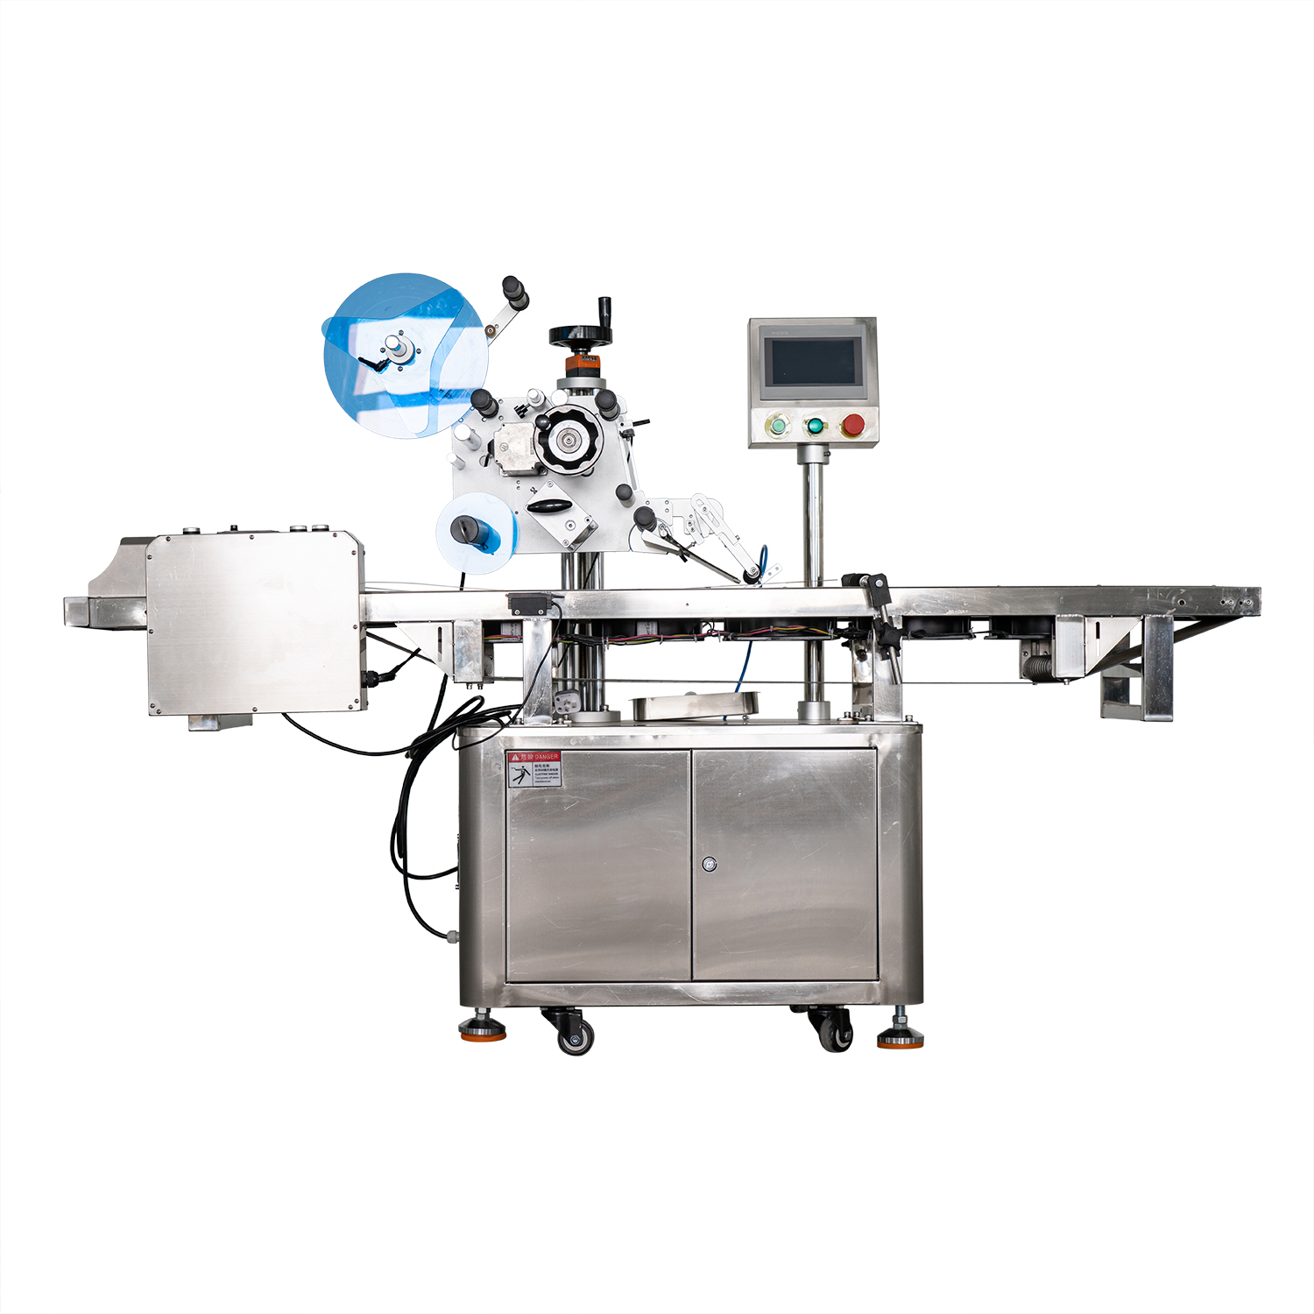

**6.Details**

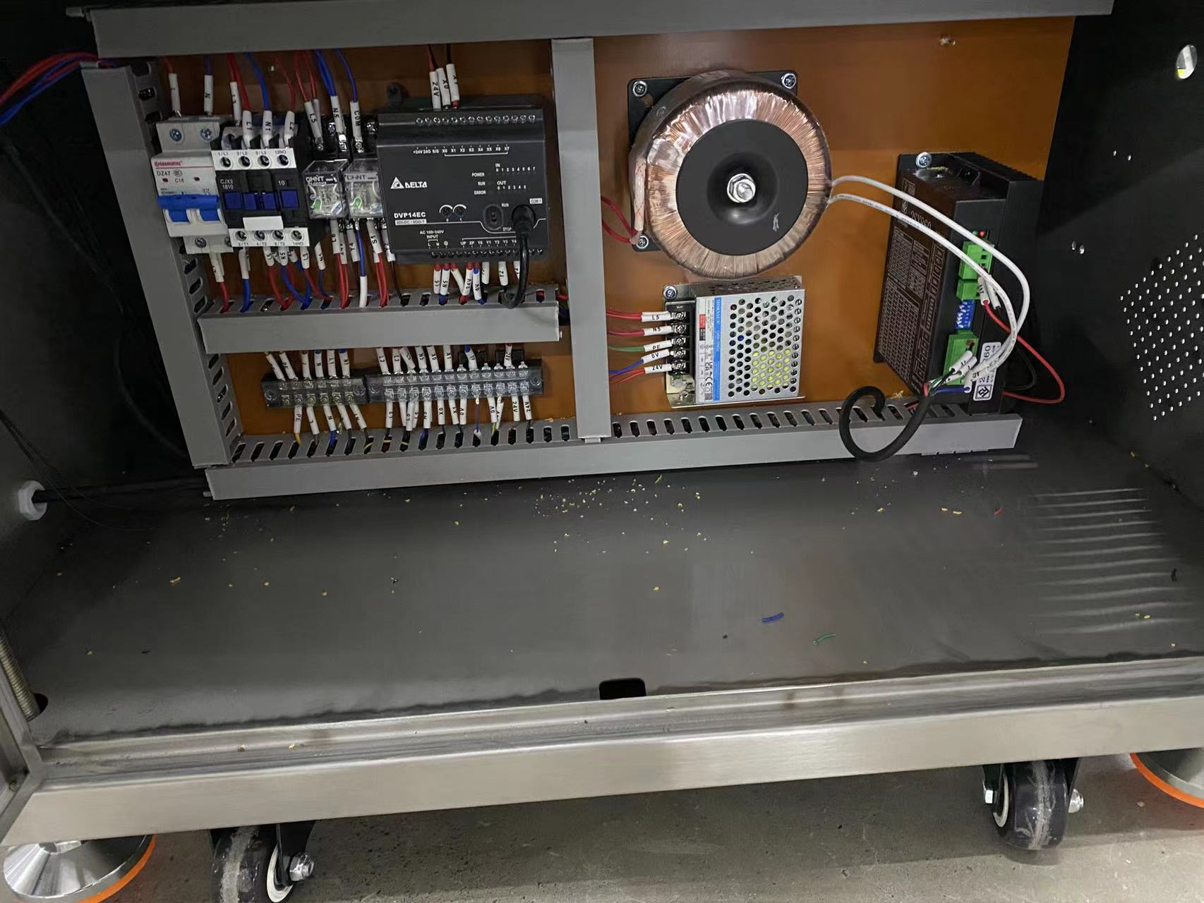

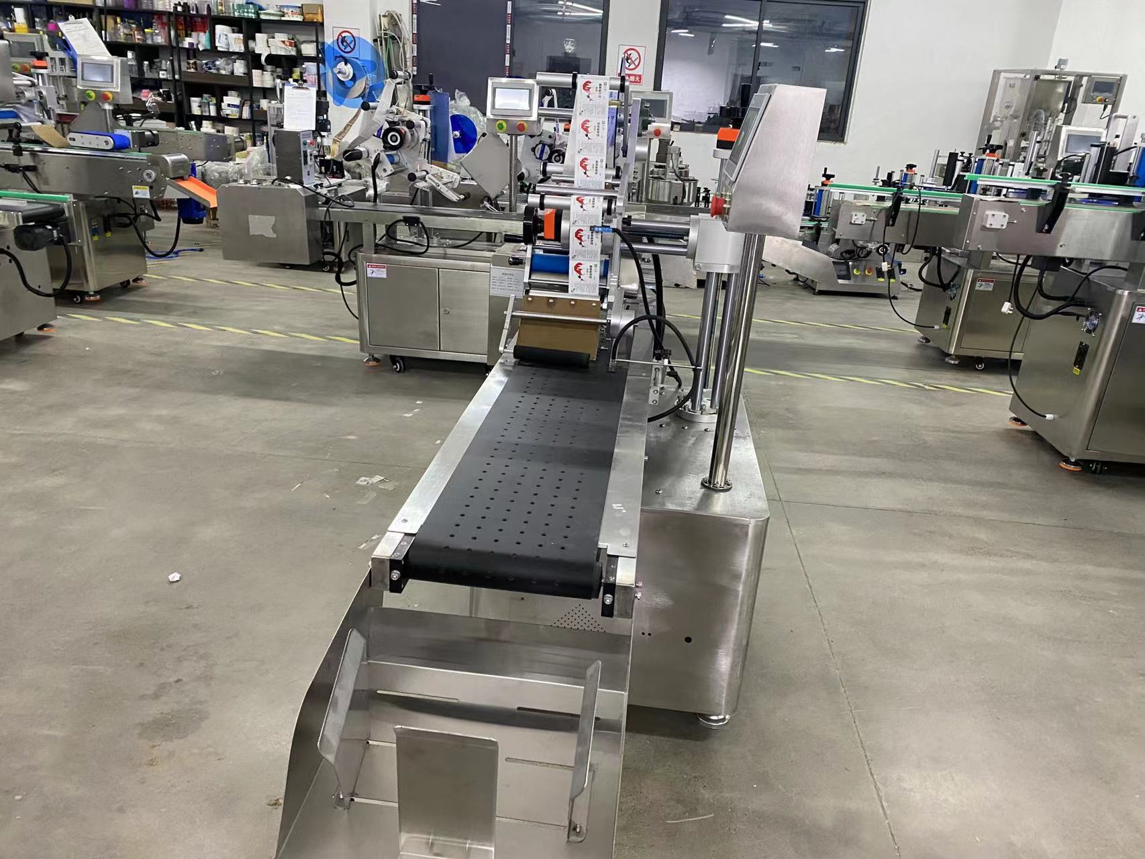

**technical specification**

|  |  |
| --- | --- |
| **适用产品尺寸**  **Applicadle product size** | **length：60mm～280mm**  **width：40mm～200mm**  **high：0.2mm～2mm** |
| **适用标签尺寸**  **Applicadle label size** | **Label length：6mm～250mm**  **Width (base paper width)：20mm～160mm** |
| **贴标速度**  **Labeling speed** | **40～150Pieces/minute (depending on product and label size）；** |
| **贴标精度**  **Labeling accuracy** | **±1mm (Does not include product or label errors)；** |
| **整机尺寸**  **Overall size** | **约2200mm×700mm×1400mmmm（Length × width × height)；** |
| **适用电压**  **Adaptable voltage** | **220V/50HZ；** |
| **整机重量**  **Tatal weight** | **About 180Kg。** |

|  |  |
| --- | --- |
| **标准配置明细**  **Configuration list** | |
| **名称/Name** | **品牌/Brand** |
| **中间继电器**  **auxiliary relay** | **正泰**  **ZHENGTAI** |
| **侧标电眼**  **photosensor** | **西克/劳易测 /中芯**  **Sick/Leuze/zxcg** |
| **触摸屏**  **Touch screen** | **昆仑通态/台达**  **MCGS/Delta** |
| **PLC** | **松下/台达**  **Panasonic/Delta** |
| **测物电眼**  **Bottle sensor** | **松下**  **Panasonnic** |
| **输送电机**  **Conveyor Drive Motor** | **东邦调速电机**  **DPG** |
| **牵引电机**  **servo motor** | **赛研步进电机**  **Research stepper motor** |
| **开关电源**  **Switching power suppl** | **正泰**  **ZHENGTAI** |
| **分卡电机**  **Paging machine** | **东邦调速电机**  **DPG** |

**Note: After-Sales Service:**

**1. Equipment Warranty Terms:**

**(1) One-year warranty on the entire machine. Repairs and replacements for quality-related defects are free of charge during the warranty period. Wear-and-tear parts are excluded from coverage.**

**(2) Lifetime maintenance support. Repairs outside the warranty period incur service and material costs. Lifetime spare parts supply and technical support are guaranteed.**