**Plan Labeling machine**

**About Us**

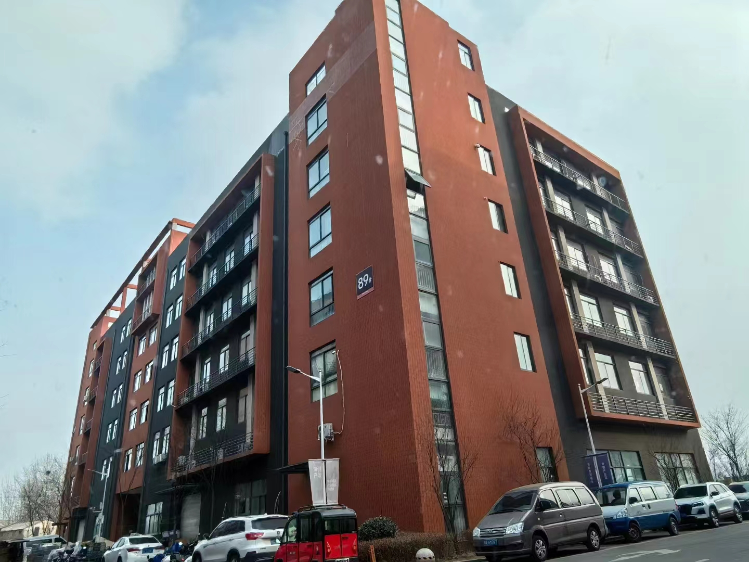

**Our company, located at Building 2-103, Zhongkai Enterprise City, National Economic and Technological Development Zone, Xinxiang City, Henan Province, is a regional branch of a leading labeling machinery manufacturer originally based in Dongguan. We specialize in designing and manufacturing advanced labeling machines, filling systems, and intelligent post-filling packaging equipment.**

**We deliver customized automation solutions for diverse industries, including food and beverage, pharmaceuticals, cosmetics, electronics, logistics, and tobacco. Our clients include globally recognized brands such as China Tobacco, Shuanghui, Muyuan, Sanquan, Antuo Biotech, White Elephant, Mixue, Tianbing Group, and others.**

**With a strong presence across China, we also serve international markets. We have established partnerships in Southeast Asia, the Middle East, Latin America, and Europe, supported by our independent import/export license to ensure seamless global operations.**

**Corner of the exhibition hall**

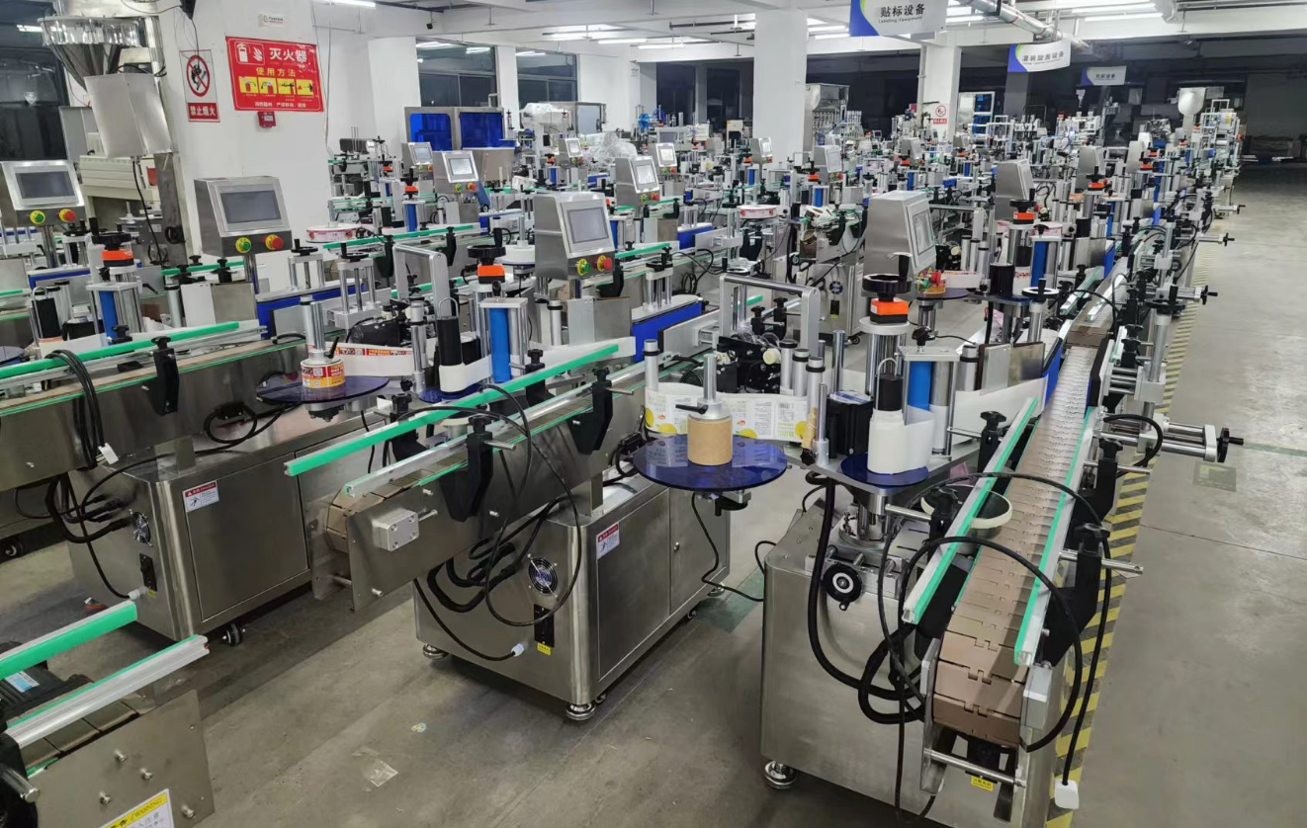

**Warehouse corner**

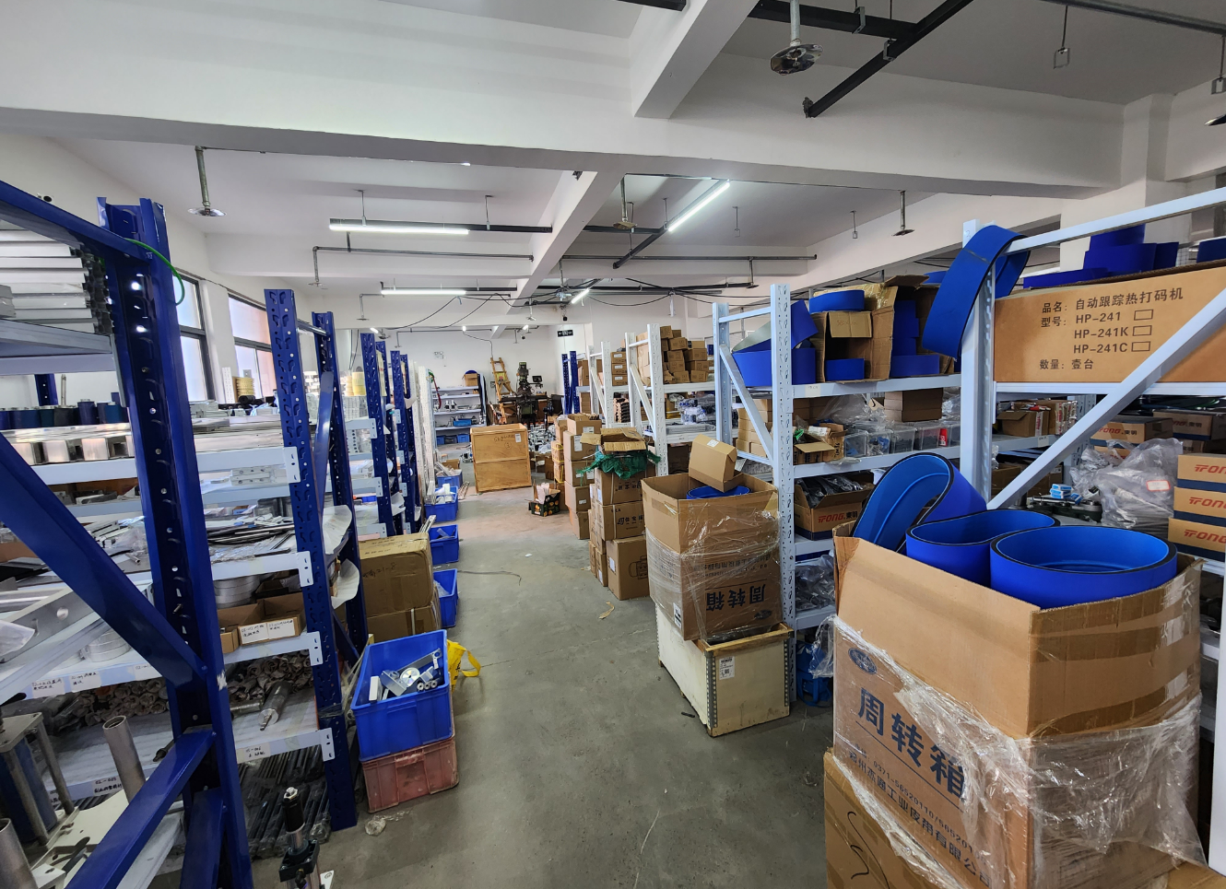

**Description of products**

**1.Primary Applications**

**Suitable for labeling or adhesive film application on flat surfaces of items such as books, folders, boxes, cartons/bags. Adaptable to uneven surfaces with adjustable smoothing mechanisms. Ideal for large flat products and wide-range flat object labeling.**

**Optional Upgrades:**

**Modular integration of ribbon coders or inkjet printers onto the labeling head to imprint production dates, batch numbers, or barcodes directly onto labels.**

**In-line inkjet printers** on the conveyor for pre-labeling or post-labeling coding (e.g., dates, batch codes, barcodes) on products.**

**2.Scope of Application**

* **Compatible Labels: Self-adhesive labels, adhesive films, electronic regulatory codes, barcodes, etc.**
* **Applicable Products: Items requiring label or film application on flat or slightly curved surfaces.**
* **Industries: Printing, stationery, food, personal care, electronics, pharmaceuticals, etc. Application Examples: Book surface labeling, folder labeling, package box labeling, sheet material labeling, etc.**

**3.Working Process**

**Core Mechanism:**

**Sensors detect the product’s presence and trigger the labeling control system. The PLC-controlled system activates the motor to dispense and apply the label at the precise position. The product then passes through a smoothing mechanism to ensure permanent adhesion, completing the labeling cycle.**

**Operational Steps:**

**Place product (inline compatible) → Automated conveying → Product alignment → Product detection → Label application → Labels moothing → Collect labeled product**

**4.Functional Features**

**High-Precision Labeling: Stepper/servo motor-driven label dispensing ensures accuracy. Self-correcting label path mechanism prevents lateral deviation. Eccentric wheel-driven traction system eliminates label slippage.**

**Robust Construction: Triple-arm adjustment mechanism enhances structural stability for long-term durability.**

**24/7 Operation Capability:Engineered for continuous industrial workflows.**

**Quick Adaptability 6-axis adjustable mounting base simplifies product changeovers, reducing downtime.**

**Flexible Integration: Operates standalone or integrates into production lines with minimal layout complexity.**

**Smart Automation: Photoelectric tracking enables "no product, no labeling logic. Auto-calibration and label detection prevent waste.**

**User-Friendly Interface:Touchscreen with intuitive parameter adjustments, fault diagnostics, and multilingual support (Chinese annotations standard).**

**Advanced Management Tools:**

**- Production counting**

**- Energy-saving mode**

**- Production quota alerts**

**- Role-based parameter access control.**

**Optional Upgrades:**

**① Heat coding/inkjet printing**

**② Automated product collection (product-specific)**

**③ Automated feeding system (product-specific)**

**④ Additional labeling units**

**⑤ Customized solutions (client-defined).**

**5.Machine pictures**

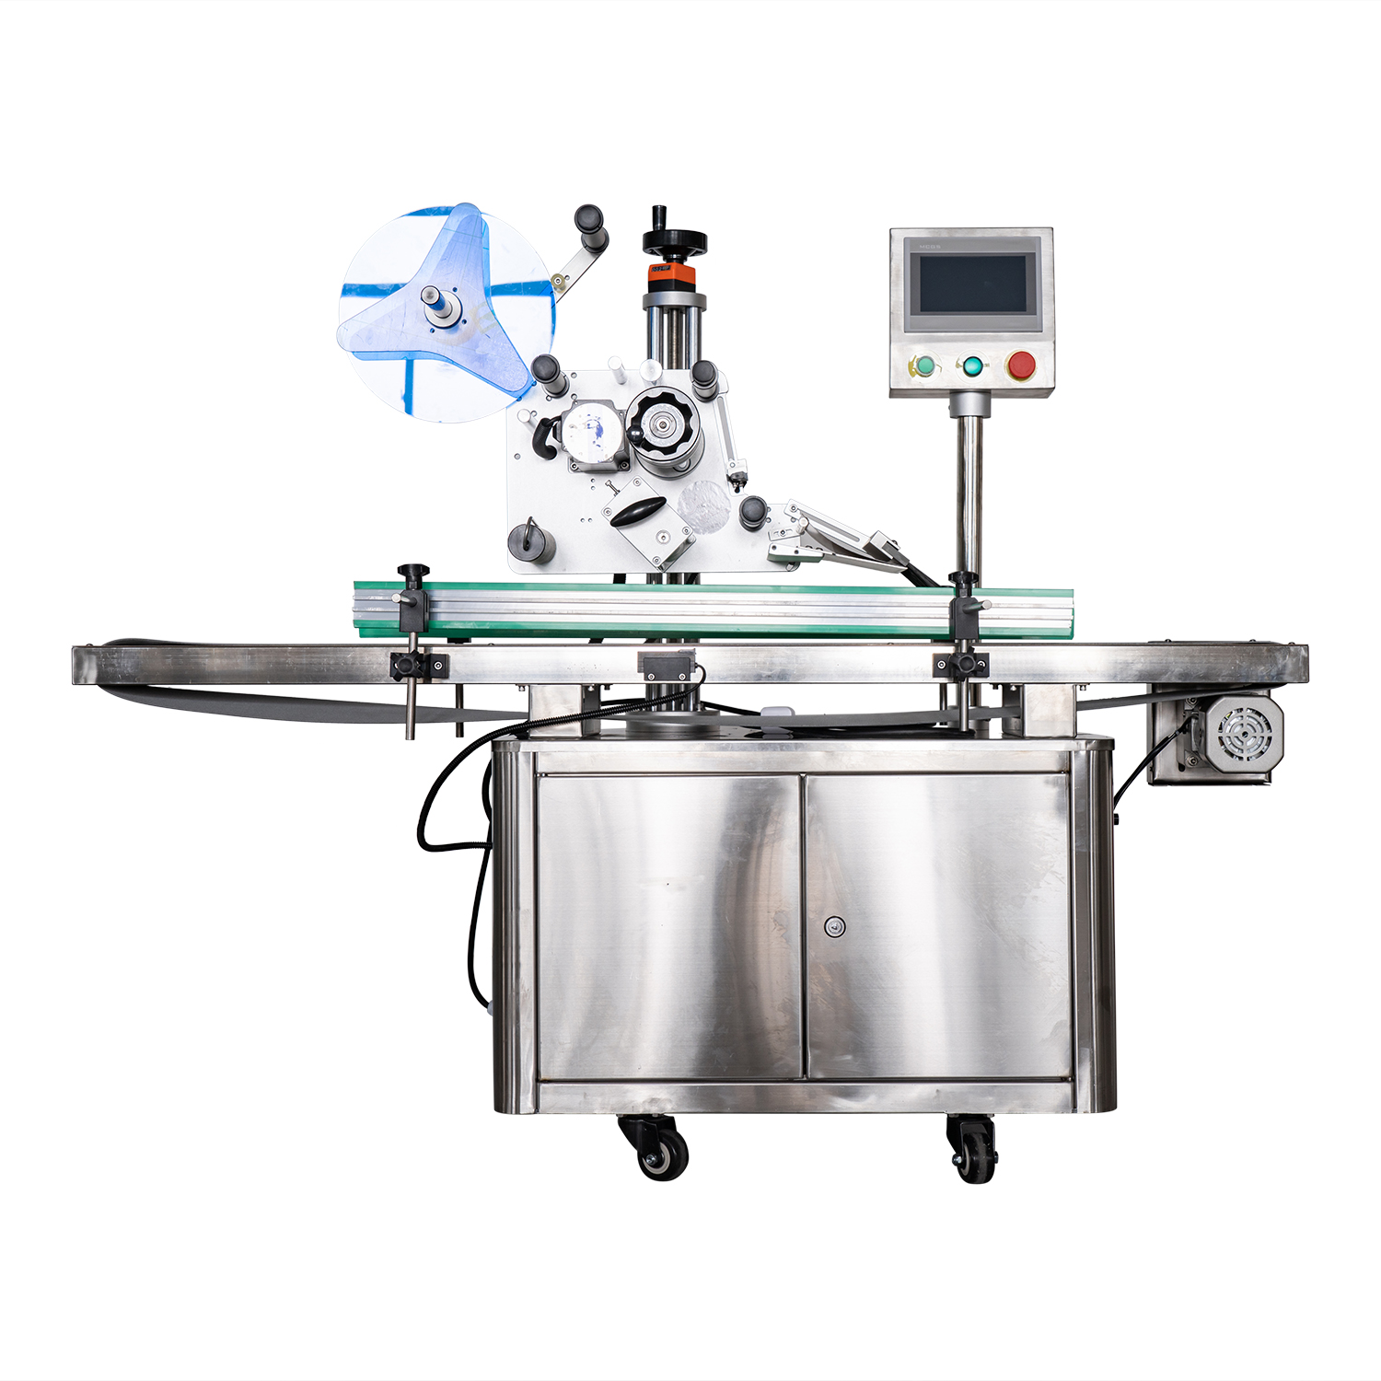

**6.Details**

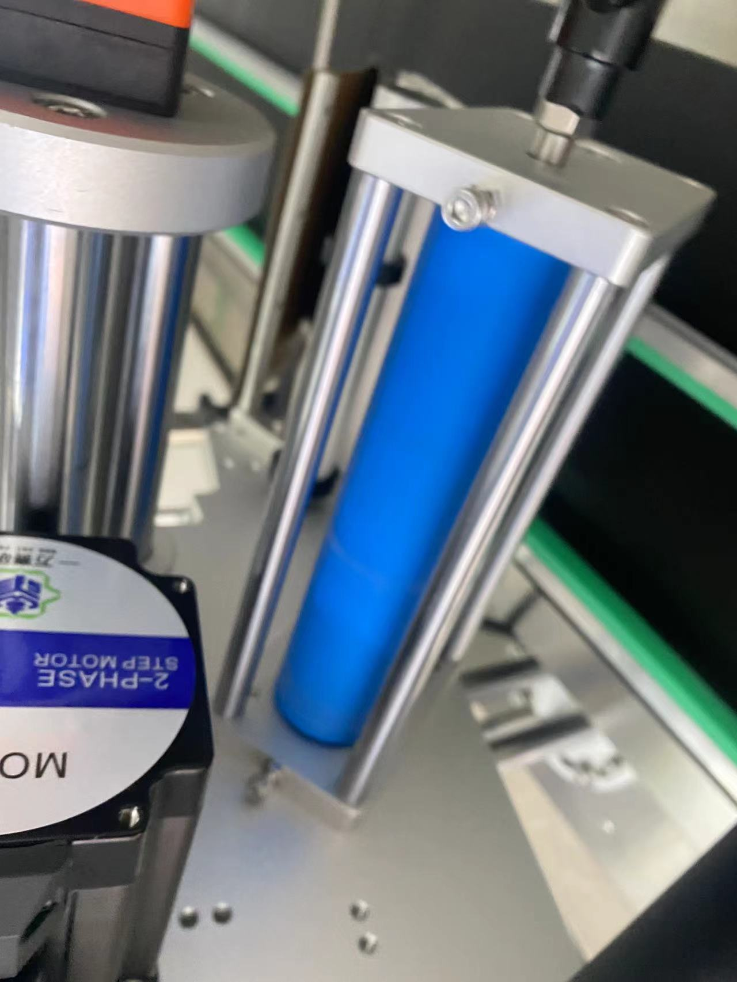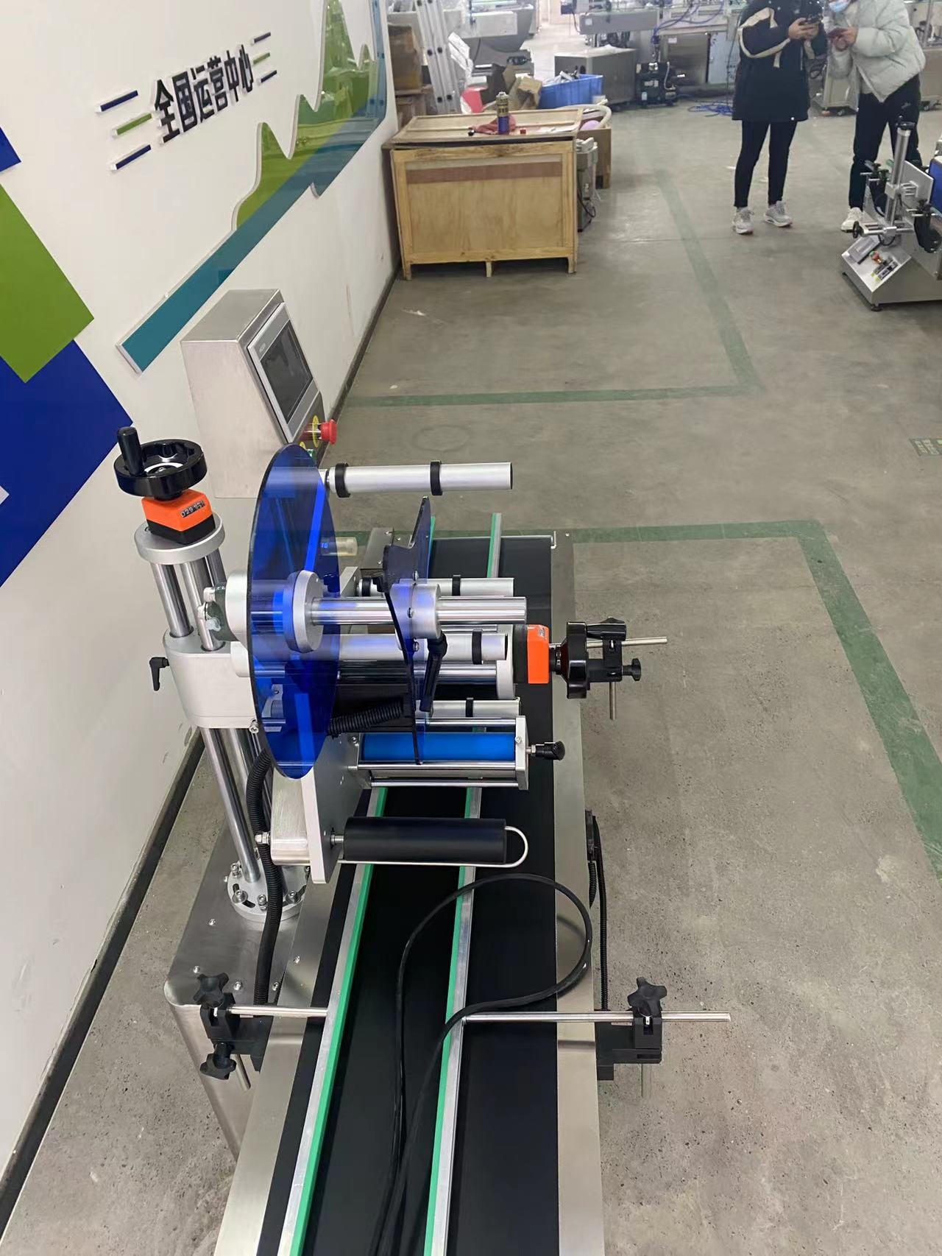

**technical specification**

|  |  |
| --- | --- |
| **适用产品尺寸**  **Applicadle product size** | **Length：40mm～400mm**  **width：40mm～200mm**  **height：5mm～150mm** |
| **适用标签尺寸**  **Applicadle label size** | **length：6mm～250mm**  **Width (base paper width）：20mm～160mm** |
| **贴标速度**  **Labeling speed** | **20～80Pieces/minute (depending on product and label size)）；** |
| **贴标精度**  **Labeling accuracy** | **±1mm (Does not include product or label errors)；** |
| **整机尺寸**  **Overall size** | **About1600mm×780mm×1400mm（长×宽×高）；** |
| **适用电压**  **Adaptable voltage** | **220V/50HZ；** |
| **整机重量**  **Tatal weight** | **About 140Kg。** |

|  |  |
| --- | --- |
| **标准配置明细**  **Configuration list** | |
| **名称/Name** | **品牌/Brand** |
| **中间继电器**  **auxiliary relay** | **正泰**  **ZHENGTAI** |
| **侧标电眼**  **photosensor** | **西克/劳易测 /中芯**  **Sick/Leuze/zxcg** |
| **触摸屏**  **Touch screen** | **昆仑通态/台达**  **MCGS/Delta** |
| **PLC** | **松下/台达**  **Panasonic/Delta** |
| **测物电眼**  **Bottle sensor** | **松下/中芯**  **Panasonnic/zxcg** |
| **输送电机**  **Conveyor Drive Motor** | **东邦调速电机**  **DPG** |
| **牵引电机**  **servo motor** | **赛研步进电机**  **Research stepper motor** |
| **开关电源**  **Switching power suppl** | **正泰**  **ZHENGTAI** |

**After-Sales Service:**

**1. Warranty Terms:**

**- (1) Full machine warranty for 1 year. Components confirmed as quality defects will be replaced free of charge (excludes wear-and-tear parts).**

**- (2) Lifetime maintenance support. Post-warranty repairs incur cost-based fees. Lifetime spare parts supply and technical assistance guaranteed.**