**Double side Flat bottle Labeling machine**

**About Us**

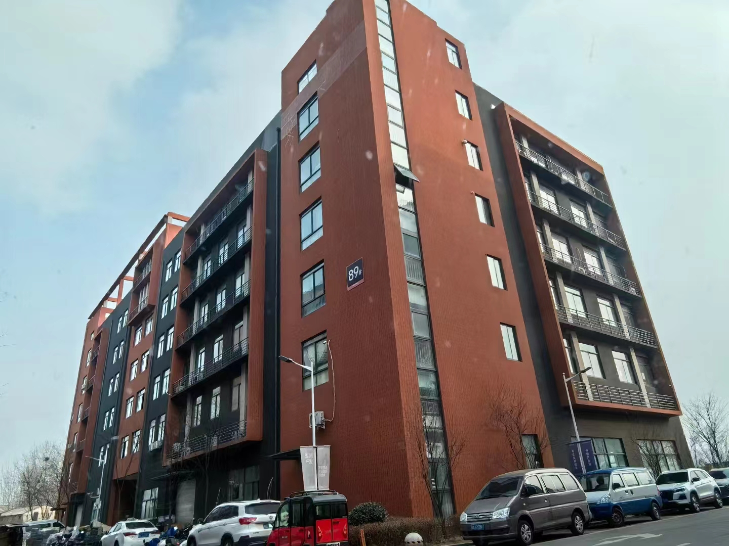

**Our company, located at Building 2-103, Zhongkai Enterprise City, National Economic and Technological Development Zone, Xinxiang City, Henan Province, is a regional branch of a leading labeling machinery manufacturer originally based in Dongguan. We specialize in designing and manufacturing advanced labeling machines, filling systems, and intelligent post-filling packaging equipment.**

**We deliver customized automation solutions for diverse industries, including food and beverage, pharmaceuticals, cosmetics, electronics, logistics, and tobacco. Our clients include globally recognized brands such as China Tobacco, Shuanghui, Muyuan, Sanquan, Antuo Biotech, White Elephant, Mixue, Tianbing Group, and others.**

**With a strong presence across China, we also serve international markets. We have established partnerships in Southeast Asia, the Middle East, Latin America, and Europe, supported by our independent import/export license to ensure seamless global operations.**

**Corner of the exhibition hall**

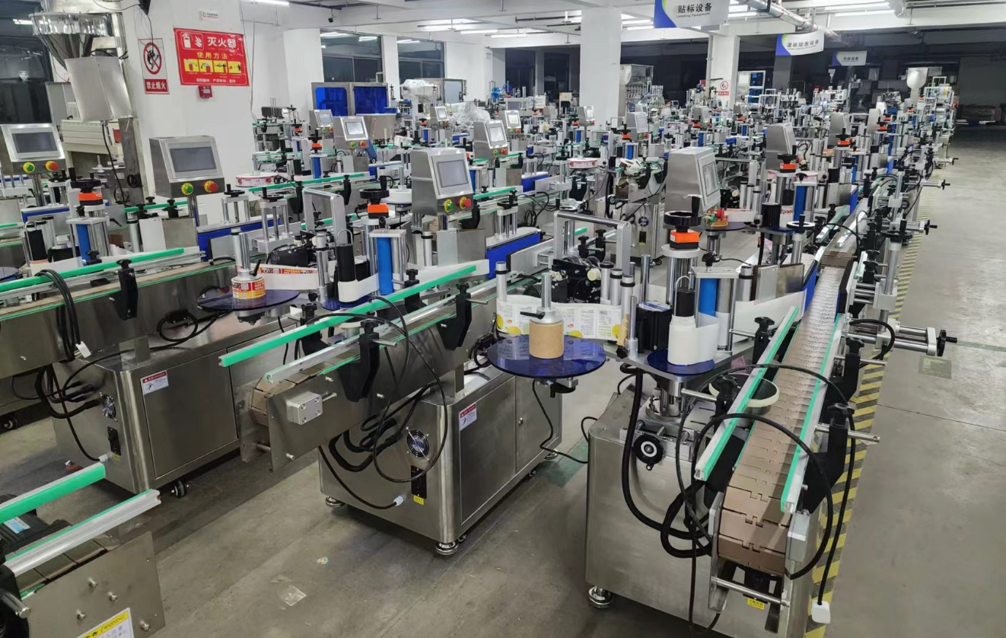

**Warehouse corner**

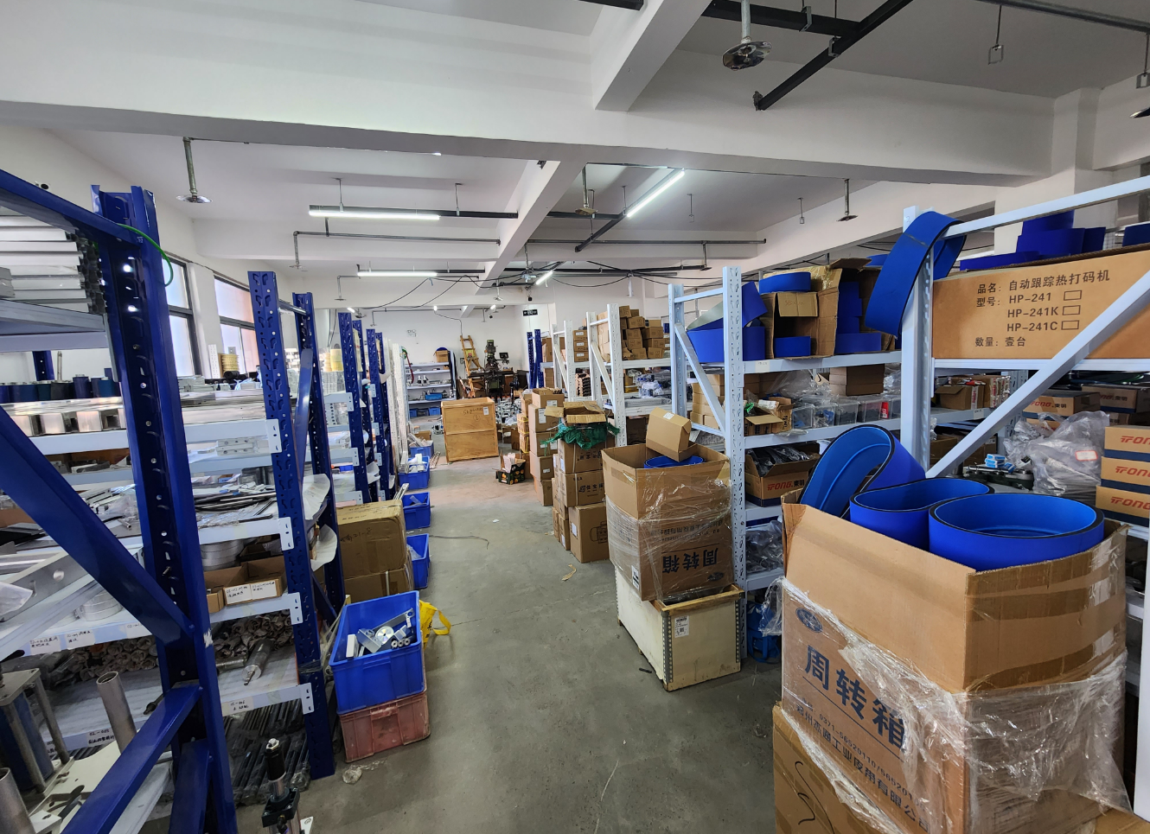

**Description of products**

**1.Suitable for single-sided and dual-sided labeling on flat, round, and square bottles, such as shampoo flat bottles, round/square mineral water bottles, lubricant flat bottles, and hand wash round bottles. Enables simultaneous two-sided labeling, with dual labeling to enhance production efficiency. Widely used in daily chemicals, bottled water, cosmetics, petrochemical, pharmaceutical, and related industries.**

**2.Applicable Labels: Self-adhesive labels, self-adhesive films, electronic supervision codes, barcodes, etc. Applicable Products: Products requiring label application on side flat surfaces, large-curvature side surfaces, or cylindrical surfaces. Industries: Widely applied in cosmetics, daily chemicals, electronics, pharmaceuticals, hardware, and plastics industries. Application Examples: Labeling on shampoo flat bottles, lubricant flat bottles, shampoo round bottles, etc.**

**3.Working Process**

**Core Operating Principle: A sensor detects the passing product and sends a signal to the labeling control system. At the precise position, the control system dispenses and applies the label to the target area of the product. As the product moves through the label-pressing device, the label is firmly adhered. This completes the application of a single label.**

**Operational Steps: Place products (compatible with conveyor lines) -> Product conveyance -> Product spacing adjustment -> Labeling (automated by the device) -> Collect labeled products.**

**4.Functional Features**

**Versatile Capability: A single machine handles single-sided and dual-sided labeling for four bottle types (round, flat, square, and irregular-shaped bottles).**

**Precision Guidance System: Dual-sided rigid plastic synchronous guide chains ensure automatic bottle centering, minimizing manual alignment requirements for loading or conveyor integration. Supports standalone operation or seamless production line connectivity.**

**Stable Conveyance: Spring-loaded pressing mechanism ensures smooth product flow and compensates for bottle height variations.**

**Automatic Spacing Control: Integrated bottle spacing system adjusts gaps before guiding to ensure stable conveyance and labeling accuracy.**

**Dual-Label Pressing:Two-stage pressing mechanism guarantees precision—initial alignment followed by compression to eliminate air bubbles and secure label edges.**

**Smart Automation: Intelligent control with photoelectric tracking prevents labeling without detected products, auto-corrects missing labels, and detects label presence to avoid waste and missed applications.**

**GMP-Compliant Design: Constructed with stainless steel and high-grade aluminum alloy for durability and hygiene. Features robust, sleek construction for industrial aesthetics.**

**5.Machine pictures**

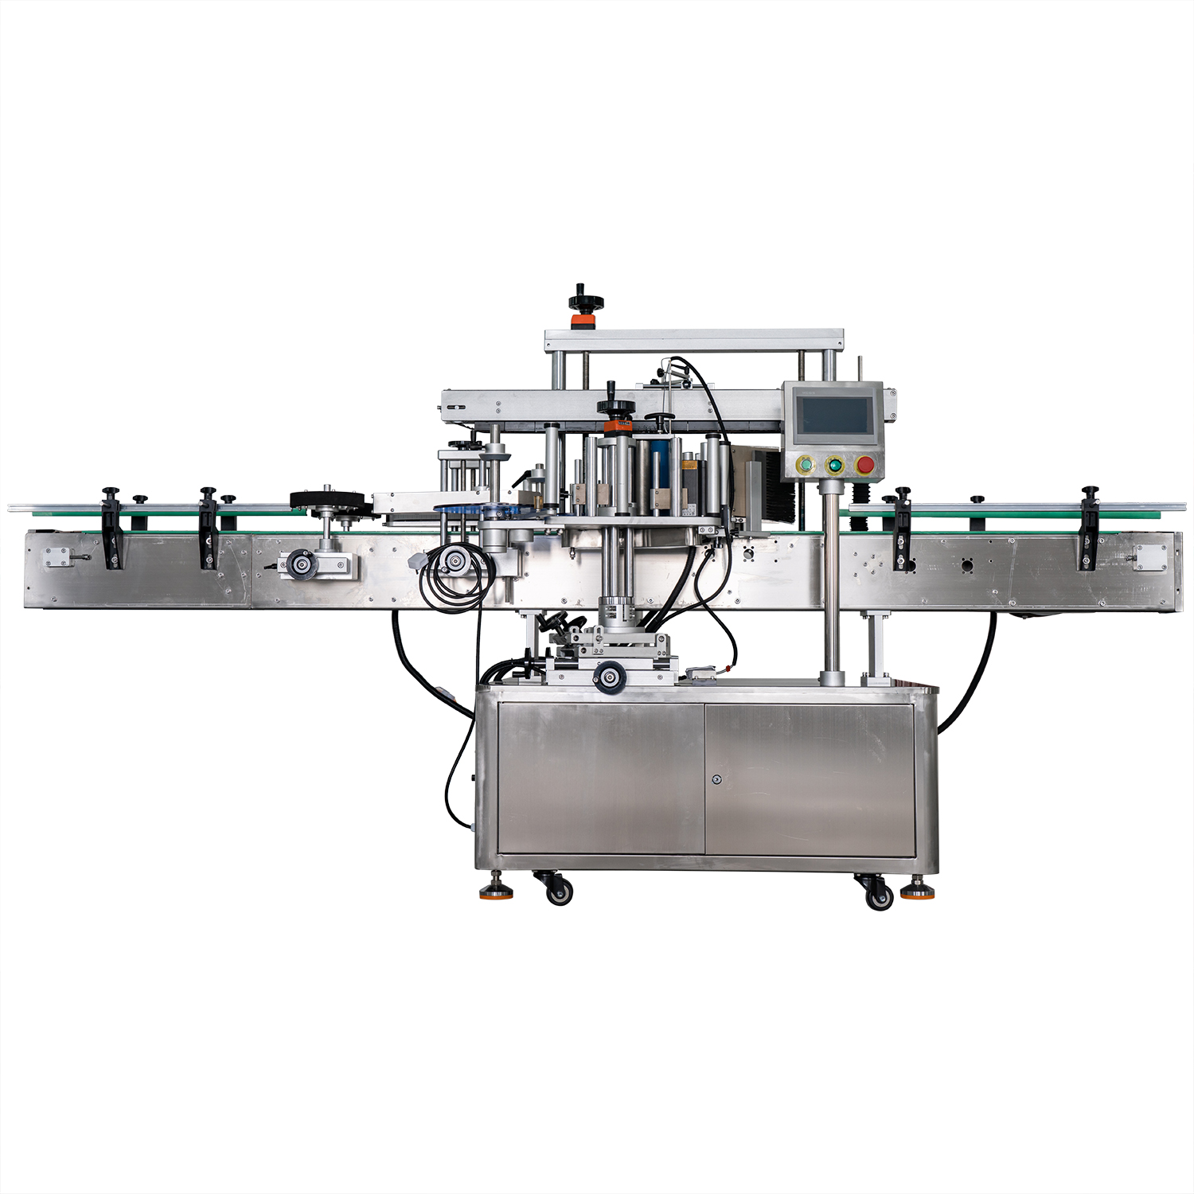

**6 Details**

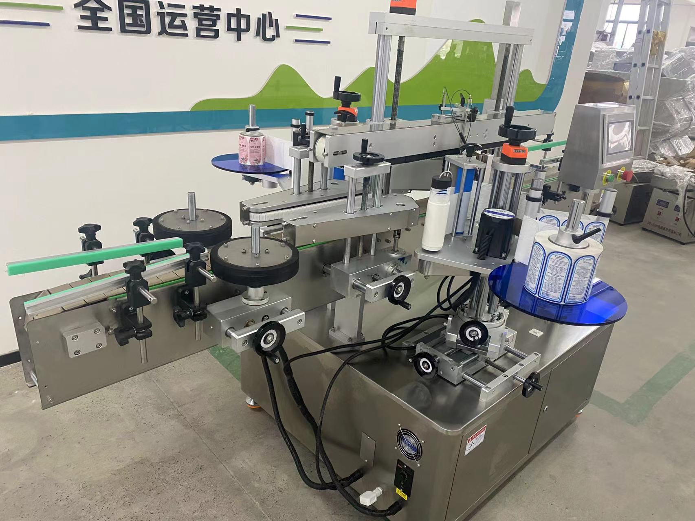

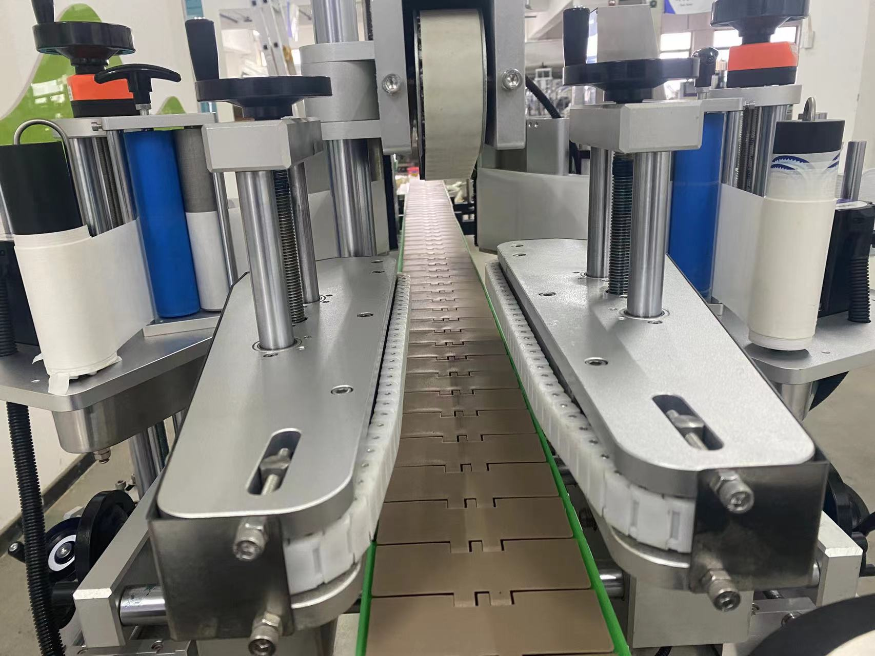

**technical specification**

|  |  |
| --- | --- |
| **适用产品尺寸**  **Applicadle product size** | **Length：20mm～250mm**  **Width：30mm～90mm**  **Height：60mm～280mm** |
| **适用标签尺寸**  **Applicadle label size** | **Length:：20mm～200mm**  **Width:（Bottom paper width）：20mm～160mm** |
| **贴标速度**  **Labeling speed** | **30～100Pieces/minute (related to product and label size)；** |
| **贴标精度**  **Labeling accuracy** | **±1mm (Does not include product or label errors)；** |
| **整机尺寸**  **Overall size** | **约2600mm×1450mm×1600mm（Length × Width × Height）**； |
| **适用电压**  **Adaptable voltage** | **220V/50HZ；** |
| **整机重量**  **Tatal weight** | **About 380Kg。** |

|  |  |
| --- | --- |
| **标准配置明细**  **Configuration list** | |
| **名称/Name** | **品牌/Brand** |
| **中间继电器**  **auxiliary relay** | **正泰**  **ZHENGTAI** |
| **侧标电眼**  **photosensor** | **西克/劳易测 /中芯**  **Sick/Leuze/zxcg** |
| **触摸屏**  **Touch screen** | **昆仑通态/台达**  **MCGS/Delta** |
| **PLC** | **松下/台达**  **Panasonic/Delta** |
| **测物电眼**  **Bottle sensor** | **松下/中芯**  **Panasonnic/zxcg** |
| **输送电机**  **Conveyor Drive Motor** | **川铭变频电机**  **Chuan ming** |
| **牵引电机**  **servo motor** | **赛研步进电机**  **Research stepper motor** |
| **导瓶电机**  **Flask motor** | **东邦调速电机**  **DPG** |
| **分瓶电机**  **Straight slide track** | **东邦调速电机**  **DPG** |

**Note: After-Sales Service:**

**1. Equipment Warranty Terms:**

**(1) One-year warranty on the entire machine. Repairs and replacements for quality-related defects are free of charge during the warranty period. Wear-and-tear parts are excluded from coverage.**

**(2) Lifetime maintenance support. Repairs outside the warranty period incur service and material costs. Lifetime spare parts supply and technical support are guaranteed.**