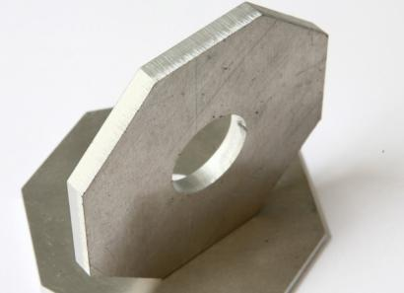
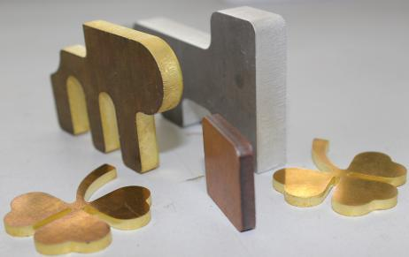
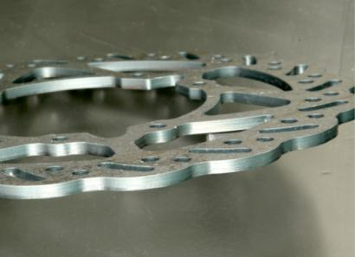

(PICTURE FOR REFERENCE)
1.Characteristic

The most advanced optical fiber laser is adopted by the SF3015FL optical fiber laser cutting machine, which output high energy density laser beam that focuses on the surface of the work-piece and the region irradiated by an ultra fine focal spot will be instant melting and gasification. Position of the spot can be changed by the numerical control mechanical system to finish automatic cutting.

Designed into gantry structure and double driving, this fiber laser cutting machine has the characteristics of stability, good rigidity and high speed. Its movement speed can reach 80m/min above.

The bed is formed by welding and more times aging treatment is done. Some transmission components equipped, such as the reducer, guide rail and rack and pinion, are foreign well-known brands. The structure that beams and columns are combined into one part, the transmission between Rack and pinion, these all ensure that the machine is fast dynamic response and good stability. That represents the direction of the development of laser cutting machine.

2.Laser cutting machine configuration
Machine tool main machine is composed of bed, beam, Z axis device, operation control part, gas path water and other parts.
- Bed part: The bed adopts welding structure, rough machining after annealing to eliminate the internal stress, and finishing after secondary vibration time effect treatment, which better solves the stress caused by welding and processing, thus greatly improving the stability of the machine tool. The bed wall panel structure adopts split splicing structure, and the large scale extension of the bed can be realized through high-precision processing. X, Y, Z axis are imported servo motors, equipped with high-rigidity precision reducer and high-precision rack and pinion, high-precision linear guide rail and other efficient transmission. The mechanism effectively ensures the accuracy of the transmission.
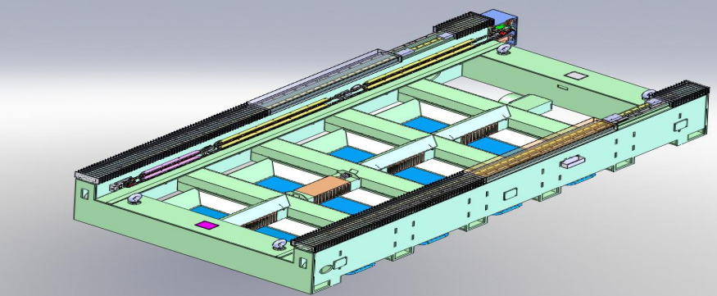

- Beam part: the beam adopts lightweight casting or welding structure (refer to the contract for details), roughed after annealing to eliminate the internal stress, and finished after secondary vibration aging treatment, which better solves the problems caused by casting and processing. The resulting stress greatly improves the stability of the machine tool.
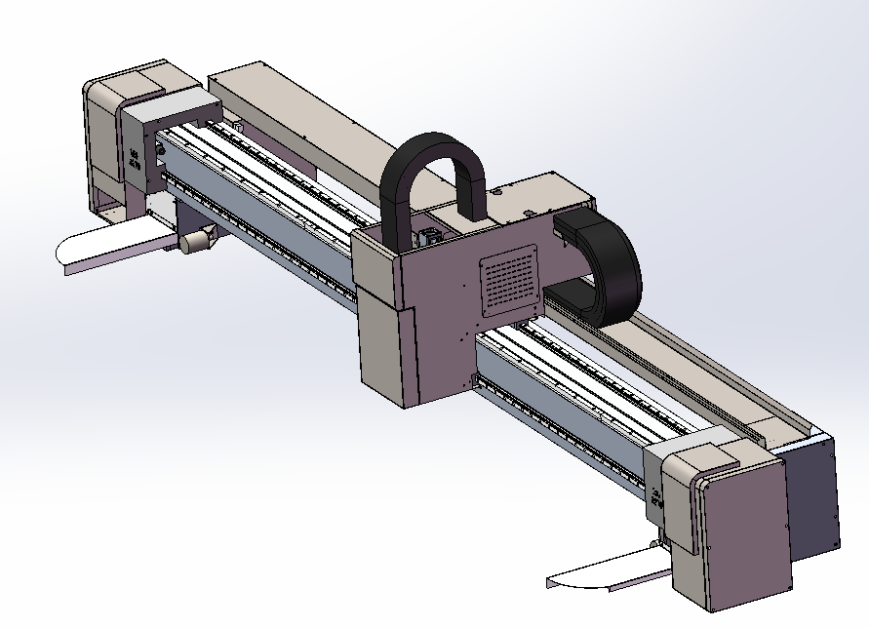
- Z axis device, gas path:
The system reads the Z-axis capacitance sensor to detect the distance signal, so as to accurately control the control height of the cutting head and the plate surface
The cutting quality is affected by the uneven cutting material. The cutting gas path is divided into oxygen, air and nitrogen, the gas is freely switched, and the gas element is selected from Japan imported SMC brand, high pressure control precision, good stability.
- Dust suction device (optional)
One end of the beam blows, the other end vacuums, and moves synchronously with the beam.
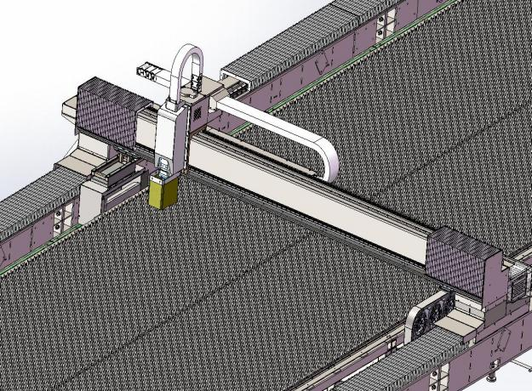

- Cutting head

The cutting head adopts the most advanced intelligent cutting head, built-in multiple groups of sensors, modular design, focusing speed, high precision, closed-loop pressure and other characteristics, the cutting head is a capacitive non-contact height automatic tracking system, the current maximum laser power: 6KW-- 40KW, temperature, humidity, air pressure, focus can be viewed and controlled through the system.

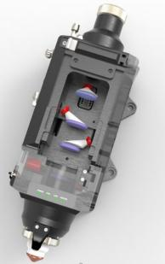

3.System
3015-6000W fiber laser cutting machine adopts Berchu 4000 numerical control system, which is a full-function control system specially launched for laser cutting, representing the most professional laser processing numerical control system, compact structure, strong professionalism and mold
Block type, excellent performance, simple operation and easy to learn.
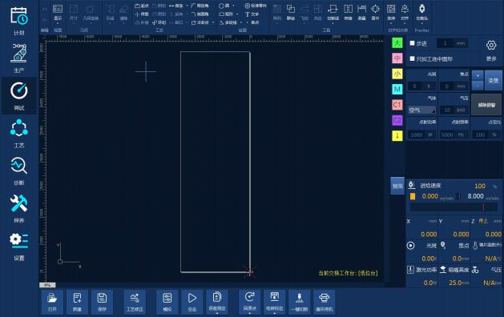

4.Main parts and designs

Operation system | 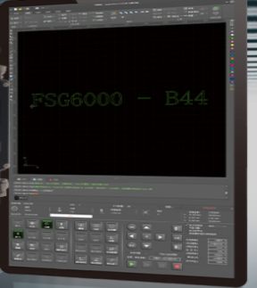 | Berchu 4000
Laser power source |  | Max 6000W, famous laser power source manufacturer
Cutting head | 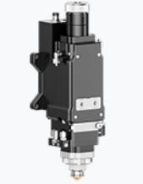 | Automatic focus 421 series from Switzerland, professional laser cutting head supplier
Driving system | 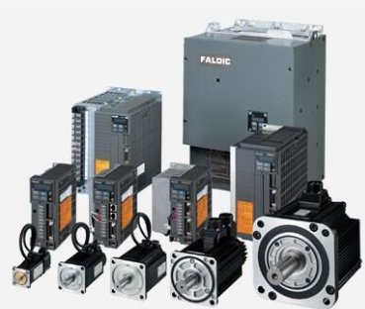 | 1.3KW 3pcs  0.4KW 1pc
Linear guide | 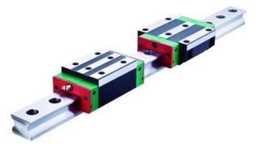 | HIWIN
Auto lubrication system | 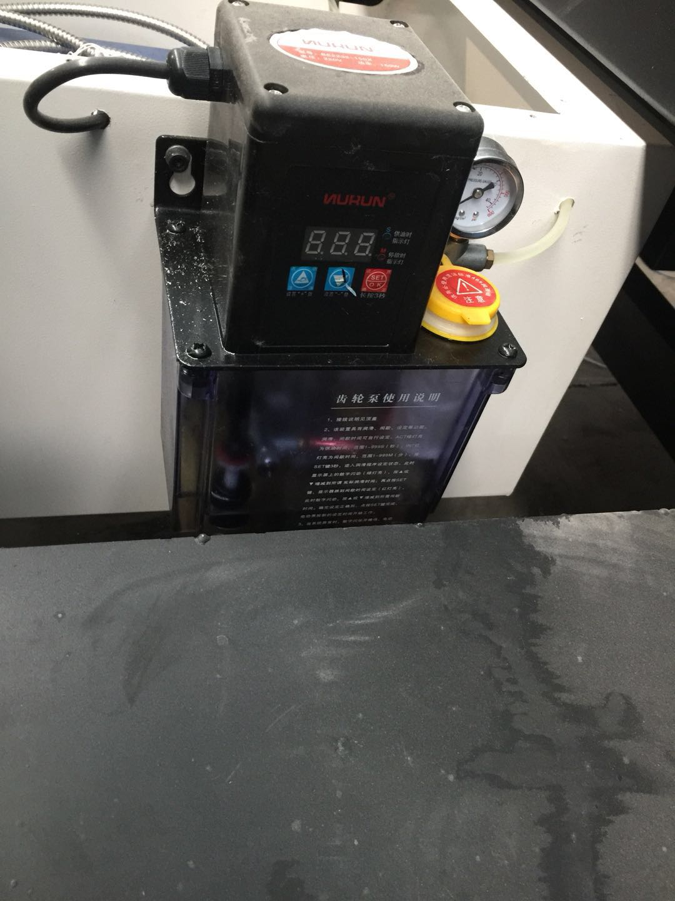 | Auto lubrication system for the gears, racks and guide rail
Water cooling system | 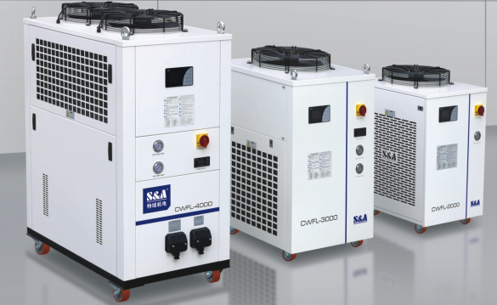 | Water cooling system is mainly for cooling of the cutting head, and the temperature is controlled automatically

