1.Main Usage
W24S is hydraulic 3 roller type profile bending machine, which is mainly used in various steel profile bending. It can roll “O” shape work-pieces. It is widely in petrol, chemical, shipyard, metal working and machine manufacturing industries.
2.Main structure of machine
W24S mainly has machine body, side roller part, support roller part, molds, electrical system, and hydraulic system.
Three rollers are driven rollers. Top roller is fixed. Two bottom rollers go up and down and do tilting movement around arc, which is hydraulically controlled by oil cylinder. To bend asymmetrical section profiles, the machine is equipped with support roller devices that can be arbitrarily raised and rotated. The lifting and rotation of the support roller can prevent and correct the bending defects of asymmetrical sections.
The control system is made up of PLC+ touch screen. Touch screen can display displacement of rollers which makes operation more easier. Rotary motion of three roller shaft is equipped with a brake device to ensure the accurate positioning of the work-piece when bending. The machine as a whole has enough strength and rigidity, easy installation and maintenance.
3.Mechanism drive system
The three rollers of this machine are all active rollers, which are driven by hydraulic motor and transferred to side rollers through gear transmission, and to the upper roller through gear and chain transmission.
4.Working process and working field
4.1 Working process
4.1.1 Step one:
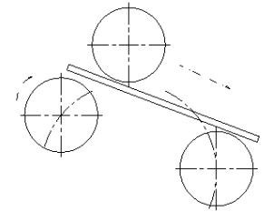
The right roller is located at the lower limit position, the left roller rises to clamps the work-piece with the main roller.
4.1.2 Step two:
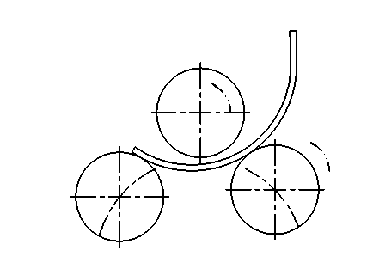
The right roller rises slowly and begins to roll and pre-bend between the main roller and the left roller.
4.1.3 Step three
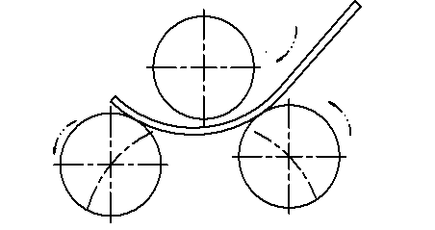
The left roller goes down while the right roller goes up. The material is sent to the left side, and three rollers begin to roll, pre-bend between the main roller and the right roller.

4.1.4 Step four
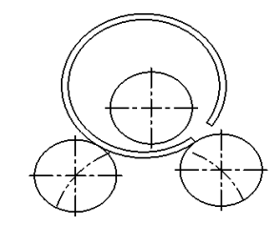

Finish rolling and pre-bending of work-piece.
4.2 Working field
The main parameters on form means the max. bending capacity with best working efficiency. If other steel profile like square, angle, only if the bending resistant modulus less than 100cm³, then it is available to finish bending on this W24S-100.
4.3 Bending way
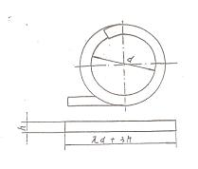
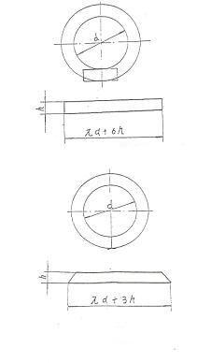

5.Hydraulic system
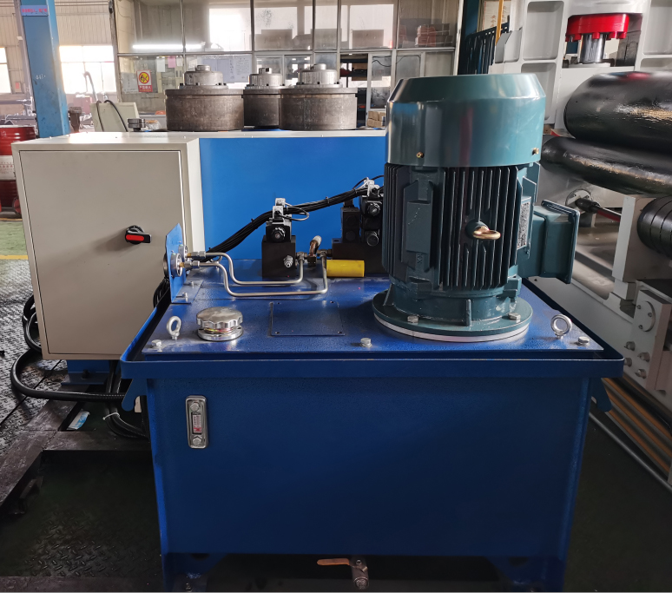
The hydraulic system pressure relief valve is electromagnetically controlled. The rise and fall of roller cylinder through two solenoid valve lift on both sides can be achieved when the electromagnetic relief valve has electricity and builds pressure on the system. The electric situation of the electromagnetic directional valve determines the working situation of the actuator (lifting of the cylinder, positive and reverse rotation of the motor), and the hydraulic control check valve keeps pressure on the actuator.
The system's working fluid is 30#-40# ordinary hydraulic oil. Motor rotation should be checked before testing. Observe the fluid level for the secondary fueling. It should be checked every six months, check the extent of oil deterioration or replace it with the new oil. Oil temperature is less than 70 ° C.
6.Electrical system
  - Voltage: 380V, 3 phase, 50Hz
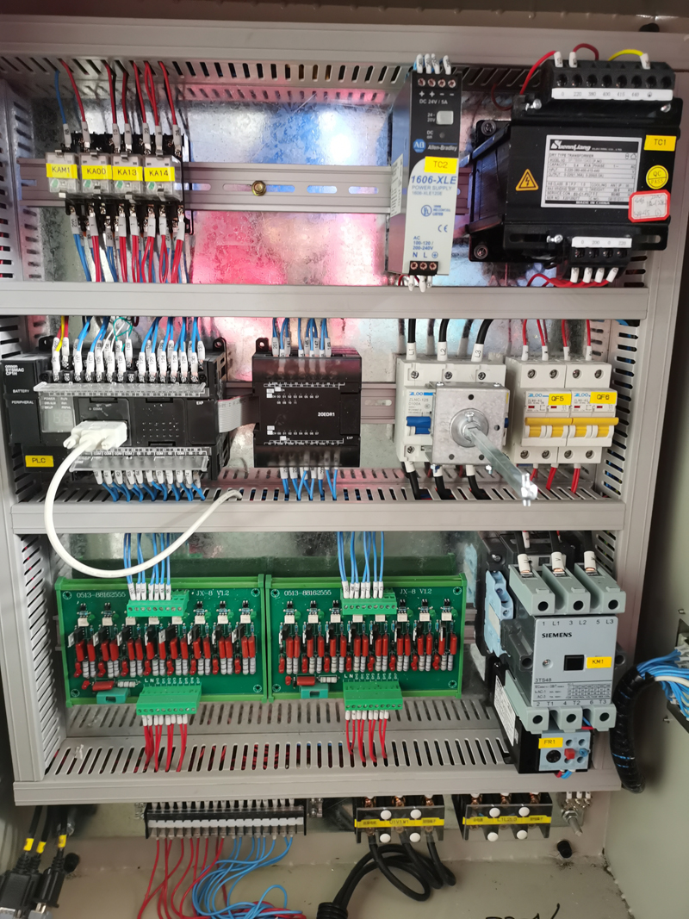
Electrical cabinet

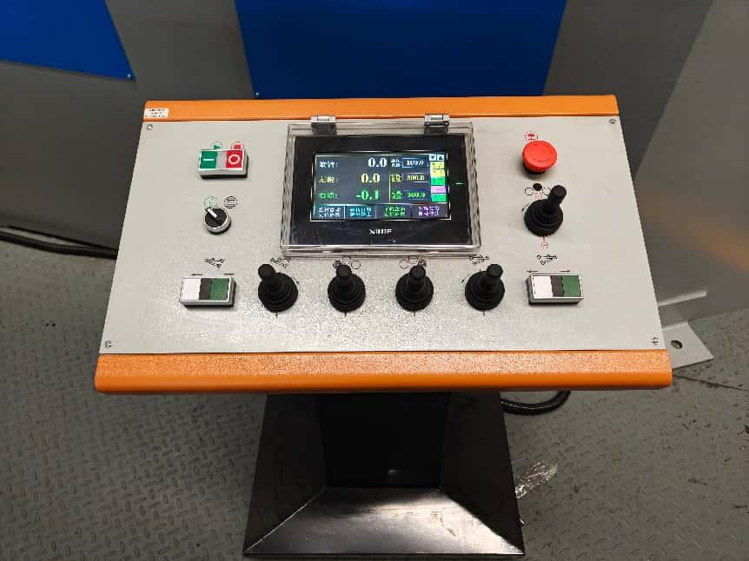
Control panel
The electrical control part of the machine is based on the contactor as the core, with electrical control system and hydraulic execution system in order to realize the machine movements. The amount of each movement can be displayed by digital display of control panel, which is easy to operate directly. The buttons on the operating panel can realize automatic control of roller lifting on both sides by setting the data.
High precision displacement sensor is adopted to ensure the position accuracy and realize the real-time monitoring of the position of each work roller.
This configuration has been proved to have the advantages of strong anti-interference ability, long service life, earthquake resistance and stable operation after being used by so many users.
7.Installing and Debugging
7.1 Installing
We pack the machine as a whole in steel carton. When arriving in client’s part, please check the correspondence of packing list and real machine. Before debugging, please inject oil to machine.
7.2 Debugging
7.2.1 Preparation before debugging
Please check all connects and clamping parts.
Please check the hydraulic oil level, and check if the lubrication is okay.
Please check the voltage of electricity.
7.2.2 Run without loading
After check above all, please run the main drive and do up and down movements, take 15 minutes as a cycle.
Check and adjust the up roller and sides rollers, to make the distance is suitable and workable.
7.2.3 Test requirements
Movements should be smooth on both sides of roller
Roller rotation and lift should be flexible
All transmission parts should have no abnormal noise
All fasteners are not allowed to loosen, need to be well-oiled.
Bearing temperature should not exceed 35 ° C, the highest temperature should not exceed 70 ° C, bearing the temperature should not exceed 40 ° C, the highest temperature should not exceed 70 ° C, the hydraulic pump oil temperature should not exceed 60 ° C .
7.2.4 Load test
Normal test run is possible after no-load test.
The general procedure is as follows:
Basic parameters in the table according to the provisions of the relevant profile parameters expected, pre-bend sections of treated end.
7.2.5 Load test requirements
Load testing should meet the basic parameters of the relevant performance requirements.
Load and load operation process, the transmission system should be stable, no abnormal noise. Working system, the operating system should be flexible, accurate and reliable. The bearing temperature must not exceed the above requirements.
In the process of rolling, there is no slipping phenomenon between molds and the profiles.
8.Operation
8.1 Preparation and inspection before use
Before using, please read this note to understand the aircraft's technical performance and operational methods, in strict accordance with the safe operation of the system and in accordance with the requirements of Article 7.2.1 to prepare the work, and then remove roll profiles oxide, while grinding edge, bulldozing weld.
8.2 Safety and protection
When using the machine, please pay great attention to the following safety matters.
8.2.1 Work overload is strictly prohibited.
8.2.2 In the process of use, if found to have irregular noise, it should be immediately stopped to check.
8.2.3 In the process of use, it should be always checked that the transmission mechanism of the joints have no loose, no damage.
8.3 Operation way
According to profile dimensions, lower the side rollers to a certain height.
The profiles will be processed and sent on both sides of the roller.
Control operating lever, until it meets the requirements data.
When main drive is stopped, lowered side roller, then remove the work-piece.
- Machine lubrication
Reasonable lubrication of the transmission part and sliding surface of the machine is an effective measure to reduce power consumption and prolong machine life. Therefore, it is necessary to select reasonable lubricating grease and establish necessary lubricating system.
9.1 According to the working conditions of the machine, regular lubrication is adopted.
9.1.1 Each bearing is lubricated with grease, and lubricating oil is added regularly according to the user's situation, generally once every six months.
9.1.2 Gear oil gun lubricating oil regularly, every shift.
9.1.3 Add lubricating oil to the oil gun at the chain, every shift.
9.2 Lubrication system and matters needing attention
9.2.1 Oil each lubrication point before each shift.
9.2.2 The whole lubrication system should be cleaned once 150 hours after the machine starts working, and then at least once a year. If the machine is in continuous full load state for a long time, it should be cleaned once half a year.
- Machine maintaining
The proper use and reasonable maintenance and repair, not only can prolong the life of the machine, but also reduce the cost of repairs. The maintenance includes the following main points:
10.1 The machine must be running at a normal and well-oiled circumstances. User should strictly enforce the lubrication system.
10.2 During rolling profiles, user should promptly remove the oxidation between the profiles and dies.
10.3 The vulnerability of the timely replacement of worn parts and the loss of too many performance requirements of the original parts.
10.4 Regular maintenance of the electrical system, dust, and timely replacement of failed components.
10.5 In the machine of running, user should pay attention to a movement parts of the temperature does not exceed the prescribed limits.

