**Android Multimedia All-in-One Control Board Specification**

(Model: AD320)

Table of contents

Chapter 1 Product Overview 2

1.1 General 2

1.2 Field of application 3

1.3 Features 3

1.4 Appearance and interface diagram 3

Chapter II List of Basic Functions 5

Chapter III PCB dimensions and interface layout 8

3.1 PCB dimension drawing (135mm * 94mm) 8

3.2 Description of interface parameters 7

Chapter IV Electrical Performance 163

# Chapter 1 Product Overview

## 1.1 General

* RK3288 Android integrated board adopts Rockchip RK3288 quad-core chip scheme and supports Google Android 5.1 system. RK3288 is the world's first new quad-core ARM A17 core chip, the world's first chip supporting the latest super Mali-T76x series GPU, and the world's first 4Kx2K hard decoding H.265 chip, supporting the decoding of mainstream audio and video formats and pictures. Support dual-screen different display function, dual 8/10-bit LVDS interface, support 3840 * 2160, can drive 7 "to 108" 4K * 2K display screen, support EDP/MIPI display interface output. Support 4K * 2K level
* HDMI-2160p output supports 4K level video playback. Support infrared remote control, WIFI/Bluetooth, 4G/3G module
* Remote control/gravity sensing/GPS/support serial port expansion/IO port expansion/MIPI camera and other functions, rich interfaces, widely used in advertising machine, interactive machine, security, industrial control and other intelligent control fields. Because of the characteristics of hardware platform and Android intelligence, it can be used on the intelligent terminal motherboard when human-computer interaction and network equipment interaction are needed.

## 1.2 Field of application

* Advertising machine
* Interactive all-in-one machine
* Industrial control computer

## 1.3 Features

 High performance. RK3288 chip adopts quad-core A17 scheme, which is one of the most powerful quad-core chips on the market at present. The powerful Mali-T76x GPU can play high-definition 4K * 2K videos in various formats and handle complex interactive operations.

◆ High stability. RK3288 Android integrated board, in terms of hardware and software, adds its own unique technology to ensure the stability of the product, which can make the final product unattended for 7 * 24 hours.

 High scalability. Four USB ports, three serial ports, two I2C interfaces, four IO expansion ports and one SPI interface can expand more peripheral devices.

## 1.4 Appearance and interface diagram

**Front:**

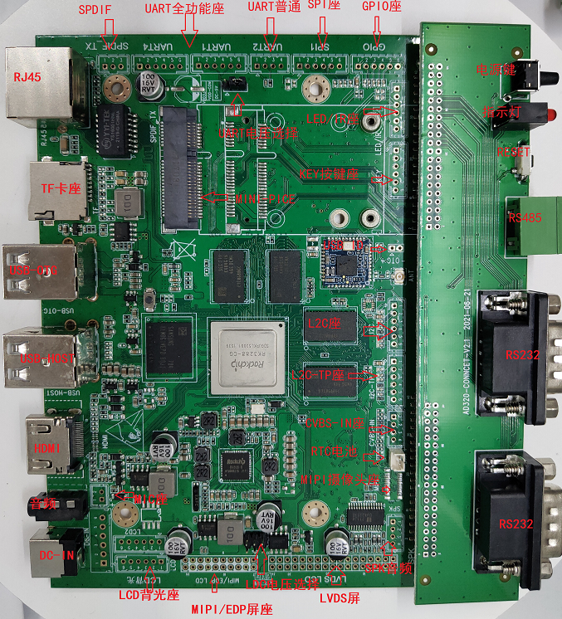

**Reverse:**

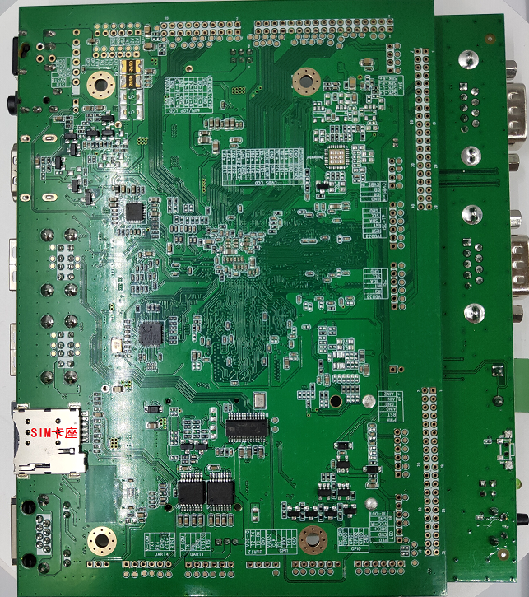

**With housing:**

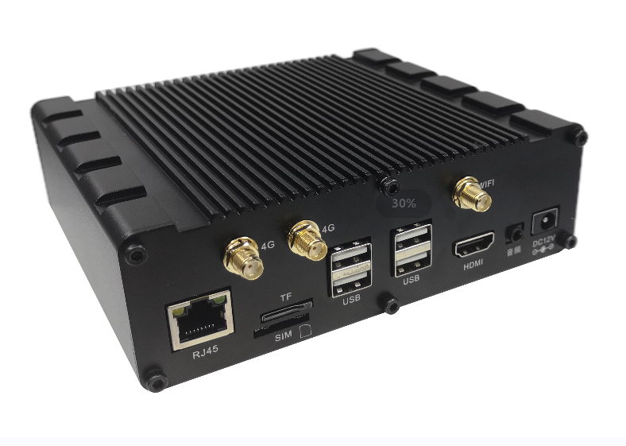

Shell size: 149 * 46 * 122.5mm

# Chapter II List of Basic Functions

|  |  |  |
| --- | --- | --- |
| **Main hardware indicators** | | |
| CPU | Rockchip RK3288 Most Powerful Quad-Core 1.8GHz Cortex-A17 Quad-Core GPU Mail-T764 | |
| Memory | DDR3 1G/2G (default) (up to 4G) | |
| Built-in memory | 8GB (default)/16g/32g optional | |
| Display interface | EDP/MIPI interface, LVDS interface (single, 6-bit dual, 8-bit, 10-bit dual). Support the maximum resolution of 3840 * 2160, support HDMI 7 "" -108 "" 4K * 2K display screen, supporting dual-screen different display function | |
| Operating System | Android 7.1 | |
| Touch screen | I2C interface is provided (multi-point capacitive touch can be supported).  Support USB interface (multi-point infrared touch, multi-point capacitive touch, multi-point resistive touch, multi-point nano-film touch, multi-point acoustic touch, multi-point optical touch.) | |
| Network | It is equipped with RJ45 Gigabit Ethernet port (RTL8211E) and supports Ethernet. | |
| WIFI/BT | RTL8723BS, WIFI 2.4G 802.11 a/B/gn BT 4.0 (default) |
| AP6330, WIFI 5.0 G/2.4G 802.11 a/B/gn BT 4.0 (optional) |
| With 3G function, support WCDMA, EVDO, CDMA, GSM), 2G/3G full band support 850/900/1800/1900MHz/2100MHz (optional) | |
| With 4G function, LTE-TDD/LTE-FDD/TD-SCDMA/EDGE/GPRS/GSM  Optional) | |
| Video playback | Support WMV, AVI, FLV, RM, rmvb, MPEG, ts, MP4, etc. | |
| Image rotation | Supports 0, 90, 180, 270 degree manual/auto rotation. Support gravity sensing function (optional) | |
| Real time clock | Built-in real-time clock power supply battery, support timing on and off | |
| Watchdog | Support Software, Hardware Watchdog | |
| Interface | 2-channel serial port R232, 1-channel serial port TTL, supporting various serial devices, printers, card swiping and other peripherals | |
| 4-way USB, supporting various USB peripherals (camera, TP …) | |
| LVDS/EDP/MIPI/HDMI-B | |
| GPIO，IR，SPI, 12C-TP, 12C | |
| Audio and video output | Left and right channel output, built-in 8R/5 W * 2 power amplifier | |
| System upgrade | Support USB upgrade and network upgrade | |

# PCB dimensions and interface layout

## 3.1 PCB dimension drawing (144mm * 122mm)

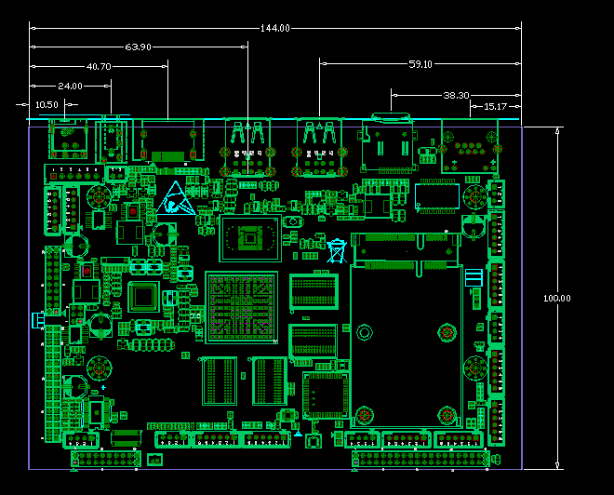

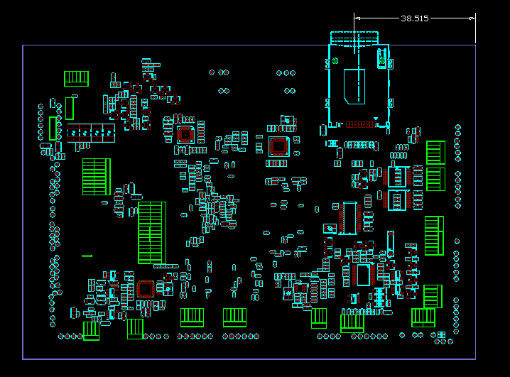

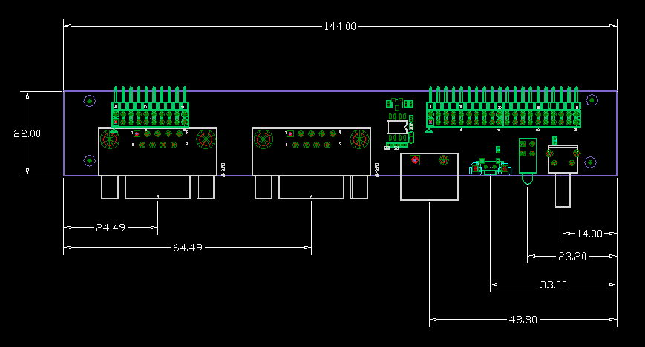

PCB: 6-layer board

Size: 144 * 122mm, board thickness: 1.6mm

Screw hole size: 3 mm X 5

## 3.2 Description of interface parameters

**◆ J1 DCIN power input interface (XH female, 1 * 6pin, 2.54mm)**

|  |  |  |  |  |
| --- | --- | --- | --- | --- |
| **Serial number** | **Definition** | **Attribute** | **Description** | |
| 1 | DCIN | Input | 12V input | 座子6PIN.png |
| 2 | DCIN | Input | 12V input |
| 3 | GND | Ground wire | Ground wire |
| 4 | GND | Ground wire | Ground wire |
| 5 | 5VSTB | Input | STB 5V power input |
| 6 | STB | Output | STB signal detection port |

* **J36 IR/LED remote control/LED indicator (PH female, 1 * 6pin, 2.0mm)**

|  |  |  |  |  |
| --- | --- | --- | --- | --- |
| **Serial number** | **Definition** | **Attribute** | **Description** | |
| 1 | LED-R | Output | Red light-Powering on | QQ截图20141105170909.jpg |
| 2 | GND | Ground wire | Ground wire |
| 3 | LED-G | Output | Blue light-power on working status |
| 4 | VCC-IR | Output | IR output |
| 5 | GND | Ground | Ground wire |
| 6 | IR | Input | IR infrared input |

* **J11 KEY key interface (PH female seat, 1 * 6pin, 2.0mm)**

|  |  |  |  |  |
| --- | --- | --- | --- | --- |
| **Serial number** | **Definition** | **Attribute** | **Description** | |
| 1 | PWR | Output | POWER key | QQ截图20141105170909.jpg |
| 2 | RESET | Output | RESET key |
| 3 | ADC0 | Output | AD 0 sampling key value input |
| 4 | GND | Ground wire | Ground wire |
| 5 | AIN1 | Input | AD1 Sample Input |
| 6 | AIN2 | Input | AD2 Sample Input |

* **J16 GPIO (PH female, 1 * 6pin, 2.0mm)**

|  |  |  |  |  |
| --- | --- | --- | --- | --- |
| **Serial number** | **Definition** | **Attribute** | **Description** | |
| 1 | DC-QQ截图20141105170909.jpgGPIO | Output | 3.3 V supply output | QQ截图20141105170909.jpg |
| 2 | GPIO0 | I/O | Common I/O port default pull-up |
| 3 | GPIO1 | I/O | Common I/O port default pull-up |
| 4 | GPIO2 | I/O | Common I/O port default pull-up |
| 5 | GPIO3 | I/O | Common I/O port default pull-up |
| 6 | GND | Ground wire | Ground wire |

* **J24 SPI (PH female, 1 * 6pin, 2.0mm)**

|  |  |  |  |  |
| --- | --- | --- | --- | --- |
| **Serial number** | **Definition** | **Attribute** | **Description** | |
| 1 | VDD-3V | Output | 3.3 V supply output | QQ截图20141105170909.jpg |
| 2 | SCK | Clock | SPI clock |
| 3 | CS | Output | SPI chip select |
| 4 | MISO | I | SPI Signal Output |
| 5 | MOSI | O | SPI Signal Input |
| 6 | GND | Ground wire | Ground wire |

* **J8 J20 UART 1 UART4 (PH female, 1 * 6pin, 2.0mm) _ default R232**

|  |  |  |  |  |
| --- | --- | --- | --- | --- |
| **Serial number** | **Definition** | **Attribute** | **Description** | |
| 1 | VCOM | Output | 3.3 V/5V supply output | QQ截图20141105170909.jpg |
| 2 | TX | Output | Serial data transmission |
| 3 | RX | Input | Serial data reception |
| 4 | GND | Ground wire | Ground wire |
| 5 | CTS | Input | Request to send |
| 6 | RTS | Output | Clear Send |

* **J7 UART2 (PH female, 1 * 4pin, 2.0mm) default TTL**

|  |  |  |  |  |
| --- | --- | --- | --- | --- |
| **Serial number** | **Definition** | **Attribute** | **Description** | |
| 1 | VCC-IO | Output | 3.3 V supply output | QQ截图20141105165655.jpg |
| 2 | TX | Output | Serial port data transmission |
| 3 | RX | Input | Serial port data receiving |
| 4 | GND | Ground wire | Ground wire |

* **J25 SPDIF (PH female, 1 * 3pin, 2.0mm) _ default NC option**

|  |  |  |  |
| --- | --- | --- | --- |
| **Serial number** | **Definition** | **Attribute** | **Description** |
| 1 | TX | Data | SPDIF data transmission |
| 2 | VDD-3V | Output | 3 V supply output |
| 3 | GND | Ground wire | Ground wire |

* **J38 backlight control interface (PH female, 1 * 6pin, 2.0mm)**

|  |  |  |  |  |
| --- | --- | --- | --- | --- |
| **Serial number** | **Definition** | **Attribute** | **Description** | |
| 1 | 12V | Output | 12 V power output | QQ截图20141105170909.jpg |
| 2 | 12V | Output | 12 V power output |
| 3 | BL-EN | Output | Backlight enable control |
| 4 | BL-ADJ | Output | Backlight brightness control |
| 5 | GND | Ground wire | Ground wire |
| 6 | GND | Ground wire | Ground wire |

* **J9 SPK audio interface (PH female, 1 * 4pin, 2.0mm)**

|  |  |  |  |  |
| --- | --- | --- | --- | --- |
| **Serial number** | **Definition** | **Attribute** | **Description** | |
| 1 | SPK-L+ | Output | Audio output left + | QQ截图20141105165655.jpg |
| 2 | SPK-L- | Output | Audio Output Left- |
| 3 | SPK-R- | Output | Audio Output Right- |
| 4 | SPK-R+ | Output | Audio output right + |

* **J17 MIC interface (PH female, 1 * 2 pin, 2.0mm)**

|  |  |  |  |
| --- | --- | --- | --- |
| **Serial number** | **Definition** | **Attribute** | **Description** |
| 1 | MIC+ | Output | Audio input + |
| 2 | MIC- | Input | Audio Input- |

* **J37 LCD panel voltage selection jump cap (double row pin, 2 * 3pin, 2.0mm) Note the following jump cap**

**3V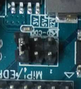 5V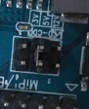 12V** 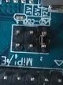

* **J22 LVDS interface (double-row pin, 2 * 17pin, 2.0mm)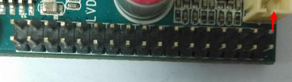red arrow is the first pin**

|  |  |  |  |
| --- | --- | --- | --- |
| **Serial number** | **Definition** | **Attribute** | **Description** |
| 1 | VCC | Output | LCD power output, + 3.3v/+ 5V/+ 12V optional, |
| 2 |
| 3 |
| 4 | GND | Ground wire | Ground wire |
| 5 |
| 6 |
| 7 | 0-VN0 | Data | Pixel0 Negative Data (Odd) |
| 8 | 0-VP0 | Data | Pixel0 Positive Data (Odd) |
| 9 | 0-VN1 | Data | Pixel1 Negative Data (Odd) |
| 10 | 0-VP1 | Data | Pixel1 Positive Data (Odd) |
| 11 | 0-VN2 | Data | Pixel2 Negative Data (Odd) |
| 12 | 0-VP2 | Data | Pixel2 Positive Data (Odd) |
| 13 | GND | Ground wire | Ground wire |
| 14 | GND | Ground wire | Ground wire |
| 15 | 0-VNC | Clock | Negative Sampling Clock (Odd) |
| 16 | 0-VPC | Clock | Positive Sampling Clock (Odd) |
| 17 | 0-VN3 | Data | Pixel3 Negative Data (Odd) |
| 18 | 0-VP3 | Data | Pixel3 Positive Data (Odd) |
| 19 | 1-VN0 | Data | Pixel0 Negative Data (Even) |
| 20 | 1-VP0 | Data | Pixel0 Positive Data (Even) |
| 21 | 1-VN1 | Data | Pixel1 Negative Data (Even) |
| 22 | 1-VP1 | Data | Pixel1 Positive Data (Even) |
| 23 | 1-VN2 | Data | Pixel2 Negative Data (Even) |
| 24 | 1-VP2 | Data | Pixel2 Positive Data (Even) |
| 25 | GND | Ground wire | Ground wire |
| 26 | GND | Ground wire | Ground wire |
| 27 | 1-VNC | Clock | Negative Sampling Clock (Even) |
| 28 | 1-VPC | Clock | Positive Sampling Clock (Even) |
| 29 | 1-VN3 | Data | Pixel3 Negative Data (Even) |
| 30 | 1-VP3 | Data | Pixel3 Positive Data (Even) |
| 31 | 1-VN4 | Data | Pixel4 Negative Data (Even) |
| 32 | 1-VP4 | Data | Pixel4 Positive Data (Even) |
| 33 | 0-VN4 | Output | Pixel4 Negative Data (Odd) |
| 34 | 0-VP4 | Output | Pixel4 Positive Data (Odd) |

* **J18 EDP/MIPI interface (double row header, 2 * 10pin, 2.0mm)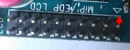red arrow is the first pin**

|  |  |  |  |
| --- | --- | --- | --- |
| **Serial number** | **Definition** | **Attribute** | **Description** |
| 1 | VCC | Power source | LCD power output, + 3.3 V/+ 5V/+ 12V selectable, |
| 2 |
| 3 |
| 4 | GND | Ground wire | Ground wire |
| 5 |
| 6 |
| 7 | D0- | I/O | Data D0- |
| 8 | D0+ | I/O | Data D0 + |
| 9 | D1- | I/O | Data D1- |
| 10 | D1+ | I/O | Data D1 + |
| 11 | D2- | I/O | Data D2- |
| 12 | D2+ | I/O | Data D2 + |
| 13 | GND | Ground | Ground |
| 14 | GND | Ground | Ground |
| 15 | AXUN | I | Data |
| 16 | AXUP | O | Data |
| 17 | D3- | I/O | Data D3- |
| 18 | D3+ | I/O | Data D3 + |
| 19 | VDD33 | Output | 3.3 V supply output |
| 20 | HPD | Input | HPD detection |

* **J4 J5 J6 USB 1 USB2 USB3 (PH female, 1 * 4 pin, 2.0mm) USB HOST**

|  |  |  |  |  |
| --- | --- | --- | --- | --- |
| **Serial number** | **Definition** | **Attribute** | **Description** | |
| 1 | GND | Ground wire | Ground wire | QQ截图20141105165655.jpg |
| 2 | DP | Data | DP |
| 3 | DM | Data | DM |
| 4 | 5V | Output | 5V power output |

* **J12 I2C-TP touch screen interface (PH female, 1 * 6pin, 2.0mm) _**

|  |  |  |  |  |
| --- | --- | --- | --- | --- |
| **Serial number** | **Definition** | **Attribute** | **Description** | |
| 1 | 3.3V | Output | 3.3 V supply output | QQ截图20141105170909.jpg |
| 2 | RST | Output | Reset |
| I | INT | Input | Interrupt |
| 4 | SDA | Data | I2C data |
| 5 | SCK | Clock | I2C clock |
| 6 | GND | Ground wire | Ground wire |

* **J13 I2C interface (PH female, 1 * 6pin, 2.0mm) _ I2C**

|  |  |  |  |  |
| --- | --- | --- | --- | --- |
| **Serial number** | **Definition** | **Attribute** | **Description** | |
| 1 | 3.3V | Power source | 3.3V output | QQ截图20141105170909.jpg |
| 2 | RST | Output | Reset |
| I | INT | Input | Interrupt |
| 4 | SDA | Data | I2C data |
| 5 | SCK | Clock | I2C clock |
| 6 | GND | Ground wire | Ground wire |

* **Other standard interfaces and functions:**

|  |  |  |
| --- | --- | --- |
| Storage interface | TF card | Data storage, up to 128G |
| USB | HOST interface, supporting data storage, data import, USB mouse, keyboard, camera, touch screen, etc. |
| Ethernet interface | RJ45 connector | Support 10/100/1000 M wired network |
| HDMI interface | Standard interface | Supports HDMI data output up to 1080P |
| Headphone connector | Standard interface | 3.5mm standard interface |

# Chapter IV Electrical Performance

|  |  |  |  |  |
| --- | --- | --- | --- | --- |
| **Project** | | **Minimal** | **Typical** | **Max** |
| Supply voltage | Voltage | -- | 12 | -- |
| Ripple | -- | -- | 50mV |
| Supply current (HDMI output, no other peripherals connected) | Operating current | -- | 300mA | 350mA |
| Standby current | -- | 70mA | 100mA |
| USB power supply current | -- | -- | 500mA |
| Supply Current (LVDS) | Operating current | Depends on the screen | | |
| Standby current |
| LCD panel supply current | -- | -- | 1A(5V)/2A(12V) |
| Environment | Relative humidity | -- | -- | 80% |
| Operating temperature | -20℃ | -- | 50℃ |