**CASE STUDY**

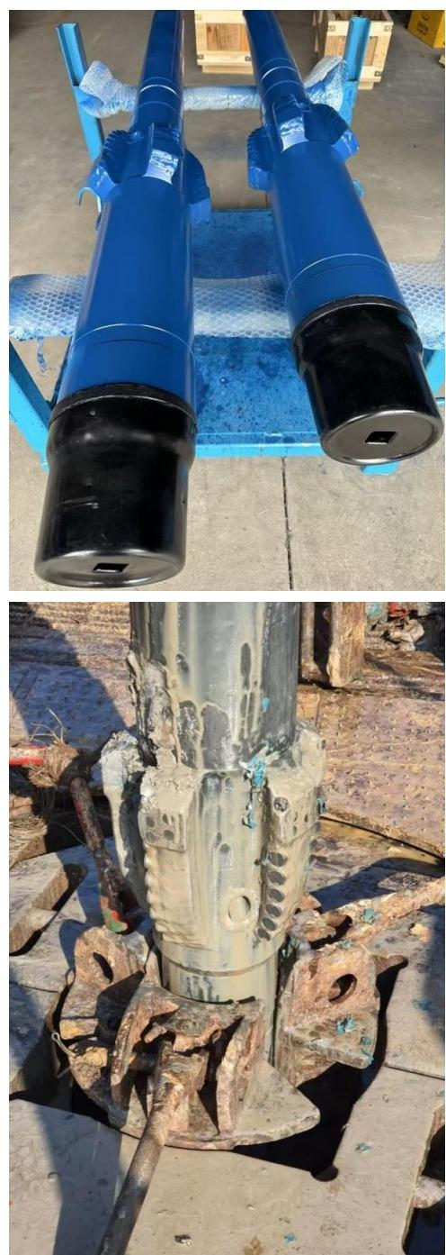

**[www.deepfast.net DF-PRIVATE](https://www.deepfast.netDF-PRIVATE)**



**HOLE OPENER**

Date:From Dec.2024 to Jan.2025 Well Location:Indonesia

Type:Fixed Cutter HO Ty S/N:186305

Size:8.50"

Nozzle:5×16(8.5")

TFA:0.982 sq.in(8.5")

Length:5.7 ft Used:RR2

Dull Grading:

In:0-0-NO-A-X-IN-NO-TD Out:0-0-NO-A-X-IN-NO-TD

**HOLE OPENER INTRODCUTION**

● All the size of the Hole Opener can be manufactured,customized

as per operation requirements.

● Integrated Structure with no moving parts,simple operation and

reliability.

● Achieve the effect as normal hole opener during

drilling operation,reducing NPT and drilling costs.

● Optimize the force balance design by using professional

design software,minimizing the impact damage caused by

unbalanced forces for smooth drilling.