Product technical specification
Product picture |  | Product dimension drawing
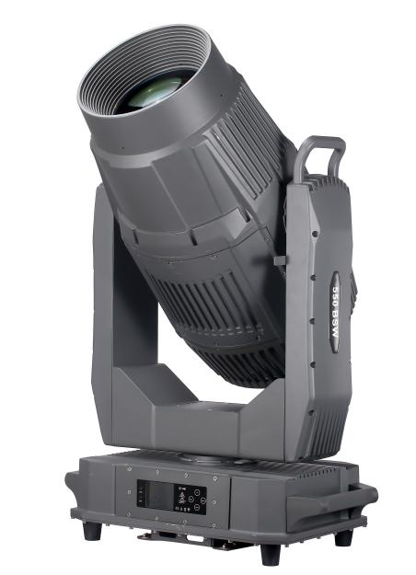 |  | 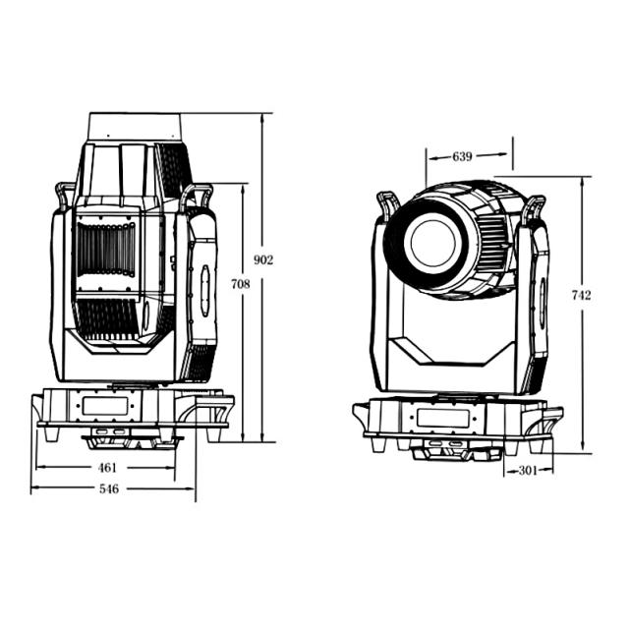
Lamp specification |  |  |  |  |  | parameter
Product name | 1400W BSWF IP 4in1 with CMY+CTO | Product model | GS-L1400QG |  | ·Power Supply:AC 100-240V,50/60Hz  ·Power consumption:1800W  ·Light Source:1400W  ·LED life expectancy: 55000 Hours  ·Color Temperature:2700K-6500K  ·Diameter of lens:132mm  ·Color Wheel:linear CMY color mixing,CTO color temperature adjustment (2700K-6500K),  1 color wheel:7 color+white light,Semi- color and rainbow effect;  (adjustable rotating speed and direction)  ·Gobo Wheel:1 static gobo wheel:7 gobos+open;  1 rotating gobo wheel:6 interchangeable gobos+open;  gobo shake(adjustable rotating speed and direction)  ·Animation wheel:Water ripple wheel  ·Prism:6-facet prism,rotatable in both directions  ·Framing shutters: 4x fast and smooth framing shutters, each individually controllable; each blade can block light completely; framing module can be rotated at ±60°  ·Zoom: electronic linear zoom 2°-50°  ·Focus:Variable motorized focus(0-100%)  ·Frost:An independent frost effect  ·Dimmer: 0-100% linear electronic dimmer  ·Strobe: 1-25Hz/s,adjustable speed  ·Movement:Pan: 540°,16 Bit movement resolution  Tilt: 270°,16 Bit movement resolution  Automatically accurate positioning  ·Control mode:DMX512,RDM,Sound,Master/Slave,Auto  ·DMX Channel:22/32/40 CH  ·Protection Rating: IP65  ·Product Size:546*301*902mm,N.W.:66.6kg  ·Carton size:720*470*1135mm,G.W:75.9kg
 |  | Lamp color | black
Net weight | 66.6kg | Gross weight | 75.9kg
Product size | 546*301*902mm | Package size | 720*470*1135mm
Degree of protection | IP65 | Lamp material | Aluminum alloy, high temperature and ultraviolet resistant engineering plastics
Optical system |  | Effect system
Light source information | 1400W White LED | Color wheel | linear CMY color mixing,CTO color temperature adjustment (2700K-6500K),  1 color wheel:7 color+white light,Semi- color and rainbow effect, (adjustable rotating speed and direction)
Light source life | 55000 Hours | Gobo wheel | 1 static gobo wheel:7 gobos+open;  1 rotating gobo wheel:6 interchangeable gobos+open;  gobo shake(adjustable rotating speed and direction)
Color temperature | 2700K-6500K | Animation wheel | Water ripple wheel
Zoom | electronic linear zoom 2°-50° | Prism | 6-facet prism,rotatable in both directions
Diameter of lens | 132mm | Framing system | 4x fast and smooth framing shutters, each individually controllable;  each blade can block light completely; framing module can be rotated at ±60°
Focus | Variable motorized focus(0-100%) | Strobe | 1-25Hz/s,adjustable speed
Frost | An independent frost effect | Dimmer | 0-100% linear electronic dimmer
Electrical connection |  | Control system
Input voltage | AC 100V-240V, 50/60Hz | Movement | Pan: 540°.16 Bit movement resolution; Tilt: 270°,16 Bit movement resolution;  Automatically accurate positioning
Whole lamp power | 1800W | Communication design | DMX wired / wireless transmission, convenient and fast software upgrade through DMX data cable.
Signal connection | 3/5 pin IP65 XLR I / O | Control Mode | DMX512,RDM,Sound,Auto,Manual,Master/Slave
Power connection | IP66 power head input | DMX Channel | 22/32/40 CH
Display | LCD digital display,support Chinese & English,Lamps and lanterns can be queried, and the service time of bulbs is convenient for maintenance
Other
Gobo+ Color |  |  |  | Effect
ROTATING GOBO WHEEL :   STATIC GOBO WHEEL :  COLOR WHEEL :  |  |  |  | 