**Four eyes two color spectator light**

**Use it to explain the book**

Please read the instructions carefully before use

**Catalogue**

Chapter 1 Precautions and Installation 1

1. Maintenance and maintenance 1

2. statement 1

3. Product precautions 1

4. Lighting installation 2

Chapter 2 Panel Operations 4

1. Lamp panel 4

2. Menu home screen 4

2.1. System Settings 5

2.2. System calibration............................................... 7

2.3. System Information 8

Chapter 3 Channel description and technical parameters ...............................10

1. Channel table.............................................................................. ..........10

2. Technical parameters............................................................................12

Chapter 4 Common Faults and Usage Notes..................................................13

1. Common fault handling 13

2. Precautions for use 14

3. RDM usage precautions 14

# Chapter 1 Precautions and installation

## tending

* The lamp should be kept dry and should not be used in a humid environment.
* Intermittent use will effectively extend the life of this lamp.
* In order to obtain good ventilation and lighting effect, attention should be paid to the regular cleaning of fans, fan nets and lenses.
* Do not use alcohol and other organic solvents to wipe the lamp shell, so as to avoid damage.

## statement

For the correct and safe use of this product, please read the instructions carefully before installation and use. This manual contains important installation and application information, and please follow the instructions strictly when installing and operating the product. Please keep this manual properly.

This product is in good condition and packaged intact upon leaving the factory. All users must strictly adhere to the warning statements and operating instructions mentioned above. Any damage caused by misuse is not covered by our warranty. Faults and issues resulting from neglecting the user manual are also not within the responsibility of the dealer. If there are any technical changes to this manual, we regret not providing prior notice.

Please be careful to remove the package, check whether the product is damaged during transportation after the package is removed, and check whether the following contents are complete.

Four eyes two color spectator light----1 unit signal line----1

Manual----1 power cord----1

## Product precautions

* To ensure the products lifespan, do not place it in damp or water-leaking areas, and never operate it in environments with temperatures exceeding 60 degrees Celsius. If the product has been exposed to extreme and unstable temperatures (such as after transportation), do not immediately connect the power supply, as moisture caused by temperature changes may damage the product. Please wait until the product returns to normal temperature before using it.
* This product can be used in the voltage range of 100-240V and is for indoor use. Please ensure that the ground voltage is not higher than the range that the product can withstand!! The power plug must be inserted into a well protected class I socket. The green or tea-green conductor must be grounded.
* Please check the power cord regularly. Make sure the power cord is not folded or damaged and not connected to other wires! Pay special attention when connecting the power cord or related wires. Unplug the power cord when not using the product or before cleaning.
* Do not tamper with this product without authorization, otherwise it may damage the product, and any damage caused is not covered by warranty. In addition, unprofessional operation may cause short circuit, burns or electric shock, etc.
* Do not store this product in a place where it is easy to loosen or shake.
* Before using the product, please familiarize yourself with the operation function of the product. Do not shake this product. Do not use brute force when installing or operating the product. Do not let unprofessional personnel operate the product. Most of the damage is caused by unprofessional operation.
* To avoid the danger of electric shock, the maintenance request of this product should be assisted by professionals.
* When the bulb is used, the power supply voltage should not change more than ±10%. If the voltage is too high, the life of the bulb will be shortened; if the voltage is too low, the color of the bulb will be affected.
* After power failure, the lamp should be fully cooled for 20 minutes before being re-electrified.
* Please read this manual carefully to ensure the normal use of this product.
* Signal line connection (DMX)

Use specification compliant RS-485 cables: shielded, 120ohm characteristic impedance, 22-24 AWG, low capacitive reactance. Do not use microphone cables or cables with different specified characteristics. Terminal connections must use 3 or 5 pin XLR male/female connectors (minimum 1 / 4 W).

Important note: The wires should not touch each other or the metal casing.

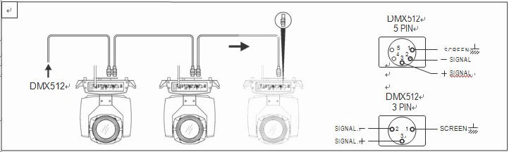

Figure 1 Schematic diagram of DMX signal cable connection

During the installation process, if the signal cable is laid over a long distance or in a noisy environment, such as a dance hall, it is recommended to use a DMX terminal (loop connection). This can prevent digital control signals from becoming muddled due to electrical noise. The DMX terminal consists of a simple XLR connector with 2 or 3 pins connected to a 120-ohm resistor. Please plug the terminal into the XLR output port of the last product, as shown in the following figure.



## Lighting installation

**Note: The lamp can be placed horizontally, hung at an angle and hung upside down. When hanging at an Angle and upside down, pay attention to the installation method.**

For safety, please hang this product away from walkways, seating areas, or areas accessible to people. Before hanging this product, make sure the mounting point can support up to 10 times the weight of this product.

The product installation must have a double protection device, such as a safety rope.

Do not stand under the installation point when hanging, removing or repairing this product.

Please ensure that the product should be installed at least 0.5 meters away from flammable materials.

Please remember to use the safety rope as a safety guarantee to prevent accidents when the fastening is loose.

**Hanging point: The top hanging requires the installation personnel to be experienced, including calculating the load requirements, using the installation materials, periodic inspection of the safety status of the installation materials and products. If you lack this knowledge, please do not try to install by yourself. If not operated correctly, it may lead to serious consequences such as personal injury.**

Before the product is powered on, be sure to complete all required hanging and installation steps.

**Quick lock hanging: The bottom of this product has a specially designed professional hanging piece, including quick lock hanging piece and safety rope hanging point (please refer to the figure below).**

When hanging this product on the truss, please remember to use the appropriate quick lock, secure it to the quick lock hanging position of the product, and hang it with an M10 screw. For further safety, attach a safety rope to the bottom of the product at the safety rope hanging point and secure it to the truss.

in compliance withgraph 2As shown, (the lamp in the figure is an example image and does not represent the actual appearance of this product) before positioning the lamp, ensure the stability of the installation location. When installing in reverse suspension, make sure the lamp does not fall off the support frame. Use a safety rope to pass through the support frame and the lamp handle for auxiliary hanging, ensuring safety and preventing the lamp from falling or sliding.

When the lamp is installed and adjusted, pedestrians are not allowed to pass under the lamp, and the safety rope is checked regularly to see if it is worn out and the hook screws are loose.

If the consequences of the fall of the lamp are caused by the unstable hanging installation, our company shall not be liable for any consequences.

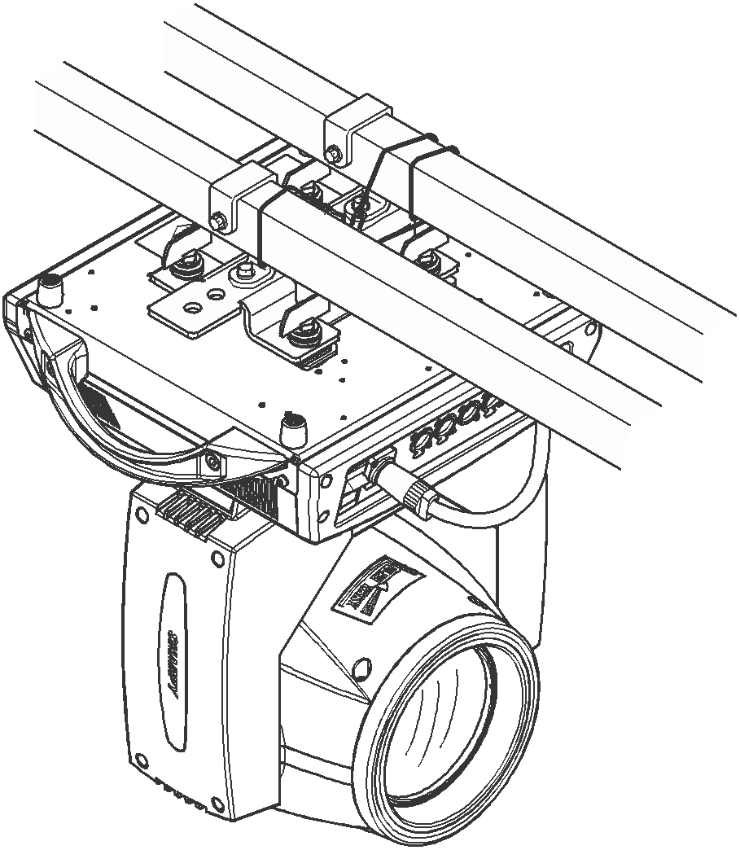

Figure 1 Schematic diagram of inverted lamp

# Chapter 2 Panel operation

## Lighting panel

The schematic diagram of the lamp panel is shown as followsgraph 2As shown:

**1) Temperature:** As shown in the figure, the board temperature is 30 degrees Celsius; if the temperature display is---℃, it indicates an abnormal temperature detection for the lamp. This could be due to a broken control connection wire. If the temperature display is ***℃ and there is a significant difference from the ambient temperature, it may indicate a short circuit in the control connection wire. A professional must inspect and repair the issue before normal use can resume.

**2) Address code:** It can display the range of 001-512, and the address code displayed on the map is 001.

**3) DMX mode:** 512 mode.

**4) Key：UP:** Up key

**MENU:** Return key

**ENTER:** Confirm key

**DOWN:** The down key

Note: Do not use a sharp object or blade to click the display to prevent damage.

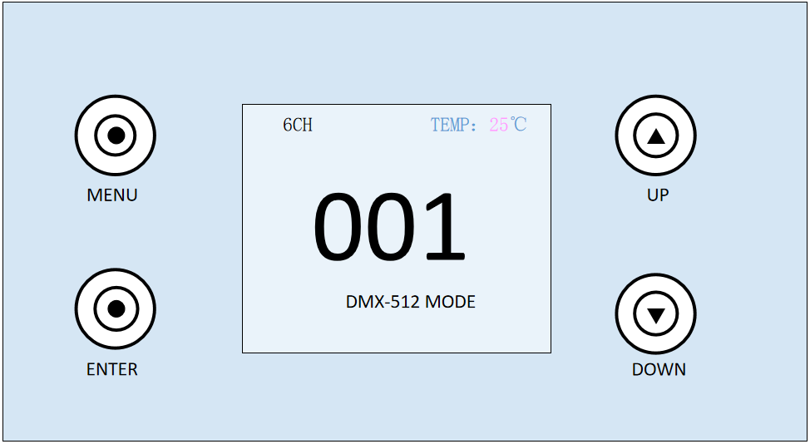

Figure 2 Schematic diagram of five-key display panel

## Menu home screen

The first interface of the menu contains 6 sub-menus. Select the corresponding sub-menu by pressing the "UP" key and "DOWN" key, and click the "ENTER" key to enter the corresponding sub-menu interface. The first interface of the menu is shown in Figure 3:

**1) Address:** Click to enter the address code setting. The number of address codes can be increased or decreased by pressing the "UP" key and "DOWN" key, and the address code displayed on the lamp panel will be updated synchronously.

**2) Settings:** Click to enter the system Settings, you can change the working mode of the lamp, working parameters and panel display Settings.

**3) Manual mode:** Click to enter the manual mode to control the functions of the lamp. See the channel table for details.

**4) Calibration:** Click the input password to enter the calibration interface, and adjust the parameters such as lamp power, motor travel and sound sensitivity.

**5) Information:** Click to enter to view system correction, software and hardware version and other information.

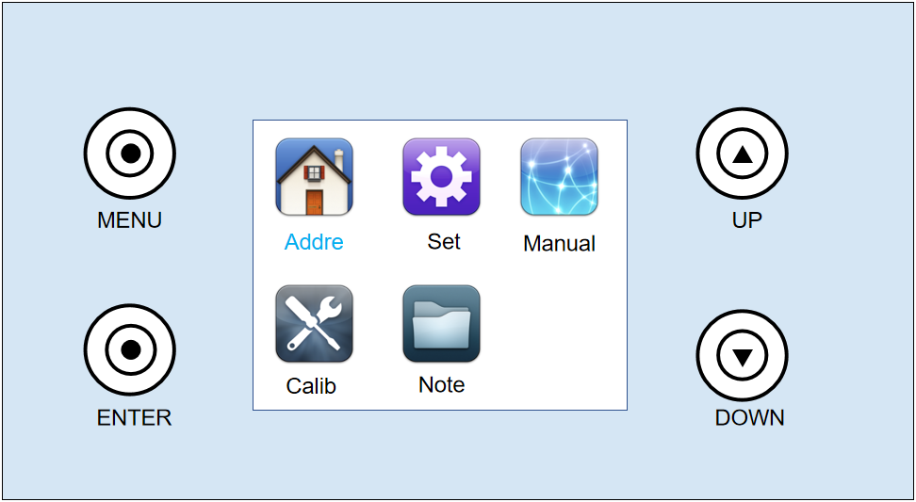

Figure 3 Determine the input window

## 2.1 System Settings

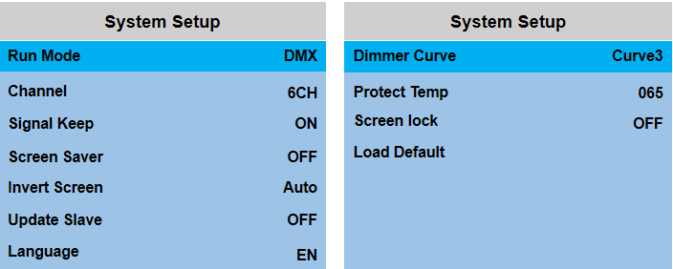

## Figure 4 System Settings interface

The system setting interface is shown in Figure 4. Enter the system setting, click the "ENTER" key to select the setting to be modified, and then select the content to be changed through the "UP" and "DOWN" keys. Finally, confirm with the "ENTER" key to change the working mode, working parameters and panel display settings of the lamp. See Table 1 for details.

|  |  |  |
| --- | --- | --- |
| **Option** | **Explain** | |
| Running mode | Lamp operation mode: DMX / voice control / self-drive 1 / self-walk 2 | |
| DMX pattern | Console mode, receiving the DMX signal |
| Self-walking mode 1 | The lamp shall be run automatically according to the built-in self-walk program 1 |
| Self-walking mode 2 | The lamp shall be run automatically according to the built-in self-walk program 2 |
| Sound control mode | When the lamp detects a strong sound, the lamp automatically runs a scene according to the built-in program, otherwise maintain the last scene |
| Channel pattern | 6CH 12CH 8CH 4CH 2CH | |
| The signal to keep | Output status of the lamp with no DMX signal | |
| close | There is no signal, so the motor and the light source return to the position and state when the reset is complete |
| open | No signal, keeping the last frame of the DMX data output |
| Screen protection | The screen is bright for a long time | |
| close | Often bright |
| open | In a static environment, the screen timing off the screen |
| Screen flip | Set the display direction of the screen | |
| close | No reversal is shown |
| open | Reverse display |
| voluntarily | The system can automatically rotate the screen according to the direction of gravity |
| Synchronous update | Synchronize the setting parameters or calibration parameters of multiple lamps | |
| close | The synchronous update function is turned off. |
| open | After opening, connect multiple lamps with DMX cable, and the information can be updated synchronously in the setting interface and calibration interface.(Note: Remove the DMX signal wire connected to the console) |
| Language | Chinese and English menu switch | |
| centre | the Chinese language |
| EN | English menu |
| The dimming curve | Curve 1 | straight line |
| Curve 2 | Anti-square rate curve |
| Curve 3 | Square rate curve |
| Curve 4 | S curve |
| Protect the temperature | 65℃ (65-85℃, default protection temperature 65℃) | |
| Screen lock | close | The screen lock function is turned off |
| open | After extinguishing the screen to prevent accidental touch, use again need to unlock first. |
| Factory data reset | Lighting parameters are returned to the factory settings | |
| cancel | res sic stantibus |
| affirm | Light ture to factory settings |

|  |  |  |
| --- | --- | --- |
| **primary menu** | **Sublevel menu** | **Three-level menu / parameters** |
| Address | 001 - 512 | (Number of channels added each time, minus normal) |
| System Settings | Running mode | DMX / self walking 1 / self 2 / voice control |
| Channel pattern | 6CH /12CH /8CH /4CH /2CH |
| Optical coupling error correction | Open / close |
| The signal to keep | Open / close |
| Screen protection | Open / close |
| Screen flip | Open / close / automatic |
| Synchronous update | Open / close |
| language | centre /EN |
| Protect the temperature | 65℃ (65-85℃, default protection temperature 65℃) |
| Screen lock | Open / close |
| factory data reset | Confirm / cancel |
| Manual mode | Current channel mode channel | 0-255 |
| System calibration | enter password | Lighting calibration |
| System info | Reset information | Device error message |
| And DMX data monitoring | Channel values for the receiving console |
| Hardware version | Displays the hardware version |
| software release | Displays the software version |

Table 1

## 2.2 System calibration

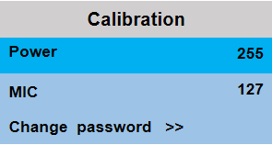

Figure 5 System calibration interface

Enter the password "6688" to enter the system calibration interface. Modify the values through the "UP" key and "DOWN" key to modify the lamp power and motor travel parameters. The system calibration interface is shown in Figure 5. See Table 2 for details.

|  |  |
| --- | --- |
| **option** | **explain** |
| Power | After entering the sub-interface, the maximum power of the lamp can be adjusted, and 255 indicates the maximum power |
| MIC sensitivity | Voice control sensitivity adjustment, default 127. The value decreases, and the sensitivity increases. The value increases and the sensitivity decreases. |
| Change password | Set the system calibration password |

Table 2

## 2.3 System Information

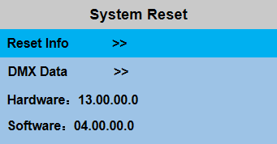

Figure 6 System information interface

Press "ENTER" directly to enter the system information interface, and select the information to be viewed through "UP" and "DOWN". Click "ENTER" to view the corresponding content. The system information interface is shown in Figure 6, and the detailed content is shown in Table 3.

|  |  |
| --- | --- |
| **option** | **explain** |
| Reset information | If the red ERR indicator is illuminated, the lamp is running wrong:  1) IC1 communication fault (communication failure between motor and display board)  2)1) IC2 communication fault (communication failure between motor and display board) |
| And DMX data monitoring | This enters the subinterface to display channel values for viewing |
| Hardware version number | Lighting hardware information  XX . XX . XX . XX  Display board version. Motor version. |
| Software version number | Lamp software version  XX . XX . XX . XX  Display board version. Motor version. |

Table 3

# Chapter 3 Channel description and technical parameters

## channel table

The specific detailed data of the channel is shown in Table 5, which can also be viewed in the manual operation interface:

**4 CH channel mode (Mode 1):**

|  |  |  |  |
| --- | --- | --- | --- |
| **4CH channel** | **The channel name** | **The channel value** | **Channel function** |
| 1 | Total frequency flash | total frequency flash | From slow to fast |
| 2 | FS | 0-5 | empty |
| 6--20 | Jump change 1 |
| 21—35 | Jump 2 |
| 36—50 | Jump change 3 |
| 51—65 | Jump 4 |
| 66—80 | Jump change 5 |
| 81—95 | Jump change 6 |
| 96—110 | Jump 7 |
| 111—125 | Jump change 8 |
| 126—140 | Jump 9 |
| 141—155 | Jump change 10 |
| 156—170 | Jump change 11 |
| 171—185 | Jump change 12 |
| 186—200 | Jump change 13 |
| 201—220 | gradual change |
| 211—240 | Pulse change |
| 241—255 | sound control |
| 3 | Functional speed | Functional speed | From slow to fast |
| 4 | W aiming | W aiming | Linear dimming, from dark to bright |

**8 CH channel mode (Mode 2):**

|  |  |  |  |
| --- | --- | --- | --- |
| **8CH channel** | **The channel name** | **The channel value** | **Channel function** |
| 1 | Total dimming | total dimming | Linear dimming, from dark to bright |
| 2 | Total frequency flash | total frequency flash | From slow to fast |
| 3 | FS | 0-5 | empty |
| 6--20 | Jump change 1 |
| 21—35 | Jump 2 |
| 36—50 | Jump change 3 |
| 51—65 | Jump 4 |
| 66—80 | Jump change 5 |
| 81—95 | Jump change 6 |
| 96—110 | Jump 7 |
| 111—125 | Jump change 8 |
| 126—140 | Jump 9 |
| 141—155 | Jump change 10 |
| 156—170 | Jump change 11 |
| 171—185 | Jump change 12 |
| 186—200 | Jump change 13 |
| 201—220 | gradual change |
| 211—240 | Pulse change |
| 241—255 | sound control |
| 4 | Functional speed | Functional speed | From slow to fast |
| 5 | 1W dimming | 1W dimming | Linear dimming, from dark to bright |
| 6 | 2W dimming | 2W dimming | Linear dimming, from dark to bright |
| 7 | 3W dimming | 3W dimming | Linear dimming, from dark to bright |
| 8 | 4W dimming | 4W dimming | Linear dimming, from dark to bright |

**4CH channel mode (Mode 3):**

|  |  |  |  |
| --- | --- | --- | --- |
| **4CH channel** | **The channel name** | **The channel value** | **Channel function** |
| 1 | 1W dimming | 1W dimming | Linear dimming, from dark to bright |
| 2 | 2W dimming | 2W dimming | Linear dimming, from dark to bright |
| 3 | 3W dimming | 3W dimming | Linear dimming, from dark to bright |
| 4 | 4W dimming | 4W dimming | Linear dimming, from dark to bright |

**2 CH channel mode (Mode 4):**

|  |  |  |  |
| --- | --- | --- | --- |
| **2CH channel** | **The channel name** | **The channel value** | **Channel function** |
| 1 | W aiming | W aiming | Linear dimming, from dark to bright |
| 2 | Total frequency flash | total frequency flash | From slow to fast |

**1CH channel mode (Mode 5):**

|  |  |  |  |
| --- | --- | --- | --- |
| **1CH channel** | **The channel name** | **The channel value** | **Channel function** |
| 1 | W aiming | W aiming | Linear dimming, from dark to bright |

Table 5

**2. Technical parameters:**

**Power supply:** AC100-240V, 50-60 HZ;

**power:** 800W；

**Light source:** single lamp bead two-color 300W;

**Type:**  one-color LED module;

**Color:** white

**Average life span:**> 20,000 hours;

**Dimming:** 0-100% from dark to bright electron;

**Display and main control:** LCD display, support Chinese and English switching; lamp information can be checked;

**Operation mode:** DMX, self-walking, voice control;

**Channel mode:** 4CH /8CH /2CH /1CH;

**Control:** DMX512 control, support RDM function; upgrade the lamps through DMX signal line;

I**ntelligent heat dissipation:** temperature sensing detection, fan speed adaptive adjustment;

**Appearance:** metal, black;

# Chapter 4 Common faults and usage precautions

## Common fault handling

The lamp contains microcomputer circuit board, high voltage power supply and other professional components. For your safety and product life, non-professionals should not dismantle the lamp and related accessories without authorization.

#### The bulb does not light (except for LED light source)

Possible causes: The bulb is not completely cooled, or the bulb has reached its life, and the treatment is as follows:

* Due to abnormal operation, the bulb is not completely cooled, let the lamp body cool for more than 10 minutes, so that its internal state is completely restored to normal, and then restart the power supply;
* Check whether the bulb has reached its service life, and replace the new bulb;
* Check whether the bulb and the ignition circuit are leaking, falling off or in poor contact;
* Replace the new light bulb.

#### The beam appears dim

Possible causes: long use time of the bulb or dirty optical path. Handle as follows:

* Check whether the bulb has reached its service life, and replace the new bulb;
* Check whether the optical parts or bulbs are clean, whether there is dust on the bulbs and other optical devices, and clean and maintain the bulbs and other parts in the lamps regularly.

#### Pattern projection is blurred

* Check that the value of the electronic focus channel is appropriate for the current projection distance.

#### The lights work intermittently

Possible causes: Internal lines enter protection mode. Handle as follows:

* Check whether the fan is running normally or dirty, resulting in the internal temperature of the lamp rising;
* Check whether the internal temperature control switch is closed;
* Check if the bulb has reached its service life and replace it with a new one.

#### The lamp is not controlled by the console after it is normally reset

Possible causes: signal line fault or lamp parameter setting is not normal, the treatment is as follows:

* Check the starting address code and check the connection of DMX signal lines (whether the signal cable is intact and whether the connector is loose);
* Add signal amplifier, add 120 ohm terminal resistor;

#### The lamp does not start

Possible causes: poor power line, handle as follows:

* Check whether the fuse on the power input socket is blown, and replace the fuse;
* The lamp is subjected to vibration during long-distance transportation, resulting in poor contact of the line
* Check the input power supply, computer board and other plug-in devices.

## Usage precautions

* Check whether the local power supply meets the rated voltage requirements of the product, and whether the leakage protector, overcurrent protector and so on meet the requirements of the load;
* Do not use power lines with damaged insulation, do not connect power lines to other wires;
* The lamp uses strong wind refrigeration, which is easy to accumulate dust, and must be cleaned once a month, especially the heat dissipation air outlet, otherwise it will be blocked by dust accumulation, resulting in poor heat dissipation and abnormal lamp.
* When installing lamps, the fixing screws must be tightened, and the safety cable should be added, and checked regularly;
* When installing and positioning the lamp, any point on the surface of the lamp should be kept at a minimum distance of 10 meters from any inflammable and explosive objects, and 2.5 meters away from the irradiated object. Please do not install the lamp directly on the surface of combustible substances;
* The continuous working time of the lamp is recommended not to exceed 10 hours, and the interval time between continuous starting of the lamp should not be less than 10 minutes, otherwise it will not be able to trigger normally due to the overheating protection of the bulb;
* The closing time of the switch valve should not exceed 5 minutes. If it is necessary to close the light for a long time, the lamp should be turned off using the control panel (lamp control channel);
* In order to ensure that multiple lamps better comply with the scene effect, the lamps should not remain in the current scene, that is, start the next scene action, and it is best that this state does not exceed 3 minutes to ensure that multiple lamps can run synchronously;
* During use, if the lamp is abnormal, the lamp should be stopped in time to prevent other faults.

## RDM usage precautions

RDM is an extended version of the DMX512-A protocol and is the Remote Device Management (Remote Device Management) protocol. Traditional DMX512 communication is unidirectional, based on the RS-485 bus, which is a time-sharing multi-point, half-duplex protocol that allows only one port to be the host output at any given time. Therefore, when using RDM, you should pay attention to the following points:

* Use a console or host device that supports the R DM protocol;
* To use a bidirectional signal amplifier, a traditional unidirectional signal amplifier is not suitable for the RDM protocol, because the RMD protocol requires feedback data, and using a unidirectional amplifier will block the return data, resulting in the search of lamps;
* All lamps must be set to D MX mode to ensure that only one host is on the signal line;
* A 120ohm impedance matching resistor must be inserted between terminals 2 and 3 of the terminal plug. When the signal line is relatively long, differential signals are more stable to reduce signal reflection, which is beneficial to communication quality;
* When the lamp receives D MX control but cannot R DM search the lamp, check the signal amplifier first, and then check whether the 2 or 3 lines of the signal line are in poor contact.