- Remove all the screws on the back cover (5pcs), and the screws under the screen (4pcs).
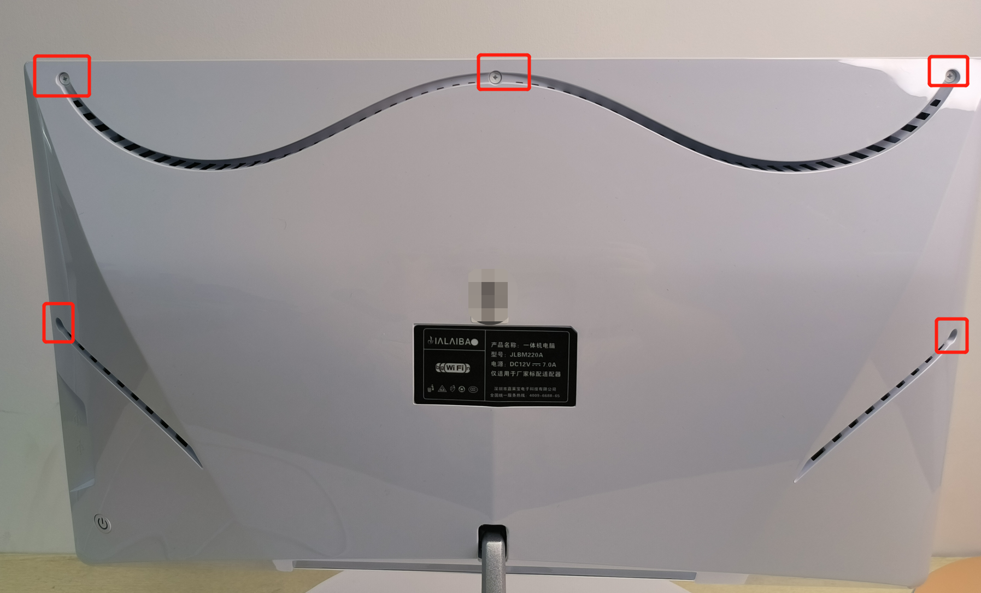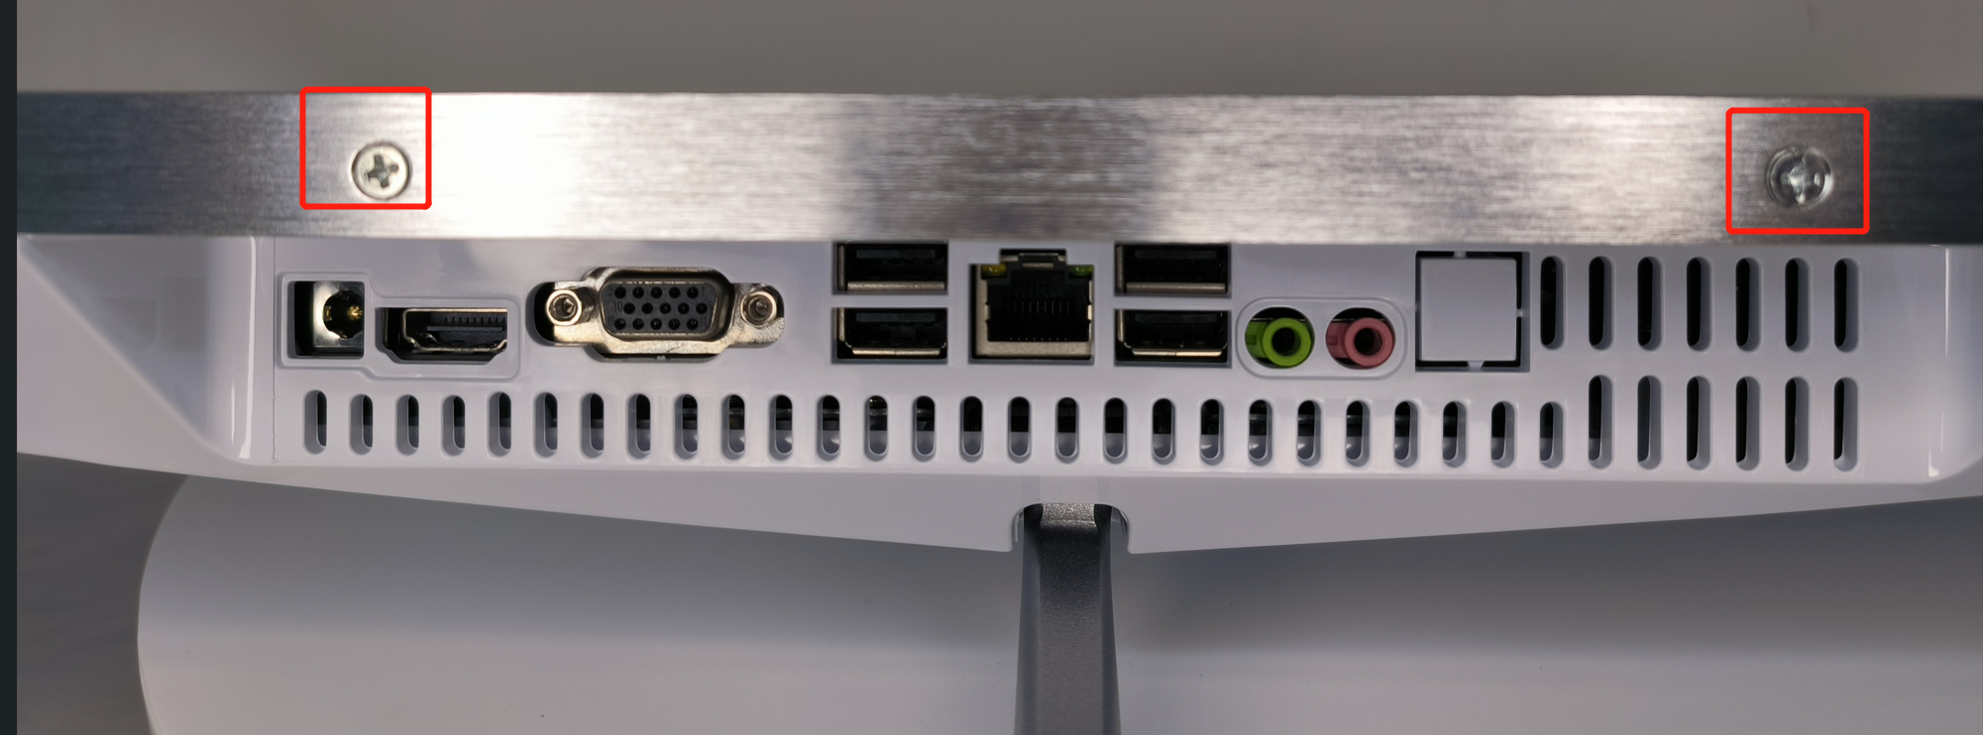

- Insert the SATA cable and Power cable into the hard disk, as below:
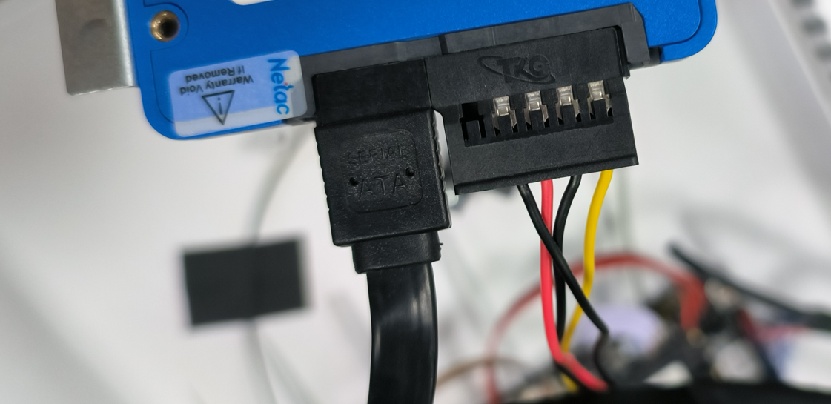
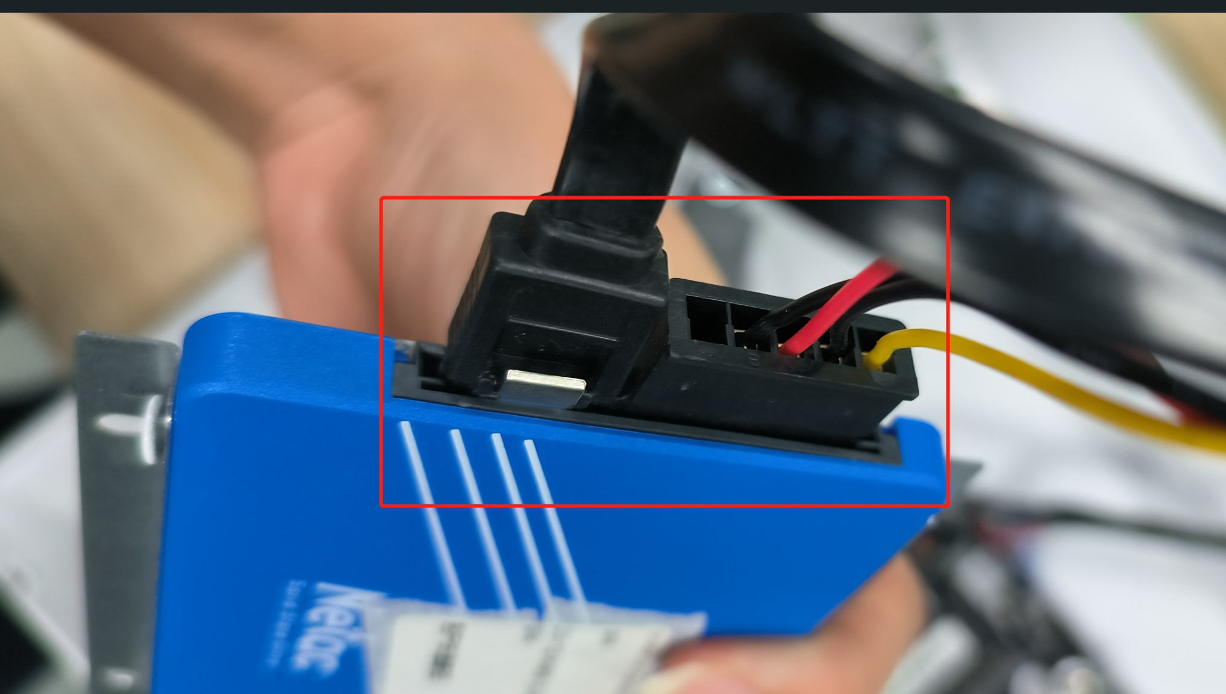

- Find the SATA interface and Power interface on the motherboard.
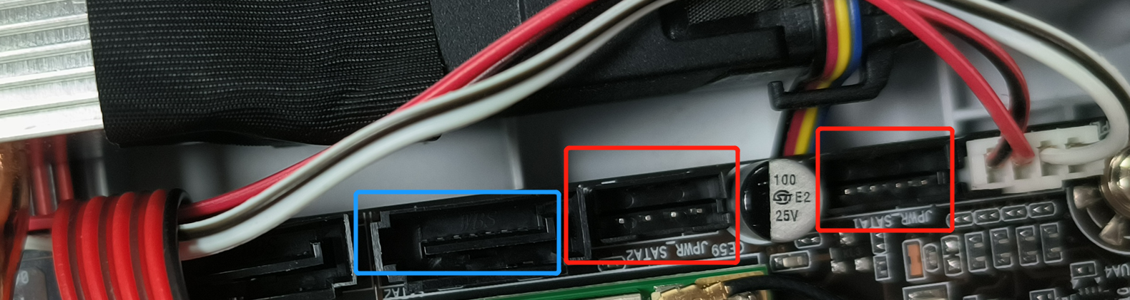
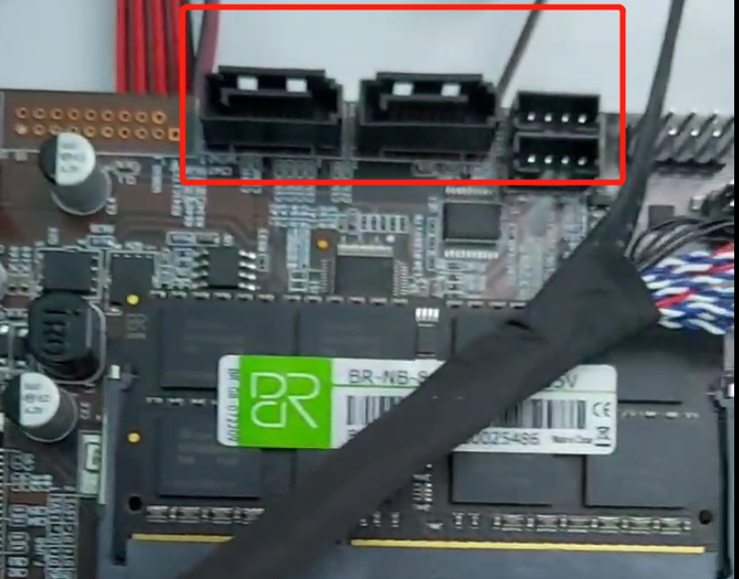

- Compare the interface pins of the line, as well as the motherboard socket pins and notes, and then insert them.
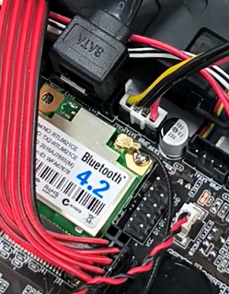

- Plug in the power adapter and turn it on. (Do not cover the back cover first).
If it boots up successfully, please transfer all the data to the new hard disk as soon as possible.
If can not, please close the computer, and remove the old hard drive (1 screw).
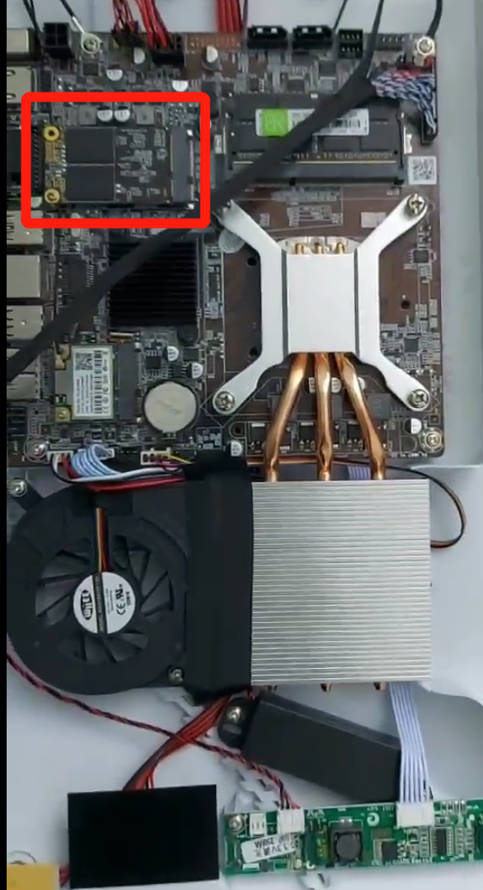
- Booting again.
If it boots up successfully, please fix the hard drive to this position and reinforce it with screws (4pcs).
Then close the back cover and re-tighten the screws.
