JK88 Freshly Ground

Coffee Machine

**User Manual**

Wuhan Gao Sheng Wei Ye Technology Co., Ltd

www. gscoffeevending.com

**CONTENTS**

Ⅰ.Product speciﬁcations ..............................................1

Ⅱ.Precautions for device use ..............................................2

Ⅲ-1.Detailed instruction of Product (External) Structure Design..............................4

Ⅲ-2.Detailed instruction of Product (internal) Structure Design ..............................5

Ⅳ.Device Installation and Setting ..............................................6

1. Power-On and Startup Instructions ...............................................6
2. Canister Installation .............................................. 7
3. Powder Addition ...............................................8
4. Add liquid excipients ...............................................8
5. Paper Cup Refill ...............................................9
6. Cup Lid Refill .............................................10
7. Coffee Bean Addition .............................................11
8. IWIFI and 4G Antenna Installation .............................................11
9. Installation of waste residue box, waste water box and water receiving tray ....12
10. WiFi Installation of 4G antenna .............................................12

Ⅴ. Small screen setting .............................................13

Ⅵ. Spare parts maintenance methods .............................................19

1. Stirring module .............................................19
2. Coffee grinder .............................................20
3. Peristaltic pump pipe .............................................20
4. Ingredients caniste .............................................21
5. Waster water tra.....................................................................................................21

Ⅶ. After-Sales Service ...........................................................................................21

Ⅷ. Bill of Materials .............................................................................................22

IX. Table of common faults and solutions ............................................................23

X. Product Warranty Card .................................................................................24

**Ⅰ. Product Specifications**

|  |  |
| --- | --- |
| Product model | JK88 freshly ground coffee vending machine |
| Power | 2900W |
| External dimensions | 700mm (W)*760mm (D)*1800mm (H) |
| Machine net weight | 120kg |
| Display screen | 21.5 inch capacitive touch screen |
| Mode of payment | QR payment(Bill+coin+exchange+card reader) |
| Storage capacity | 2pcs peristaltic pump+5pcs*4Lcanister |
| Grind and extract | 6L/1.8kg coffee bean, Ditting grinder |
| Cup size | Five tins of goblets, 320 pcs 14 oz. single-layer paper cups  210 pcs 14 oz. corn cups, 160 pcs 16 oz. corn cups. |
| Laydown mode | The program chooses automatic lid closing |
| Water feeding pattern | Bottled water or purified direct drinking water;  water purification pressure 0.5-0.7Bar; water hardness 2-8HD |
| run mode | Orbital transmission, automatic door opening and closing |
| CPU/ internal storage | Four cores 64-bit Cortex-A552.0GHz/2GRAM/32GROM |
| GPU | Mali-G52 |
| Operating system | Android11 |
| Water production method | Compressed refrigeration and heating |
| Gate lock | The electronic lock scheme can realize software control and remote lock |
| Appearance color | Black + tempered glass panel/other customization |

**Ⅱ.Precautions of device use**

|  |  |
| --- | --- |
| *Important Precautions: Please read this table carefully! | |
| Power  Supply  Standard | Due to the presence of multiple electrical components and high-voltage parts within this device, and since the outer shell is made of metal, all power supply connections must include a properly grounded wire that meets standards.  The power cable must be made of materials that comply with the power rating standards. (If the wiring does not include a ground due to site restrictions, please contact a local electrician for proper grounding installation.) |
| Device  Cooling | The sides and back of the device are equipped with ventilation and air intake  openings, so a clearance of at least 15 cm must be maintained from any obstructing walls on these three sides. |
| Device Network | The device is equipped with 4G network connectivity. Please place the device in an area with a strong network signal to avoid any impact on its normal functionality. The device also provides both a 4G network interface and a Wi-Fi network interface,  supporting 2.4G and 5GHz signals for Wi-Fi. |
| Device  Water  Supply | Please use purified water that is safe for direct consumption. If using tap water, it must be ﬁltered through a water puriﬁer to avoid food safety risks. Additionally, hard water can cause scaling in the internal pipes of the machine, leading to operational failures. |
| Device  Handling | When transporting the device, use a specialized forklift. Do not invert or lay it ﬂat, and avoid long-distance movement on casters.  Drain all water and clear out materials before transport. After moving, follow the new machine installation procedures to check the device. Allow the cooling system to sit for 24 hours before turning it on.  In winter, keep the device warm to prevent freezing damage to components. |
| Waterproof and  Rainproof | The device is not intended for outdoor use; please use it in an indoor environment. Avoid exposure to water and moisture to prevent damage and electrical hazards. Excessively bright or dim lighting may affect visibility, so choose a softly lit area for placing the device. |
| Food  Safety | Operators must hold a health certificate. Due to internal high pressure, unauthorized  Always use compliant and safe raw materials within their shelf life to prevent spoilage.  Personnel should not operate the device!  Pay attention to food safety at all stages during the operation of the device! |
| Reminder to  Use Designated Consumables | Please use our designated 14 or 16 oz paper cups with a 89 mm diameter and  corresponding lids. Ensure a loose stacking distance between the cups and lids to prevent issues such as cup or lid dropping and lid pressing failures! (Refer to the appendix for cup and lid drawings.) |
| Other  Considerations | Please ensure that dedicated personnel are assigned to study the operations and maintenance manual provided by our company. Only trained personnel are  authorized to perform routine maintenance operations. |

1.If the power cable is damaged, it must be replaced by the manufacturer, its service agent or similarly qualified persons in order to avoid a hazard.”

2.Children should be supervised to ensure that they do not play with the appliance.

3.This appliance is not intended for use by persons (including children) with reduced physical, sensory or mental capabilities, or lack of experience and knowledge, unless they have been given supervision or instruction concerning use of the appliance by a person responsible for their safety.

4. Do not store explosive substances such as aerosol cans with a flammable propellant in this appliance.

5. When disposal of the appliance, it must be done by the manufacturer or its service agent or a similarly qualified person in order to avoid fire and other hazard.

6. Water pipe connections and fixtures directly connected to a potable water supply shall be sized, installed, and maintained in accordance with federal, state, and local codes.

 Keep clear of obstruction all ventilation openings in the appliance enclosure or in the structure for building-in.

 Do not use mechanical devices or other means to accelerate the defrosting process, other than those recommended by the manufacturer.

 Do not damage the refrigerant circuit.

 Do not use electrical appliances inside the food storage compartments of the appliance, unless they are of the type recommended by the manufacturer.

Please accord to local regulations regarding disposal of the appliance for its flammable refrigerant and blowing gas. Before you scrap the appliance, please take off the doors to prevent children trapped.

Component parts shall be replaced with like components and that servicing shall be done by factory authorized service personnel, so as to minimize the risk of possible ignition due to incorrect parts or improper service.

The installation instructions for appliances that use a flammable refrigerant shall indicate the appliance is to be installed in accordance with the Safety Standard for Refrigeration Systems, ANSI/ASHRAE 15.

 Risk Of Fire or Explosion. Flammable Refrigerant Used. Do Not Use Mechanical Devices To Defrost Refrigerator. Do Not Puncture Refrigerant Tubing.

 Risk Of Fire Or Explosion. Flammable Refrigerant Used. To Be Repaired Only By Trained Service Personnel. Do Not Puncture Refrigerant Tubing.

 Risk Of Fire Or Explosion. Flammable Refrigerant Used. Consult Repair Manual/Owner's Guide Before Attempting To Install or Service This Product. All Safety Precautions Must be Followed.

 Risk Of Fire Or Explosion. Dispose Of Properly In Accordance With Federal Or Local Regulations. Flammable Refrigerant Used.

Risk Of Fire Or Explosion Due To Puncture Of Refrigerant Tubing; Follow Handling Instructions Carefully. Flammable Refrigerant Used



Warning: Risk of Fire /Flammable Materials

**Ⅲ-1. Detailed description of product (external) structure design**

**Side 1**

**Front**

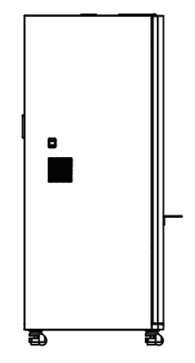

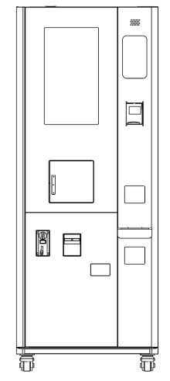

Viewing window

Card reader

(optional configuration)

21.5-inch touch screen

Dehumidification vent for mixing chamber

Take a Cover

Compressor

cooling vent

Cup dispenser opening (automatic door)

Tale a Stick

Coin acceptor (optional configuration)

Coin change

(optional configuration)

Bill acceptor (optional configuration)

**The back**

**Side 2**

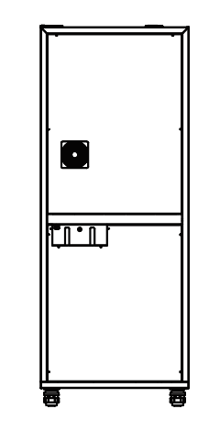

Grinder Dehumidification Vent

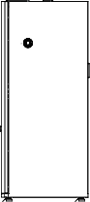

Air Intake Vent

Power cord

Tap water inlet

0.1~0.4Mpa

≤ 2.5L/min

**Ⅲ-2. Detailed description of product (internal) structure design**

**Inside front 2**

**Front interior 1**

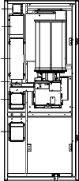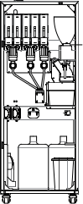

Electronic door lock switch

suona

observation window

Open the maintenance light door switch bean barn

Jars

Ejection nozzle

display screen

Grinding mill

Five downpouring cups

Blending chamber

extractor

A breaker

Install auxiliary mounting holes

Drink through the spout

peristaltic pump

Waste bins

Toasting module

Cup height adjustment hole and water tray

Leakage protection circuit breaker

Lower the pumping module

pipette box

Clean buckets

Juice syrup bottle

Waste water tank

Molten wheel

**Schematic diagram of front door Android interface**

3.5 Audio output HDMI

RJ45

SIM block

USBx2

DC

Front door control panel SWD is burned

**Schematic diagram of front door Android and control panel**

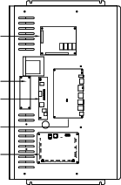

Payment

control panel

Touch screen

Display high

voltage board

Android tablets

Front door

control panel

**Ⅳ.Device Installation and Setting**

1. **Power-On and Startup Instructions**

(1) Preparations before power supply include: prepare materials and purified water source, the site must have a grounded socket, can provide stable power supply of more than 3KW, pay attention to not put the equipment in unprotected outdoor places, pay attention to sun protection and waterproof protection measures.

(2) Switch description.

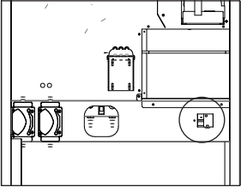

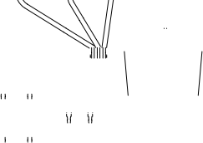

switch

As shown in the figure, the switch is a leakage protection circuit breaker that controls the power supply of the whole machine.

**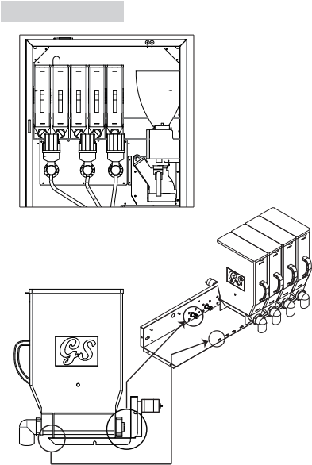****2.Canister Installation**



1. Insert the cassette into the motor shaft

2. Insert the front of the

cassette into the card slot

**3.Powder Addition**

(1) Rotate the discharge nozzle 180 in the direction of the arrow so that the nozzle is facing upwards.;

(2) Gently lift the front of the ingredient cartridge handle and pull it forward;

(3) Open the lid of the container and pour the ingredients into the canister;

(4) Align the" Connection Sleeve" at the rear of the cassette with the" Out feed Motor Shaft" and insert it into the cassette.:

(5) Rotate the nozzle on the front of the cassette 180 so that the discharge nozzle is

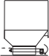facing downwards.

Insert



Pull forward

Raw



3



material



5



Discharge motor shaft

Insert



2

|  |
| --- |
|  |



|  |
| --- |
|  |

|  |
| --- |
|  |

Rotate 180°



4

Rotate 180°

Connection sleeve



Open the lid and pour in the raw material



1

**4. Liquid Ingredient Addition**

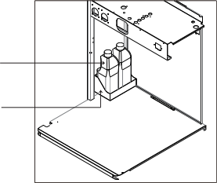

(1) Open the lid of the liquid excipient bottle, connect the stainless steel tube with the peristaltic pump hose, and then insert the stainless steel tube into the bottle.

(2) Place the auxiliary material steadily to prevent it from falling over.

Sugar box

Juice, syrup

Tips: Avoid using deformed or wet paper cups. Before placing the paper cups, please disperse the paper cups to avoid the situation of stuck cups or no cups or more cups.(Use a paper cup for the cup!)

Put the cup upside down into the cup receiver in turn.

**5. Paper Cup Refill**

Treatment of cup:

1. The cup jamming phenomenon is caused by the use of non-standard paper cups or deformed paper cups. All paper cups should be taken out, and the damaged paper cups should be removed and reinstalled.

2. If you replace the paper cup, be sure to readjust the diameter of the paper cup. Please contact the after-sales service for details.

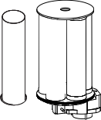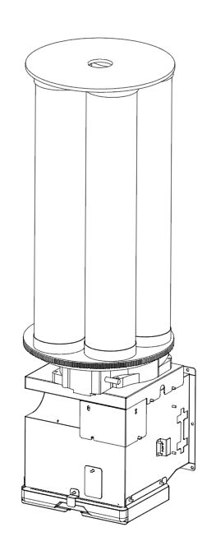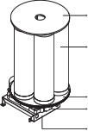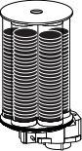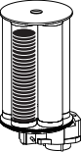

Step 1: Open the lid of the cup and bucket, and take off the cup and bucket first. (In order to avoid the paper cup falling sideways and being compacted, which will affect the effect of the cup falling.)

A goblet

Cup lid

Cups and barrels

Cup and bucket wheel

Five tube cup fixing plate

**6. Cup Lid Refill**

According to the direction of the cup lid in the right figure, add the cup lid neatly into the lid drop device and keep the distance between the cup lid evenly to avoid the situation of stuck lid or multiple lid falling.

The cup lid is inserted through the positioning rod in the direction shown in the right figure



The cup lid is inserted through the positioning rod in the direction shown in the right figure

JK88-Bucket lid

magnetic stripe

Cover plate positioning rod

1.5 inch stainless steel hinge

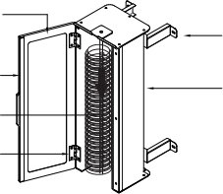

Cover the fixed plate

Sheet metal cover bucket



Note: The cup lid must use the specifications specified by our company, otherwise it is easy to fail.

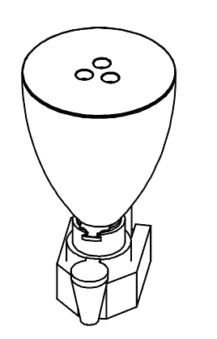

**7.Coffee Bean Addition**

(1) Remove the bean hopper lid and pour in the coffee beans.

(2) Install the bean hopper lid and open the hopper door.

Coffee Bean Hopper Door

**\*When removing the bean hopper, push the hopper door inward to close it and pull it outward to open it.**

**8.Bottled Water Installation**

(1) Insert bucket 1 into the bucket first. If only one bucket of water is installed, the suction pipe of pump 2 should be sealed to prevent dirt from entering the pipe.

(2) If a water purifier is used, switch the bottom of the machine to the inlet of the water purifier and put away the pump's suction pipe.

(3) After starting up, the pump will be prioritized to draw water from pump No.1. If there is no water in pump No.1, pump No.2 will be automatically switched on.

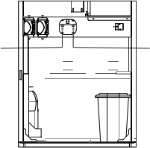

NO.1

NO.2

* Always turn off the power before changing the bucket

**9. Installation of waste residue box, waste water box and water receiving tray**

(1) The waste residue box should be placed directly below the present grinding extractor.

(2) The waste water bucket is placed in the position shown in the figure, and ensure that each waste water pipe is inside the bucket.

(3) The waste water should be checked and cleaned in time to avoid odor and overflow.

(4) The water tray can be taken out directly for cleaning.

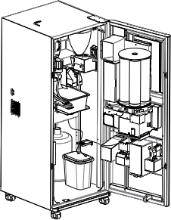 reserve 

mechanical lock

Waste bins

Water connection

Waste water 

**10.WiFi Installation of 4G antenna**

The antenna is connected to the wifi signal (4G signal) converter on top of the machine.

**Ⅴ. Small screen Settings**

When leaving the factory, the factory has configured the best design state according to customer needs. Please do not change the setting arbitrarily. If you really need to change, please contact our after-sales personnel and do it under professional guidance.

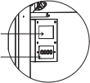

Small screen

Keypads

1. **Menu information**

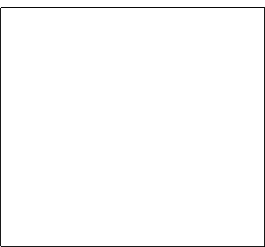

Menu Settings

parameter setting

General Settings

Water correction

function testing

Front door operation

Now build an operation

About Device:

Information:

Displays the name and version of the device

+

+u

-

Menu

Menu

Confirm

Press the "Menu" button to enter the Settings menu, press again to return; click "+" for drop-down selection, click "-" for pull-up selection;

click "Confirm" to enter the corresponding function, and click "Menu" to exit and return.



1.1 General Settings

|  |  |  |
| --- | --- | --- |
| 1 | Thermochability | On: (By default) The hot tank function is on and can produce hot water  Closed: The hot tank function has been closed and cannot produce hot water |
| 2 | Cold brain function | On: (By default) The cold tank function is on and can produce cold water  Closed: The cold tank function has been closed and cannot produce cold water |
| 3 | Buzzers | On: (By default) The motherboard buzzer produces a "beep" sound  Closed: The motherboard buzzer is prohibited from making sound |
| 4 | loudspeaker | Enabled: (By default) The motherboard voice module can speak with the function  Closed: The motherboard voice module is prohibited from speaking |
| 5 | Hot water at low temperatures | 0-100℃: The maximum temperature value shall not exceed the high temperature value of hot water; it is used to set the minimum allowable temperature value of hot water in the hot tank; default: 80℃ |
| 6 | Hot water is hot | 0-100℃: The minimum temperature must not be lower than the low temperature value of hot water; it is used to set the maximum allowable temperature value of hot water in the hot tank; default: 85℃ |
| 7 | Cold water temperatures | 0-25℃: The maximum value cannot be higher than the high temperature value of cold water; when the temperature of cold water is lower than this value, the cold tank stops refrigeration; default: 5℃ |
| 8 | Cold water, hot water | 0-25℃: The minimum value must not be lower than the low temperature value of cold water; when the temperature of cold water is higher than this value, the cold tank starts to refrigeration; default: 8℃ |
| 9 | Voice volume | 0-25: The volume of voice broadcast by the onboard voice module. Default: 20  (Note: Not the Android volume) |
| 10 | Voice tests | 1-8: You can test the broadcast effect of up to 8 kinds of speech by selecting different values |
| 11 | Cold Gallbladder Delay (minutes) | 0-180m: The waiting time between the whole machine is powered on and the cold tank starts. Default: 5m |
| 12 | Alternating duration of idle and wetting (minutes) | 0-250m: the running time of each cycle dehumidification fan in idle state;  Default: 1m  * When the hot air in the machine is not easy to be discharged, it is recommended to use the alternating dehumidification function. The machine will alternately start the dehumidification fan when idle; setting 0 means that the alternating dehumidification fan function is not used. |
| 13 | Alternating idle and intermittent duration (minutes) | 0-250m: the stopping time of each cycle dehumidification fan in idle state;  Default: 4m |

1.2 Water quantity correction

|  |  |  |
| --- | --- | --- |
| 1 | Number of channel | 1-16: The channel number of the material tank used for correction. Only the water quantity of any channel needs to be corrected, and other channels will be corrected synchronously;  Default: 1 |
| 2 | Type of effluent | Cold: (default) indicates that the current correction is for cold water. Hot: indicates that the current correction is for hot water |
| 3 | Count pulse | (Non-modifiable) The target pulse calculation value of the flowmeter when correcting the specified water quantity |
| 4 | Real pulses | (Non-modifiable) The actual number of pulses generated by the flowmeter when correcting the specified water quantity |
| 5 | Pulse inertia | 1-100: equals the difference between the actual pulse and the calculated pulse. The difference between the actual pulse and the calculated pulse should be less than or equal to 2 pulse counts; there may be slight differences between different batches of products; default: 12 |
| 6 | Calibrate the boundary | Upper value: The target water output (g) is the maximum upper limit of normal drinking water output. Lower value: The target water output (g) is the minimum lower limit of normal drinking water output.  * The upper and lower limits and the water output between the two numbers (g) are the effective range of water quantity correction, and the water output beyond this range cannot guarantee reasonable deviation of water output. |
| 7 | Hydraulic  discharge  （g） | 10-65530: To correct the amount of water that deviates. Take a regular 14oz paper cup as an example,  The recommended lower limit of the corrected water output is set to 50 (g) and the upper limit of the corrected water output is set to 300 (g).  * When the water output is less than 50g, the deviation is not easy to control. |
| 8 | No water is discharged without correction | Test function: Do not use correction parameters to output the specified water quantity; determine two information by the actual weight of water output:  1. Obtain the initial deviation from the target water quantity, and determine the initial setting value of the correction deviation based on this deviation;  2. Compare with the water output of the corrected effluent to determine the actual correction accuracy of the correction parameters. |
| 9 | correcting action (g) | (-32768) - (+32767): Adjustment value of deviation between target water output and actual water output |
| 10 | Calibrate the effluent | Test function: test the absolute deviation between the corrected water quantity and the target water quantity; the absolute deviation can be further reduced by adjusting the correction deviation (g); the absolute deviation should be controlled within 5g |

Note: During production, calibration parameters are determined before equipment leaves the factory. New devices should not use the water correction function! When the target water volume deviates significantly from actual measurements (over 15g) and there are no other abnormal components in the water circuit, you can use water correction to minimize the deviation. The final deviation should be limited to ≤10g.

How to correct water level deviation

Water deviation is divided into two types according to water temperature: hot water deviation and cold water deviation. Both deviations should be corrected separately. Take the first hot water correction as an example. The target cup capacity is 14oz.

First, complete the preparatory work before correction:

1. Ensure that the waterway and hot tank are filled with water

2. Control 1 hot water outlet section. Purpose: to drain the air in the hot water pipeline and the residual air in the hot tank

3. Ensure that the water temperature reaches the normal drinking temperature

4. Enter water quantity correction

5. Set the channel number to 1

6. Set the type of water outlet to hot water

7. Set the impulse inertia to the default value 12

8. Set the correction boundary to the lower limit value (first correct the minimum water discharge)

9. The water output (g) is set to 50

10. Perform three uncorrected effluent separately and measure the net effluent three times, in units of g; below A[1,2,3] refers to this data.

11. Take the average value of two similar numbers in data A[1,2,3] as the execution result a without correction

12. Set the difference between the water output (g) and the correction deviation (g) (which can be negative)

13. Perform three separate corrections on the effluent and measure the effluent volume three times, in units of g; below, B[1,2,3] refers to this data.

14. Take the average value of two similar numbers in data B[1,2,3] as the result of this correction effluent execution b

15. Compare the water output (g) with b, and adjust according to the actual situation on the value of the existing correction deviation (g)

16. Repeat steps 14-15 until the deviation between the corrected

effluent result and the effluent volume (g) is less than 5g;

(the deviation from the factory should be less than 3g)

17. At this point, the correction of the lower limit value of hot water is completed.

18. Go back to 8, set the correction boundary to the upper limit value (and correct the maximum water output again), set the water output (g) to 300, and execute 10~17 again, then the deviation correction of the upper limit value of hot water is completed.

19. Go back to 6, set the water type to cold water, and then execute 8~18 again, which completes the correction of the upper and lower limit deviation of cold water.

* You only need to select one of the channels from 1 to 16 for correction operation, and you can complete the cold and hot water outlet deviation correction operation of all channels!

How to adjust the deviation based on the existing correction data only needs to execute the above 13~17 and complete the corresponding (cold, hot water, upper and lower limit) deviation adjustment operation.

**1. Function test**

|  |  |  |
| --- | --- | --- |
| 1 | Empty the waterways | Function: Remove all water from the machine |
| 2 | The cup-falling test | Function: Check whether the machine can normally perform the cup dropping function |
| 3 | Channel cleaning | Function: Use hot water to clean 16 channels. The default cleaning time is 2 seconds per channel. |
| 4  5 | Full functional inspection | Function: Check the execution results of each basic function of the machine, and feedback the abnormal status of the components on the small screen. The function will be executed when the material is discharged  Because of the movement and water mixing action, all the material boxes need to be removed before this function is performed, and a vessel with a capacity of about 2L should be placed at the beverage/water outlet. |
| 6 | Sensor status | Information: Used to view the input status of the main sensor  * Exit can only be done by pressing the OK button |

The following is the complete operation process of draining the waterway:

1. First, remove the suction pipe from the bucket or close the water supply valve, and remove the pressurized water supply pipe from the inlet of the machine.

2. Second, the water drainage function is performed through the small screen

3. Finally, open the cold tank drain port and hot water drain port respectively, and wait for the function to be completed.

4. After the function is completed, the machine will continue to "beep" in a loop until power is cut off. At this time, the machine has emptied most of the water.

5. Close the cold tank drain port and hot water drain port again

* Note: After the empty waterway function is executed, the machine needs to be re-powered to operate normally.

Sensor status display instructions

|  |  |
| --- | --- |
| Display content | explain |
| X0 | The X-axis is at the starting position (the far left) |
| X1 | The water level in the waste tank has reached the warning height |
| X4 | The Z-axis is at the starting position (topmost) |
| X6 | The water tank level has reached the highest detection point |
| X7 | The water tank level has reached or exceeded the minimum detection point |
| X10 | There's a cup on the coaster |

**2. Front door operation**

|  |  |  |
| --- | --- | --- |
| 1 | Workplace number | 0-1: Move the glassware to the designated workstation.  0: indicates the delivery position/landing position; 1: indicates the preparation position |
| 2 | Check the dropped cup | Function: Check the front door cup drop function |
| 3 | Check the lid | Function: Check the function of the front door cover |
| 4 | push plate | Function: Open the cup window |
| 5 | close | Function: Close the cup taking window |

**3. Operation of freshly ground assembly**

|  |  |  |
| --- | --- | --- |
| 1 | Clean after startup | Function: Clean the present grinding module and preheat the present grinding drinking pipe |
| 2 | Evacuation | Function: Excludes emptying faults and performs emptying action. Emptying refers to the use of water to fill the internal pump and boiler space. The emptying function can only be performed when there is an emptying fault |
| 3 | Make Italian coffee | Function: Make the present grinding module complete a latte coffee making |
| 4 | Remove espresso | Function: Terminate the Italian coffee making of the present grinding module. If the Italian coffee making is not currently performed, this function is invalid. |
| 5 | System shuts down | Function: The present grinding module is put into shutdown state, but the control system is still active. |
| 6 | Temporary parameter adjustment | Used to set the parameters for making Italian coffee 4-3. These parameters can only affect the test function, and the parameters for making freshly ground coffee during formal drinking and selling are determined by the formula. |

Temporary parameter adjustment

|  |  |  |
| --- | --- | --- |
| 1 | water temperature | 70-95℃: When making Italian coffee, the target water temperature of the boiler is 5℃ |
| 2 | Powder quantity | 1-5: Coffee powder amount setting, step 1 |
| 3 | water yield | 20-250: Water quantity setting of coffee concentrate, unit: g, step 20 |
| 4 | Bean quantity correction | -20+20: fine-tune the amount of powder |
| 5 | Water level correction | -10-+10: fine-tuning the amount of water |

**Ⅵ. Maintenance Methods for Components**

Reminder: Unplug the machine before cleaning. Avoid using harsh chemicals like benzene or sodium hydroxide. For optimal performance and hygiene, clean the following parts weekly. If the machine is not in use, empty the water tank and remove any powder.

**1. Stirring Module**

1.Lift the stirring cover upwards to remove it.

2.Tilt the stirring bowl to the left and pull it out.

3.Rotate the stirring chamber counterclockwise and pull it out.

4.Pull out the stirring blade directly.

5.Rotate the water outlet clip to the shell clip position and pull it upwards.

① ② ③ ④



Clean promptly to prevent powder s pills from solidifying or water accumulation causing odors.

**2. Coffee Grinder**

(1) Cleaning: Remove the bottom panel, hold the handle, press down on the extractor flap, then pull out while pressing the black button marked "press." Rinse with clean water.

(2) Installation: Align the bottom of the extractor with the slot on the grinder, position the spout over the outlet, and push the extractor in until you hear a "click," indicating it is securely installed.

(3) It is recommended to clean the extractor after every 60-80 cups of coffee made.

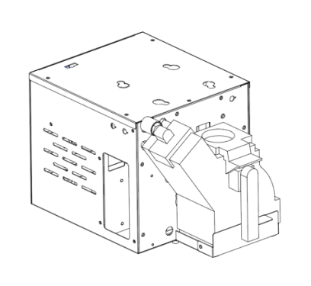

Handle

Press-down button

Press down the extractor flap

Water outlet

Bottom cover

1. **Peristaltic pump pipe**

（1）Pull the peristaltic pump latch to the right；

（2）Separate the three sections of the pipe；

（3）Replace or clean the pipes connected to the top and bottom of the peristaltic pump；

（3）Clean the internal pipes of the peristaltic pump with hot water.

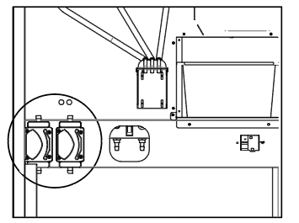

* It's recommended to automatically clean with hot water at the end of daily operations to prevent sugar syrup from solidifying. Change the pipes at least once a year, depending on sales volume.

1. **Ingredients canister**

After emptying the canister, soak it in water to dissolve any solidified ingredients. Rinse thoroughly with clean water and dry the inside with a cloth or a hairdryer. Then, add the powder according to usage needs.

(Moisture can cause ingredient solidification and affect material flow. Be sure to clean the canister weekly. If a blockage occurs, first check for solidified ingredients and clean immediately to resolve the issue.)

1. **Waste water tray**

After pouring out the accumulated water in the drip tray, soak it in water for cleaning.

After drying, place it back in its original position and clean it once a day.

**Ⅶ. After-Sales Service**

**1.Working Hours**

Workday：8:00--20:00 Holiday: 8:30--18:00

Workday：8:00--20:00 Holiday: 8:30--18:00

**2.Service Content**

1.Provide guidance on machine installation, operation, and setting.

2.Provide comprehensive training.

3.Provide remote technical support.

4.Provide on-site after-sales service when necessary.

**3.Warranty**

1.The entire machine comes with a one-year free warranty.

2.During the warranty period, any replacement parts required due to product quality issues will be provided free of charge.

3.After-sales support is primarily conducted through remote guidance, with on-site assistance as a secondary option. We provide customers

with relevant parts and instructional videos to help them resolve issues.

4.Faults caused by non-compliance with operating procedures, human factors, environmental conditions, or force majeure are not covered by the free warranty

**Ⅷ. Bill of Materials**

|  |  |  |  |  |
| --- | --- | --- | --- | --- |
| Order number | Name of accessory | Quantity | Where to leave it | Detail |
| 1 | Complete set of three types of material boxes | 5 | Accessory carton | Two nozzles are inclined to the right and three nozzles are inclined to the left |
| 2 | Waste water tank | 1 | Accessory carton | Bowl, filter screen, lid |
| 3 | Plug adapter | 1 | Accessory carton |  |
| 4 | Acrylic cup holder L type | 1 | Accessory carton | After receiving the machine, it is fixed to the side of the housing. |
| 5 | M4 screwdriver | 5 | Accessory carton | For a fixed cup |
| 7 | Tap water pipes and joints | 1 | Accessory carton |  |
| 8 | Stainless steel bent pipe | 2 | Accessory carton | Connect to the peristaltic pump silicone tube and draw the syrup. |
| 9 | Iron rod for dropping the lid | 1 | Accessory carton |  |
| 10 | Waste bins | 1 | Accessory carton | Use with coffee grounds |
| 11 | 3rd Cup bucket | 5 | On the chandelier | Used for a goblet |
| 12 | Bean Bag | 1 | Accessory carton |  |
| 13 | Wifi receiving antenna | 2 | Accessory carton | The customer installs it on the nut at the top of the machine |
| 14 | certificate | 1 | Accessory carton |  |
| 15 | A set of tools | 1 | Accessory carton | A hex key and a cross key  A 7MM sleeve |
| 16 | Emergency key | 1 | On top of the machine |  |

**IX. Table of common faults and solutions**

|  |  |  |
| --- | --- | --- |
| Fault code | Cause analysis | Countermeasures and solutions |
| E01 | The machine tank is empty | Refill water; Check and repair the fault of the water level switch |
| E02 | The chalice has no cup | Refill the cup; check the fault of the remaining cup sensor |
| E04 | The sensor is abnormal | Check whether the hot and cold water NTC is abnormal; check whether the water level switch is abnormal |
| E05 | The core of dry grinding extraction is missing | Check that the extractor is properly installed |
| E06 | The boiler is overheated | Clean the scale of the grinding boiler; adjust the pressure parameters of the extraction device when the water flow is too slow |
| E07 | The grinding machine needs to be emptied | Check whether the water inlet of the grinding machine is blocked; overhaul the flowmeter of the grinding machine |
| E08 | The core of the grinding machine is blocked | Reduce the amount of freshly ground powder; add grease to the internal running parts of the extractor |
| E09 | The NTC status of the polished surface is abnormal | Overhaul of NTC of freshly made boiler |
| E10 | The current grinding module is offline | Overhaul the communication part of the freshly polished module |
| E11 | The quick-mold module is offline | Overhaul the communication part of the quick-solve motherboard |
| E12 | Orbital foreign bodies | Check whether there is a foreign object blocking the track and cannot be reset or go to the work station |
| E13 | Payment module offline | Repair the communication part of the payment module |
| E14 | Front door module offline | Overhaul the communication part of the front door module |
| E15 | The ice making module is offline | Check the communication part of the ice making module; the ice maker is not on |
| E17 | The grinding module is faulty | Now repair the faulty mold module |
| E19 | Pump booster failure | Overhaul turbocharger pump accessories |
| E20 | Air discharge solenoid valve fault | Overhaul and drain the solenoid valve accessories |
| E21 | Electric water discharge solenoid valve is faulty | Remove electromagnet valve accessories after maintenance |
| E22 | No.1 cup holder is faulty | Falling cup card cup; repair falling cup accessories |
| E25 | Initial preheating after startup | The first time to start up, you need to wait |
| E26 | Cool the machine for the first time after startup | The first time to cool down after starting up, please wait |
| E27 | Flowmeter malfunction | Overhaul flowmeter accessories |
| A01 | No cover | Add the cup lid |
| A02 | The drop frame is faulty | The falling lid function is abnormal and needs to be replaced and repaired |
| A03 | The drop cap is abnormal | Check whether the cover is stuck on the lid |
| A05 | Thyroid failure | If the heating time exceeds the limit, check whether the temperature switch protection is working |
| A06 | Cold shoulder | Cooling time exceeds, overhaul compressor accessories |
| A09 | A cup has a cup | There is an undrawn drink or foreign matter in the cup; the laser beam sensor is abnormal |
| A10 | Tank 1 is dry | The water pump of bucket No.1 exceeds the time limit, so replace bucket No.1 |
| A11 | Tank 2 is dry | 2. If the water bucket draws water for too long, replace bucket No.2 |
| A100 | Tank 1 is full | The no. 1 waste water tank is full and needs to be cleaned up in time |
| A101 | Tank 2 is full | 2. The waste water barrel is full and needs to be cleaned in time |

**X. Product Warranty Card**

|  |
| --- |
| **Warranty card** |
| User profile Time:   |  |  |  |  | | --- | --- | --- | --- | | Name |  | Tel |  | | Address |  | | | | Model |  | Maintenance  time |  | | Order time |  | Order price |  | | Maintenance records | Maintenance time | Causes of faults and repairs | | |  |  | | |  |  | |   **Warranty instructions**  1. Please keep this card as a proof of repair.  2. 1 year warranty from the date of sale.  3. Warranty equipment in the warranty period, under normal use and maintenance, the machine itself, the components of the material and process  problems, the occurrence of failures, the investigation is true, the Company will provide repair and replacement of spare parts.  4. During the warranty period, if any of the following matters occur, the  Company has the right to refuse service or to charge material and service fees.  (1) Failure to provide warranty card and valid proof of purchase.  (2) Man-made non-normal external damage.  (3) Damage caused by dismantling and repairing by non-authorised maintenance service providers of our company.  (4) Natural disasters or other force majeure because of failure and damage.  (5) Other tasks intentionally damaged.  5. Our company reserves the right of ﬁnal interpretation of all contents. |



Wuhan Gao Sheng Wei Ye Technology Co., Ltd

Add: B2 Bld, Dahualing Industrial Zone, JiangXia, Wuhan, Hubei, China Zip