Quality Assurance Process

Please provide us below details to check and get the guarantee.
Please do NOT open the product and check by yourselves without our permission!
- Provide few pictures of the product to check the appearance (as the picture shows):
Must be clearly enough to see there’s no damage and disassembly.
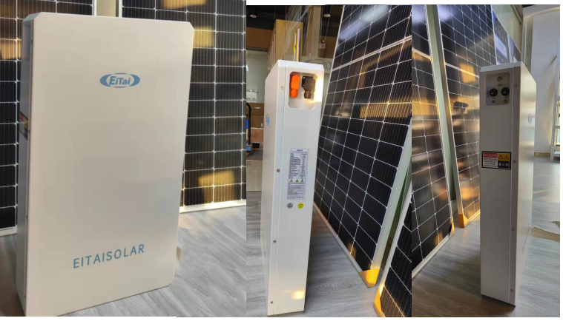

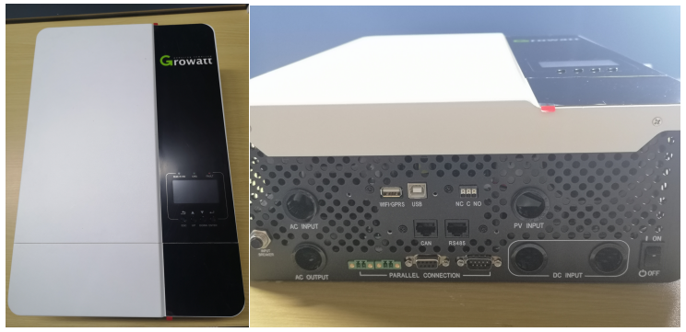

- Provide the picture of the nameplate/ monitor account details to check the related information (as the picture shows)：
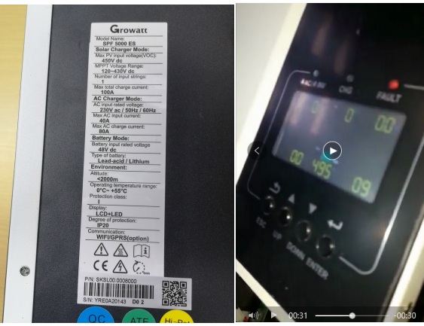

- Provide the PI with date or order details to check the guarantee valid period ( as the picture shows):

Thanks for all the help, we will check and reply with satisfactions.

