智能柔性折弯中心

说 明 书

Intelligent Flexible Bending Center User Manual
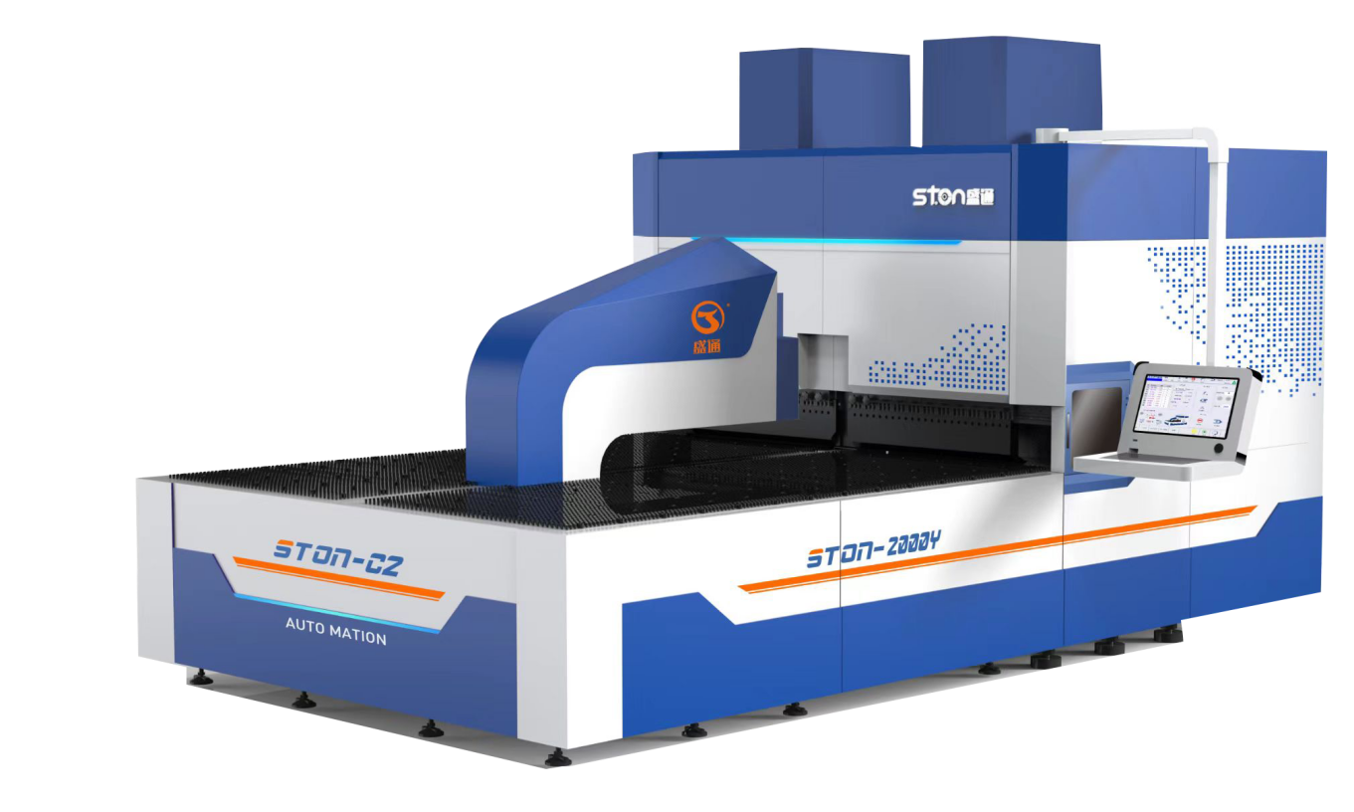

青岛盛通机械科技有限公司

Qingdao Shengtong Mechanical Technology Co., Ltd.

目录
Contents

前 言Forward 4
一. 产品概述 Product Overview 4
二. 产品特点 Product Features 4
5.可与激光、塔冲、机械手等设备组合，组成全自动生产线。 5
It can be combined with laser, turret punch and manipulator to form a fully automatic production line. 5
三．设备安全使用须知 Safety Instructions 5
1. 安全警告标志 6
Safety warning signs 6
2.一般注意事项： 7
General precautions: 7
四．折弯中心的构造说明及主要参数 9
Structural Description and Main Parameters of Bending Center 9
1. 设备构造图 9
Equipment Structure Diagram 9
2. 设备工作原理说明 Description of Working Principle 11
3.设备型号及主要参数 12
Equipment Model and Main Parameters 12
3.1 产品型号、名称：Product type and name 错误！未定义书签。
3.2 通用参数General parameters 错误！未定义书签。
3.3 设备参数Equipment parameters 错误！未定义书签。
五．设备的吊运及安装前准备 15
Equipment Lifting and Preparation Before Installation 15
1. 空间限制 space limitation 15
2. 安装环境 Installation environment 16
3. 地基：Foundation 17
4. 吊运 Lifting 17
5. 安装前检查 Pre-installation inspection 18
六.设备安装调试及操作流程 18
Installation, Commissioning and Operating Procedures 18
1.设备安装调试：Installation and commissioning 18
2.操作流程：Operating procedures 19
七. 柔性折弯中心系统说明 Description of Flexible Bending Center System 19
1、系统构成 System Configuration 19
2、系统操作手册 System Operation Manual 20
一、显示画面介绍 Introduction of display screen 20
2. 零点设定方法 Zero setting method 26
2.2.1.3 U轴和Y1 Y2零点校正功能 错误！未定义书签。
U-axis and Y1 Y2 zero correction function
2. 在主页面上点击档案，可进入档案页面，会显示所有的档案……………………………….. 错误！未定义书签。

Click File on the home screen to enter the file screen and all files will be displayed.
2.6 警报显示Alarm display 错误！未定义书签。
2.7 程序编辑页面 Program edit screen 32
2.8 监看页面 Monitoring screen 37
2.9 运动方向 Direction of movement 38
二、加工操作流程 Processing Procedures 40
1.1 参数设定 Parameter setting 40
1.2 折弯步骤 Bending steps 54
2.24 特殊动作1示意图Special action 1 diagram 70
三、加工案例 Processing Cases 75
3.1 折盒子工件加工 Box folding 75
3.1.1 产品样式及尺寸 Product type and size 75
3.1.2 产品工艺分解 Product process breakdown 76
3.1.3 编程设定 Programming setting 77
3.1.2 副刀动作编辑 Auxiliary tool movement edit 87
3.1.5 试加工及精度补偿 Test processing and accuracy compensation 89
3.2 偏心工件加工 Processing of eccentric workpiece 92
3.2.1 产品样式及尺寸 Product type and size 92
3.2.2 产品工艺分解 Product process breakdown 93
3.2.3 编程设定 Programming setting 93
3.3 空心板及小尺寸工件 Hollow plate and small-size workpiece 95
3.3.1 产品样式及尺寸 Product type and size 95
3.3.2 产品工艺分解 Product process breakdown 95
3.3.3 编程设定 Programming setting 96
八. 设备的润滑及保养 Lubrication and maintenance of equipment 97
1、润滑系统 Lubrication System 97
2.润滑系统注意问题 Lubrication system precautions 99
九、电气原理图 Electrical Schematic 101

前 言

Forward
非常感谢您选择使用青岛盛通科技机械有限公司生产的柔性折弯中心，请仔细阅读本使用说明书，便于您安全使用该产品。
Thank you for choosing the flexible bending center produced by Qingdao Shengtong Mechanical Technology Co., Ltd. Please read this manual carefully so as to use the product safely.

产品概述 Product Overview
柔性折弯中心是一款新型、高效、智能的自动化薄板折弯设备。集成了先进的控制系统和精密的机械结构，可实现高效率、高精度的自动化作业，对钣金行业是一个带来巨大帮助。
Flexible bending center is a new, efficient and intelligent automatic sheet bending equipment. It integrates advanced control systems and sophisticated mechanical structures to achieve high-efficiency and high-precision automatic operations, which is a great help to the sheet metal industry.

产品特点 Product Features
1.高效性:设备能够快速完成大量重复性工作，显著提高生产效率，
High efficiency: The equipment can quickly complete a large amount of repetitive work to significantly improve production efficiency.
2.精准度:设备采用精密机械和控制系统，保证作业的高精度，
Accuracy: The equipment adopts precision machinery and control systems to ensure high precision of the operation.
3.稳定性:设备经过严格的质量检测，保证长时间稳定运行
Stability: The equipment has undergone strict quality testing to ensure long-term stable operation.
4.智能化:设备支持多种智能控制模式，可根据生产需求进行灵活调整。
Intelligent: The equipment supports a variety of intelligent control modes, which can be flexibly changed according to production needs.

5.可与激光、塔冲、机械手等设备组合，组成全自动生产线。

It can be combined with laser, turret punch and manipulator to form a fully automatic production line.

三．设备安全使用须知 Safety Instructions
全面了解设备性能，自觉遵守设备的各种操作说明是实现设备无故障工作的前提条件，因此我们特别强调的是，本说明书是设备的重要组成部分，操作设备前必须认真阅读，了解设备结构性能，安全操作规范和设备上的警告标牌内容，严格按要求操作，否则会造成人员伤亡事故或者设备损坏事故。
A comprehensive understanding of the equipment performance and conscious compliance with operating instructions are prerequisites for trouble-free operation of the equipment. Therefore, please be noted that this manual is an important part of the equipment. Please carefully read it before operation to understand the equipment structure and performance, safe operating procedure and warning signs on the equipment and operate strictly according to the requirements, otherwise it may cause injury or death or equipment damage.
设备的安装、操作、保养、检修要经过专门培训的专业人员按照使用说明书中的规定按步骤进行。设备操作、维修用钥匙应由专业人员保管、使用。
This equipment must be installed, operated, maintained and overhauled by specially trained professionals according to the steps specified in this manual. Keys for equipment operation and maintenance shall be kept and used by designated personnel.

安全警告标志 Safety warning signs
本设备安全警告分两类。一类为人身安全警告，如果不及时回避可能对人身造成伤亡。
There are two types of safety warnings for this equipment. One is personal safety warning and failure to follow the warning may cause injury or death.

第二类为设备安全警告，如果不按警告操作将对设备本身造成损坏。

The second is equipment safety warning and failure to follow the warning will cause damage to the equipment.
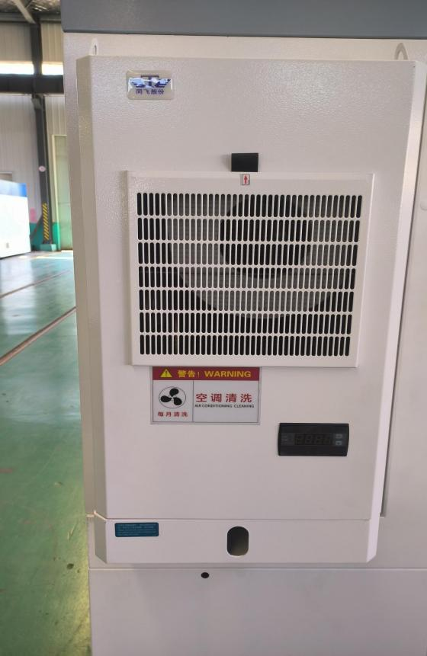
此警告为空调清洗提醒，请按照警告操作，以免空调运行不良导致设备故障。
This warning is a reminder to clean the air conditioner. Please follow the warning to avoid equipment failure due to poor operation of the air conditioner.

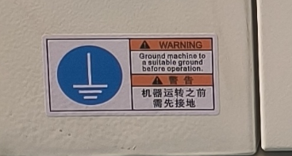

接地提醒，否则设备不能正常运行
Grounding reminder. The equipment will not operate properly if not followed.
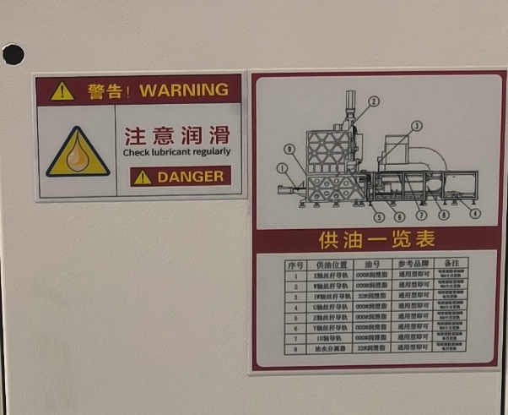

润滑系统提醒，请使用指定的润滑油或润滑脂。并按期检查
Lubrication system reminder. Please use specified lubricating oil or grease, and check them regularly.

2.一般注意事项：General precautions
2.1 不要弄脏、损坏或移走安全警告标志
Do not stain, damage or remove safety warning signs.
2.2 未经培训和授权人员请勿操作和维修设备
Untrained and unauthorized personnel are not allowed to operate or repair the equipment.
2.3 操作或维修时请认真阅读使用说明，确定完全了解所有指示
Please read the manual carefully during operation and repair to make sure that all instructions are fully understood.
2.4 当有2位以上人员一起操作时，相互之间一定要密切沟通
When more than two personnel operate together, they must communicate closely with each other.
2.5 操作者应清楚知道紧急停止按钮的位置，出现危急情况请按紧急按钮
The operator shall clearly know the position of the E-stop button and press the E-stop button in case of emergency.
2.6 设备运作时严禁在设备上装卸、检测工件或者清扫工作台面等
It is strictly forbidden to load/unload or inspect workpieces or clean the worktable of the equipment when the equipment is running.

四．折弯中心的构造说明及主要参数

Structural Description and Main Parameters of Bending Center

1. 设备构造图 Equipment Structure Diagram
图一 内部结构图
Fig. 1 Internal Structure Diagram
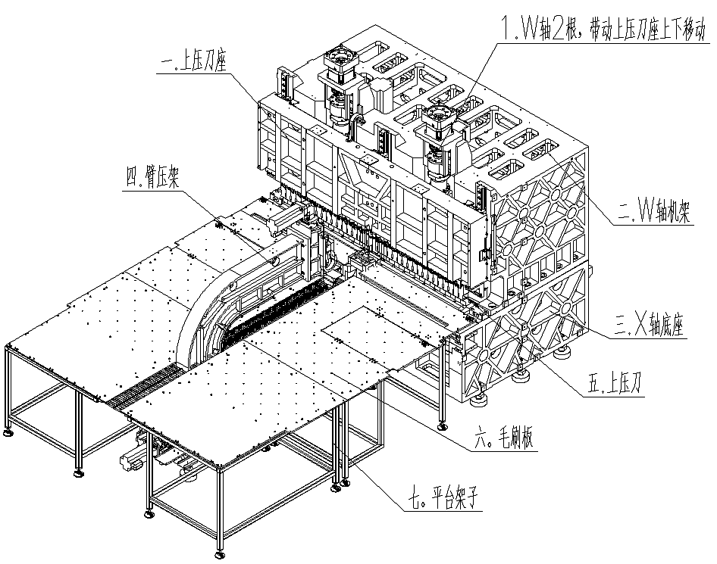
7.Platform frame
6.Brush plate
5.Upper press tool
3.X-axis base
2.W-axis frame
Arm press
1.Two W axes drive the upper tool holder to move up and down
1.Upper press tool holder
2.Two Z axes drive the U-shaped tool holder to move up and down
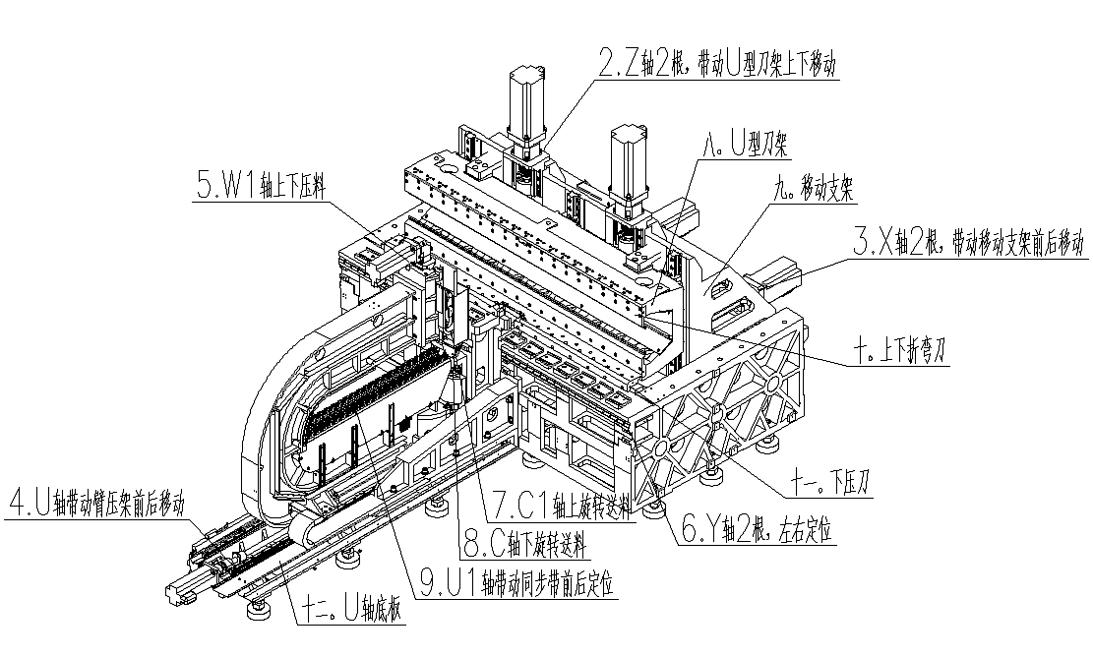
12. U-axis base plate
4. U-axis drives arm press to move back and forth
9.U1轴带动同步带前后定位
9.U1-axis drives the synchronous belt for front and rear positioning
8.C轴下旋送料 8. C1-axis rotates downward to feed
7. C1-axis rotates upward to feed
6. Two Y axes for left and right positioning
11. Lower press tool
10.Upper and lower bending tool
3. Two X axes drive the moveable bracket to move back and forth
9. Moveable bracket
8. U-shaped tool holder
5.W1 axis presses material up and down
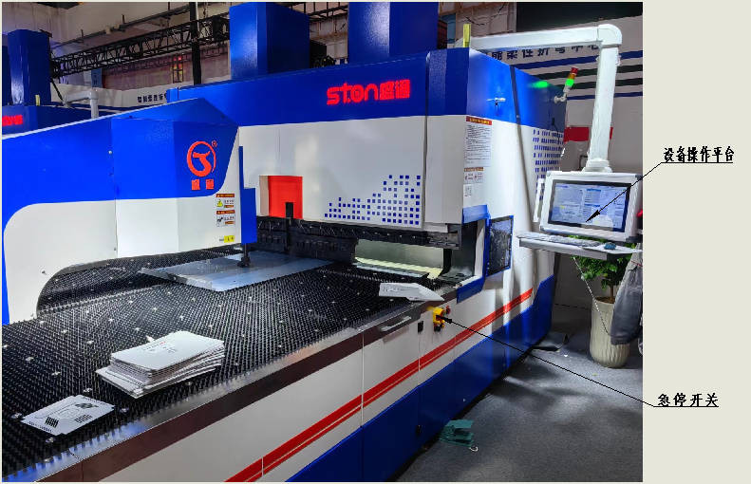
E-stop button
Equipment operating platform
图二 设备急停开关位置及设备操作平台
Fig. 2 Position of E-stop Button and Equipment Operating Platform

设备工作原理说明 Description of Working Principle
工作台：工作台由毛刷板和支架组成。毛刷板上均布牛眼轴承，能使钢板在工作台上以任意角度旋转和在X轴方向运动。
Worktable: The worktable consists of brush plate and bracket. Bullseye bearings are evenly distributed on the brush plate to make the steel plate rotate at any angle and move in the X-axis direction of the worktable.
压臂部分：压臂部分由压臂、底座、压杆以及导轨、丝杠等组成，由电机和丝杆提供动力。从而夹紧物料并使其按折弯要求旋转或是沿X轴方向运动。
Press arm assembly: The press arm assembly is composed of press arm, base, press rod, guide rail and lead screw. It is powered by motor and screw rod. It can clamp the material and rotate it according to the bending requirements or move it along the X-axis direction.

上压刀座部分：由上压刀座、上压刀调节座以及导轨、丝杠、电机等组成。在折弯过程中提供压力使板材固定在下压刀上。或者根据折弯工艺要求提供压死边的动力。
Upper press tool holder assembly: It consists of upper press tool holder, upper press tool adjusting seat, guide rail, lead screw and motor. It provides pressure during the bending process to fix the plate on the lower press tool or provide the power to press the dead edge according to the requirements of the bending process.
W轴机架：上压刀座安装在W轴机架上，对上压刀座起到支撑固定作用。其变形量直接决定了设备精度。
W-axis frame: The upper press tool holder is installed on the W-axis frame to support the upper press tool holder. Its deformation directly determines the accuracy of the equipment.
X轴底座：X轴底座是设备主体的基础，同时下压刀和板材定位机构也安装在X轴底座上。
X-axis base: The X-axis base is the basic part of the equipment. The lower press tool and the plate positioning mechanism are also installed on the X-axis base.
U型刀架及移动支架部分：移动支架通过导轨、丝杠与X轴底座连接，由伺服电机提供动力，使其精确的沿X轴运动。U型刀架通过导轨、丝杠与移动支架连接，由伺服电机提供动力，使其精确的沿Z轴方向运动。这两部份通过控制系统，按照折弯要求进行高精度的协同运动，从而实现了复杂、准确的折弯动作。
U-shaped tool holder and movable bracket assembly: The movable bracket is connected with the X-axis base through the guide rail and the lead screw, and is powered by the servo motor to move accurately along the X-axis. The U-shaped tool holder is connected with the movable bracket through the guide rail and the lead screw, and is powered by the servo motor to move accurately along the Z-axis. These two parts are controlled by the control system to carry out high-precision movement according to the bending requirements to achieve complex and accurate bending action.
控制系统：由工业计算机、控制器、驱动器、伺服电机以及外部输入端组成。
Control system: It consists of industrial computer, controller, driver, servo motor and external input terminal.

3.设备型号及主要参数 Equipment Model and Main Parameters

3.1 产品型号、名称：Product model and name

智能柔性折弯中心：STON-C2

Intelligent flexible bending center: STON-C2
序号 No. | 名称 Name
1 | 最快折弯速度  Fastest bending speed | 0.2秒/刀  0.2s/tool
2 | 送料台面  Feeding table | 毛刷、万向球  Brush, universal ball
3 | 润滑管路  Lubrication line | 铜 管  Copper pipe
4 | 最小折弯厚度（mm）  Min. bending thickness (mm) | 0.15
5 | 动 力 合 页 刀  Powered hinged tool | 标配  Standard
6 | 高级指令  Advanced command | 标配  Standard
7 | 圆弧指令  Arc command | 标配  Standard
8 | 吸盘组件宽窄更换  Replacement of chuck assembly width
9 | 吸盘组升降  Chuck assembly lifting | 选配  Optional
10 | C轴升降  C-axis lifting | 选配  Optional
11 | 自动润滑功能  Automatic lubrication function | 标配  Standard
12 | 偏载检测功能  Bias load detection function | 标配  Standard
13 | 偏载随动功能  Bias load follow-up function | 标配  Standard
14 | 板厚检测功能  Plate thickness detection function | 标配  Standard
15 | 自动上料接口  Automatic feeding interface | 标配  Standard
16 | 高速控制模组  High speed control module | 标配  Standard
17 | 压平功能  Flattening function | 标配  Standard
18 | 上下压死边  Up/down pressed dead edge | 标配  Standard
19 | 上折弯副刀  Upper auxiliary bending tool | 选配  Optional
20 | 下折弯副刀  Lower auxiliary bending tool | 选配  Optional
21 | 折刀调节装置  Bending tool adjustment device | 标配  Standard
22 | 操作手轮  Hand wheel | 标配  Standard
23 | 云端管理功能  Cloud-based management function | 标配  Standard
24 | 控制系统  Control system | 进口品牌  Imported brand
25 | 伺服电机、驱动  Servo motor, driver | 进口/国产伺服  Imported/domestic servo
26 | 铸造机身  Cast body | 河 南 许 昌  Xuchang, Henan
27 | 焊接机身  Welded body | 青 岛 盛 通  Qingdao Shengtong
28 | 送 料 架  Feeding rack | 青 岛 盛 通  Qingdao Shengtong
29 | 减 速 机  Reducer | 上海BITPASS/摩多利  Shanghai BITPASS/Motoreducer
30 | 丝 杆  Screw rod | 南京工艺/陕西汉江  Nanjing Technical Equipment/Shaanxi Hanjiang
31 | 导 轨  Guide rail | 南京工艺/罗思特  Nanjing Technical Equipment/Roust
32 | 轴 承  Bearing | 日本 NSK/NACHI  Japan NSK/NACHI
34 | 电 器 件  Electrical parts | 施耐德、欧姆龙  Schneider, Omron
35 | 光 栅 尺  Grating ruler | 苏 州 SINO  Suzhou SINO
37 | 机用空调  Air conditioner | 同 飞 制 冷  Tongfei Refrigeration
38 | 气动配件  Pneumatic accessories | 台湾亚德客  AirTAC, Taiwan
39 | 吸 盘  Chuck | AIRBEST 品牌(压臂式不含)  AIRBEST (Press arm type excluded)
40 | 联 轴 器  Coupling | 日 本三 木  Miki Pulley
41 | 润滑系统  Lubrication system | 广 东 鼎 燊  Guangdong Dingshen
42 | 额定电压  Rated voltage | 380V
43 | 最大折弯厚度（mm）  Max. bending thickness (mm) | 不锈钢1.2 冷 板2.0 铝 板3.0  Stainless steel 1.2 Cold plate 2.0 Aluminum plate 3.0
44 | 最小折弯高度  Min. bending height | 4mm

3.3 设备参数 Equipment parameters
序号  No. | 名称  Name | STON-C2
1 | 最大折弯长度（mm）  Max. bending length (mm) | 2000*1500
2 | 最大折弯高度（mm）  Max. bending height (mm) | 170/300
3 | 送料方式  Feeding method | 压臂式  Press arm type
4 | 四边成型最小尺寸  Min. four-edge forming size | 140*190mm
5 | 单边成型最小尺寸  Min. single-edge forming size | 140mm

五．设备的吊运及安装前准备

Equipment Lifting and Preparation Before Installation

1. 空间限制 Space limitation
本设备外观尺寸如表，但 考虑到设备操作的便利，设备维修及电源供应的位置，设备四周应保留较大的空间，以方便工作。因此设备在安装时，如果场地空间允许，尽可能的符合下图所示的最小占地面积要求。
The dimensions of this equipment are as shown in the table. Considering the convenience of equipment operation/maintenance and location of power supply, a large space shall be left around the equipment to facilitate work. Therefore, the equipment shall be installed in such a way that it meets the minimum footprint requirements shown in the following diagram, if space on the site permits.
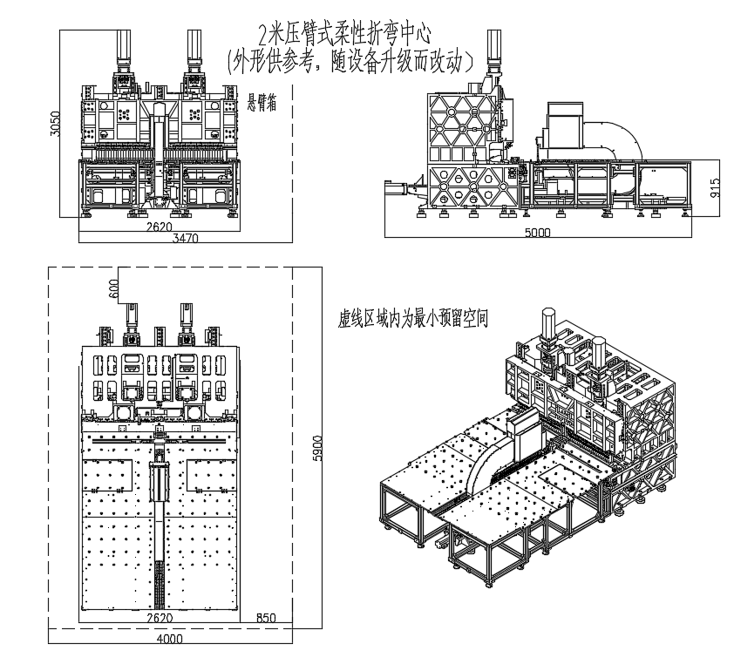
2m press arm type flexible bending center
(The outline is for reference only and subject to change with equipment upgrade)
Cantilever box
The dotted area is the minimum reserved space

安装环境 Installation environment
2.1 电压供给：三相交流380V±10％
Voltage supply: Three-phase AC 380V±10％
2.2 电源频率：50±1Hz
Power frequency: 50±1Hz
2.3 气压供给：0.6MPa，最好过滤
Air pressure supply: 0.6 MPa, preferably filtered
2.4 接地电阻应小于4Ω
Grounding resistance: <4Ω

地基：Foundation
设备摆放位置事先规划好，确定安装位置后，务必在设备到厂前打好地基。为了长时间维持机床的高精度，应准备对设备重量有足够耐力、能维持设备稳定和水平的地基。
The position of the equipment shall be planned in advance. After the installation position is determined, the foundation must be laid before the equipment arrives at the factory. In order to maintain high precision of the equipment for a long time, the foundation shall be firm enough to bear the weight of the equipment and keep the equipment stable and level.
设备自身带有可调节脚蹄，故地基不要预埋地脚螺栓，且平面度保持好，头尾高度差小于10mm。
The equipment is equipped with adjustable feet, so anchor bolts shall not be embedded in the foundation and the flatness shall be well maintained with the height difference between head and tail not less than 10mm.
我们建议地基用水泥浇筑，厚度不能低于200mm。如果地基构建场所的土壤条件很差，浇筑厚度应适当加大。
We recommend that the foundation be poured with cement with thickness not less than 200mm. If the soil conditions of the foundation construction site are very poor, the pouring thickness shall be appropriately increased.

吊运 Lifting
因发货为组装后的部件，质量较大，在吊运时应考虑吊运工具的能力。
Because the equipment is shipped after assembly and has a large mass, the capacity of the lifting tool shall be considered during lifting.
吊运时应垂直吊运，立放，不得失去平衡，吊运过程中设备不能受到撞击与振动。
It shall be lifted and placed vertically without losing balance. During lifting, the equipment shall not be subjected to impact and vibration.
吊运时要确认起吊位置在货物的重心上。
Make sure that the lifting position is on the center of gravity of the equipment during lifting.
吊运过程中有两个以上的人共同工作时一定要有协调指挥。
When more than two personnel are working together during the lifting process, they must be coordinated and instructed.

安装前检查 Pre-installation inspection
检查零部件在运输过程中是否有损坏。
Inspect the parts for damage during transportation.
按照装箱单清点零部件，检查是否齐全。
Count the parts according to the packing list and check whether they are complete.
检查管路、电路系统插头有无松动。

Check whether the pipes and circuit system plugs are loose.

六.设备安装调试及操作流程

Installation, Commissioning and Operating Procedures

1.设备安装调试：Installation and commissioning
设备在公司安装调试完成并测试合格后分解发货。在用户家需要对分解的部件重新进行安装调试。
The equipment has been installed, commissioned and tested in the factory before shipment. The disassembled parts need to be re-installed and commissioned by the user.
安装现场照明要适合操作，光源位置不应影响操作者视线或造成操作者不舒服。
The lighting at the installation site shall be suitable for the operation and the position of the light shall not affect the operator's line of sight or cause discomfort to the operator.
安装由我公司专业人员或在我公司专业人员指导下进行。安装调试后交付用户，并对用户操作人员进行培训，最终用户签写验收单后交付使用。
The installation shall be carried out by or under the guidance of the professionals of the company. We will provide training for user's operators after installation and commissioning. The equipment will be put into operation after the end user signs the acceptance form.

2.操作流程：Operating procedures
设备开机前检查电源和气源、检查各运动部件位置有无杂物等安全隐患。
Before starting the equipment, check the power supply and gas source and check whether there are any potential safety hazards such as debris in the moving parts.
根据工件拼刀及决定是否用合页刀，做好折弯前准备
Combine tools and decide whether to use hinged tool according to the workpiece and prepare for bending.
进入操作系统工作
Enter the operating system to work.

柔性折弯中心系统说明
Description of Flexible Bending Center System

1、系统构成 System Configuration
    LAN |  | ……
① ② ③

序号 No. | 名称 Name | 规格 Specifications
① | 工业计算机  Industrial computer | 主频:2.0GHz 以上,内存:4GB 以上  Main frequency: >2.0 GHz, memory: >4GB
② | 运动控制器  Motion controller | 支持  Support |  | 协议  protocol
③ | 伺服电机  Servo motor | 支持  Support |  | 协议  protocol

2、系统操作手册 System Operation Manual

一、显示画面介绍 Introduction of display screen

2.1 主页面介绍 Introduction of home screen
开机时自动至编程界面
The system automatically enters the programming screen after power on.
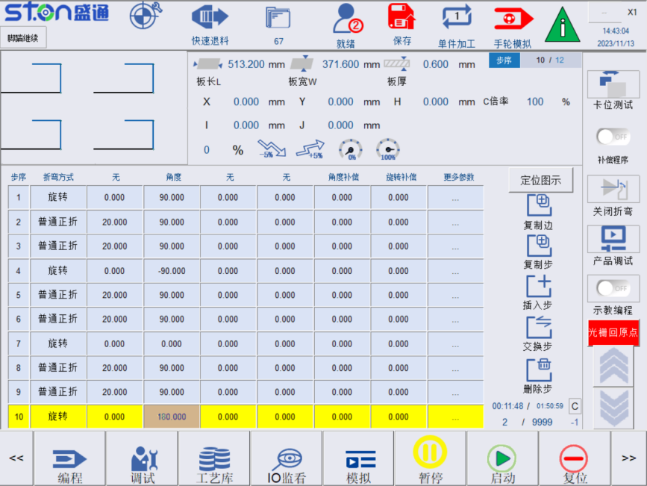
项目  Items | 说明  Description | 备注  Remarks
模式选择  Mode selection | 进入模式选择窗口，可进行加工模式切换，总共有两个状态可以切换，自动模式和手轮模式  Enter the mode selection screen to switch the processing mode and there are two modes to switch: Auto mode and handwheel mode.
单件加工/循环加工  Single-piece processing / Cycle processing | 单件加工：单件加工完成后，机构进入暂停状态。  Single-piece processing: After the single-piece processing is completed, the system enters a pause state.  循环加工：加工循环进行。  Cycle processing: The processing is carried out in cycles.
档案管理  File management | 加工编辑的工艺档案会保存在这里  The processing files and edited process files will be saved here.
手轮模拟开/关  Handwheel simulation ON/OFF | 在启动执行加工程式时，按下手轮模拟打开，意为通过手轮摇杆控制加工程式执行，正向摇动即按照程式方向执行，反向摇动即按照程序回退执行。  When starting the processing program, press the handwheel simulation ON, which means that the processing program is controlled by the handwheel joystick. Turning clockwise means executing according to the programmed direction and turning counterclockwise means reversing according to the program. | 重启控制器后，手轮模拟默认打开。  After restarting the controller, the handwheel simulation is enabled by default.
保存  Save | 此为加工执行时/轴向手动移动时运动倍率。  This is the motion ratio during processing /manual axial movement.
权限登陆  Login permission | 切换当前操作权限  Switch current operation permissions.
快速退料  Quick unfeed | 按下快速退料，W轴和W1轴会松开板材。  Press Quick Unfeed and the W and W1 axes will release the plate.
警报  Alarm | 显示当前警报信息。如有警报，则为红色闪烁显示，点击查看警报信息。  Display the current alarm information. If there is an alarm, it will flash red. Click to view the alarm information.
L U D R方向键  L U D R direction keys | 上一页，下一页切换，向左向右方向切换。  Switch to the previous page, next page, left and right.
键盘开启  Keypad ON  键盘关闭  Keypad OFF | 开启关闭小键盘  Turn on or off the keypad.

2.2 编程页面 Programming screen
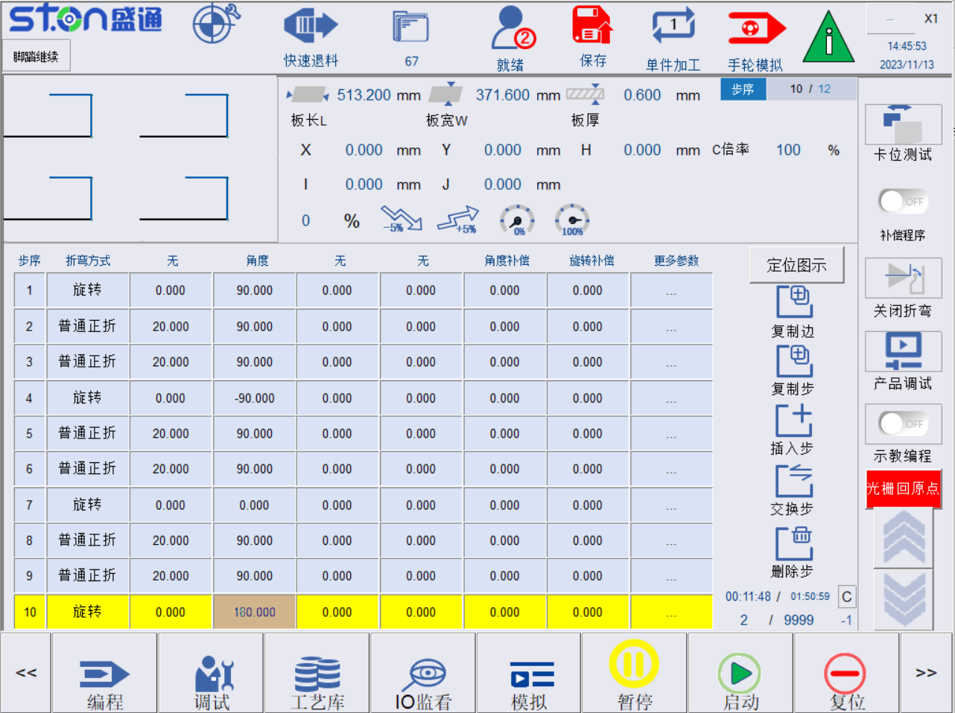
图1.2 编程页面
Fig. 1.2 Programming Screen

2.2.1 模式切换 Mode switching
在任意画面下，按下模式选择图标，进入模式切换窗口，可进行系统模式切换。系统提供：自动、手轮、原点等三种模式，切换到手动模式或手轮模式可进行轴向移动，见图1.3所示。
In any screen, press the Mode selection icon to enter the mode switching window to switch the system mode. The system has three modes: Auto, handwheel and origin. Switch to manual mode or handwheel mode for axial movement as shown in Fig. 1.3.
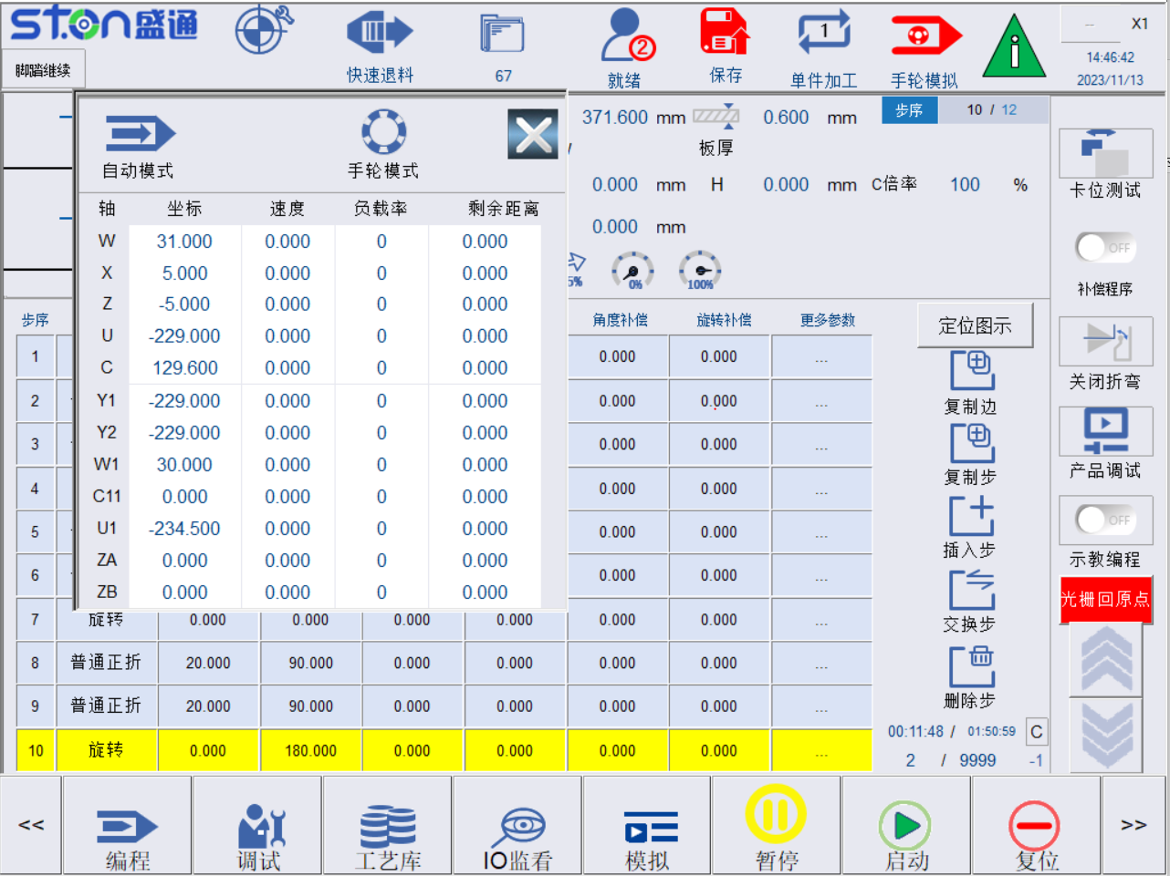
模式说明：Mode description:
1、自动模式：该模式下，机台执行加工动作；控制器需处于该模式时，按下启动按钮才会启动机台加工。
Auto mode: In this mode, the equipment performs processing actions. When the controller is in this mode, press the Start button to start processing.
2、手轮模式：该模式下，使用者可通过手轮驱动某个轴向单独运动（不同于手轮模拟功能）。
Handwheel mode: In this mode, the user can use the handwheel to drive a certain axial movement individually (different from the handwheel simulation function).
3、原点模式：该模式下，使用者可进行机台原点设定，默认不可选只有在设定原点时才是原点模式。
Origin mode: In this mode, the user can set the origin of the equipment and it cannot be selected by default. The origin mode is only used when the origin is set.
折弯步骤编辑和保存档案时，请将控制器切换到自动模式。
Switch the controller to auto mode when editing and saving bending steps.

2.2.1.1 手轮模式 Handwheel mode
在任意画面中（图1.4）:模式切换，点击手轮模式，可切换到手轮模式，旋转手轮上的波段开关，可对轴向进行选择。
In any screen (Fig. 1.4): Mode switching. Click the handwheel mode to switch to the handwheel mode, and rotate the band switch on the handwheel to select the axial direction.
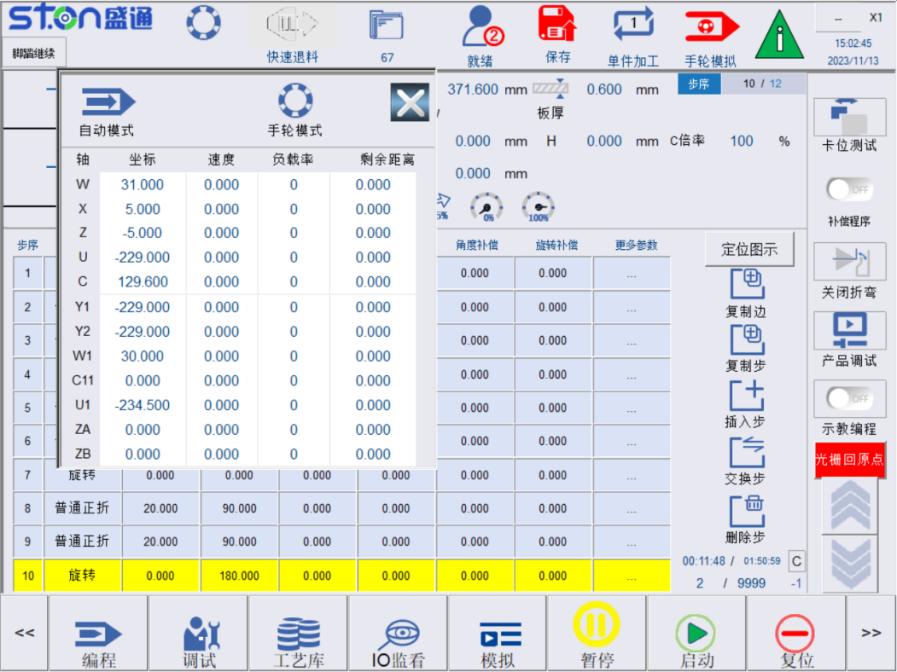
图1-6示，此处未选择轴向，轴向选择显示“-- X1”
Fig. 1-6 shows that the axial direction is not selected and shows "--X1” when the axial direction is selected.
上述手轮中,波段开关分为两块：
In the above handwheel, the band switch has two parts:
耦合模式下：旋钮旋向X、Y、Z、4、5、6、7、8，六段分别对应画面中W、X、Z、U、W1、Y1、Y2、W1，可通过画面上的按钮启用C11轴,，U1轴，副刀左Z3轴和副刀右Z4轴。
Coupling mode: Turn the knob to X, Y, Z, 4, 5, 6, 7 and 8, the six segments correspond to W, X, Z, U, W1, Y1, Y2 and W1. You can enable the C11 axis, U1 axis, left Z3 axis of auxiliary tool and right Z4 axis of auxiliary tool by using the buttons on the screen.
旋钮旋向倍率：X1、X10、X100在画面中分别显示（特别提示：当轴向是U轴时，X100会显示为X300）。
Knob rotation ratio: X1, X10, and X100 are displayed respectively in the screen (Special tips: When the axial direction is the U-axis, X100 will be displayed as X300).
手轮使用注意事项：Precautions for use of handwheel:
1、切换到手轮模式，打到对应的轴向，选定倍率旋钮，摇动摇杆，正向为顺时针、反向为逆时针。
Switch to handwheel mode, turn to the corresponding axial direction, select the ratio knob and turn the joystick. The forward direction is clockwise and the reverse direction is counterclockwise.
2、当自动执行程序加工时，主画面手轮模拟开启，可同时使用摇杆控制程序执行。此时波段开关选档无效。
When the programmed processing is automatically executed, the handwheel simulation on the home screen is enabled and the joystick can be used to control the program. At this time, the band switch selector cannot be used.

2.2.1.2 原点模式 Origin mode
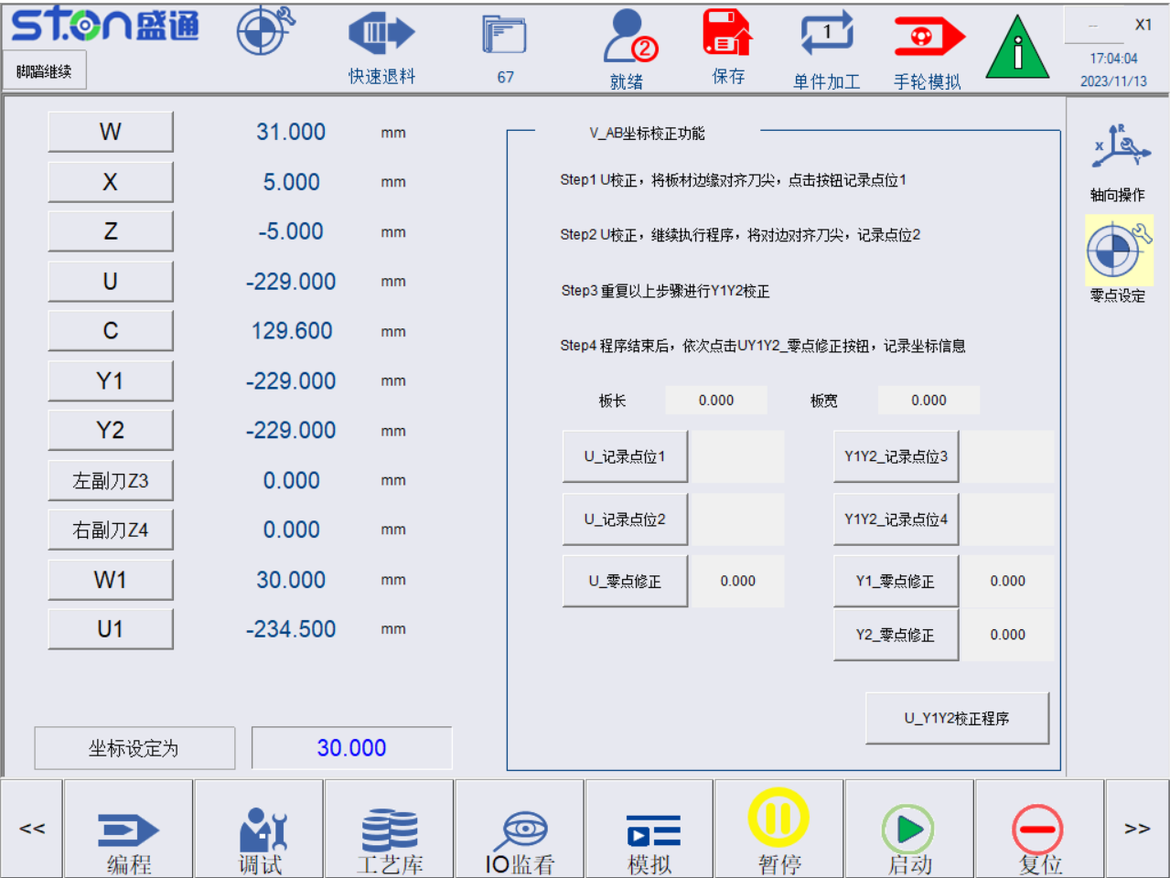
图1.5 原点模式及原点设定页面
Fig. 1.5 Origin Mode and Origin Setting Screen
- 登录系统权限2-3，可通过下方按键“调试”进入后台参数，点击零点设定可进入轴向零点设定页面
Log in to the system with permission 2-3. You can enter the background parameters by clicking the "Debug” button. Click the Zero Setting button to enter the axial zero setting screen.
- 零点设定方法
Zero setting method
a）在手轮模式下，将轴向移动到对应位置
In the handwheel mode, move the axial direction to the corresponding position.
b）测量机构到目标零点距离A
Measure the distance A to the target zero point.
c）将A值输入到坐标设定输入框
Enter the A value into the coordinate input box.

d) 点击对应轴向按钮，将该轴向零点设定

Click the corresponding axial button to set the axial zero point.

2.2.1.3 U轴和Y1 Y2零点校正功能 U-axis and Y1Y2 zero correction function
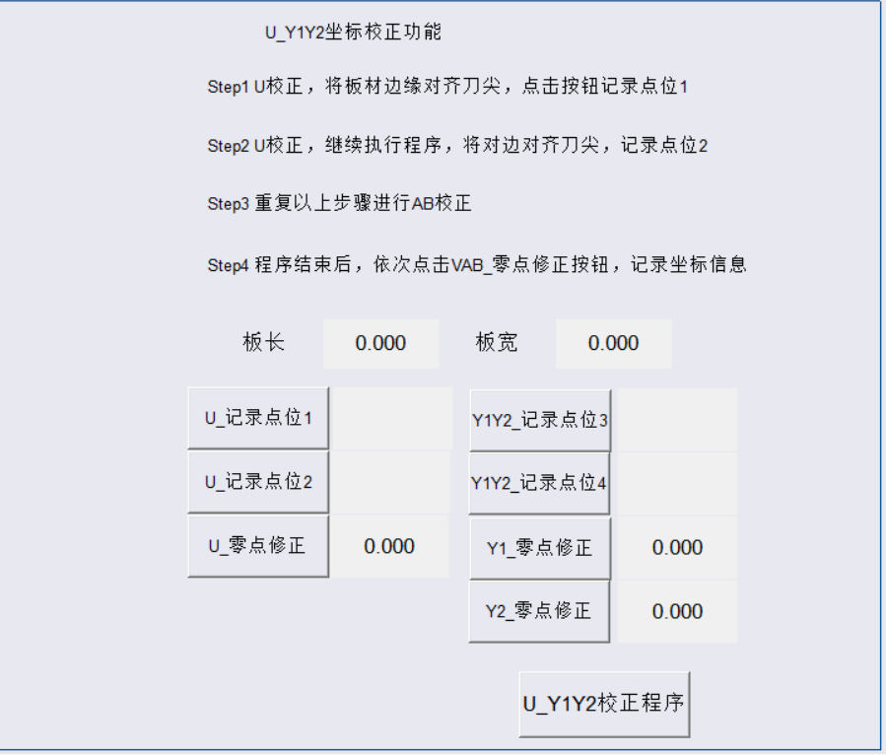
图1.6 零点自动矫正功能页面
Fig. 1.6 Automatic Zero Point Correction Function Screen
此功能是为了防止人为设置零点错误，开发的自动校正功能，具体的操作为：
This is an automatic correction function developed to prevent human error in setting zero point. The specific operation is as follows:
1、如果要使用此功能，进入页面首先点击下方U_Y1Y2矫正程序按钮。这之后程序开始执行。
To use this function, first click the U_Y1Y2 correction program button below. After that, the program will be executed.
2、输入板材长和板材宽，尽量使用标准板，否则也可能导致矫正的坐标不准。
Enter the length and width of the plate. Try to use standard plate, otherwise the corrected coordinates may also be inaccurate.
3、将板材放上去后，踩脚踏，使用手轮模拟，摇手轮，U轴会送料将板材送过去，等将板材的一边与压刀下平面平齐之后，点击U记录点位1，然后，U轴会回退，之后换到另一边，同样的方法，点击U记录点位2。
After putting the plate on, step on the pedal, use the handwheel to simulate, turn the handwheel and the U-axis will feed the plate. After one side of the plate is level with the lower plane of the press tool, click the U-axis record point 1, and then the U-axis will retreat. Change to the other side and click the U-axis record point 2 in the same way.
4、都修正完毕之后，点击U零点修正，会自动将U轴修正后的坐标写入到零点设定界面。
After all corrections are completed, click U-axis zero correction and the corrected coordinates of U-axis will be automatically written to the zero setting screen.
5、之后摇动手轮，Y1 Y2会移动，当Y1 Y2同时移动碰到板材侧边时，点击Y1Y2记录点位3，会记住当前的坐标，之后会换边，自动同样的方式，点击Y1 Y2记录点位4。点击Y1和Y2零点修正会自动修正Y1 Y2的零点坐标并写入。
After that, turn the handwheel, Y1 and Y2 will move. When Y1 and Y2 touch the side of the plate, click Y1 and Y2 to record point 3, and the current coordinates will be saved. Then the edge will be changed. Click Y1 and Y2 to record point 4 in the same way. Clicking Y1 and Y2 zero correction will automatically correct the zero coordinates of Y1 and Y2 and write them.
2.3 权限管理 Permission management
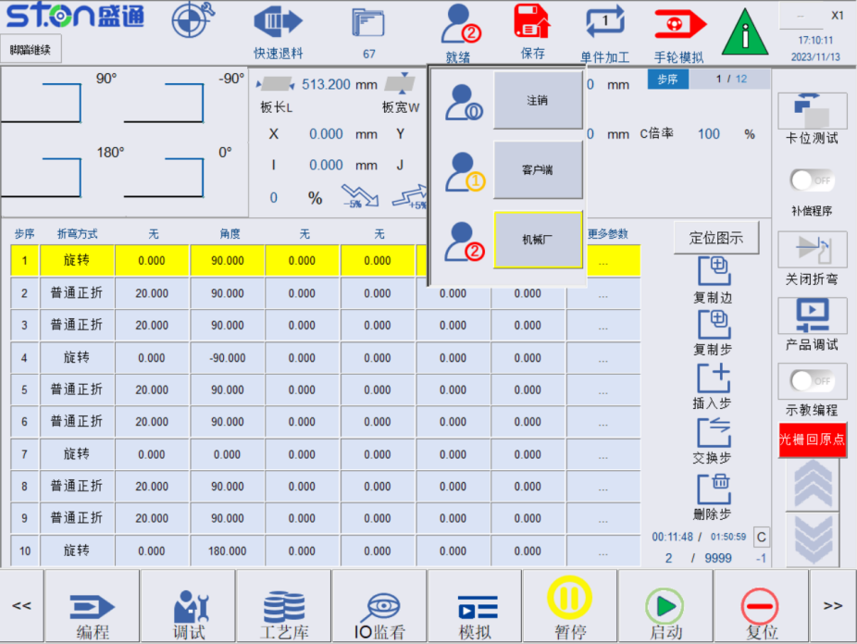
图1.7 权限管理
Fig. 1.7 Permission Management
表1.2 权限管理
Table 1.2 Permission Management
权限等级  Permission Level | 密码  Password | 备注  Remarks
操作员  Operator | 520 | 仅可进行简单的启动加工、档案汇入汇出、加工档修改  Only start processing, file import/export and processing file modification are available.
机械厂  Machine factory | 521 | 可进行大部分的参数的修改  Most parameters can be modified.
注销  Cancel | 无  No | 删除目前获取的所有权限  Delete all currently obtained permissions.

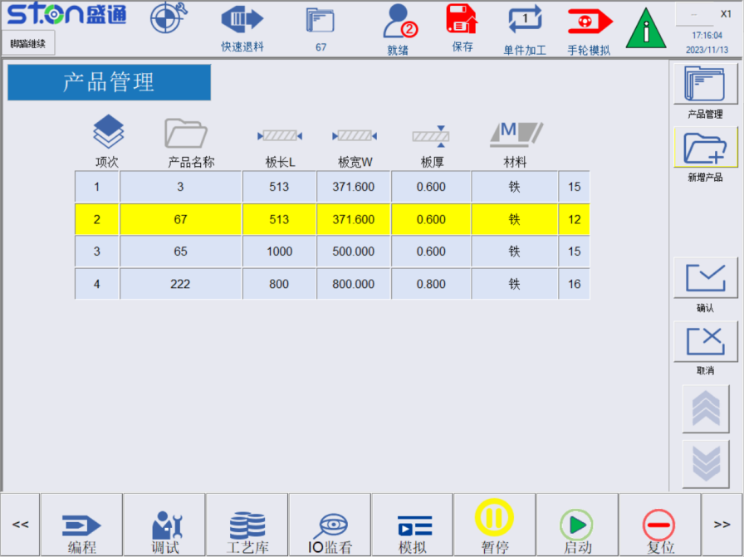

2.4 档案存储 File storage
- 状态栏的储存按钮即可保存当前数据，并生成加工档（如图1.9所示）。
Click the Save button in the status bar to save the current data and generate a processing file (as shown in Fig. 1.9).
- 在主页面上点击档案，可进入档案页面，会显示所有的档案。
Click File on the home screen to enter the file screen and all files will be displayed.
  - 页面中选择档案，点击确认可进入产品编程页面。
Select the file on the page and click OK to enter the product programming screen.
  - 新增产品可以添加新产品。
New products can be added in the New Product.
  - 产品管理中可以删除档案信息
File information can be deleted from the Product Management.

2.6 警报显示 Alarm display
在主功能条点击“警报”可以查看“现在警报”、“历史警报”和“储存警报”。
Click “Alarm" in the main function bar to view "Current Alarm", "Historical Alarm" and “Save Alarm".
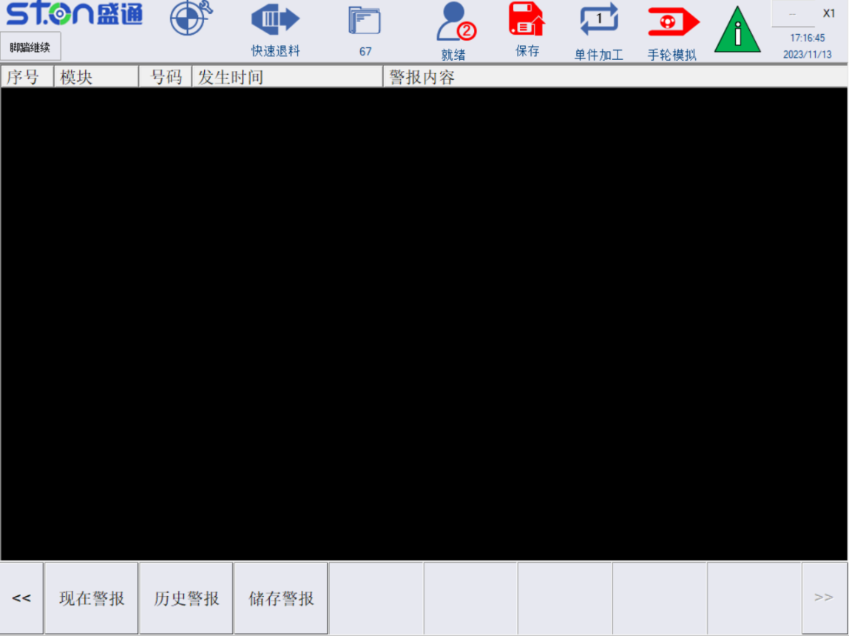
图1.10 警报页面
Fig. 1.10 Alarm Screen
现在警报：查看系统当前发生的警报，包含警报号码，发生时间，以及警报内容等信息。
Current alarm: View the current alarm of the system, including the alarm number, occurrence time and alarm information.
历史警报：查看系统发生过的历史警报内容。
Historical alarm: View the information of historical alarms that have occurred.
储存警报：将警报文件储存至外部存储记忆体装置。
Save alarm: Save the alarm file to an external storage device.

2.7 程序编辑页面 Program edit screen

2.7.1 编程画面功能介绍 Introduction of programming screen functions
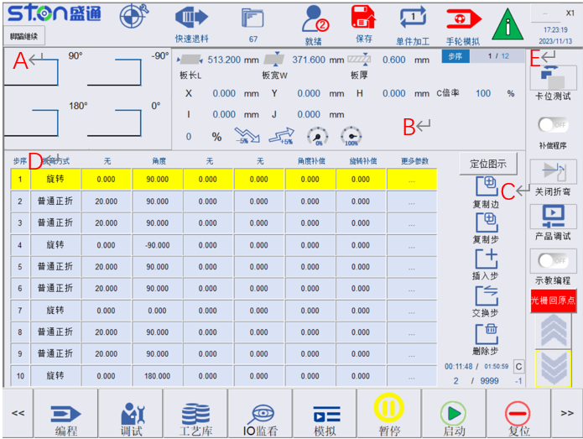
图1.11编辑页面主画面显示
Fig. 1.11 Home Screen of Edit Screen
表1.3编辑画面功能介绍
Table 1.3 Introduction of Edit Screen Functions
区域  Area | 说明  Description | 功能介绍  Functions | 备注  Remarks
A | 图形模拟  Graphical simulation | 当前边的2D图形显示  2D graphical display of the current edge.
B | 板材参数数据  Plate parameter data | 修改当前次序的边号,设置板长板宽等参数  Modify the edge number of the current order and set parameters such as plate length and width.
C | 功能按钮  Function button | 功能按钮选择  Function button selection.
D | 折弯步骤编辑及折弯边选择  Bending step edit and bending edge selection. | 当前边的折弯工艺步编写  Bending step preparation of the current edge. | 通过旋转步序来对应选择要折弯的边  Select the edge to be bent by rotation steps
E | 功能按钮  Function button | 功能按钮选择  Function button selection.

2.7.2 调试页面参数介绍 Introduction of debug screen parameters
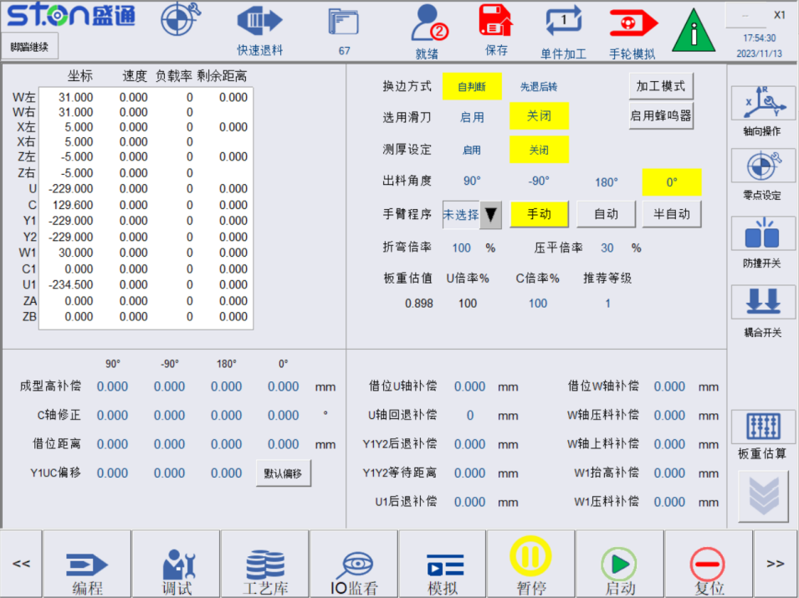
图1.12 板材参数页面
Fig. 1.12 Plate Parameter Screen
表1.6
Table 1.6
参数名  Parameter Name | 操作说明  Operating Instructions | 备注  Remarks
换边方式设定  Edge-changing method setting | 选择换边时板材旋转动作  Select plate rotation action during edge changing.  - 自判断：最优旋转路径  Self-judgment: Optimal rotation path.  - 先退后转：送料轴先回退到安全位置再旋转板材  Retract first and then rotate: The feed shaft first retracts to a safe position and then rotates the plate. | 自判断适用小尺寸板  Self-judgment for small size plates.
选用滑刀  Select slide tool | 启用：此次折弯过程使用滑刀。  ON: The slide tool is used in this bending process.  关闭：此次折弯过程不使用滑刀  OFF: The slide tool is not used in this bending process.
是否启用测厚  Whether to enable thickness measurement | 若需要使用测厚请选择打开  Please select ON if thickness measurement is required.
定位方式  Positioning method | 定位方式选择  Positioning method selection  - 定位宽内角定位  Inner angle positioning of positioning block  - 外侧定位块定位  Positioning of outer positioning block  - 内侧定位块定位  Positioning of inner positioning block  - 组合定位  combined positioning | 需要根据加工板材形状，选择合适的定位方式，并设相关参数  Select the appropriate positioning method and set the relevant parameters according to the shape of the processed plate.
手臂程序  Arm program | 选择手臂使用的程序及选择手臂启动状态  Select the program used by the arm and select the start state of the arm.
折弯倍率及压平倍率  Bending ratio and flattening ratio | 折弯动作及死边压平时倍率  Bending action and dead edge flattening ratio.
板重计算  Plate weight calculation | 计算当前板材VC应选择的加工倍率  Calculate the processing ratio selected for the current plate VC.

2.7.3 进阶参数解释 Advanced parameter description
按钮名称  Button Name | 操作说明  Operating Instructions | 备注  Remarks
成型高补偿  Forming high compensation | a）设定每边的加工后成型高度补偿值，避免换边旋转时W轴抬起过高或过低。  Set the post-processing forming height compensation value for each edge to avoid the W-axis being lifted too high or too low when rotating on the other side.
C轴修正  C-axis correction | 补偿边1-边4折弯时板材旋转的角度  Compensate for the angle of plate rotation when bending edge 1-edge4.  1、可人工手动输入  Can be entered manually  a）点击C轴修正，输入每边左右两侧的已折弯过后的尺寸，自动计算边1-边4的C轴修正值  Click C-axis correction, enter the dimensions of the left and right sides of each edge after bending and automatically calculate the C-axis correction values ​​of edge 1 to edge 4. | 观测时，参考边远离观测者  The reference edge shall be far away from the observer.
加工模式  Processing mode | 可选择有工件实际加工和无工件试跑  Actual processing with workpiece and test run without workpiece can be selected.
借位  Borrowing | 用于加工中间空心板做的中间过渡功能，实际使用的时候回配合借位V补偿一起使用  It is used to for intermediate transition function when processing intermediate hollow plate. In actual use, it is used together with borrowing V compensation. | 二次定位功能  Secondary positioning function
借位U补偿  Borrowing U compensation | 临边借位时，U轴夹料位置前后补偿  When borrowing from the edge, the U-axis clamping position is compensated back and forth.
借位W回抬补偿  Borrowing W back lift compensation | 借位动作中W轴抬起补偿量  W-axis lifting compensation in borrowing action.
Y1UC偏移  Y1UC offset | Y1 U：上料时板材前后左右偏移量  Y1 U: Front, back, left and right offset of the plate when feeding.  C：压料时压杆角度  C: Press bar angle when pressing materials. | 若无特殊要求，可不进行设置  It is not necessary to set if there is no special requirement.
进阶参数  Advanced parameters | 特殊工艺参数设定  Special process parameter setting  - W轴初始高度补偿  W-axis initial height compensation  - W轴压料补偿  W-axis pressing compensation  - Y1Y2定位后 后退距离补偿  Backward distance compensation after Y1Y2 positioning  - U1轴定位后 后退补偿  Backward compensation after U1-axis positioning  - W1压臂下料抬高补偿  W1 press arm lifting compensation  - W1压臂压料补偿  W1 press arm pressing compensation  - 死边拍平W轴倍率  W-axis ratio of dead edge flattening | 若无特殊要求，可不进行设定  It is not necessary to set if there is no special requirement.
折弯动作开/关  Bending action ON/OFF | 开启时，进行正常折弯动作，关闭后，折弯刀会回退到指定位置，不进行折弯。  When it is ON, normal bending action is carried out. When it is OFF, the bending tool will retreat to the designated position without bending.
卡位测试  Snap test | 测试当前工件和设定参数是否匹配  Test whether the current workpiece matches the set parameters.
补偿程序  Compensation program | 补偿程序打开后，可以进行加工中进行补偿，每走到一步都会停下，观察折弯位置，且不进行折弯  After the compensation program is started, compensation can be performed during processing. The machine will stop at each step to check the bending position without bending.
产品调试  Product adjustment | 折弯中心产品调试功能，可以对送料长度，折弯角度，C轴偏移在折弯过程中进行重新实时写入。  The product adjustment function of the bending center can re-write the feeding length, bending angle and C-axis offset in real time during the bending process. | 需要配合示教编程一起使用，且关闭补偿程序  It needs to be used in conjunction with teaching program and the compensation program is turned off.
折弯/死边倍率  Bending/dead edge ratio | 折弯和拍死边时候的倍率  Bending and dead edge pressing ratio.

2.8 监看页面 Monitoring screen
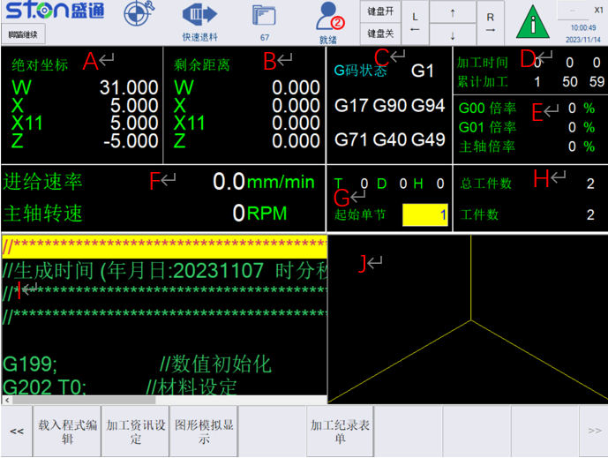
图1.13 加工监看页面
Fig. 1.13 Processing Monitoring Screen
表1.8 加工监看页面功能
Table 1.8 Processing Monitoring Screen Functions
区域  Area | 显示内容  Displayed Information
A | 显示当前坐标系下的各轴坐标，可上下翻页  Display the coordinates of each axis in the current coordinate system, and can be paged up and down.
B | 显示加工中各个运动轴向剩余移动距离，可上下翻页  Display the remaining moving distance of each moving axis during processing and can be paged up and down.
C | 显示当前加工时运行G码状态  Display the running G-code status for the current processing.
D | 显示当前加工时间、累计加工时间  Display current processing time and total processing time.
E | 显示当前加工总倍率  Display the current total processing ratio.
F | 显示当前运行合成进给倍率  Display the current total feed rate.
G | 显示当前加工运行行号  Display the current processing line number.
H | 显示当前加工件数、总件数  Display the current number of processed pieces and the total number of pieces.
I | 显示当前加工程序档  Display the current processing program file.
J | 显示当前加工档折弯刀运行轨迹  Display the bending tool running track of the current processing file.

2.9 运动方向 Direction of movement
轴向示意图：箭头指向为坐标轴正方向，见图1.14所示。
Axial diagram: The arrow shows the positive direction of the coordinate axis as shown in Fig. 1.14.

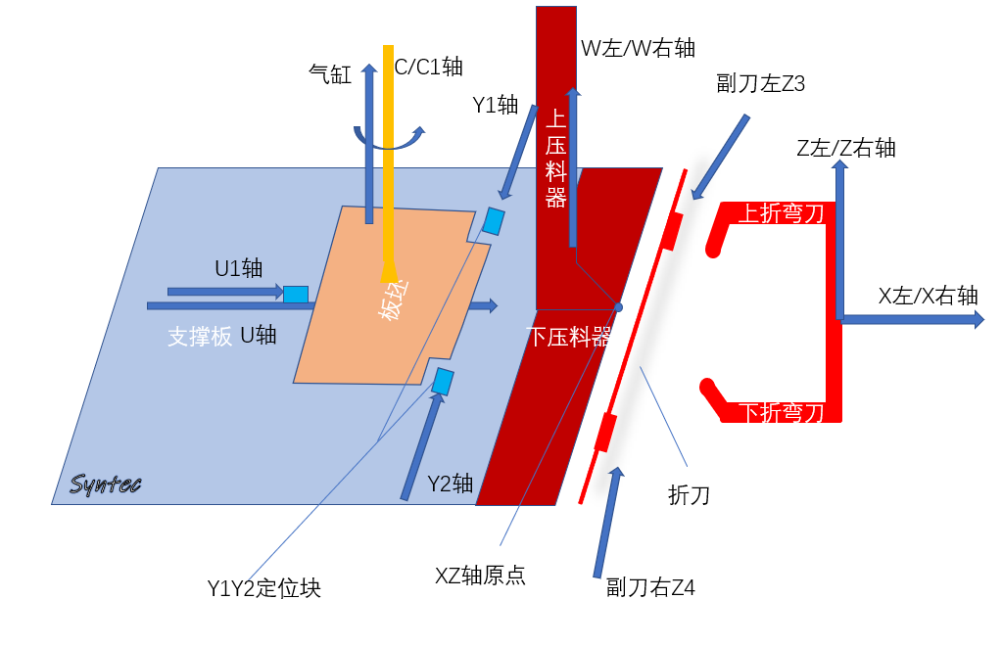
Upper bending tool
Auxiliary tool right Z4
XZ-axis origin
Y1Y2 positioning block
Bending tool
Y2-axis
Slab
X left/X right axis
Lower presser
Lower bending tool
U 轴
U-axis
支撑板
Support plate
U1轴U1-axis
Z left/Z right axis
上压料器
Upper presser
Auxiliary tool left Z3
W left/W right axis
Y1轴Y1-axis
C/C1轴C/C1-axis
气缸Cylinder

二、加工操作流程 Processing Procedures

1.1 参数设定 Parameter setting

1.1.1 加工工艺设定 Processing process setting
进入板材设定页面（图2.1所示）
Enter the plate setting screen (shown in Fig. 2.1)
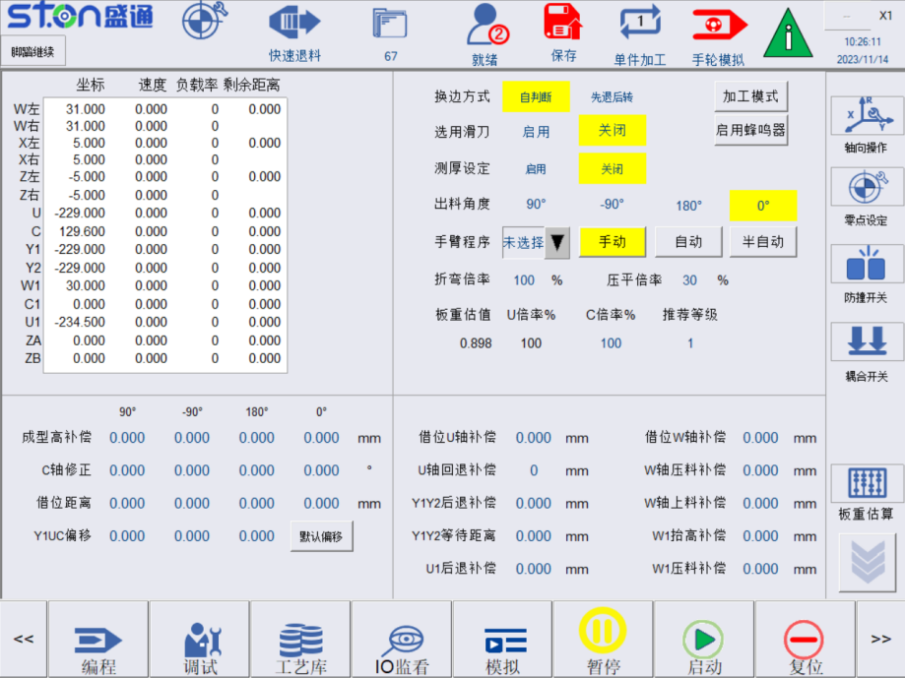
图2.1 加工参数设定页面
Fig. 2.1 Processing Parameter Setting Screen

1.1.1.1 滑刀及测厚设定：Slide tool and thickness measurement setting
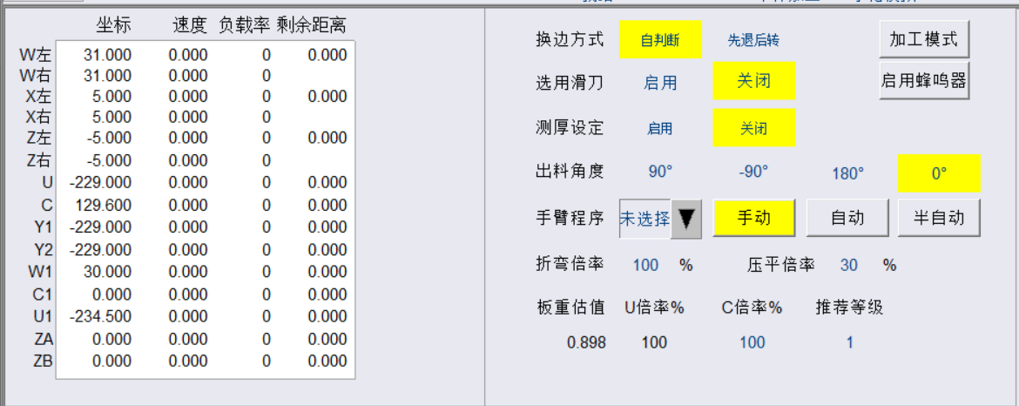
图2.2 工艺选择页面
Fig. 2.2 Process Selection Screen
当折弯需要滑刀时，可选择滑刀开启。当需要测厚是，可打开测厚设定
When slide tool is required for bending, the slide tool can be selected. When thickness measurement is required, the thickness measurement setting can be opened.

1.1.1.2 换边方式设定：Edge-changing method setting
图2.3 选择模式选择页面
Fig 2.3 Mode Selection Screen
自判断模式：执行换边动作时，自动规划板坯换边路径，推荐小板使用。
Self-judgment mode: When performing the edge changing action, the edge changing path is automatically planned and it is recommended for small plates.
先退后转模式：执行换边动作时，V轴先回退到位，C轴再旋转到位。
Retract first and then rotate mode: When performing the edge changing action, the V-axis retracts to the position first, and then the C-axis rotates to the position.1.1.1.3 定位方式：Positioning method
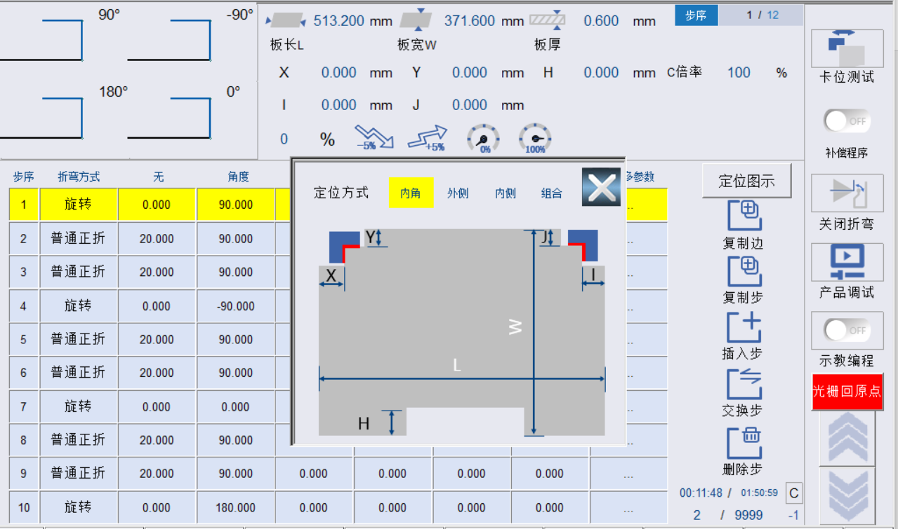
图2.4 定位方式页面
Fig. 2.4 Positioning Method Screen
定位方式选择界面（图2.5）提供4种定位方式，选择使用指定的定位面来定位板坯，并在下方红框内输入定位相关参数。
The positioning method selection screen (Fig. 2.5) provides four positioning methods. Select to use the specified positioning screen to position the slab and enter the positioning parameters in the red box below.
内角：使用“L”型定位块的内角面（如图2.6红色边线所示）去定位板坯。
Interior angle: Use the interior angle face of the "L" positioning block (as shown by the red line in Fig. 2.6) to position the slab.

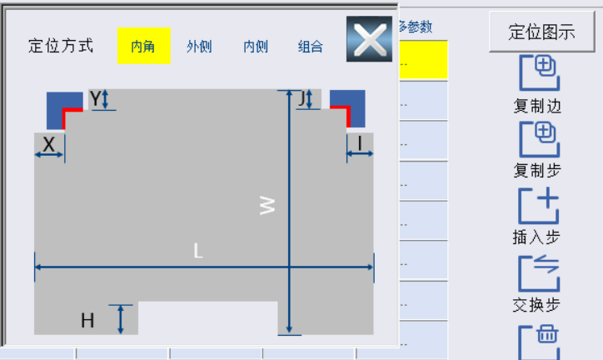
图2.5 内角定位图
Fig. 2.5 Interior Angle Positioning Diagram
外侧：使用“L”型定位块的外侧定位面（如图2.7红色边线所示）去定位板坯。
Outer side: Use the outer positioning surface of the "L" positioning block (as shown by the red line in Fig. 2.7) to position the slab.
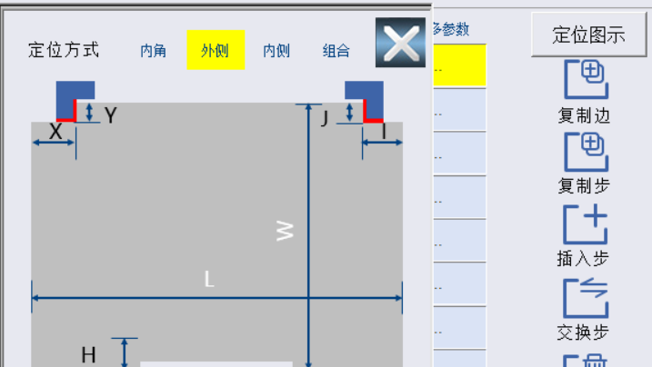
图2.6 外侧定位图
Fig. 2.6 Outer Side Positioning Diagram
内侧：使用“L”型定位块的内侧定位面（如图2.7红色边线所示）去定位板坯。
Inner side: Use the inner positioning surface of the "L" positioning block (as shown by the red line in Fig. 2.7) to position the slab.
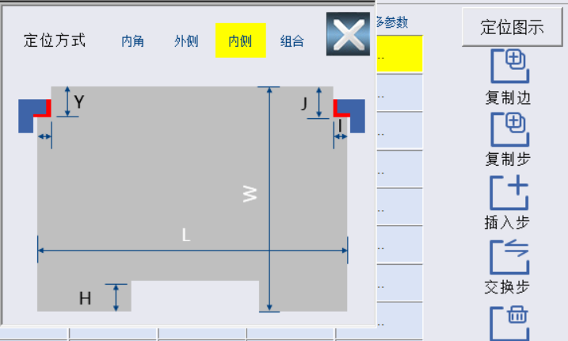
组合：使用“L”型定位块的两个侧面（如图2.7红色边线所示）去定位板坯。
Combination: Use both sides of the "L" positioning block (as shown by the red line in Fig. 2.7) to position the slab.
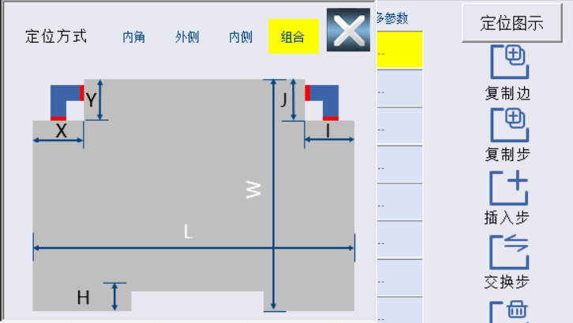
图2.8 组合定位图
Fig. 2.8 Combined Positioning Diagram

1.1.2 板材参数设定 Plate parameter setting
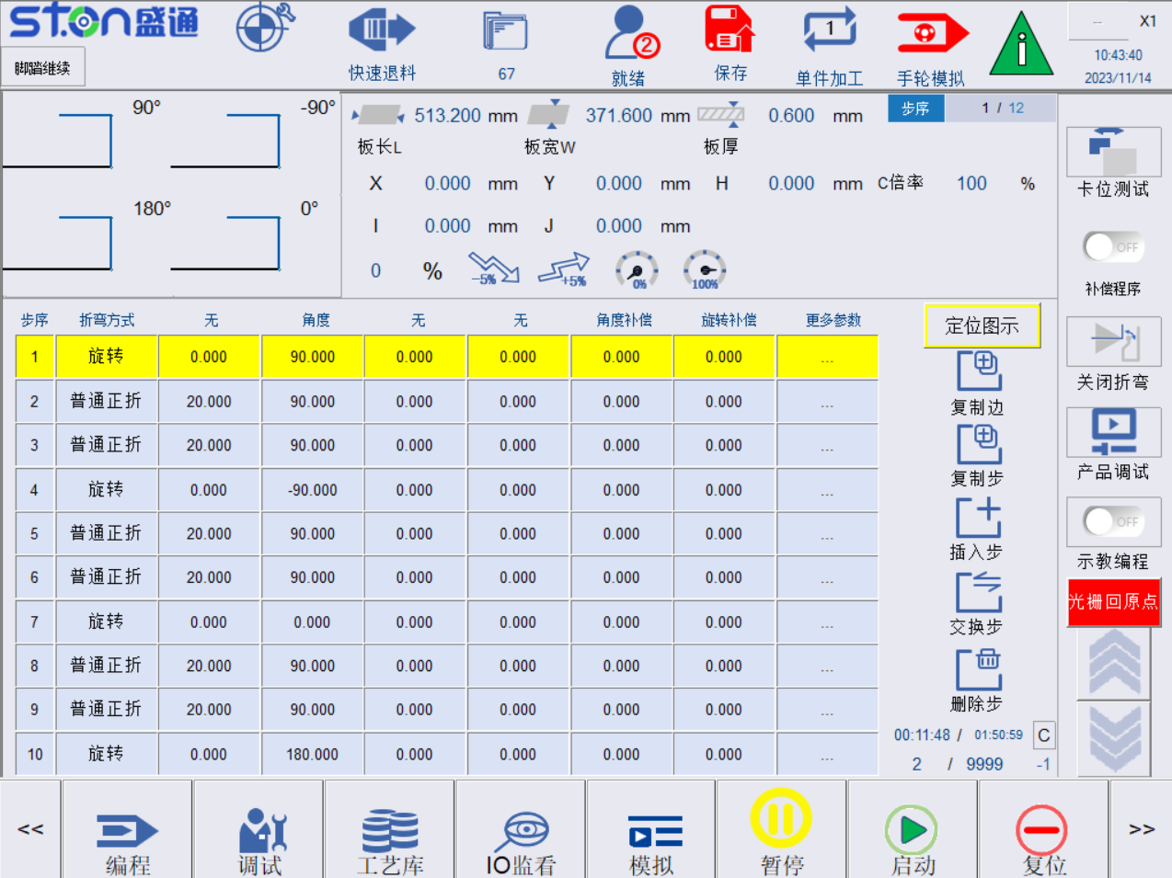
图2.9 板材参数设定
Fig. 2.9 Plate Parameter Setting

1.1.2.1 板坯尺寸 Slab dimensions
板坯厚度：Slab thickness:
测量实际待加工板坯厚度填入，冷板板厚范围是0.2~1.2mm,铝板板厚范围是0.2~2.0之间，不锈钢板厚范围是0.2~1mm之间。
Measure the actual thickness of the slab to be processed. The thickness range of the cold plate is 0.2-1.2mm, the thickness range of the aluminum plate is 0.2-2.0mm and the thickness range of the stainless steel plate is 0.2-1mm.
板坯长：Slab length:
按照板坯装料位置，参考图示测量实际板材的长度。
Measure the length of the actual plate according to the slab feeding position and the diagram.
板坯宽：Slab width:
按照板坯装料位置，参考图示测量实际板材的宽度。
Measure the width of the actual plate according to the slab feeding position and the diagram.

1.1.3 进阶参数选择 Advanced parameter selection
板材参数页面提供辅助折弯功能，可实现空心板，小尺寸板，偏心板等产品加工，提供压深补偿，旋转补偿等精度补偿参数，如图2.11所示。
The plate parameter screen provides auxiliary bending function, which can be used to process hollow plates, small-size plates and eccentric plates. It also provides accuracy compensation parameters such as depth compensation and rotation compensation as shown in Fig. 2.11.
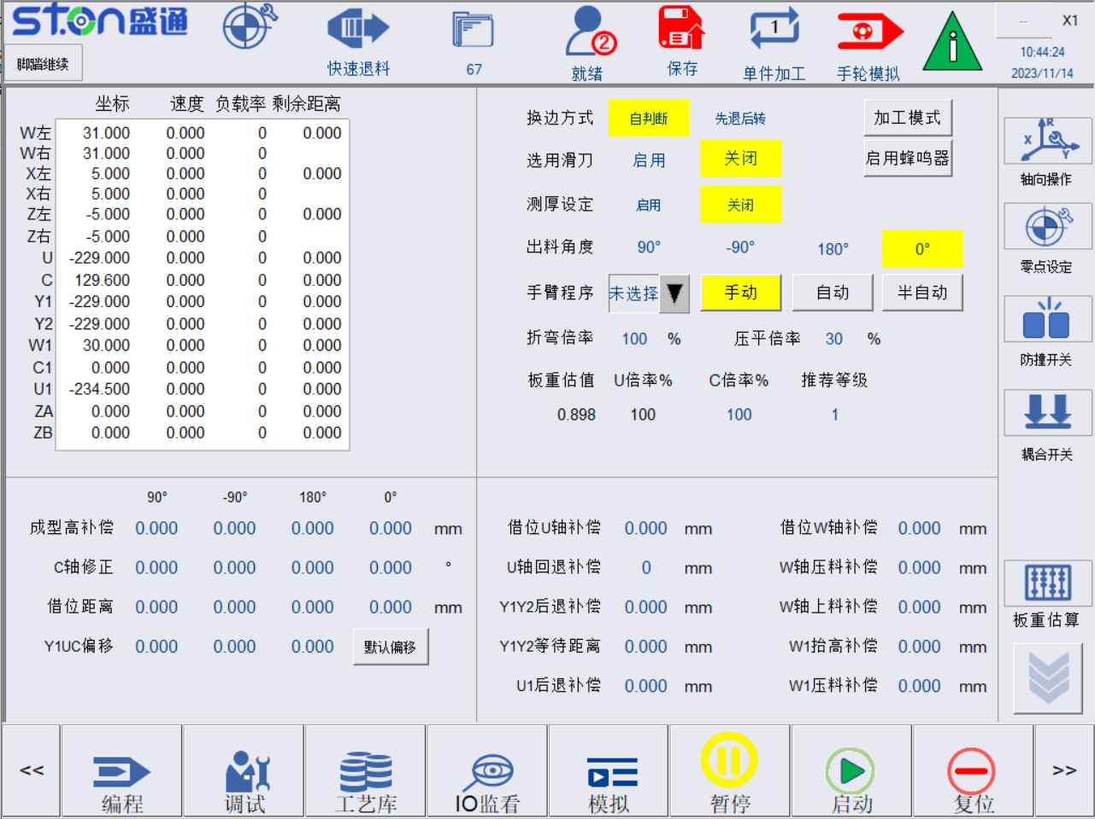
图2.10 辅助功能参数
Fig. 2.10 Auxiliary Function Parameters

1.1.3.1 成型高补偿 Forming height compensation
成型高为产品的成型高度，按下保存按钮时，控制器会根据编程自动计算成型高，换边及退料时，可通过该补偿值调整压刀抬起高度。
The forming height is the forming height of the product. When the Save button is pressed, the controller will automatically calculate the forming height according to the program. When changing edges and unfeeding materials, the lifting height of the press tool can be adjusted by using this compensation value.

1.1.3.2 C 轴修正 C-axis correction
边1_C轴修正：边1折弯时，C轴角度补偿量，可正可负。
Edge 1_C-axis correction: When edge 1 is bent, the C-axis angle compensation can be positive or negative.
边2_C轴修正：边2折弯时，C轴角度补偿量，可正可负。
Edge 2_C-axis correction: When edge 2 is bent, the C-axis angle compensation can be positive or negative.
边3_C轴修正：边3折弯时，C轴角度补偿量，可正可负。
Edge 3_C-axis correction: When edge 3 is bent, the C-axis angle compensation can be positive or negative.
边4_C轴修正：边4折弯时，C轴角度补偿量，可正可负。
Edge 4_C-axis correction: When edge 4 is bent, the C-axis angle compensation can be positive or negative.

1.1.3.3 借位距离 Borrowing distance
借位功能主要加工空心板或正常无法加工的窄板。
The borrowing function is mainly used to process hollow plates or narrow plates that cannot be processed normally.
借位距离：指定位块偏离板材中心的距离，为正值。如图2.13所示
Borrowing distance: Refer to the distance of the positioning block from the center of the plate, and it is positive as shown in Fig. 2.13

初始借位方向：默认偏向边3，可以选择偏向边4和居中

Initial borrowing direction: Toward edge 3 by default and you can select toward edge 4 or in the center.
借位U补偿：板材换边时，U轴前后运动补偿量，确保上压料器可压住板子并且不会压住已折起边。数值为正则向折弯刀方向运动，数值为负则背离折弯刀方向运动，注意该参数仅对旋转到邻边时有效。
Borrowing U compensation: During the edge changing, the U-axis moves back and forth to compensate for the amount of movement to ensure that the upper presser can press the plate without folded edge. If the value is positive, it moves in the direction of the bending tool, and if the value is negative, it moves away from the bending tool. Please note that this parameter is only valid when rotating to the adjacent edge.
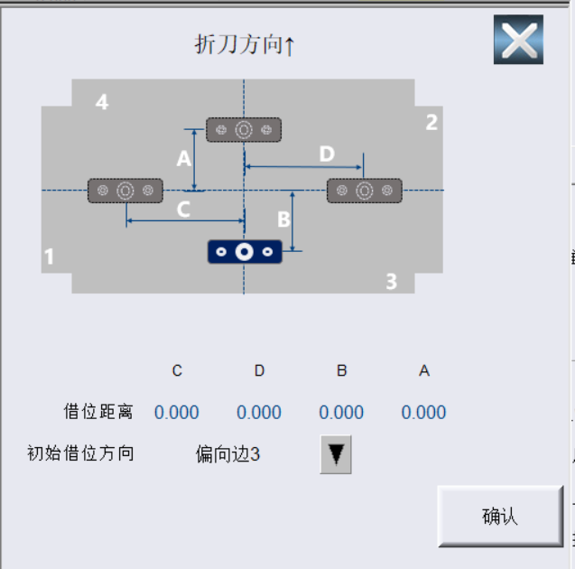
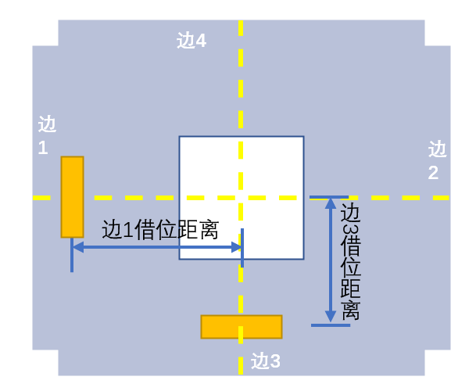
Edge 3 borrowing distance
Edge 1 borrowing distance
Edge 3
Edge 2
Edge 4
Edge 1
图2.12 借位功能示意图
Fig. 2.12 Borrowing Function Diagram

1.1.3.4 初定位偏移 Initial positioning offset
初定位偏移功能，可在定位时，将定位块、U轴、C轴进行偏移，以实现更灵活的加工状态,例如，无偏移时，U轴定位机械坐标为-800，若设置U轴偏移为20mm,则在初定位时，U轴会正方向偏移20mm，机械坐标变为-780。
The initial positioning offset function can be used to offset the positioning block, U-axis and C-axis during positioning to achieve a more flexible processing state. For example, when there is no offset, the mechanical coordinate of U-axis positioning is-800. If the U-axis offsets 20mm, the U-axis will offset by 20mm in the positive direction during initial positioning and the mechanical coordinate becomes -780.

1.1.3.5 加工模式选择 Processing mode selection
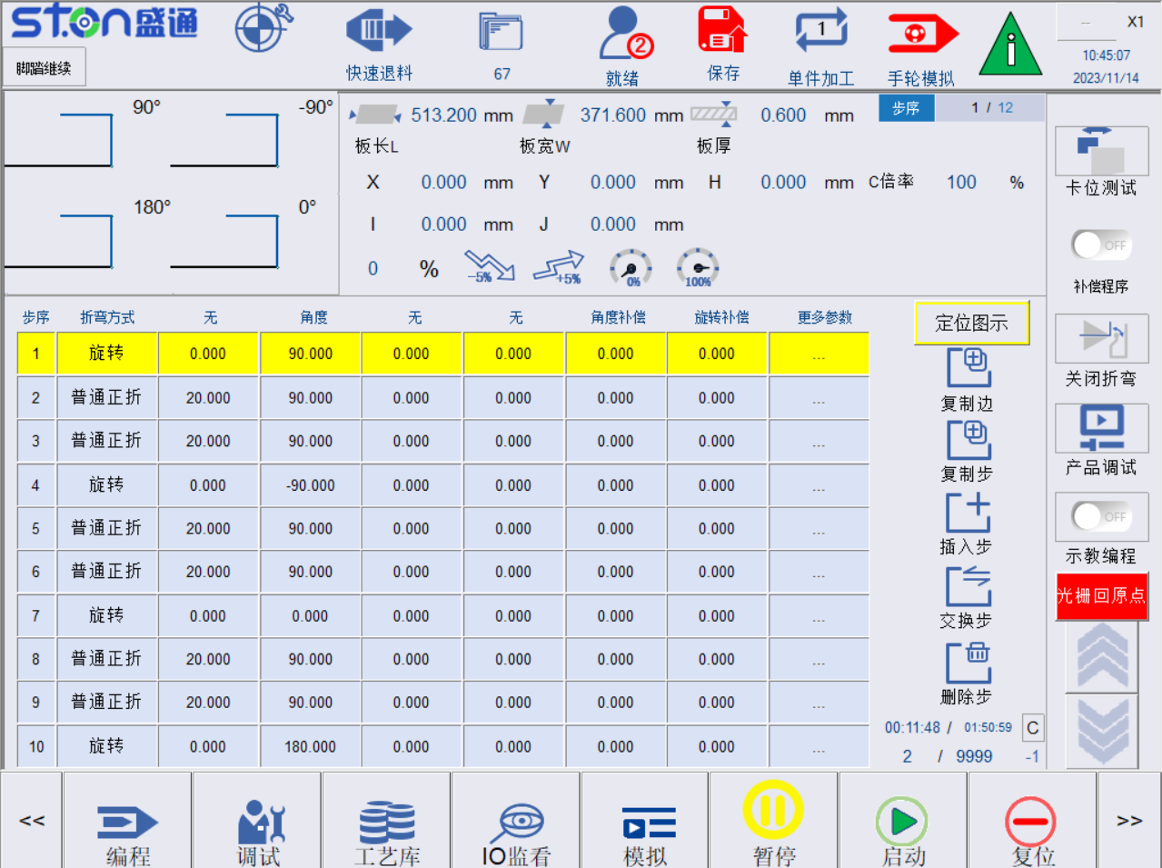

图2.13 折弯动作开启/关闭示意图
Fig. 2.13 Bending Action On/Off Diagram
执行折弯动作：可切换为屏蔽折弯动作，屏蔽折弯动作时，折弯刀不会执行折弯动作。
Perform bending action: It can be switched to shield the bending action. When shielding the bending action, the bending tool will not perform the bending action.

1.1.3.5 折弯倍率 Bending ratio
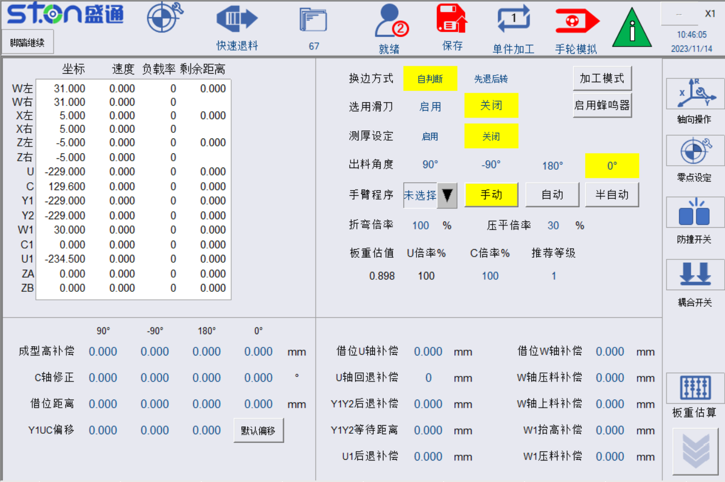
图2.14 折弯刀折弯倍率
Fig. 2.14 Bending Ratio of Bending Tool
设定折弯时，折弯刀折弯速度倍率，倍率0时默认为100%。
When bending is set, the bending speed ratio of the bending tool is 100% by default when the ratio is 0.
压平倍率：压死边时W轴压料过程的速度倍率。
Flattening ratio: The speed ratio of the W-axis pressing process when the dead edge is pressed.

1.1.3.6 光栅回原点 Grating back to origin
图2.15 拼刀计算页面
Fig. 2.15 Combined Tools Calculation Screen
系统开机时，如果是增量式光栅，点击光栅回原点按钮，让光栅回到原点后才能进行加工。
If it is an incremental grating when the system is turned on, click the grating back to origin button to let the grating return to the origin before processing.

1.1.3.7 VC等级估算（板重估算）：VC grade estimation (plate weight estimation)
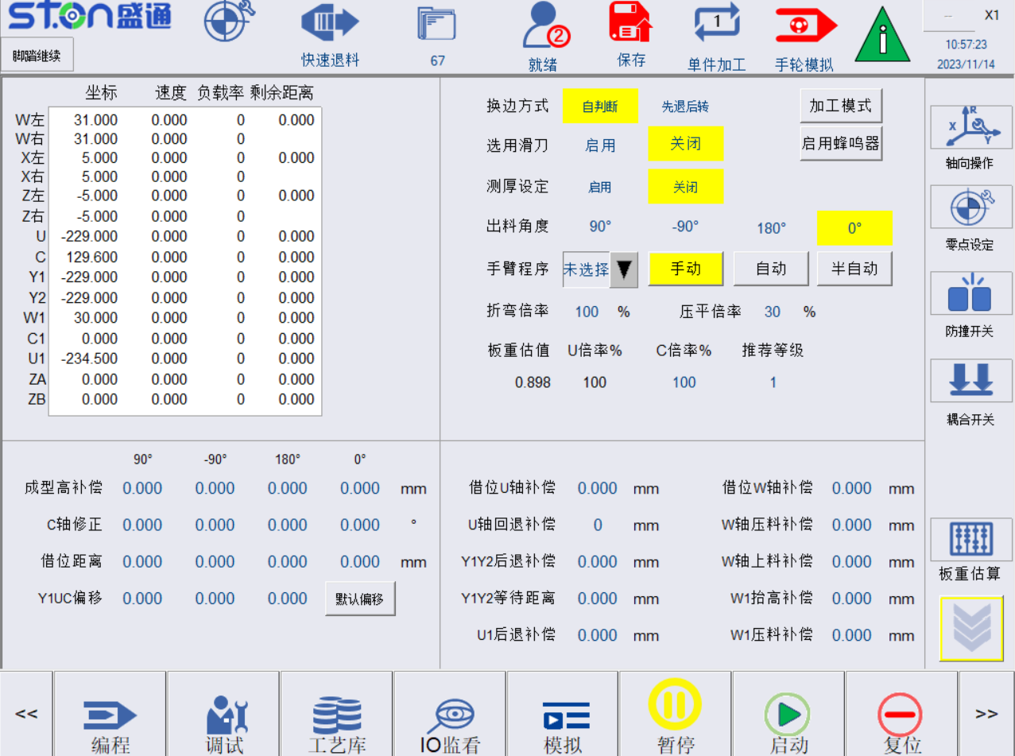
图2.16 板重估算
Fig. 2.16 Plate Weight Estimation
根据本页面上的材料、板坯厚度、板坯长度、板坯宽度初步计算板材重量，并根据参数设定页面的重量表格的等级规划，刷新当前V、C、VC轴加工倍率。
Preliminarily calculate the plate weight according to the material, slab thickness, slab length and slab width on this screen, and refresh the current V, C and VC axis processing rate according to the grade of the weight table on the parameter setting screen.
手动输入推荐等级，可切换当前加工倍率。
Manually enter the recommended grade to switch the current processing ratio.

1.2 折弯步骤 Bending steps

1.2.1 程序编辑 Program edit
在主页面，依次点击自动，可进入到折弯步骤编辑页面如图2.17所示。
On the home screen, click Auto to enter the bending step edit screen as shown in Fig. 2.17.

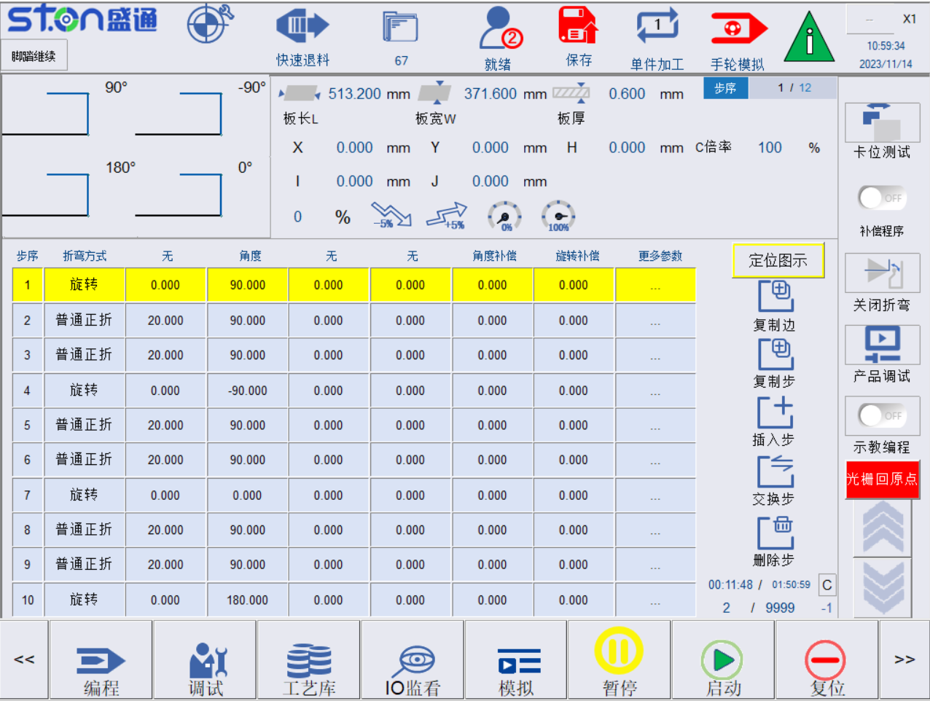
图2.17 折弯步骤编辑页面
Fig. 2.17 Bending Step Edit Screen

表2-1 折弯编程参数说明
Table 2-1 Description of Bending Programming Parameters
名称  Name | 意义及动作  Meaning and Action
次序1-次序4  Order 1-4 | 折弯先后次序，按照次序1到4的顺序进行折弯作业。  Bending order. Perform bending operations in the order 1 to 4.  如果按下次序1-次序4其中一个按钮，即可点亮当前按钮  If you press one of the buttons in order 1-4, the current button will light.
边1-边4  Edge 1- 4 | 编辑对应边1-边4的程序  Edit the program corresponding to edge 1- 4.
档案管理  File management | 可切换已保存过的产品数据  Switch the saved product data.
镜像边  Mirrored edge | 可选择边1-边4任意边数据复制到当前边  Any edge data from edge 1 to edge 4 can be selected and copied to the current edge.
插入步  Insert step | 在光标所在行下方插入一行  Insert a line below the line where the cursor is located.
删除步  Delete step | 删除光标所在行  Delete the line where the cursor is located
交换步  Exchange step | 交换指定两个边的数据  Exchange data for the specified two edges.
删除全部  Delete all | 清空当前表格的数据  Clear all data of the current table.
上页/下页  Previous/next page | 表格页面切换  Change the table page.

1.2.2 折弯工艺说明 Description of bending process
目前折弯中心可实现6种标准折弯工艺：普通正折、普通反折、圆弧正折、圆弧反折、死边正折、死边反折，以及一种自定义动作，特殊动作和保压动作。
At present, the bending center can be used to realize six standard bending processes: Ordinary forward bending, ordinary reverse bending, arc forward bending, arc reverse bending, dead edge forward bending and dead edge reverse bending, including a custom action, special action and pressure holding action.

1.2.2.1 普通_正折示意图：Ordinary forward bending diagram
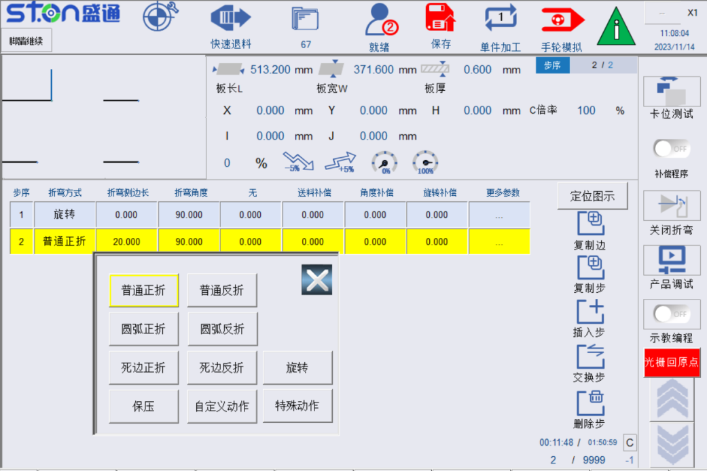

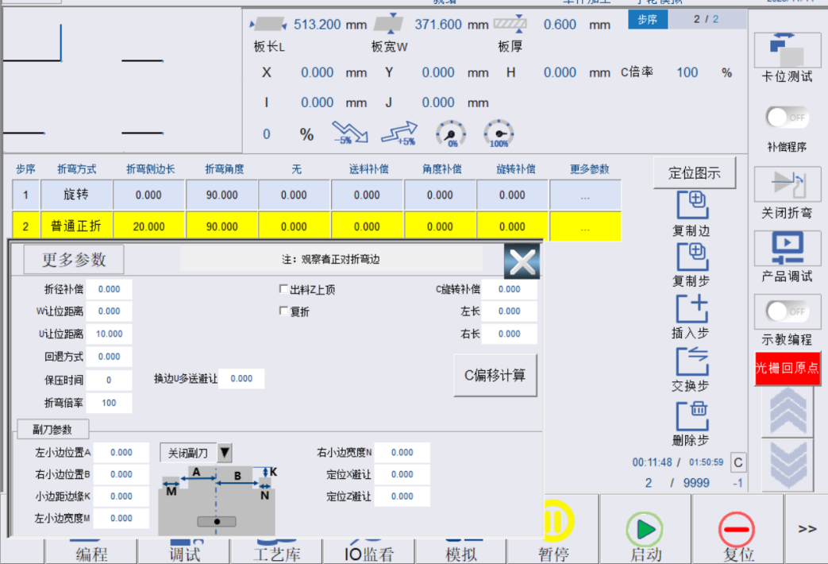
图2.18 普通正折及更多参数示意图
Fig. 2.18 Ordinary Forward Bending and Parameter Diagram
选择折弯工艺后，系统自动添加默认数值，并更新图形模拟，电机更多参数，可弹出更多参数设置框，普通正折引数说明如下：
After selecting the bending process, the system automatically adds the default value and updates the graphic simulation. For more parameters of the motor, the parameter setting box can pop up. The ordinary forward bending argument is described as follows:
折边长度：板坯折弯伸出长度。
Bending length: The extended length of the slab when it is bent.
折弯角度：当前步板材折弯角度，0°默认为90°。
Bending angle: The bending angle of the plate in the current step, 0° is 90° by default.
U让位距离：当前边折弯完成后，板材送料距离。每边中间步可不设定，每边最后一步需设定整体送料距离，方便W压料轴抬刀不干涉板材，该参数程序自动计算。
U clearance distance: The plate feeding distance after the bending of the current edge. The middle step of each edge does not need to be set and the overall feeding distance needs to be set in the last step. It is convenient for the W press shaft to lift the tool without interfering with the plate. The parameter program will automatically conduct calculation.
角度补偿：当前边设定折弯角度微补偿。
Angle compensation: Sets micro compensation for the bending angle of the current edge.
送料补偿：U轴送料单步补偿。
Feeding compensation: Single-step compensation for U-axis feeding.
折径补偿：折弯画圆弧半径补偿。
Bending radius compensation: Compensation for the radius of the bending arc.
W让位距离：W轴抬起高度补偿。
W clearance distance: W-axis lifting height compensation.
回退方式：折弯后回退（0 正常回退 1 先后退再向下）。
Retraction method: Retraction after bending (0: normal retraction, 1: retract first and then downward).
C旋转偏移：C轴单步旋转补偿。
C-axis rotation offset: C-axis single-step rotation compensation.
换边U多送避让：换边时，U轴会多送此补偿距离。
Edge change U overfeed avoidance: When changing edges, the U-axis will overfeed this compensation distance.
出料Z上顶：出料时，Z轴会上顶防止刮到板材。
Discharge Z-axis top up: When discharging, the Z-axis will top up to prevent scratching the plate.
复折：勾选后，会进行两次折弯。
Double bending: When checked, two bending actions will be performed.

1.2.2.2 普通_反折示意图：Ordinary reverse bending diagram
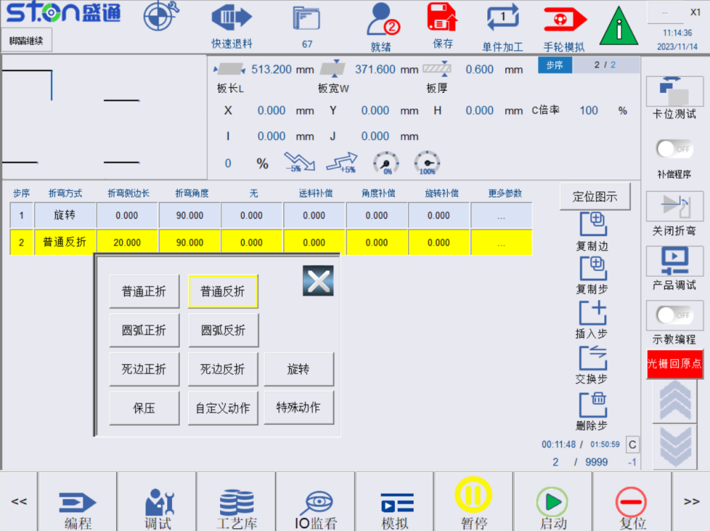

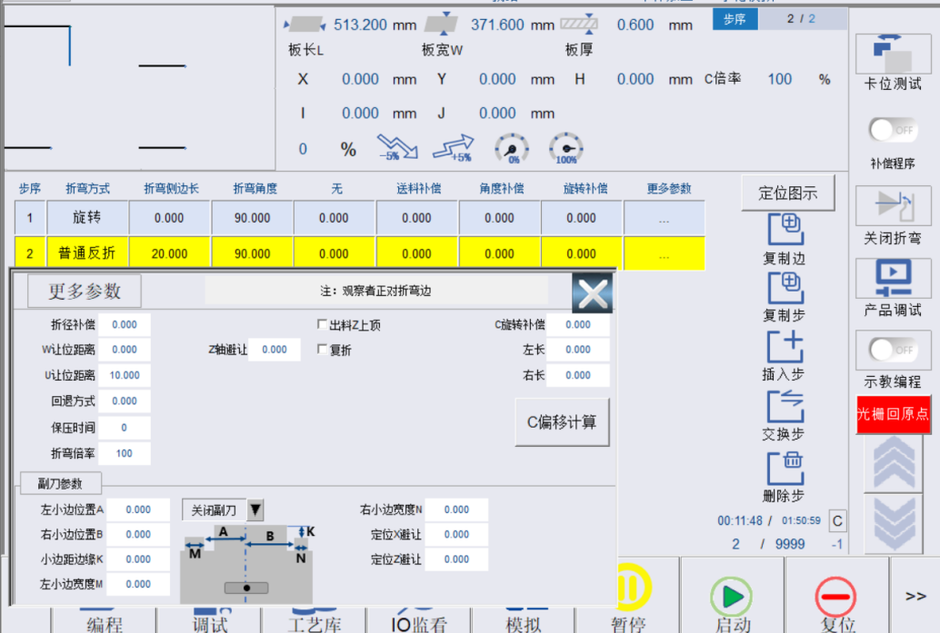
图2.19 普通负折示意图
Fig. 2.19 Ordinary Reverse Bending Diagram
折边长度：板坯折弯伸出长度。
Bending length: The extended length of the slab when it is bent.
折弯角度：当前步板材折弯角度，0°默认为90°。
Bending angle: The bending angle of the plate in the current step, 0° is 90° by default.
U让位距离：当前边折弯完成后，板材送料距离。每边中间步可不设定，每边最后一步需设定整体送料距离，方便W压料轴抬刀不干涉板材，该参数程序自动计算。
U clearance distance: The plate feeding distance after the bending of the current edge. The middle step of each edge does not need to be set and the overall feeding distance needs to be set in the last step. It is convenient for the W press shaft to lift the tool without interfering with the plate. The parameter program will automatically conduct calculation.
角度补偿：当前边设定折弯角度微补偿。
Angle compensation: Sets micro compensation for the bending angle of the current edge.
送料补偿：U轴送料单步补偿。
Feeding compensation: Single-step compensation for U-axis feeding.
折径补偿：折弯画圆弧半径补偿。
Bending radius compensation: Compensation for the radius of the bending arc.
W让位距离：W轴抬起高度补偿。
W clearance distance: W-axis lifting height compensation.
C旋转偏移：C轴单步旋转补偿。
C-axis rotation offset: C-axis single-step rotation compensation.
Z轴避让：反折后，Z轴会多避让此距离。
Z-axis avoidance: After reverse bending, the Z-axis will avoid this distance.
出料Z上顶：出料时，Z轴会上顶防止刮到板材。
Discharge Z-axis top up: When discharging, the Z-axis will top up to prevent scratching the plate.
复折：勾选后，会进行两次折弯。
Double bending: When checked, two bending actions will be performed.

1.2.2.3 圆弧_正折示意图：Arc forward bending diagram
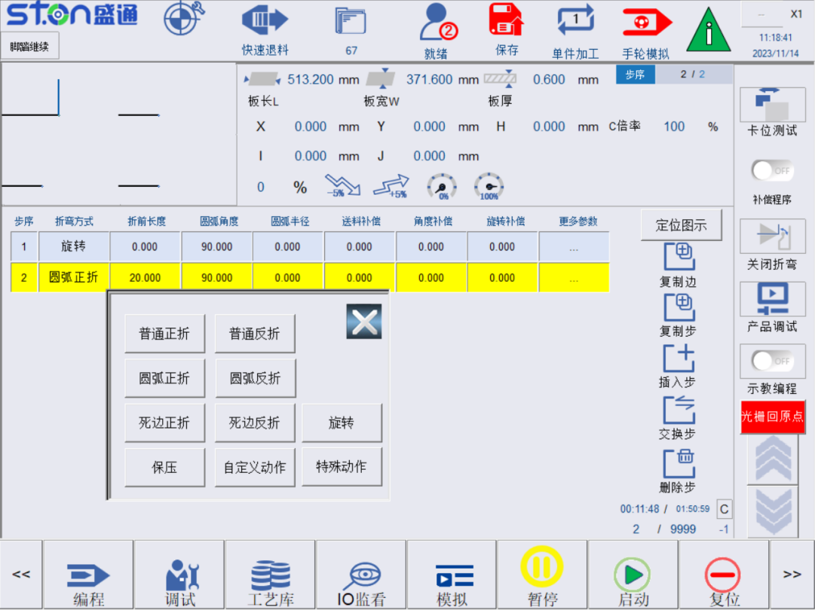
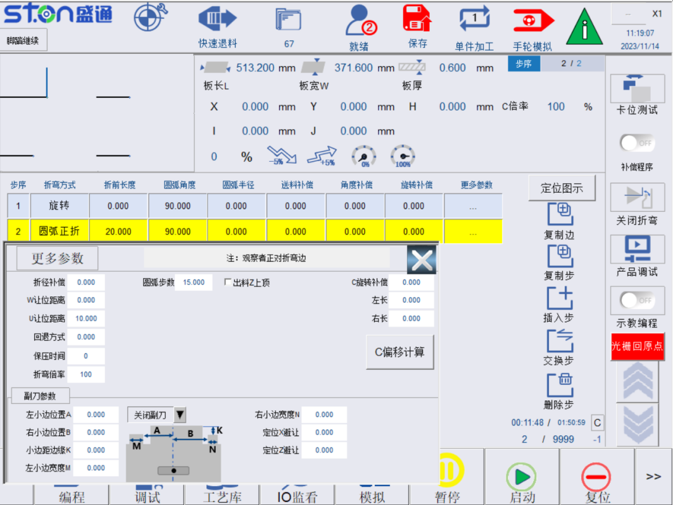
图2.20 圆弧正折示意图
Fig. 2.20 Arc Forward Bending Diagram
折边长度：板坯折弯伸出长度。
Bending length: The extended length of the slab when it is bent.
圆弧角度：圆弧折弯角度，使用范围0-360°。
Arc angle: Arc bending angle and the applicable range is 0-360°.
折弯半径：成型圆弧半径。
Bending radius: The radius of the formed arc.
折弯步数：圆弧折弯次数。如：90度圆弧折弯，30步，单步折弯角度为90/30=3°。
Bending steps: The arc bending number. For example: 90° arc bending, 30 steps and single-step bending angle is 90/30 = 3°.
让位距离：当前步折弯完成后，板材送料距离。每边中间步可不设定，每边最后一步需设定整体送料距离，方便W压料轴抬刀不干涉板材，该参数程序自动计算。
Clearance distance: The plate feeding distance after the current bending step is completed. The middle step of each edge does not need to be set and the overall feeding distance needs to be set in the last step. It is convenient for the W press shaft to lift the tool without interfering with the plate. The parameter program will automatically conduct calculation.
角度补偿：当前边设定折弯角度微补偿。
Angle compensation: Sets micro compensation for the bending angle of the current edge.
送料补偿：U轴单步送料补偿。
Feeding compensation: U-axis single-step feeding compensation.
折径补偿：折弯画圆弧半径补偿。
Bending radius compensation: Compensation for the radius of the bending arc.
W让位距离：W轴抬起高度补偿。
W clearance distance: W-axis lifting height compensation.
回退方式：折弯后回退（0 正常回退 1 先后退再向下）。
Retract method: Retraction after bending (0: normal retraction, 1: retract first and then downward).
C旋转偏移：C轴单步旋转补偿。
C-axis rotation offset: C-axis single-step rotation compensation.
出料Z上顶：出料时，Z轴会上顶防止刮到板材。
Discharge Z-axis top up: When discharging, the Z-axis will top up to prevent scratching the plate.

1.2.2.4 圆弧_反折示意图：Arc reverse bending diagram:
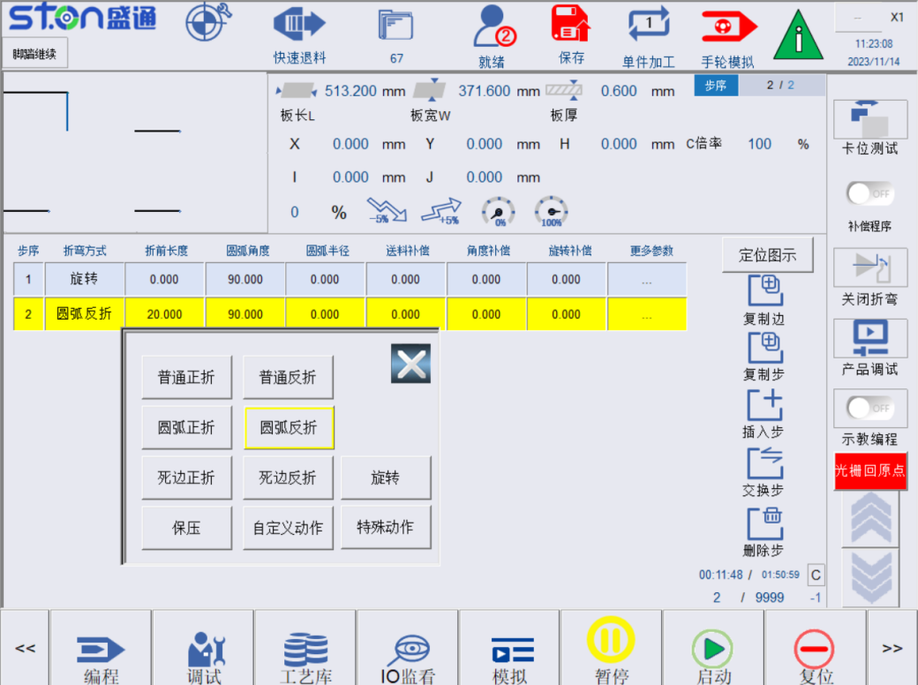
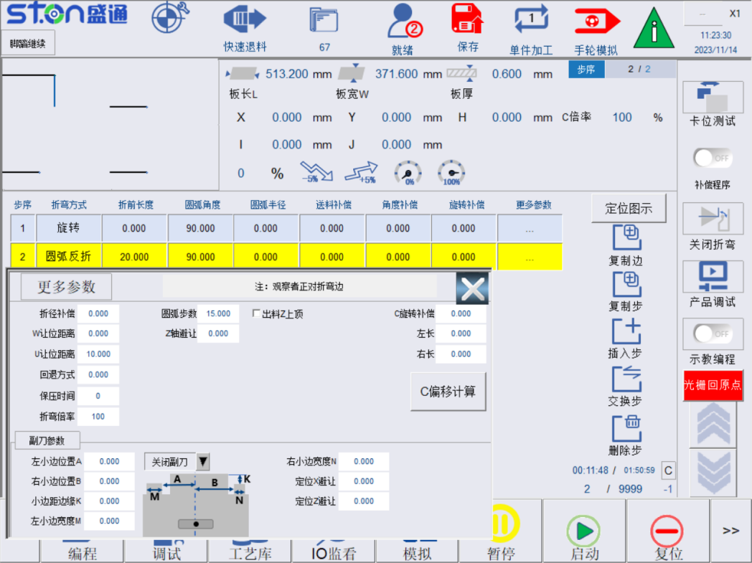
图2.21 圆弧负折示意图
Fig. 2.21 Arc Reverse Bending Diagram
折边长度：板坯折弯伸出长度。
Bending length: The extended length of the slab when it is bent.
圆弧角度：圆弧折弯角度，使用范围0-360°。
Arc angle: Arc bending angle and the applicable range is 0-360°.
折弯半径：成型圆弧半径。
Bending radius: The radius of the formed arc.
折弯步数：圆弧折弯次数。如：90度圆弧折弯，30步，单步折弯角度为90/30=3°。
Bending steps: The arc bending number. For example: 90° arc bending, 30 steps and single-step bending angle is 90/30 = 3°.
角度补偿：当前边设定折弯角度微补偿。
Angle compensation: Sets micro compensation for the bending angle of the current edge.
送料补偿：U轴单步送料补偿。
Feeding compensation: U-axis single-step feeding compensation.
折径补偿：折弯画圆弧半径补偿。
Bending radius compensation: Compensation for the radius of the bending arc.
W让位距离：W轴抬起高度补偿。
W clearance distance: W-axis lifting height compensation.
回退方式：折弯后回退（0 正常回退 1 先后退再向下）。
Retraction method: Retraction after bending (0: normal retraction, 1: retract first and then downward).
C旋转偏移：C轴单步旋转补偿。
C-axis rotation offset: C-axis single-step rotation compensation.
Z轴避让：反折后，Z轴会多避让此距离。
Z-axis avoidance: After reverse bending, the Z-axis will avoid this distance.
出料Z上顶：出料时，Z轴会上顶防止刮到板材。
Discharge Z-axis top up: When discharging, the Z-axis will top up to prevent scratching the plate.
1.2.2.5死边_正折示意图：Dead edge forward bending diagram
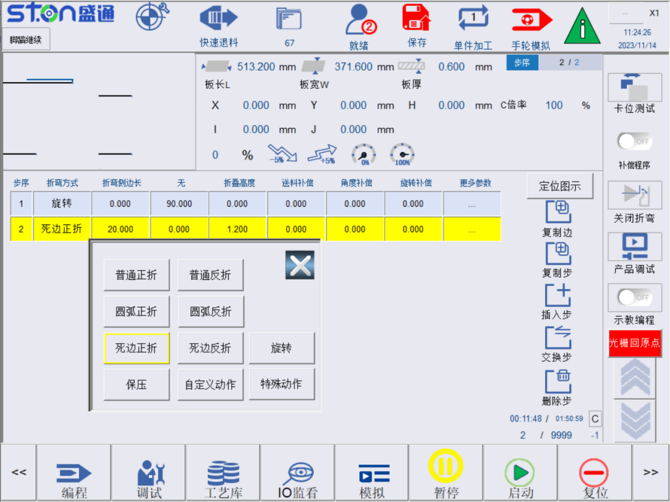
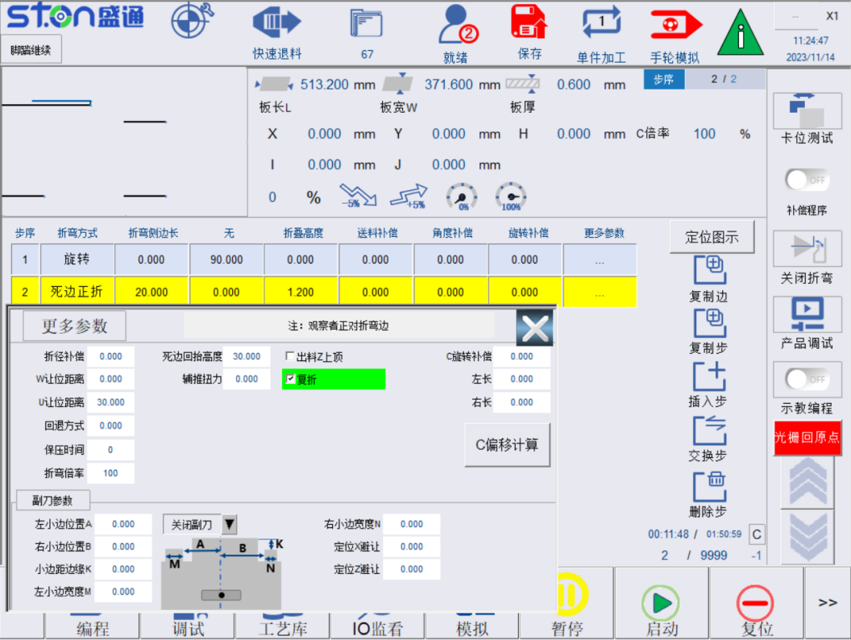
图2.22 死边正折示意图
Fig. 2.22 Dead Edge Forward Bending Diagram
折边长度：压死边伸出长度
Bending length: The extended length of the dead edge when it is pressed.
回抬高度：死边折弯默认为135°，折弯后W压料轴抬起高度
Lifting height: The default value of dead edge bending is 130° and it is the lifting height of W press shaft after bending.

折叠高度：压死边W轴压料高度，一般设定为两个板厚

Folding height: The W-axis pressing height on the dead edge, generally set to two plate thicknesses.
角度补偿：当前边设定折弯角度微补偿
Angle compensation: Micro-compensation of the bending angle of the current edge.
送料补偿：U轴单步送料补偿。
Feeding compensation: U-axis single-step feeding compensation.
折径补偿：折弯画圆弧半径补偿。
Bending radius compensation: Compensation for the radius of the bending arc.
W让位距离：W轴抬起高度补偿。
W clearance distance: W-axis lifting height compensation.
C旋转偏移：C轴单步旋转补偿。
C-axis rotation offset: C-axis single-step rotation compensation.
Z轴避让：反折后，Z轴会多避让此距离。
Z-axis avoidance: After reverse bending, the Z-axis will avoid this distance.
死边回抬高度：死边折弯时W轴抬高距离。
Dead edge lifting height: The W-axis lifting distance when the dead edge is bent.
辅推扭力：死边下压时压料轴最大限制扭力。
Auxiliary thrust torque: The maximum limiting torque of the press shaft when the dead edge is pressed.
复折：勾选后，会进行两次折弯。
Double bending: When checked, two bending actions will be performed.

死边_反折示意图 Dead edge reverse bending diagram

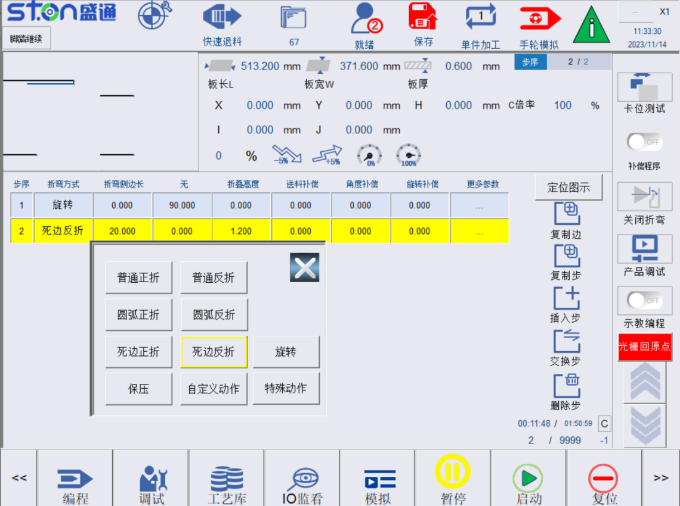

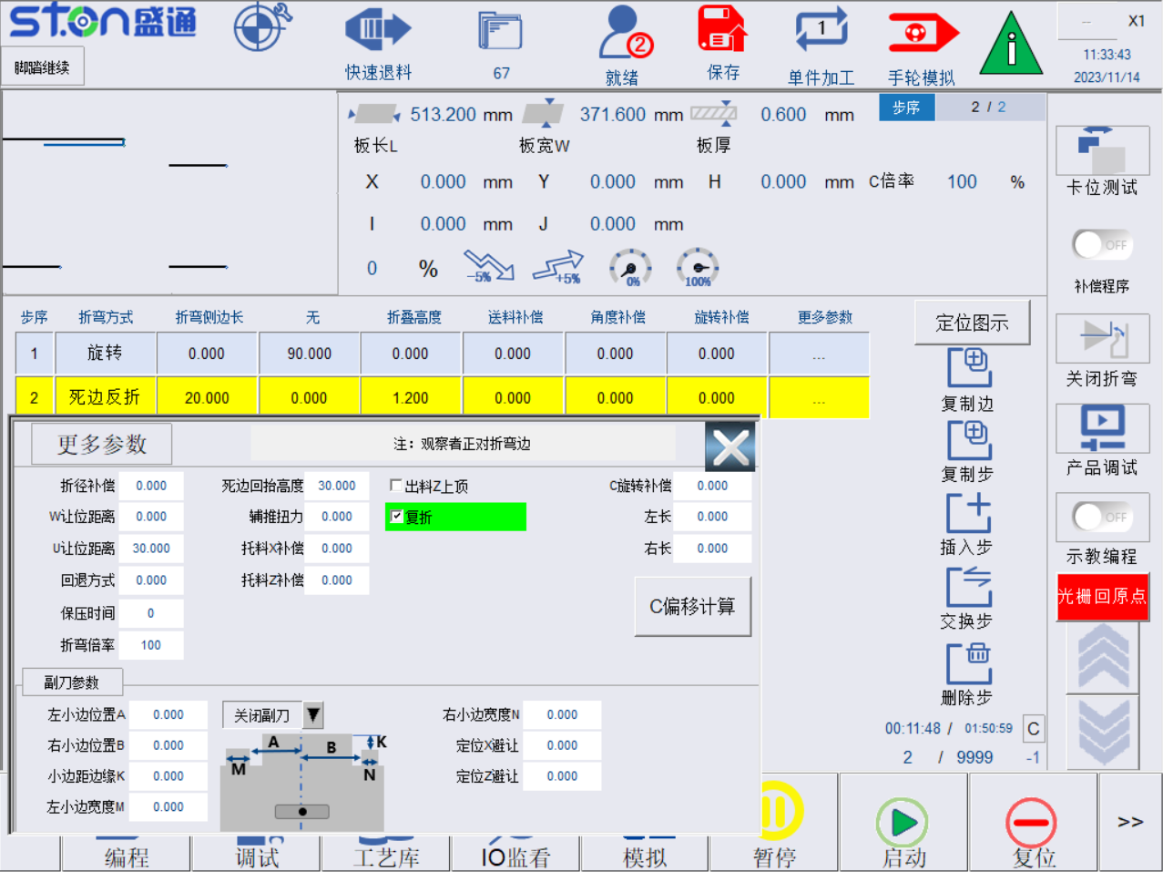
图2.23 死边反折示意图
Fig. 2.23 Dead Edge Reverse Bending Diagram

折边长度：压死边伸出长度 ，反死边托料长度

Bending length: The extended length of the dead edge when it is pressed and the material length of the dead edge.
回抬高度：死边折弯默认为135°，折弯后W压料轴抬起高度
Lifting height: The default value of dead edge bending is 130° and it is the lifting height of W press shaft after bending.
折叠高度：压死边W轴压料高度，一般设定为两个板厚
Folding height: The W-axis pressing height on the dead edge, generally set to two plate thicknesses.
角度补偿：当前边设定折弯角度微补偿。
Angle compensation: Sets micro compensation for the bending angle of the current edge.
折弯方式：0_宽度折弯，1_锋利折弯
Bending method: 0: Width bending, 1: Sharp bending
送料补偿：U轴单步送料补偿。
Feeding compensation: U-axis single-step feeding compensation.
折径补偿：折弯画圆弧半径补偿。
Bending radius compensation: Compensation for the radius of the bending arc.
W让位距离：W轴抬起高度补偿。
W clearance distance: W-axis lifting height compensation.
C旋转偏移：C轴单步旋转补偿。
C-axis rotation offset: C-axis single-step rotation compensation.
Z轴避让：反折后，Z轴会多避让此距离。
Z-axis avoidance: After reverse bending, the Z-axis will avoid this distance.
死边回抬高度：死边折弯时W轴抬高距离。
Dead edge lifting height: The W-axis lifting distance when the dead edge is bent.
辅推扭力：死边下压时压料轴最大限制扭力。
Auxiliary thrust torque: The maximum limiting torque of the press shaft when the dead edge is pressed.
复折：勾选后，会进行两次折弯。
Double bending: When checked, two bending actions will be performed.
拖料X补偿：向上顶料时X补偿。
Material X-axis compensation: X-axis compensation when pushing material upward.
拖料Z补偿：向上顶料时Z补偿。
Material Z-axis compensation: Z-axis compensation when pushing material upward.

2.2.2.7 特殊动作1示意图 Special action 1 diagram
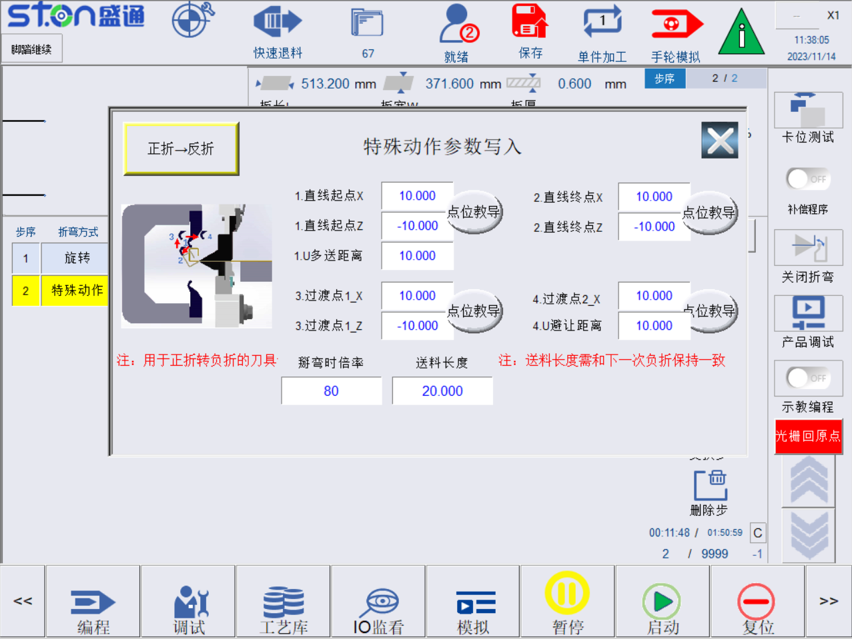

2.24 特殊动作1示意图

2.24 Special action 1 diagram

直线起点XZ：图示XZ折弯点1位置

Straight line start point XZ: The diagram shows the XZ bending point 1 position.
直线终点XZ：图示XZ折弯点2位置
Straight line end point XZ: The diagram shows the XZ bending point 2 position.
过渡点1_XZ：过渡让位点，图示XZ折弯点3位置
Transition point 1_XZ: Transition point. The diagram shows the XZ bending point 3 position.
过渡点2_XZ：过渡让位点，图示XZ折弯点3位置
Transition point 2_XZ: Transition point. The diagram shows the XZ bending point 3 position.
送料长度：下一次反/正折时，送料长度
Feeding length: The feeding length during the next reverse/forward bending.
反折→正折：可通过此按钮切换特殊动作执行方向，如上图所示
Reverse → forward bending: You can use this button to switch the execution direction of special actions as shown in the above figure.

2.2.2.8 保压功能示意图 Pressure holding function diagram
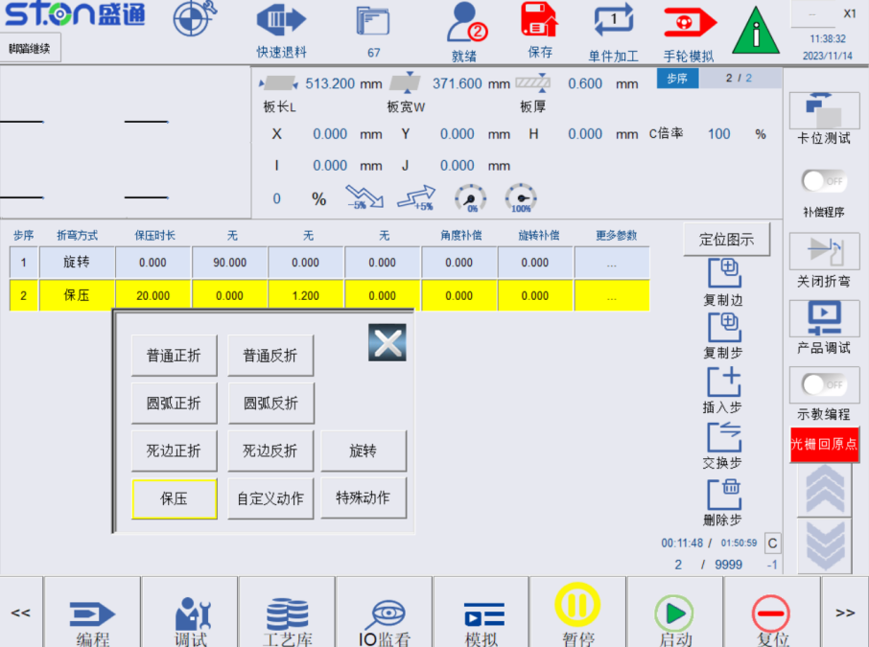
图2.25 保压功能示意图
Fig. 2.25 Pressure Holding Function Diagram
保压功能单位为毫秒，设定保压时间后，后续折弯步骤均开启保压，若要关闭保压功能，需将保压时间设置为0。
The unit of the pressure holding function is milliseconds. After setting the pressure holding time, pressure holding must start for the subsequent bending steps. To turn off the pressure holding function, set the pressure holding time to 0.

2.2.2.9 副刀功能示意图 Auxiliary tool function diagram
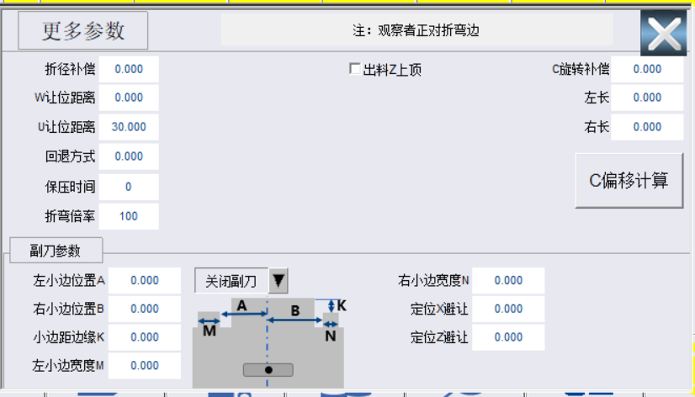
图2.26 副刀动作示意图
Fig.2.26 Auxiliary Tool Action Diagram
关闭/开启副刀：副刀动作开启关闭，开启后此编程动作会被副刀动作代替
Auxiliary tool ON/OFF: The auxiliary tool action is turned on and off, and this programmed action will be replaced by the auxiliary tool action after turning on.
左小边位置A：折弯中心线到左边板材位置边缘的距离。
Left small edge position A: The distance from the bending center line to the edge of the left plate.
左小边位置B：折弯中心线到右边板材位置边缘的距离。
Left small edge position B: The distance from the bending center line to the edge of the right plate.
左小边宽度M：副刀折弯板材的宽度。
Left small edge width M: The width of the plate bent by the auxiliary tool.
小边距边缘K：当前副刀边缘与上一刀折弯线的距离。
Small margin edge K: The distance between the current auxiliary tool edge and the bending line of the previous tool.
右小边宽度N：副刀折弯板材的宽度。
Right small edge width N: The width of the plate bent by the auxiliary tool.
定位X避让：副刀定位移动时折刀X方向避让补偿，输入正数向X正方向运动，输入负数向X负方向移动。。
Positioning X avoidance: The bending tool X direction avoidance compensation when the auxiliary tool is positioned and moved. Enter positive number to move to the X positive direction and enter negative number to move to the X negative direction.
定位Z避让：副刀定位移动时向折刀Z方向避让补偿。
Positioning Z avoidance: The bending tool Z direction avoidance compensation when the auxiliary tool is positioned and moved.

2.3 加工前的准备 Preparation before processing
1.确认检查编程参数是否保存。
Check whether the programming parameters are saved.
2.确认程序生成是否正常。
Confirm whether the program is generated normally.
3.确认手轮模拟是否打开。
Confirm whether the handwheel simulation can be enabled.
4.启动加工，摇动手动。
Start processing and turn manually.
5.机床提示上料时，按下上料确认按钮。
Press the OK button when the machine prompts feeding.
6.机械摇动手轮，空跑整个流程。
Mechanically turn the handwheel and run the entire process without load.
7.空跑确认无误后，上料后再用手轮加工一遍。
After idle run is confirmed to be correct, use the handwheel to process it again after feeding.
上料加工确认无误后，关闭手轮模拟，正常上料加工。
After confirming that the feeding and processing are correct, turn off the handwheel simulation to perform normal feeding and processing.

三、加工案例 Processing Cases

3.1 折盒子工件加工 Box folding

3.1.1 产品样式及尺寸 Product type and size
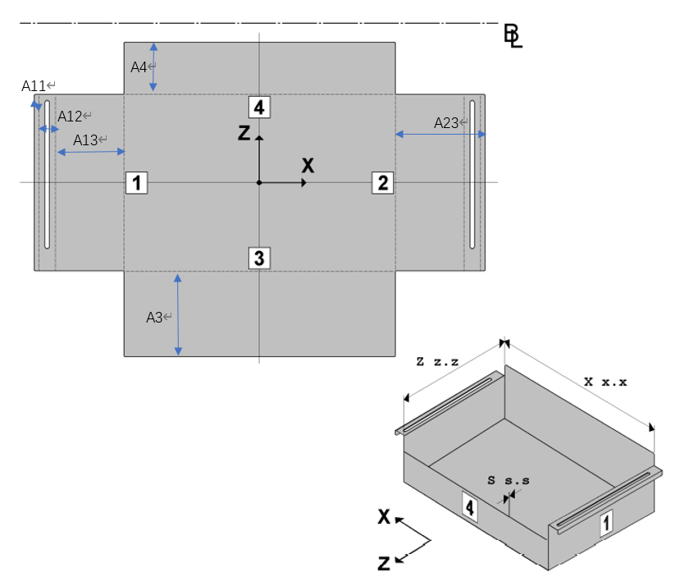
图3.1 盒子展开及成型图
Fig. 3.1 Box Unfolding and Forming Diagram
表3.1 板材尺寸 单位: mm
Table 3.1 Plate Dimensions Unit: mm
板材尺寸  Plate Dimensions | A3 | A4 | A11 | A12 | A13 | A3 | A4
800*600*1.0 | 68 | 35 | 8 | 20 | 40 | 45 | 35

3.1.2 产品工艺分解 Product process breakdown
第一边工艺依次为：普通反折、普通反折、普通正折。
The first edge is processed as follows: Ordinary reverse bending, ordinary reverse bending and ordinary forward bending.
第二边工艺依次为：普通反折、普通反折、普通正折。
The second edge is processed as follows: Ordinary reverse bending, ordinary reverse bending and ordinary positive bending.
第三边工艺依次为：普通正折。
The third edge is processed as follows: Ordinary positive bending.
第四边工艺依次为：普通正折。
The fourth edge is processed as follows: Ordinary positive bending.
以上折弯工艺的角度均为90°。
The angle of the above bending process is 90°.
折弯次序分析：Bending order analysis:
折弯中心默认上料时，正对折弯刀的边为第4边，第四边的对边为第三边，第4边左侧为第1边，右侧为第3边。
When the bending center is fed by default, the edge opposite to the bending tool is the 4th edge, the edge opposite to the 4th edge is the 3rd edge, the left side of the 4th edge is the 1st edge and the right side is the 3rd edge.
产品成型后，盒子底面为长方形，因此为方便拼刀，选取先加工短边的方式，即先加工边1和边2，再加工边4和边3。
After the product is formed, the bottom of the box is rectangular. In order to facilitate tool combination, the short edge is processed first, that is, edge 1 and edge 2 are processed first, and then edge 4 and edge 3.

3.1.3 编程设定 Programming setting
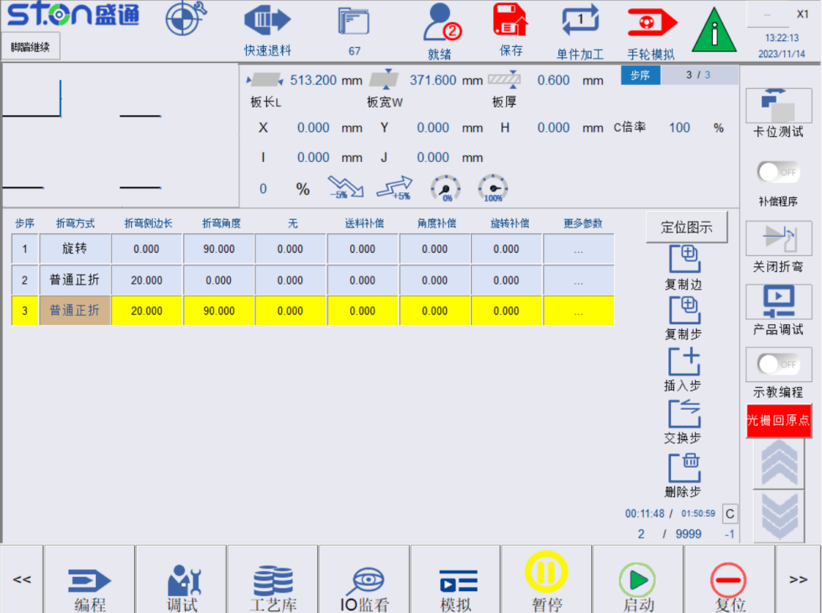
图3.2折弯步骤页面
Fig. 3.2 Bending Step Screen
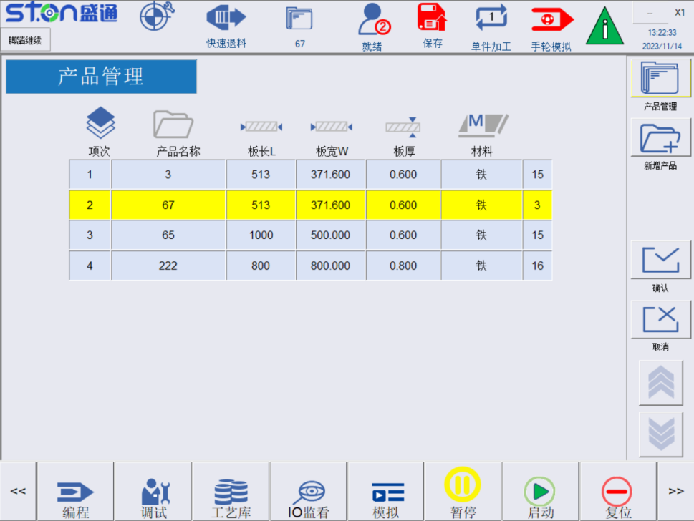
图3.3 档案管理页面
Fig. 3.3 File Management Screen
在软体主页面，点击下方按键列程式编辑->折弯步骤，切换到折弯步骤页面，如图3.2所示。
On the home screen of the software, click the Program Edit button -> Bending Steps to switch to the bending step screen as shown in Fig. 3.2.
新建产品：New product:
因为是首次折弯该产品，所以，需要新建该产品，具体操作为：点击“档案管理”图标，切换到档案管理页面，如图3.3所示，点击侧面按键“新建档案”输入档案名称如“test”，完成新建档案，设置材料，工艺等，点击按键“确定”即可完成档案的切换，并回到折弯步骤页面。
Because this product is bent for the first time, it is necessary to create a new product. The specific operation is as follows: Click the "File Management" icon to switch to the file management screen as shown in Fig. 3.3. Click the "New File" button to enter the file name such as "test" to complete the creation of new file. Set materials and process, click the "OK" button to complete the file switching and return to the bending step screen.
折弯步骤编辑：Bending step edit:
前述分析为，折弯的次序依次为：边1、边2、边4、边3，使用的是通过编程区的旋转动作来控制，旋转编程依次对应为90、-90、0、180，所以编程到对应边时，需要添加旋转步骤。
According to the aforementioned analysis, the bending order is: Edge 1, edge 2, edge 4 and edge 3, which are controlled by the rotation action of the programming area. The rotation program corresponds to 90, -90, 0 and 180 in turn. So when programming the corresponding edge, a rotation step needs to be added.
● 选择工艺旋转，设置角度为90，编辑折弯步骤，其工艺为普通反折、普通反折、普通正折，编程步骤如下，完成编程的页面见图3.4：
● Select process rotation, set the angle to 90° and edit the bending steps. The processes are ordinary reverse bending, ordinary reverse bending and ordinary forward bending. The programming steps are as follows. See Fig. 3.4 for the programming completion screen:
√ 第一折为普通反折，步骤1，折弯类型选择“普折_反”，折弯侧边长设置为A11长度，即为8mm，折弯角度设置为90度，回退方式设置为0即“折弯后原路返回”，角度补偿按需设置。
√ The first bending is ordinary reverse bending. Step 1: Select “ordinary bending _ reverse" as the bending type, set the bending side length to A11, that is, 8mm, set the bending angle to 90°, set the retreat method to 0, that is, "retreat along the original path after bending", and set the angle compensation as needed.
√ 第二折为普通反折，步骤2，折弯类型选择“普折_反”，折弯侧边长设置为A12长度，即为20mm，折弯角度设置为90度，回退方式设置为0即“折弯后原路返回”，角度补偿按需设置。
√ The second bending is ordinary reverse bending. Step 2: Select “ordinary bending _ reverse" as the bending type, set the bending side length to A12, that is, 20mm, set the bending angle to 90°, set the retreat method to 0, that is, "retreat along the original path after bending", and set the angle compensation as needed.
√ 第三折为普通正折，步骤2，折弯类型选择“普折_正”，折弯侧边长设置为A13长度，即为40mm，折弯角度设置为90度，回退方式设置为0即“折弯后原路返回”，翻边设置为0即不翻边，U让位距离为W轴抬起时，防止上压刀刮到板子时的U轴让位距离，该值自动计算，默认即可，角度补偿按需设置。
√ The third bending is ordinary forward bending. Step 2: Select “ordinary bending_forward" as the bending type, set the bending side length to A13, that is, 40mm, set the bending angle to 90°, set the retreat method to 0, that is, "retreat along the original path after bending", set the flanging to 0, that is, no flanging, and the U clearance distance is the U-axis clearance distance when the W-axis is lifted to prevent the upper press tool from scraping the plate. This value is automatically calculated and the default is acceptable. Angle compensation can be set as needed.
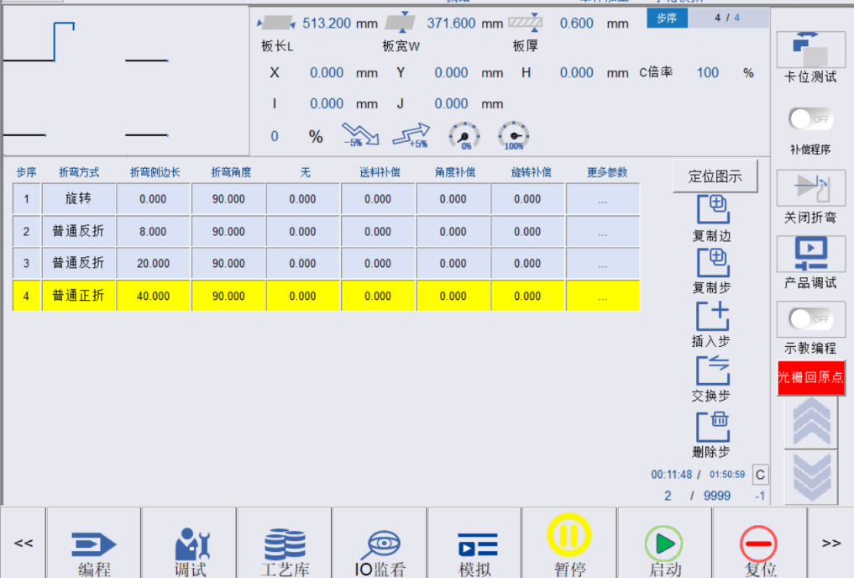
图3.4 边1编程结果
Fig. 3.4 Edge 1 Programming Results
- 选择工艺旋转，设置角度为-90，对边2进行折弯步骤编辑，次序2对应边2，其工艺为普通反折、普通反折、普通正折，编程步骤如下，完成编程的页面见图3.5：
- Select process rotation, set the angle to -90° and edit the bending step of edge 2. Order 2 corresponds to edge 2, and its processes are ordinary reverse bending, ordinary reverse bending and ordinary forward bending. The programming steps are as follows. See Fig. 3.5 for the programming completion screen:
√ 因为边2的工艺与边1完全一样，因此可采用“复制步”功能，将边1的工艺步骤复制到边2，具体操作为，复制步，弹出镜像边对话框，输入复制参考步2-4，粘贴到目标步为6，点击确定，即可复制成功。
√ Because the process of edge 2 is exactly the same as that of edge 1, you can use the “Step Copy" function to copy the process steps of edge 1 to edge 2. The specific operation is as follows: Copy the step and the mirror edge dialog box will pop up, enter “copy reference step 2-4”, paste it to the target step 6, click OK and the copy will be successful.
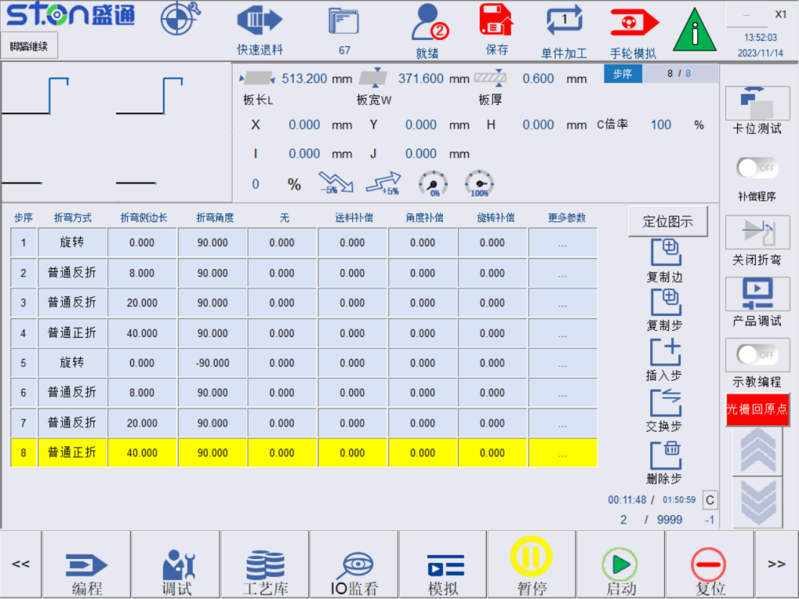
图3.5 边2编程结果
Fig. 3.5 Edge 2 Programming Results
- 选择工艺旋转，设置角度为0，对应边4，对次序3进行折弯步骤编辑，其工艺为普通正折，编程步骤如下，完成编程的页面见图3.6：
- Select process rotation, set the angle to 0° for edge 4, and edit the bending step of order 3. The process is ordinary forward bending. The programming steps are as follows. See Fig. 3.6 for the programming completion screen:
√ 第一折为普通正折，步骤1，折弯类型选择“普折_正”，折弯侧边长设置为A4长度，即为35mm，折弯角度设置为90度，回退方式设置为0即“折弯后原路返回”，翻边设置为0即不翻边，U让位距离为W轴抬起时，防止上压刀刮到板子时的U轴让位距离，该值自动计算，默认即可，角度补偿按需设置。
√ The first bending is ordinary forward bending. Step 1: Select “ordinary bending_forward" as the bending type, set the bending side length to A4, that is, 35mm, set the bending angle to 90°, set the retreat method to 0, that is, "retreat along the original path after bending", set the flanging to 0, that is, no flanging, and the U clearance distance is the U-axis clearance distance when the W-axis is lifted to prevent the upper press tool from scraping the plate. This value is automatically calculated and the default is acceptable. Angle compensation can be set as needed.
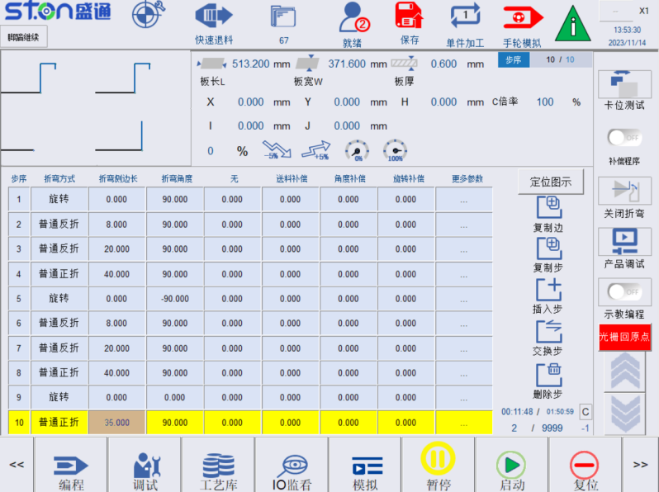
图3.6 边4编程结果
Fig. 3.6 Edge 4 Programming Results
- 选择工艺旋转，设置角度为180，对次序3进行折弯步骤编辑，次序4对应边3，其工艺为普通正折，编程步骤如下，完成编程的页面见图3.7：
- Select process rotation, set the angle to 180, edit the bending step of order 3, order 4 corresponds to edge 3, and its process is ordinary forward folding. The programming steps are as follows. See Figure 3.7 for the programming completion screen:
√ 第一折为普通正折，步骤1，折弯类型选择“普折_正”，折弯侧边长设置为A4长度，即为68mm，折弯角度设置为90度，回退方式设置为0即“折弯后原路返回”，翻边设置为0即不翻边，U让位距离为W轴抬起时，防止上压刀刮到板子时的U轴让位距离，该值自动计算，默认即可，角度补偿按需设置。
√ The first bending is ordinary forward bending. Step 1: Select “ordinary bending_forward" as the bending type, set the bending side length to A4, that is, 68mm, set the bending angle to 90°, set the retreat method to 0, that is, "retreat along the original path after bending", set the flanging to 0, that is, no flanging, and the U clearance distance is the U-axis clearance distance when the W-axis is lifted to prevent the upper press tool from scraping the plate. This value is automatically calculated and the default is acceptable. Angle compensation can be set as needed.

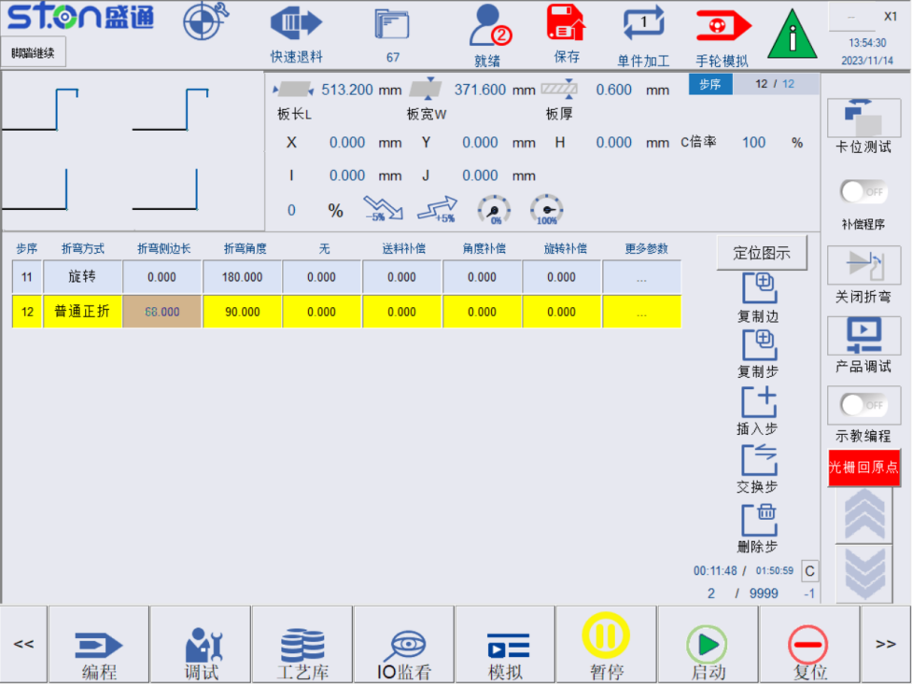
图3.7 边3编程结果
Fig. 3.7 Edge 3 Programming Results
退料边：选择折弯完成时回拉的边，建议选择次序4对应的边，这时出料角度就选择0°（若次序4对应边回退有干涉择可以选择其他边）。
Unfeed edge: Select the edge to be pulled back when bending is completed. It is recommended to select the edge corresponding to order 4. At this time, the discharge angle shall be 0° (Other edges can be selected if there is interference in the retraction of the edge corresponding to order 4).
▷ 折弯步骤编辑：Bending step edit:
编程页面，可以看到板材参数页面，如图3.8所示。
Programming screen. The following is the plate parameter screen as shown in Fig. 3.8.
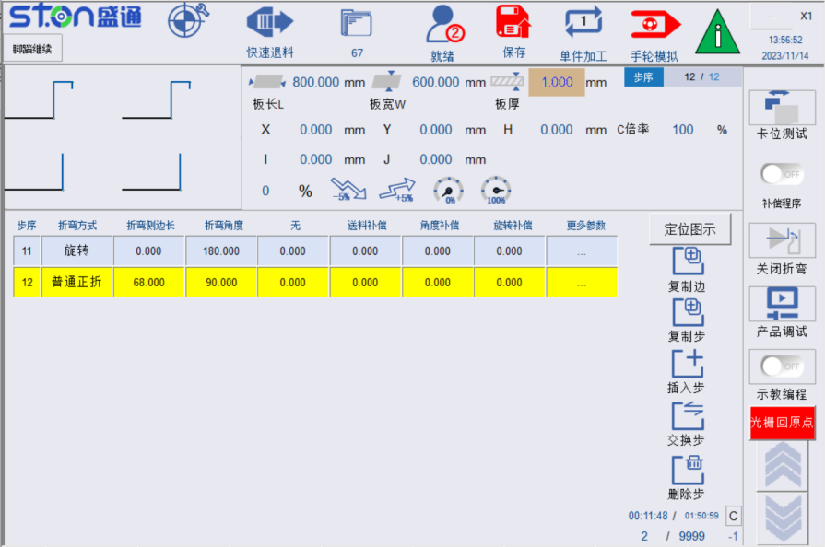
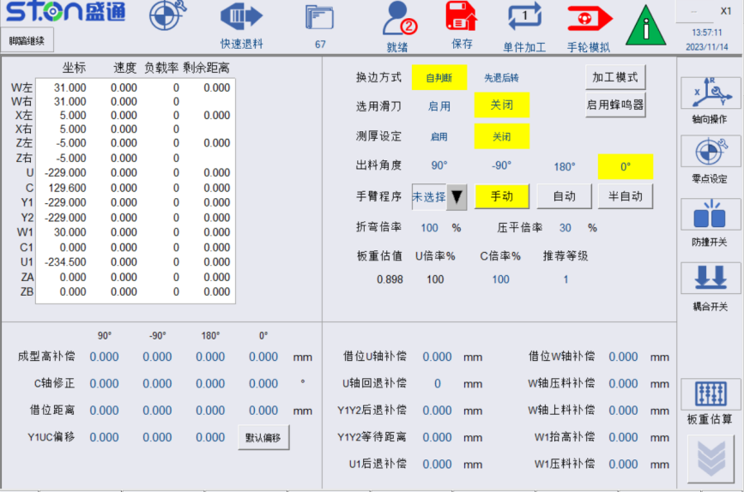

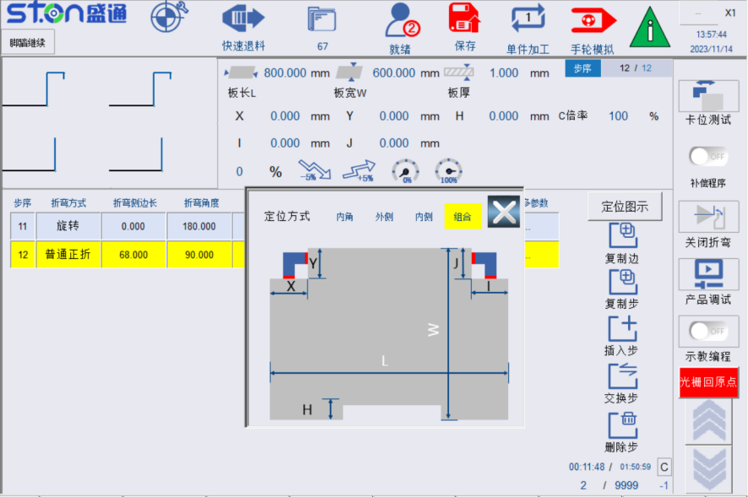
图3.8 板材参数页面
Fig. 3.8 Plate Parameter Screen
- 加工工艺设定：
- Processing process setting:
- 选择模式设定：板材换边时的路径，建议大板用先退后转模式，小板使用自判断模式。
- Selection mode setting: The path when the plate changes its edges. It is recommended to use “retract first and then rotate” mode for large plates and use “self-judgment” mode for small plates.
- 是否使用滑刀：即合页刀，当装有滑刀时，应设置为使用。
- Whether to use slide tool: It is hinged tool. When equipped with slide tool, it shall be set to use.
- 定位方式：因此板材缺角为68mm * 35mm，大于定位块40mm * 40mm的尺寸，可选用组合定位方式。
- Positioning method: The missing angle of the plate is 68mm*35mm, which is larger than the size of the positioning block 40mm*40mm. Therefore, a combined positioning method can be selected.
- 板材参数：
- Plate parameters:
- 输入板材长，宽，板厚：800mm * 600mm * 1.0mm。
- Enter plate length, width and thickness: 800mm * 600mm * 1.0mm.
- 根据图示，确认并输入X、I、Y、J的数值。
- Confirm and enter the values for X, I, Y and J according to the diagram.
- 点击板重计算，计算初步的C轴旋转倍率。
- Click Plate Weight Calculation to calculate the preliminary C-axis rotation ratio.
- 输入折弯倍率。
- Enter the bending ratio.
- 点击保存，提示程序生成成功，则编辑OK。
- Click Save to prompt that the program is successfully generated and then click OK.

副刀动作编辑 Auxiliary tool movement edit
- 副刀动作设定：
- Auxiliary tool action setting:
- 更多参数里面，选择副刀开启，当前折弯动作就会被副刀动作代替。
- In the more parameters, select the auxiliary tool ON and the current bending action will be replaced by the auxiliary tool action.
- 输入左小边和右小边位置，分别为200,300。指的是副刀折弯板材需要距压爪中心的位置。
- Enter the left and right small edge positions respectively, i.e. 200 and 300. It refers to the position where the auxiliary tool is away from the center of the press claw when bending the plate.
- 输入小边距边缘K为100，指的是副刀距板材边缘位置
- Enter the small margin edge K as 100, which refers to the position of the auxiliary tool from the edge of the plate.
- 左小边宽度右小边宽度输入300,200，指的是需要副刀折弯的板材的宽度。
- Enter the left edge width and right edge width, i.e. 300 and 200. It refers to the width of the plate to be bent by the auxiliary tool.
- 定位X/Z避让：定位时X/Z轴避让的补偿。
- Positioning X/Z avoidance: Compensation for X/Z axis avoidance during positioning.
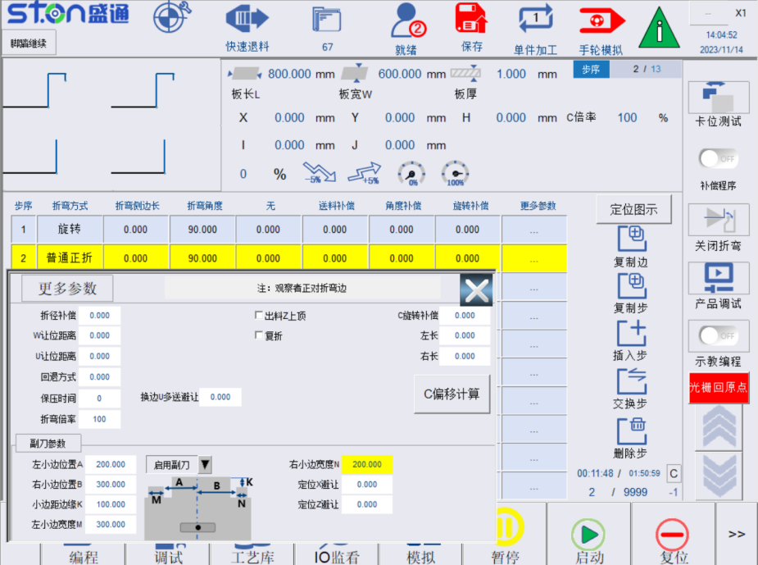
图3.9 副刀参数页面
Fig. 3.9 Auxiliary Tool Parameter Screen

3.1.5 试加工及精度补偿 Test processing and accuracy compensation
完成的编程后，可上板进行试加工，试加工时请开启手轮模拟功能，该功能开启后，使用者摇动手轮时，各个轴向才会依据折弯程序依次动作，执行加工。
After the programming is completed, you can feed the plate for test processing. Please enable the handwheel simulation function during test processing. After this function is enabled, when the user turns the handwheel, each axial direction will act in turn according to the bending program to carry out processing.
不折弯试加工：此过程为了检查送料是否到位，W1轴和W轴是否能压住板，及拼刀是否正确等，具体操作为，在板材参数页面点击按钮“执行折弯动作”，点击后变为红色背景的“屏蔽折弯动作”。
Test processing without bending: This process is to check whether the feeding is in place, whether the W1-axis and W-axis can press the plate and whether the tool combination is correct. The specific operations are as follows: Click the "Bending Action" button on the plate parameter screen and then it changes to "Shield Bending Action" with a red background.
在试折过程中，若发现，送料距离与实际不符，可通过在“折弯步骤”页面修改折弯侧边长，或更多参数内的送料补偿来修改实际送料距离，如图3.10所示。
During the test bending, if it is found that the feeding distance is inconsistent with the actual feeding distance, the actual feeding distance can be modified by modifying the bending side length on the "Bending Step" screen or by adding more parameters for feeding compensation as shown in Fig. 3.10.

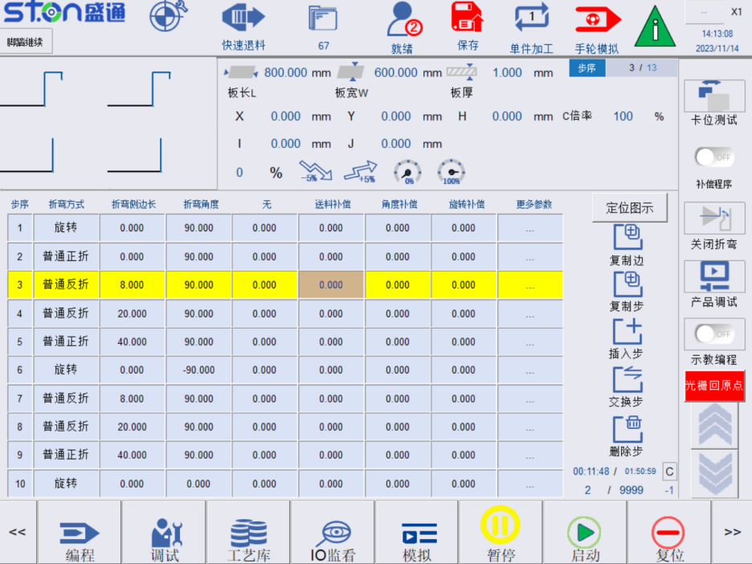
图3.10 送料补偿页面
Fig. 3.10 Feeding Compensation Screen
折弯试加工：此过程为了再次检查送料是否到位，W1轴和W轴是否能压住板，折弯角度是否正确及选择角度是否到位等，具体操作为，启用折弯动作，开启手轮模拟即可。
Test bending: This process is to check again whether the feeding is in place, whether the W1-axis and W-axis can press the plate, whether the bending angle is correct and whether the selected angle is in place. The specific operation is to enable the bending action and start the handwheel simulation.
若折弯角度不准确，例如折90度，实际角度为85度，则在编程页面指定步骤的角度补偿输入5，再次保存加工即可。
If the bending angle is inaccurate, for example, 90°, and the actual angle is 85°, enter 5 for the angle compensation of the specified step on the programming screen and save again.
若量测折起边，量测长度不相等，如边2，目标值为10mm，量测出左侧边为9.8mm，右侧边为10.3mm，则可通过板材参数页面的C轴修正进行旋转补偿，在板材参数页面，点击“C轴修正”弹出补偿弹窗，如图3.11所示，在对应边的输入框内输入9.8和10.3，点击确认即可完成C轴角度补偿，再次保存加工即可。
If the measured lengths of the bent edges are not equal, for example, for edge 2, the target value is 10mm, the measured left edge is 9.8mm, and the right edge is 10.3mm, then rotation compensation can be performed through the C-axis correction on the plate parameter screen. On the plate parameter screen, click "C-axis Correction" to pop up the compensation pop-up window as shown in Fig. 3.11. Enter 9.8 and 10.3 in the input box of the corresponding edge, click OK to complete the C-axis angle compensation and save again.

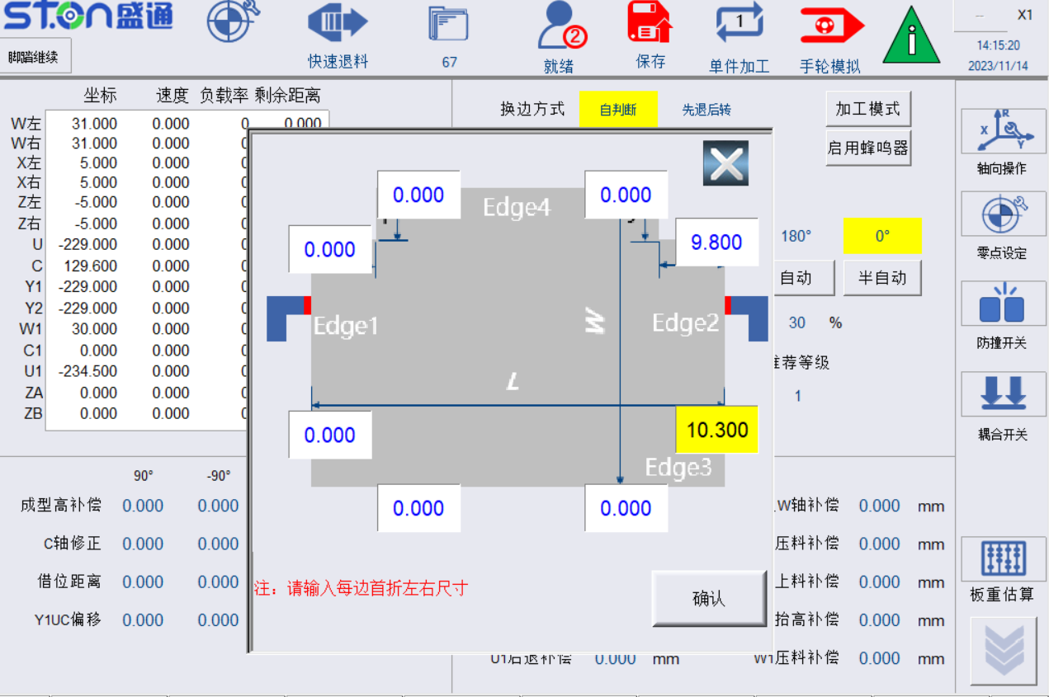
图3.11 C轴修正页面
Fig. 3.11 C-axis Correction Screen

3.2 偏心工件加工 Processing of eccentric workpiece

3.2.1 产品样式及尺寸 Product type and size
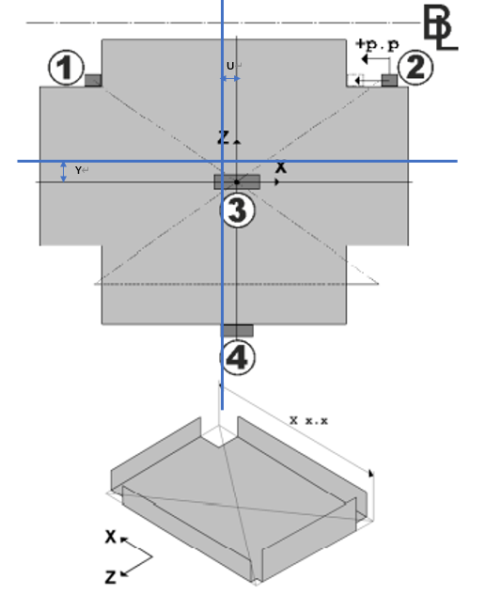
图3.12 偏心产品
Fig. 3.12 Eccentric Product

3.2.2 产品工艺分解 Product process breakdown
该板材特征为展开图中心与成型件中心不重合，或要求压杆（吸盘）夹在成型件的中心，而非板材中心，此时需要开启偏移Y1UC轴偏移功能。
The characteristic of this plate is that the center of the unfolded view does not coincide with the center of the formed part, or the press rod (chuck) is required to be clamped in the center of the formed part instead of the center of the plate. In this case, the Y1UC axis offset function needs to be enabled.
其他工艺分析请参考3.1.2。
Please refer to 3.1.2 for other process analysis.

3.2.3 编程设定 Programming setting
- 程序编辑请参考3.1.3
Please refer to 3.1.3 for program editing
- 板材参数设定
Plate parameter setting
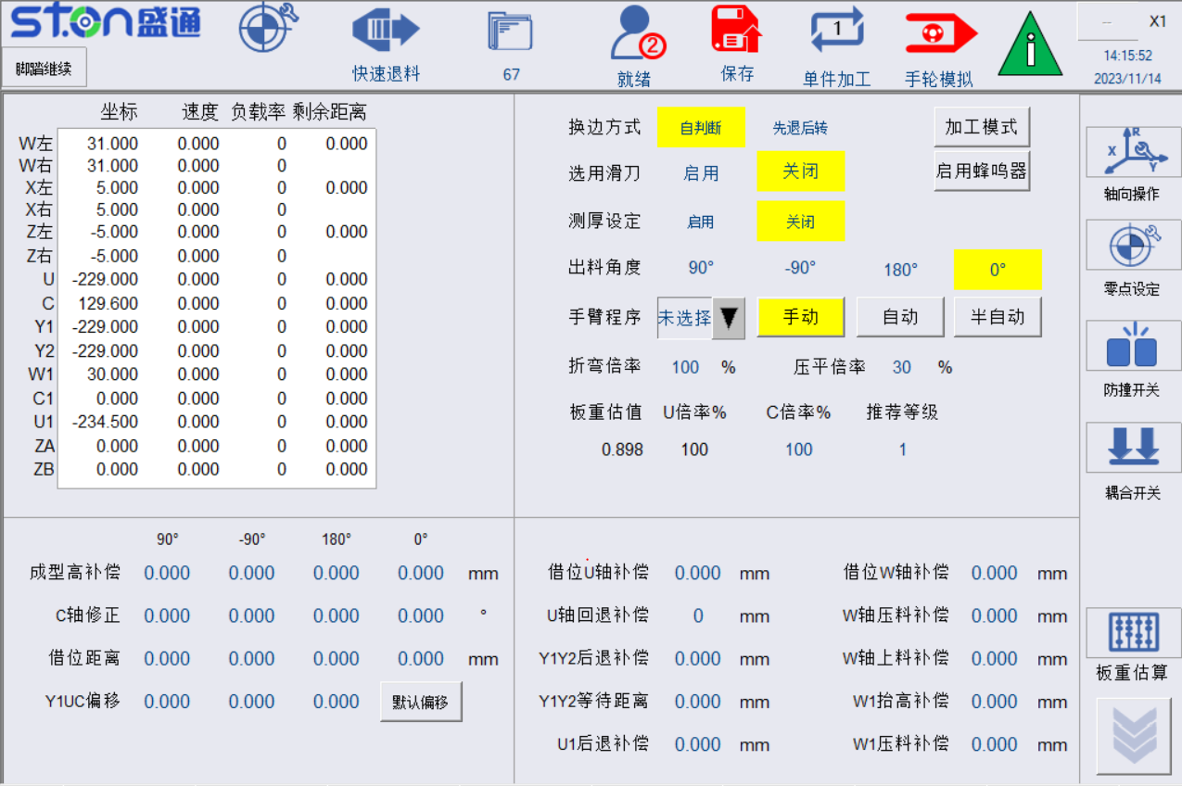
图3.13 初定位偏移功能
Fig. 3.13 Initial Positioning Offset Function
  - 测量压料位置和板材旋转中心的尺寸Y1、U
  - Measure the dimensions Y1 and U of the pressing position and the center of rotation of the plate.
  - 将Y1、U写入到定位中心偏移中，如上图所示
  - Write Y1 and U into the positioning center offset as shown in the figure above.
  - 点击保存后，提示程序生成成功后OK
  - It prompts that the program is successfully generated after saving and click OK.

3.3 空心板及小尺寸工件 Hollow plate and small-size workpiece

3.3.1 产品样式及尺寸 Product type and size
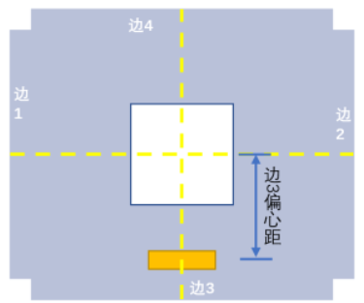
Edge 3 eccentricity
Edge 3
Edge 2
Edge 4
Edge 1
图3.14 中空板
Fig. 3.14 Hollow Plate

3.3.2 产品工艺分解 Product process breakdown
  - 请参考3.1.2
Please refer to 3.1. 2

3.3.3 编程设定 Programming setting
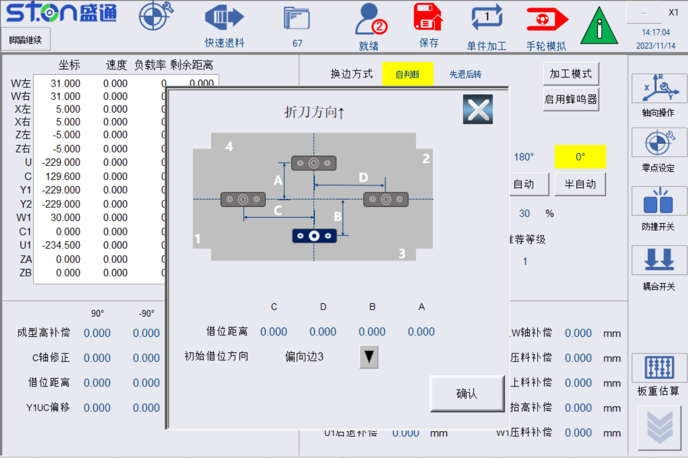
图3.15 借位功能
Fig. 3.15 Borrowing Function
  - 程序编辑请参考3.1.3
  - Please refer to 3.1. 3 for program editing.
  - 板材参数设定：记录边1和边4折弯时压料的位置距离板材中心的距离，如图3.14板材所示。
  - Plate parameter setting: Record the distance between the pressing position and the center of plate when edges 1 and 4 are bent as shown in Fig. 3.14.
  - 点击保存，提示程序保存成功后，使用手轮模拟试跑。
  - Click Save. After the program is successfully saved, use the handwheel to simulate the test run.
√ 在临边旋转时，观察在对角线位置时（如：45°）压料器是否可以压住板材，如不能压住板材，可修改借位U补偿，调整借位时U轴位置。
√ When rotating near the edge, observe whether the presser can press the plate at the diagonal position (e.g. 45°). If it cannot press the plate, you can modify the borrowing U compensation and adjust the U-axis position when borrowing.
√ 观察换边时W轴抬起高度，若W轴抬起后旋转板材任会和上压料器干涉，可通过调整借位W回抬补偿来修改借位时W位置。
√ Observe the W-axis lifting height during edge changing. If the rotating plate interferes with the upper presser after the W-axis is lifted, you can modify the W position when borrowing by adjusting the W lifting compensation.

设备的润滑及保养 Lubrication and maintenance of equipment

1、润滑系统 Lubrication System
设备有两套润滑系统。一套自动润滑系统负责X、Y、Z、W、U轴丝杆、滑动导轨的润滑。该润滑系统由润滑泵、稀油滤油器、定量加压式计量件、管路连接件和管路组成。润滑油的供给有计算机系统控制润滑泵自动、间歇的执行。如下图所示，请严格按照供油一览表的要求操作，并观察油泵里的润滑油液位，以免因缺少润滑造成对设备不可逆的损坏。
This equipment has two sets of lubrication systems. An automatic lubrication system is responsible for the lubrication of the screw rods and slide guides of X, Y, Z, W, and U axes. The lubrication system consists of lubrication pump, thin oil filter, quantitative pressurized meter, pipeline connectors and pipes. The lubrication pump is controlled by the computer to automatically and intermittently supply the lubricating oil. As shown in the figure below, please strictly follow the requirements of the oil supply schedule and observe the oil level in the oil pump to avoid irreversible damage to the equipment due to lack of lubricating oil.
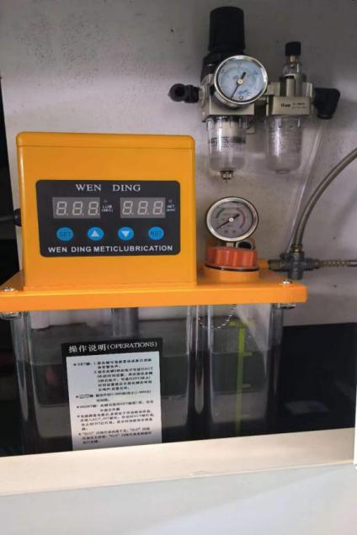
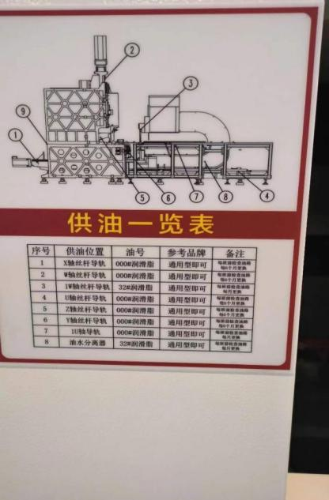

第二套润滑系统由手压式注油机、管路连接件及管路组成，负责C轴丝杠和滑动导轨的润滑。如下图所示。请1次/周，一次按5下。注意观察注油机液位，及时补充润滑油，注油一次不能太多，避免浪费润滑油和污染工作环境。
The second lubrication system consists of hand-operated oiling machine, pipe connectors and pipes. It is responsible for the lubrication of the C-axis lead screw and guide rails as shown in the following diagram. Please press 5 times at a time once a week. Pay attention to the level of the oiling machine and replenish the lubricating oil in time. Do not fill too much oil at a time to avoid waste and working environment pollution.
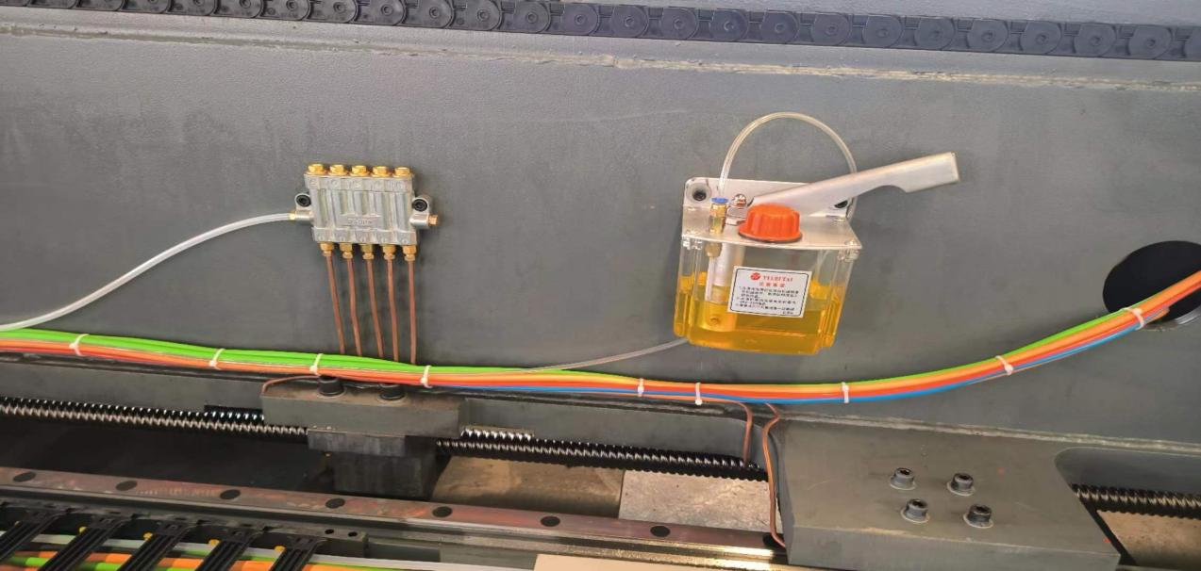

2.润滑系统注意问题 Lubrication system precautions
按说明书有关规定操作，不得违章操作，以免造成润滑装置故障
Operate according to the rules of the manual and do not violate the rules so as to avoid malfunction of the lubrication device
经常检查润滑装置电器元件与各管接件的密封情况，避免漏油、渗油现象发生。
Always check the sealing condition between the electrical components of the lubrication device and pipe connector to avoid oil leakage or seepage.
低油位发讯器发讯，应立即添加油剂，严谨油箱储油量低于最低油量标志操作，避免造成泵体机件损坏或者润滑系统供油故障。
Immediately add oil when the low level sensor sounds and the oil storage level of the oil tank shall not be lower than the minimum oil mark to avoid damage to the pump parts or oil supply failure of the lubrication system.
只允许使用指定型号的润滑油，禁止使用不同种类的润滑油，禁止液压油和润滑油混合使用。
Only designated types of lubricating oil are allowed to be used. It is prohibited to use different types of lubricating oil or to mix hydraulic oil and lubricating oil.

九、电气原理图 Electrical Schematic

电

气

原

理

图

Electrical Schematic
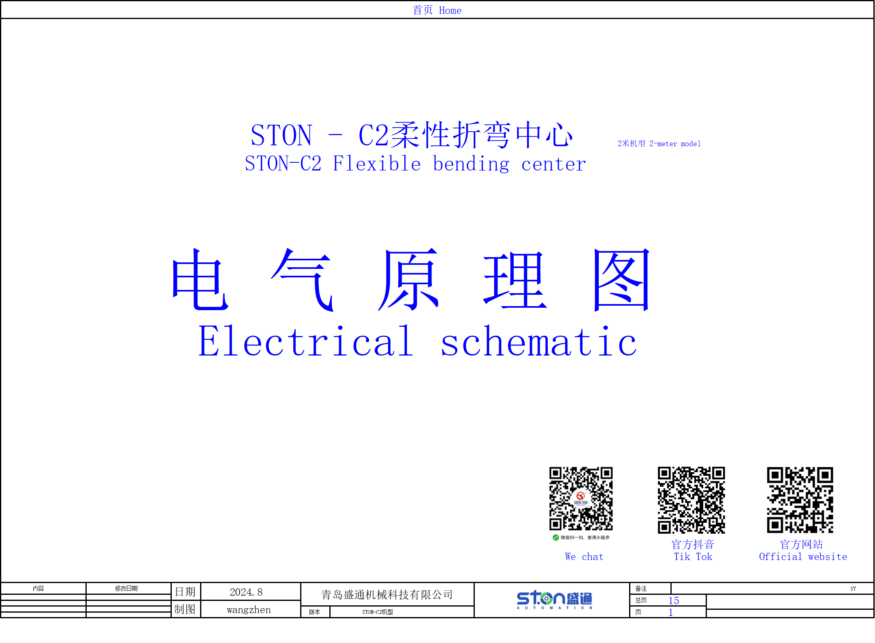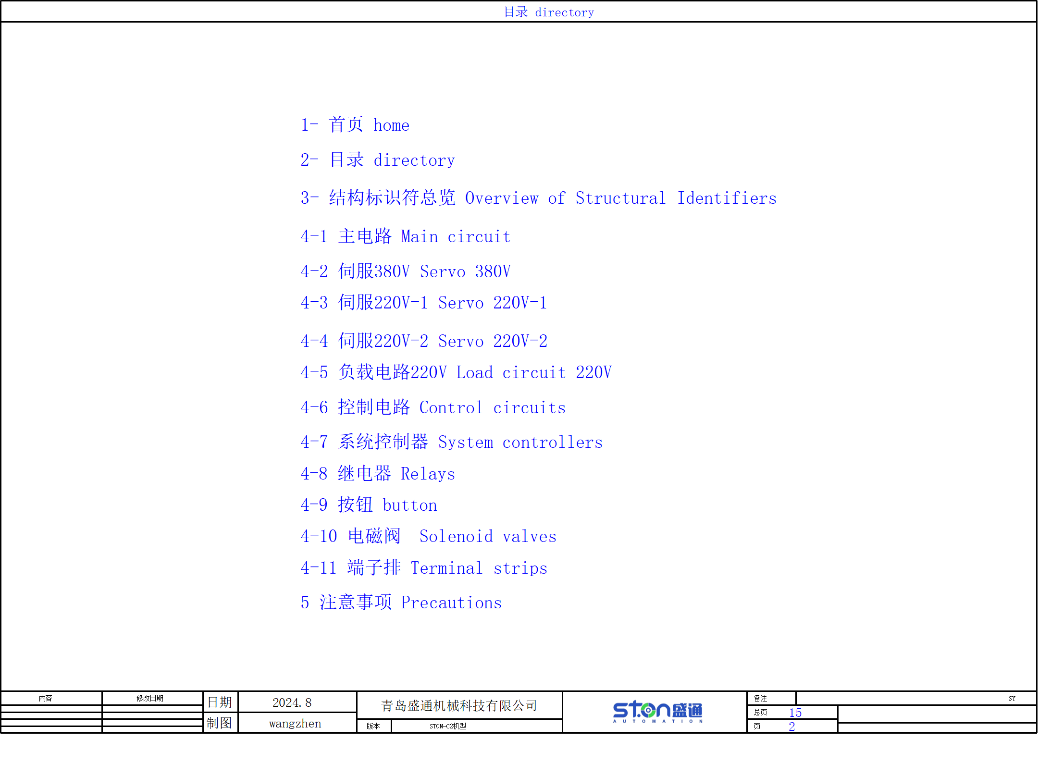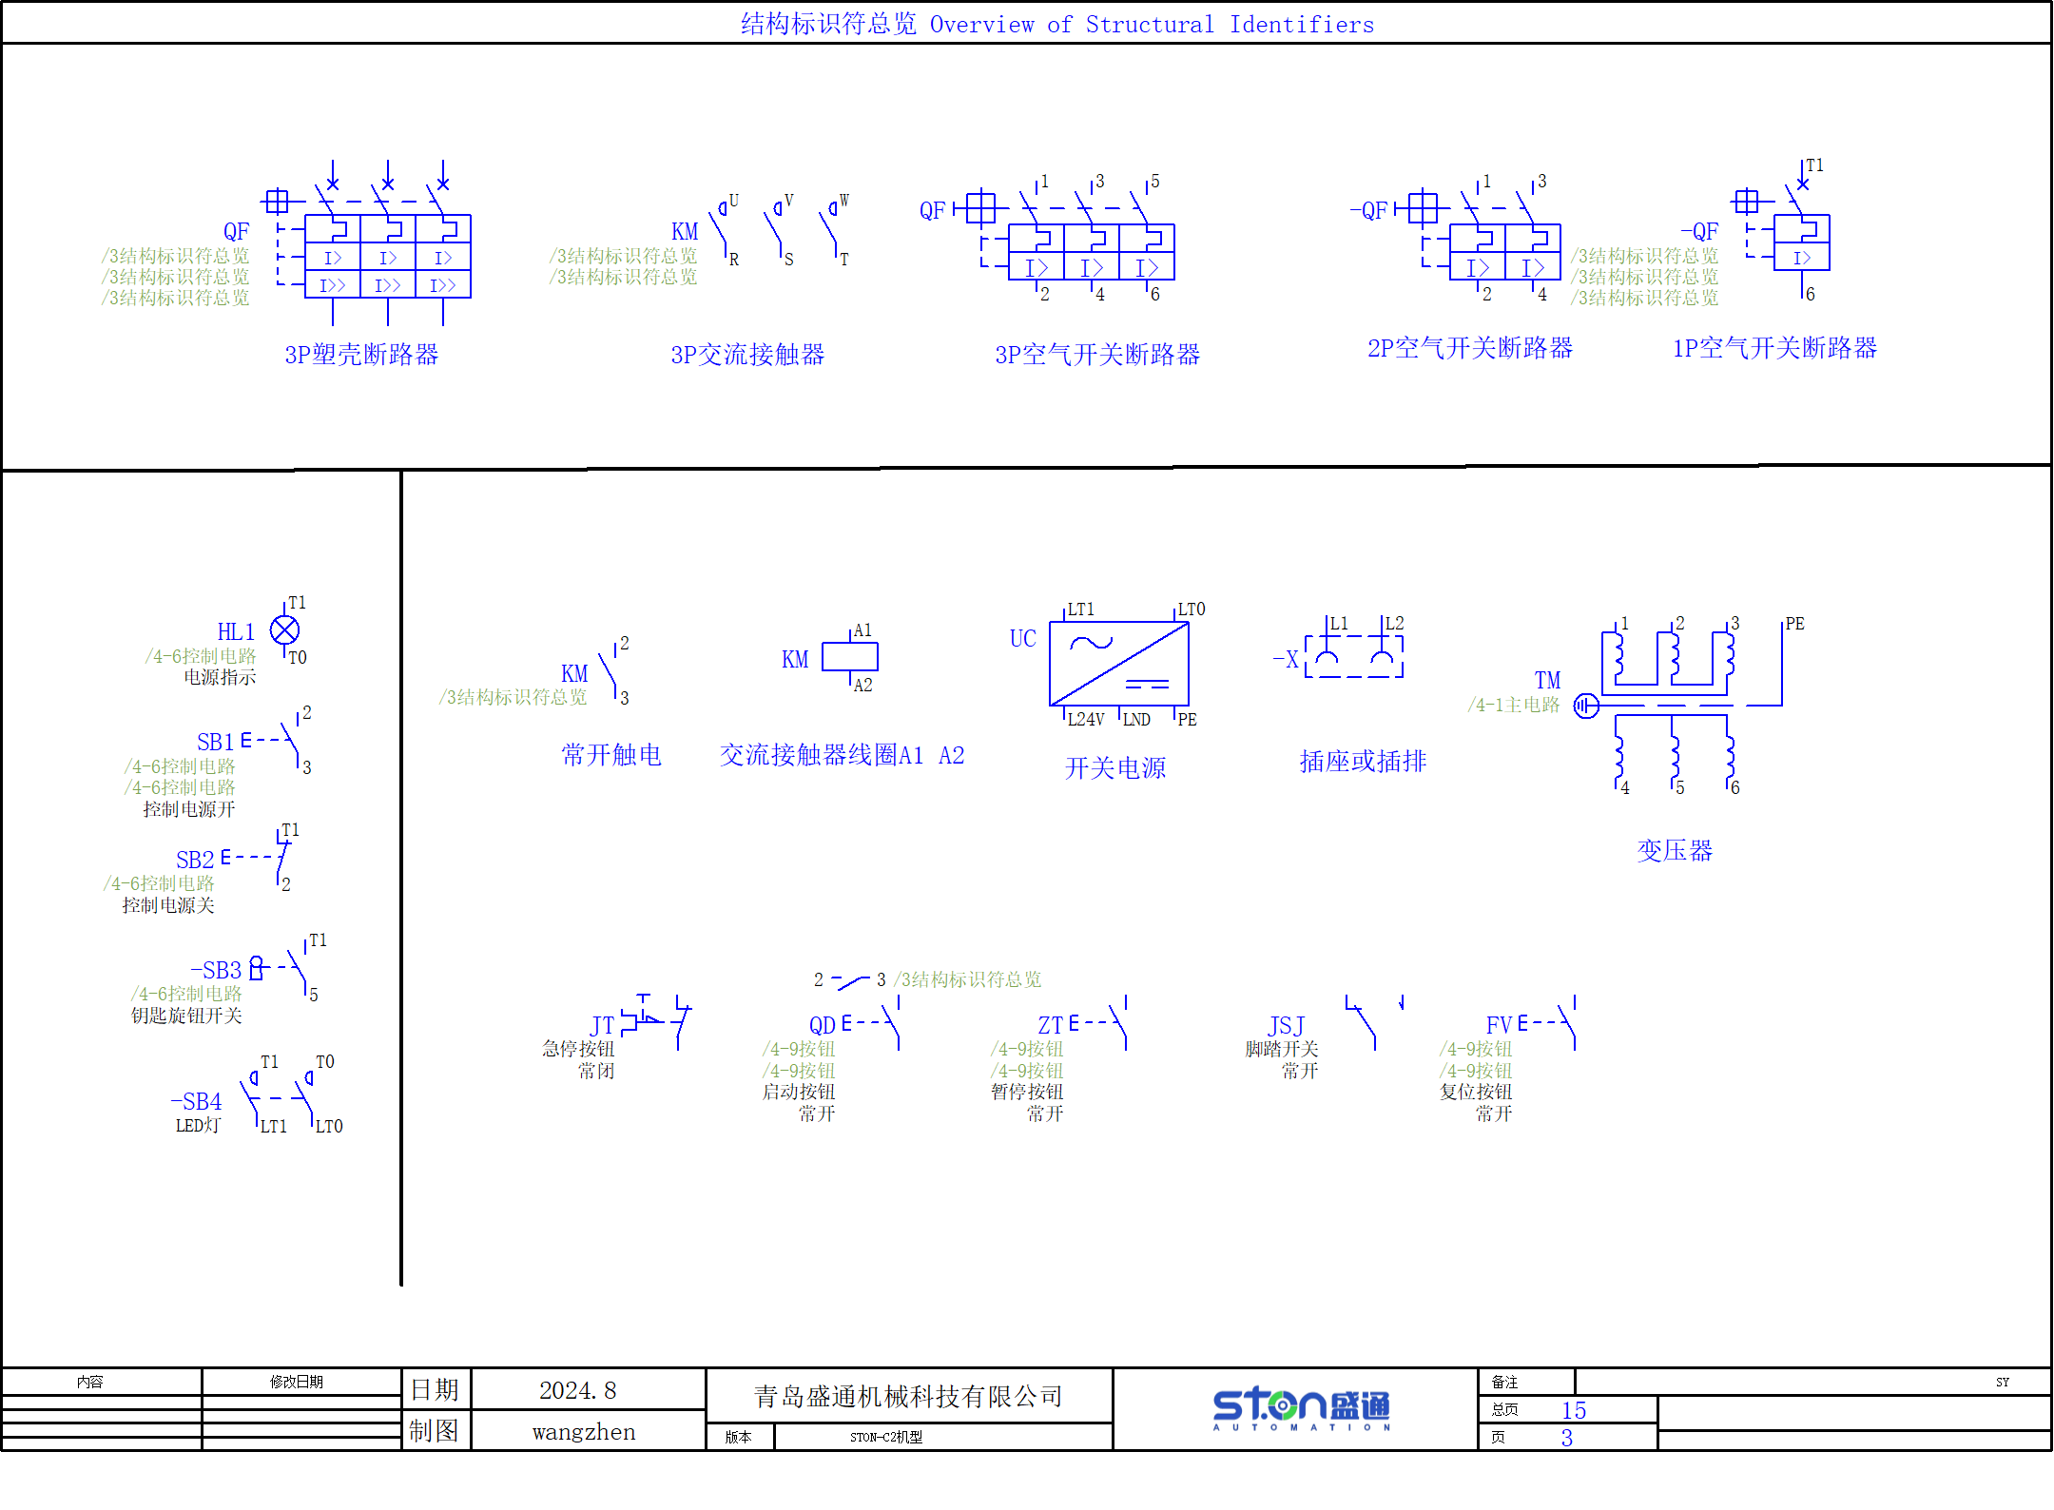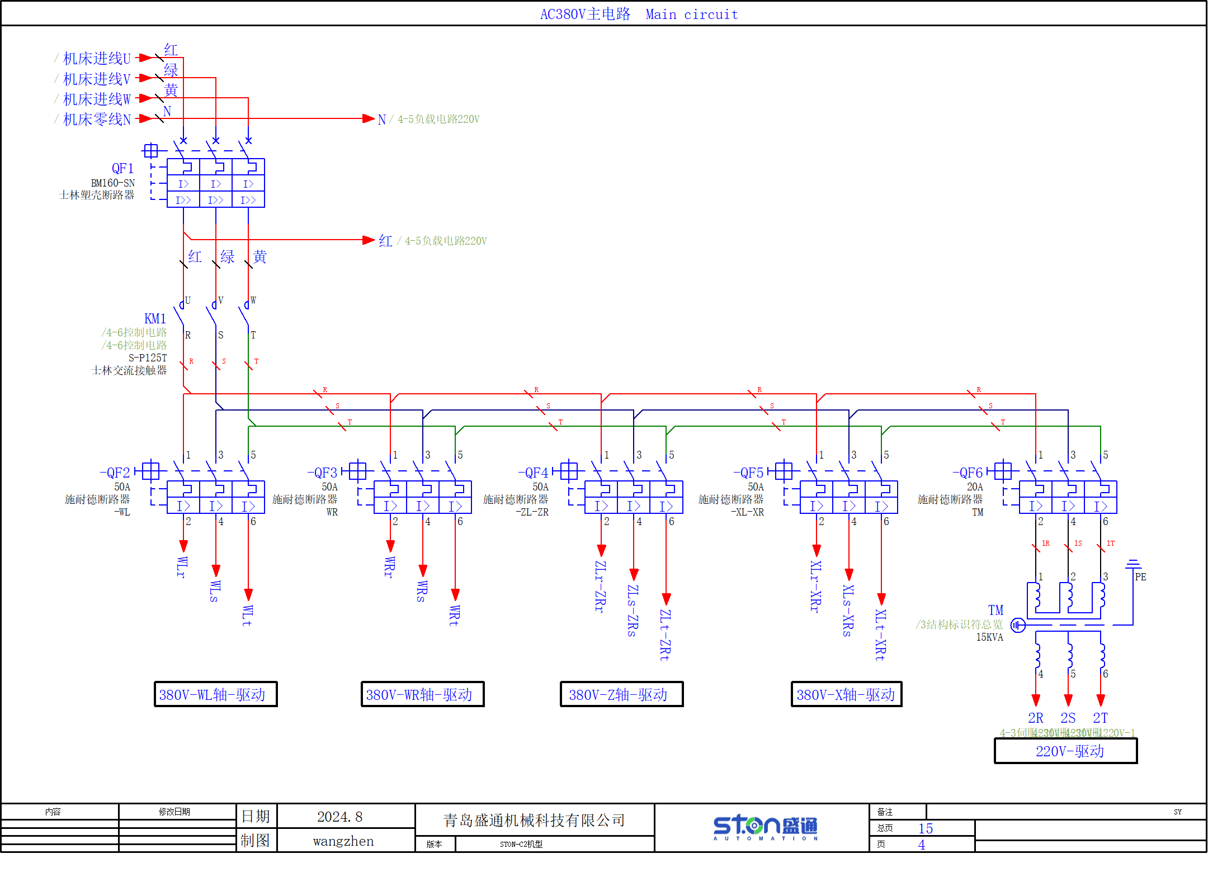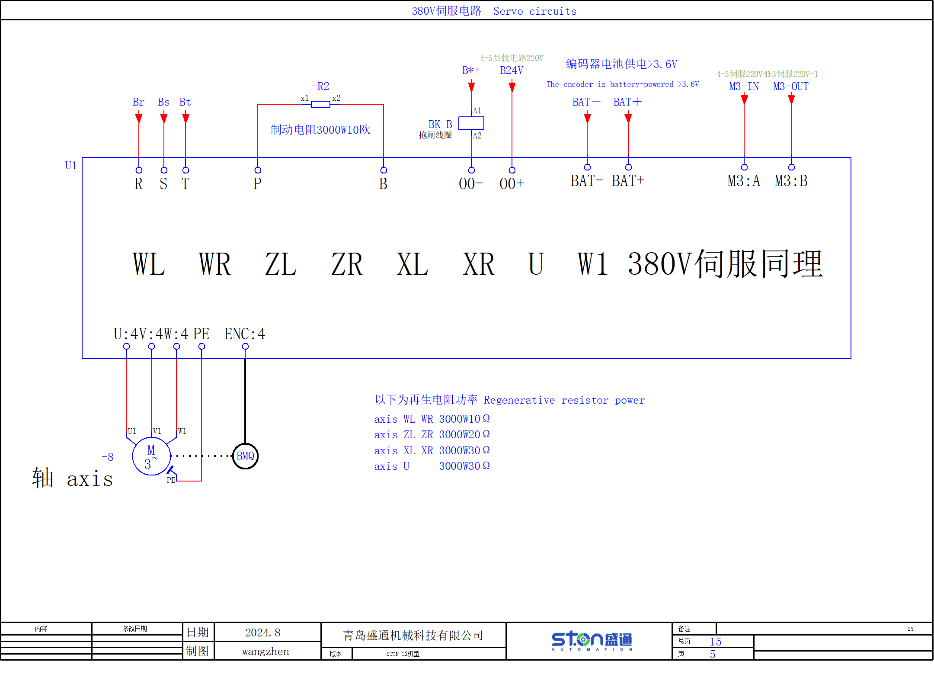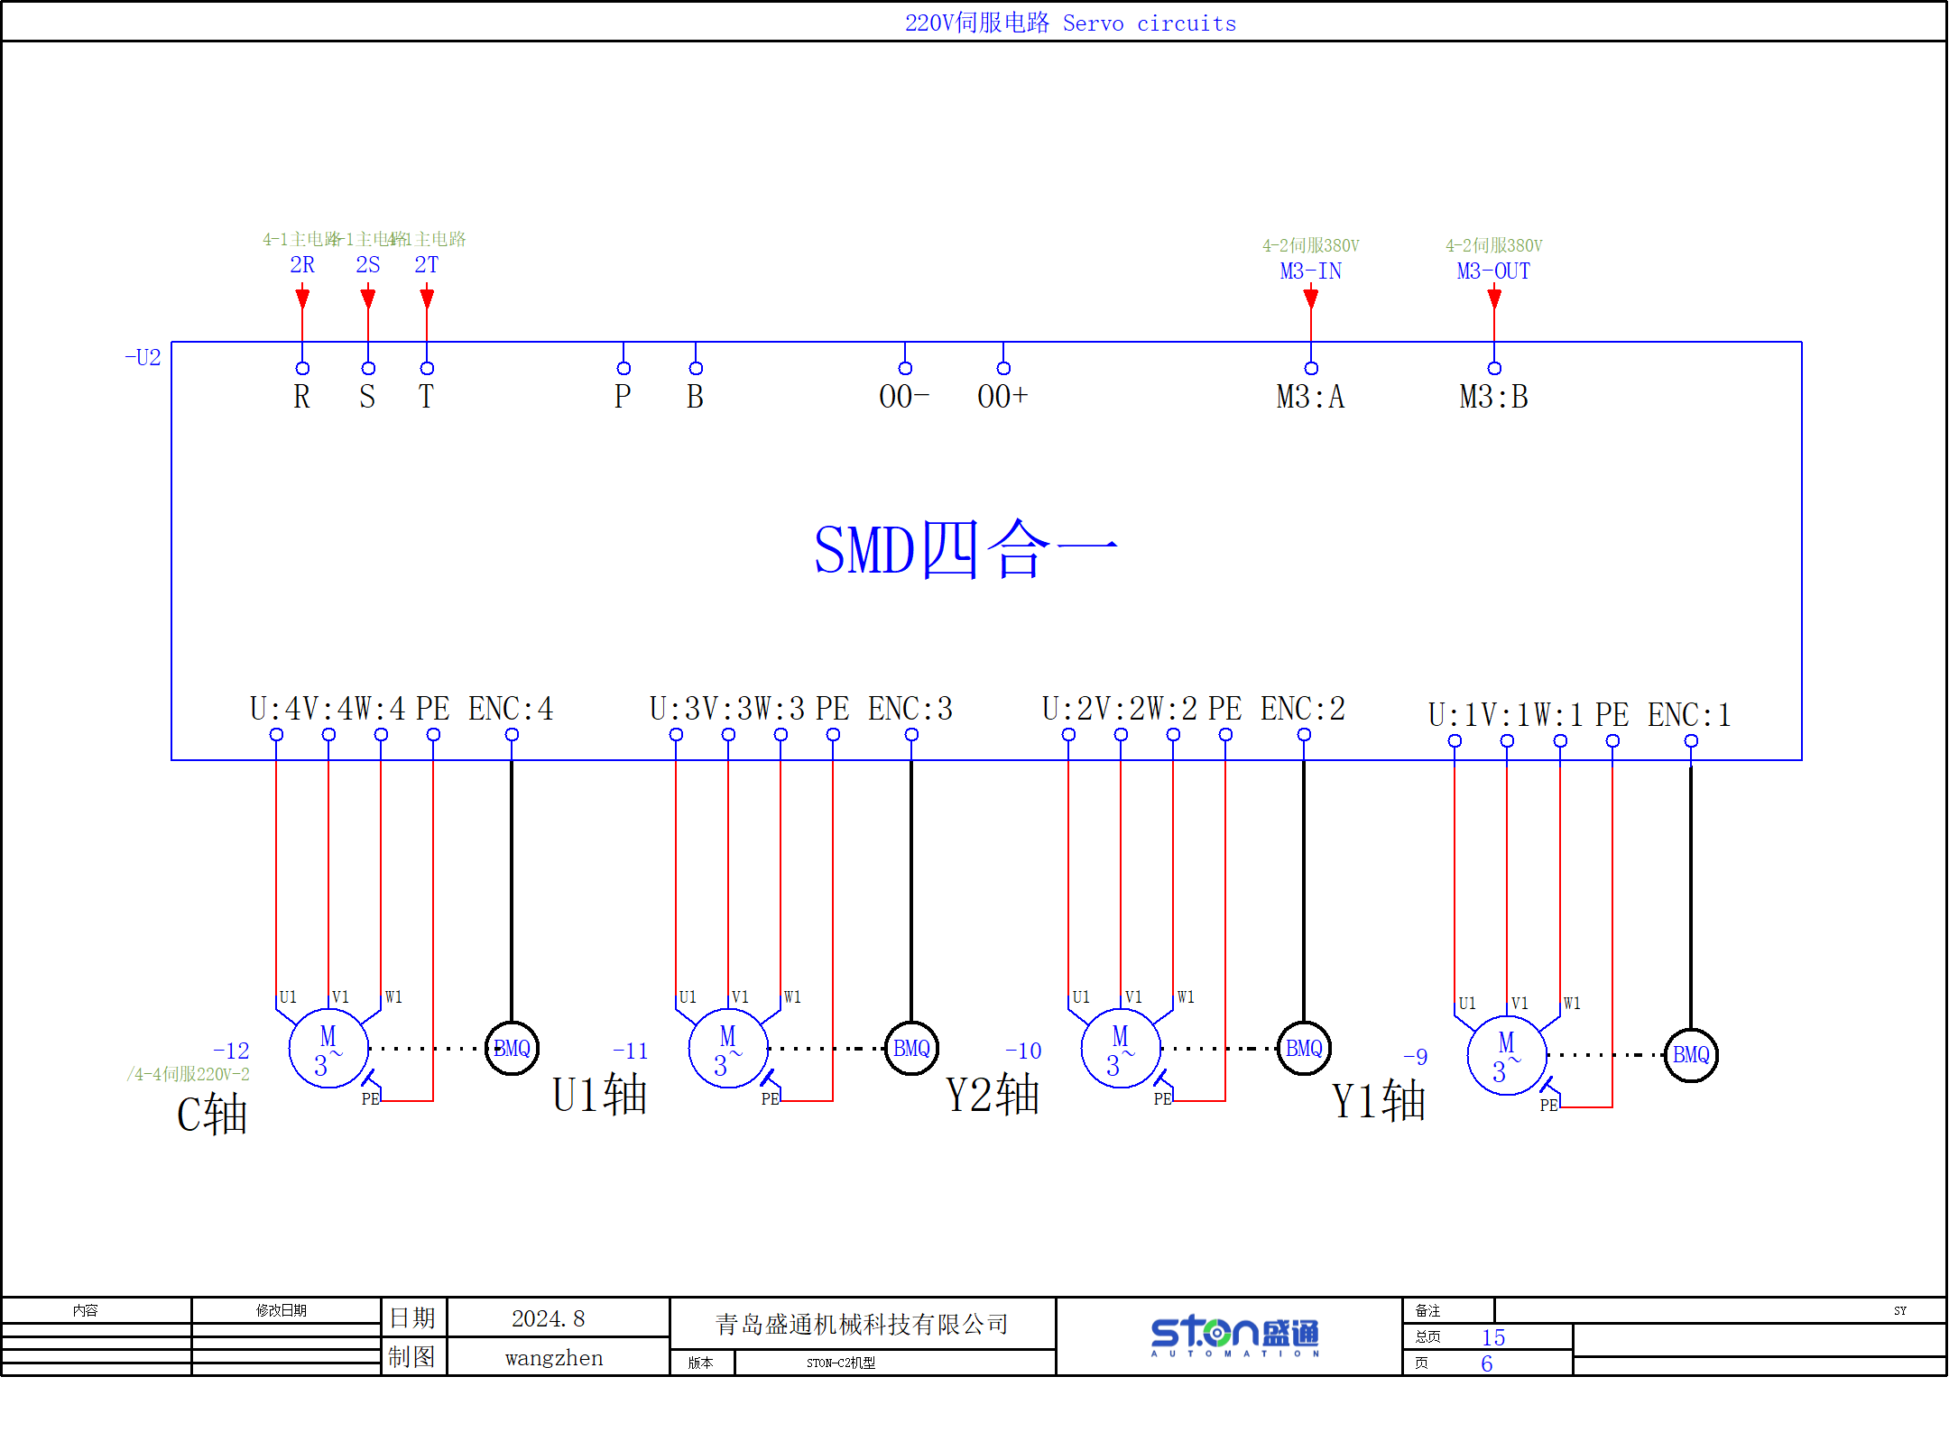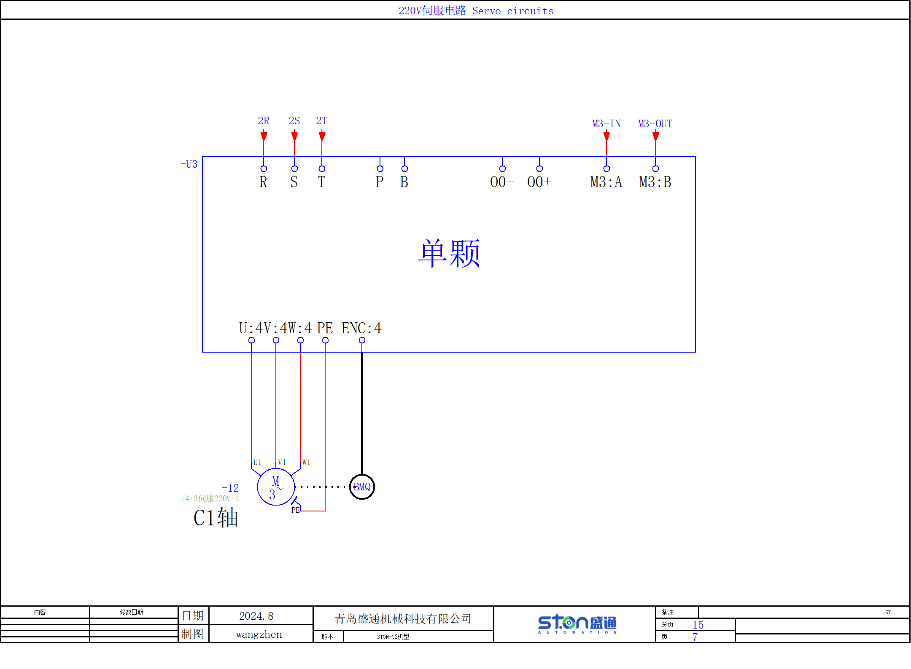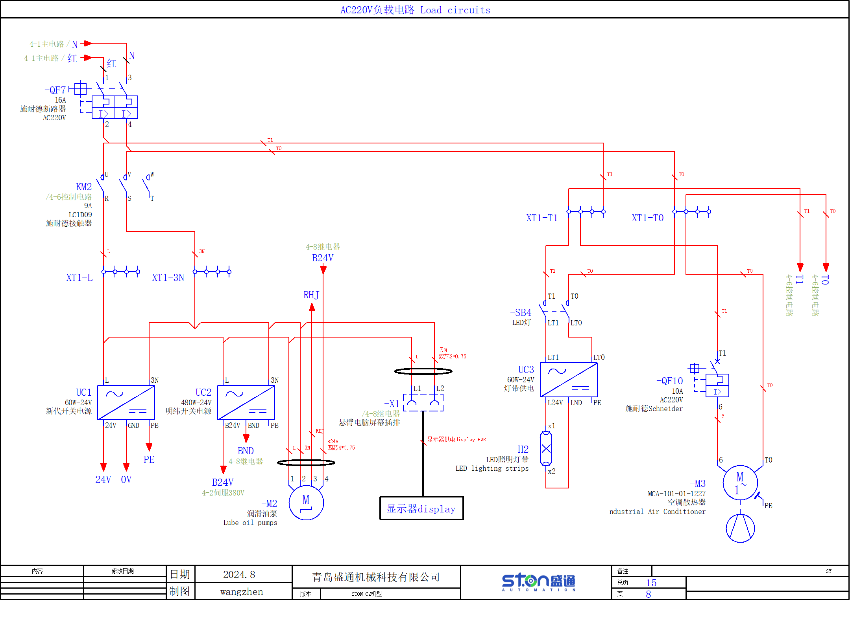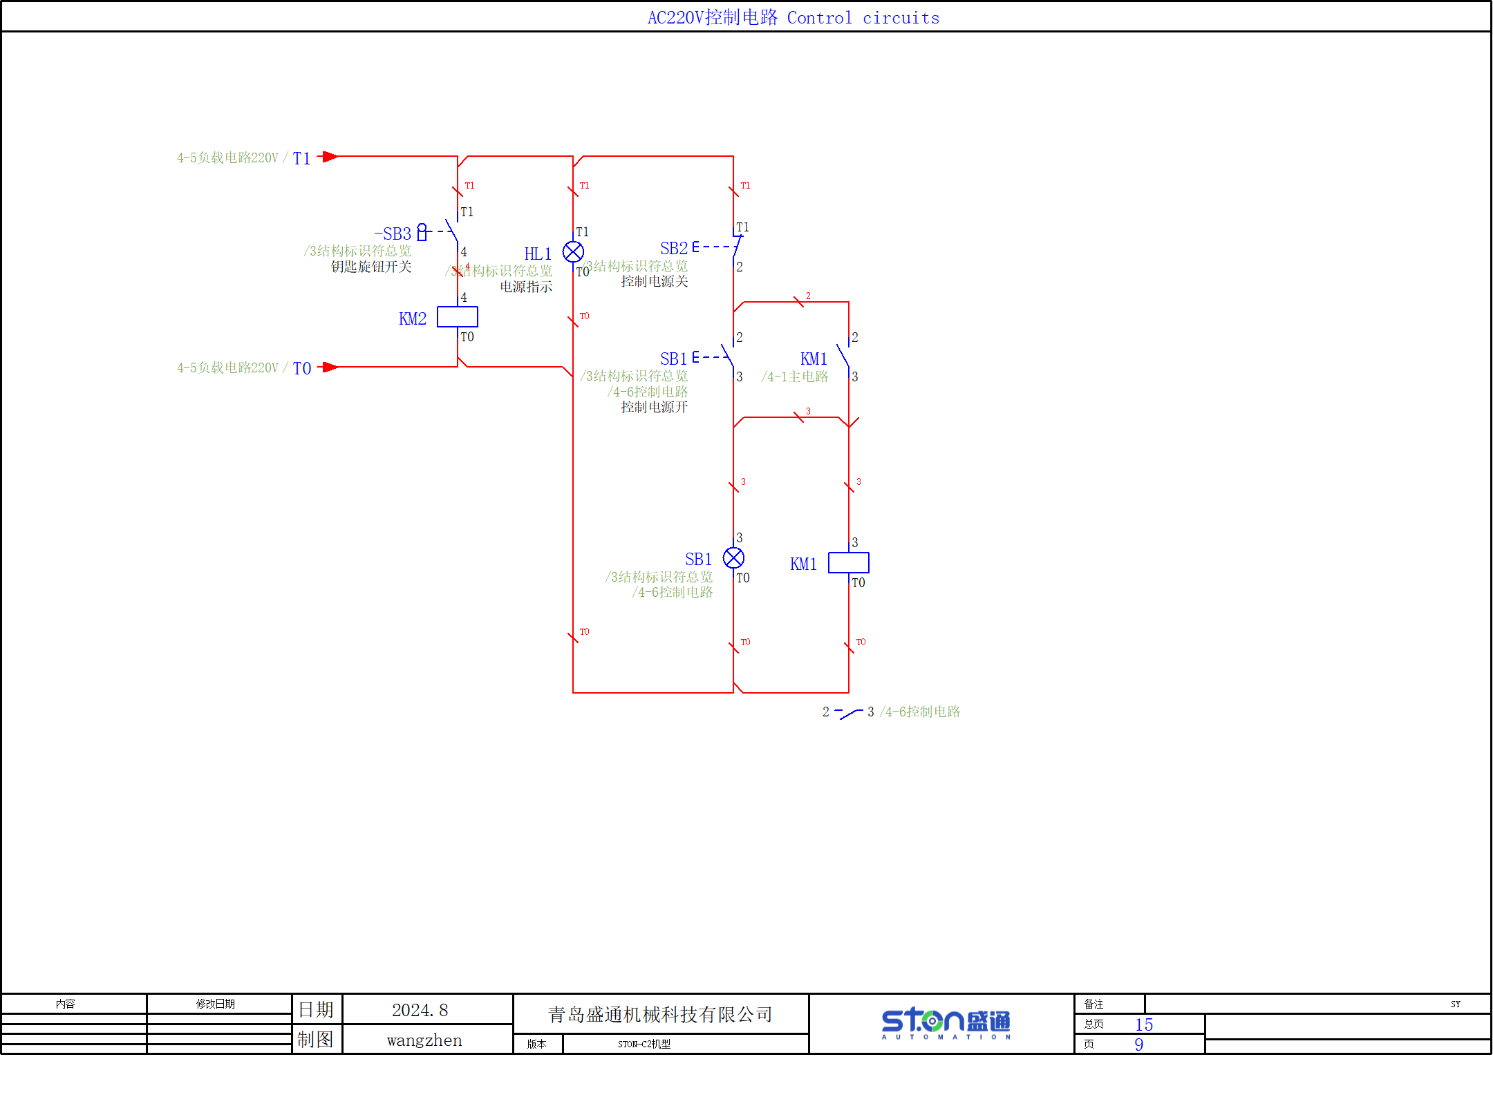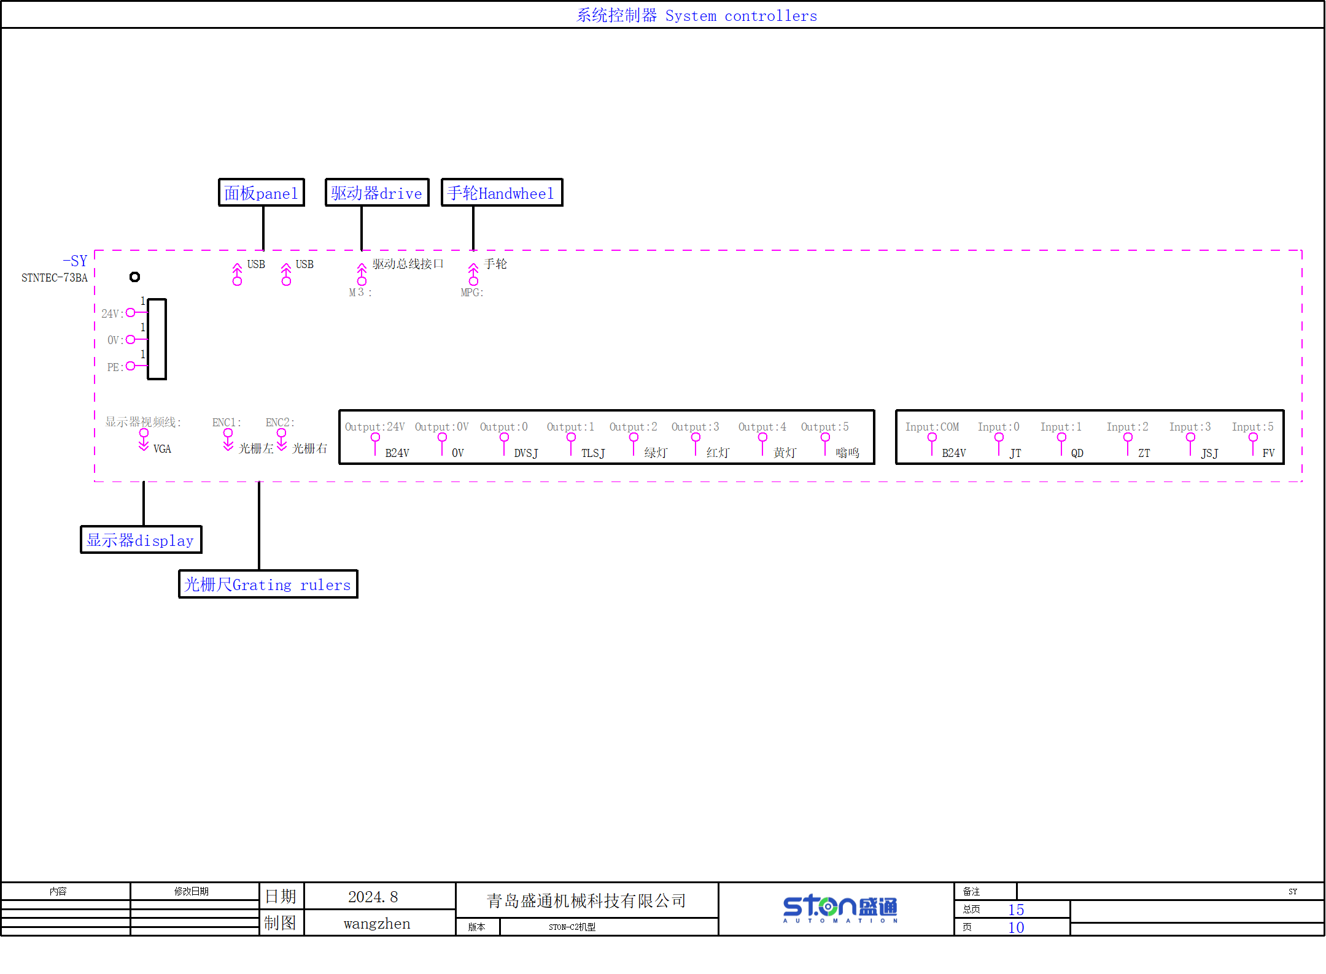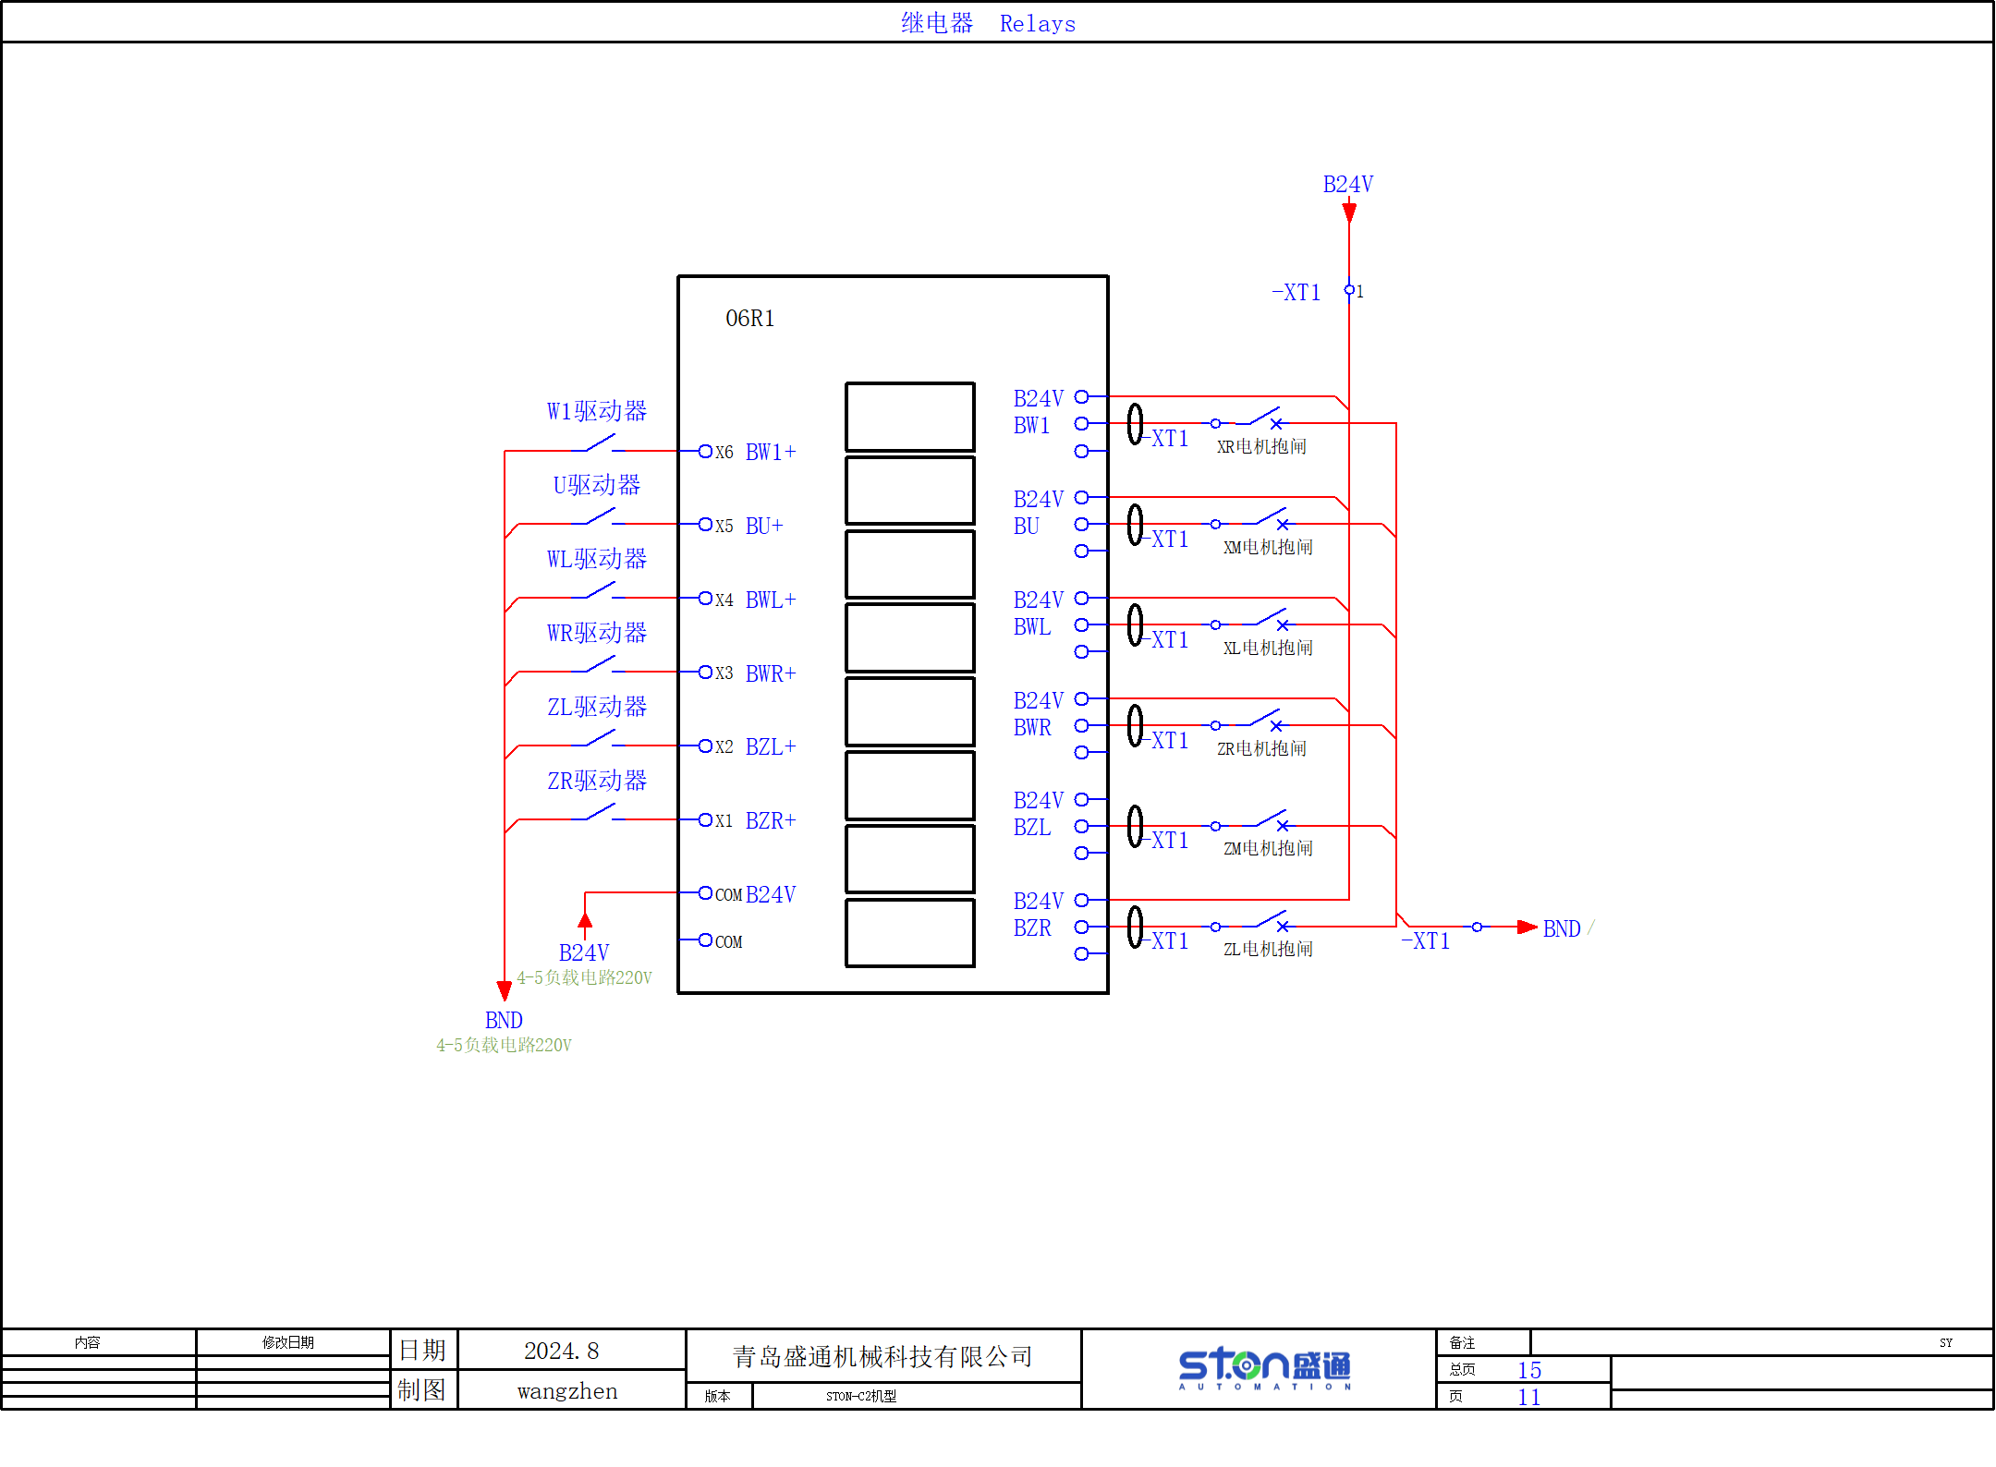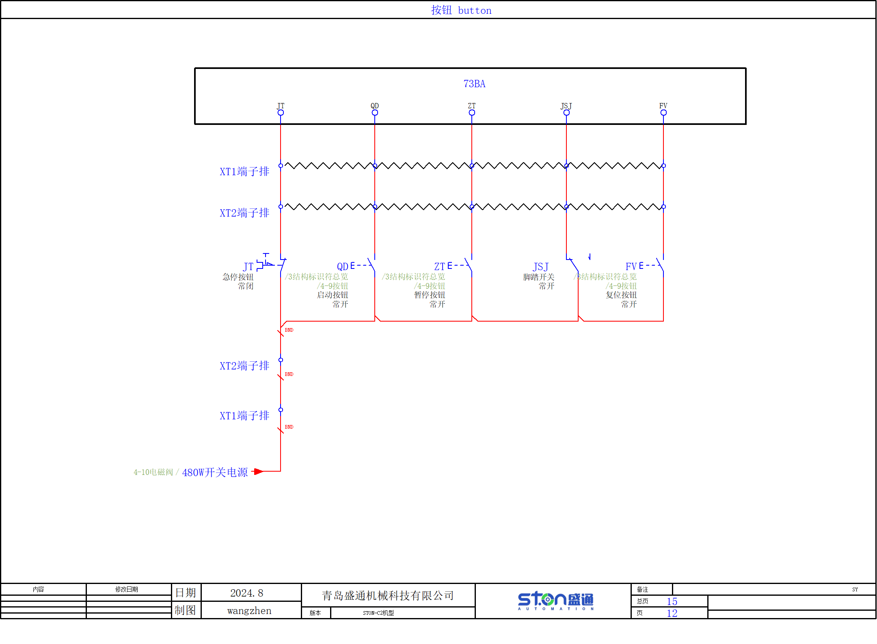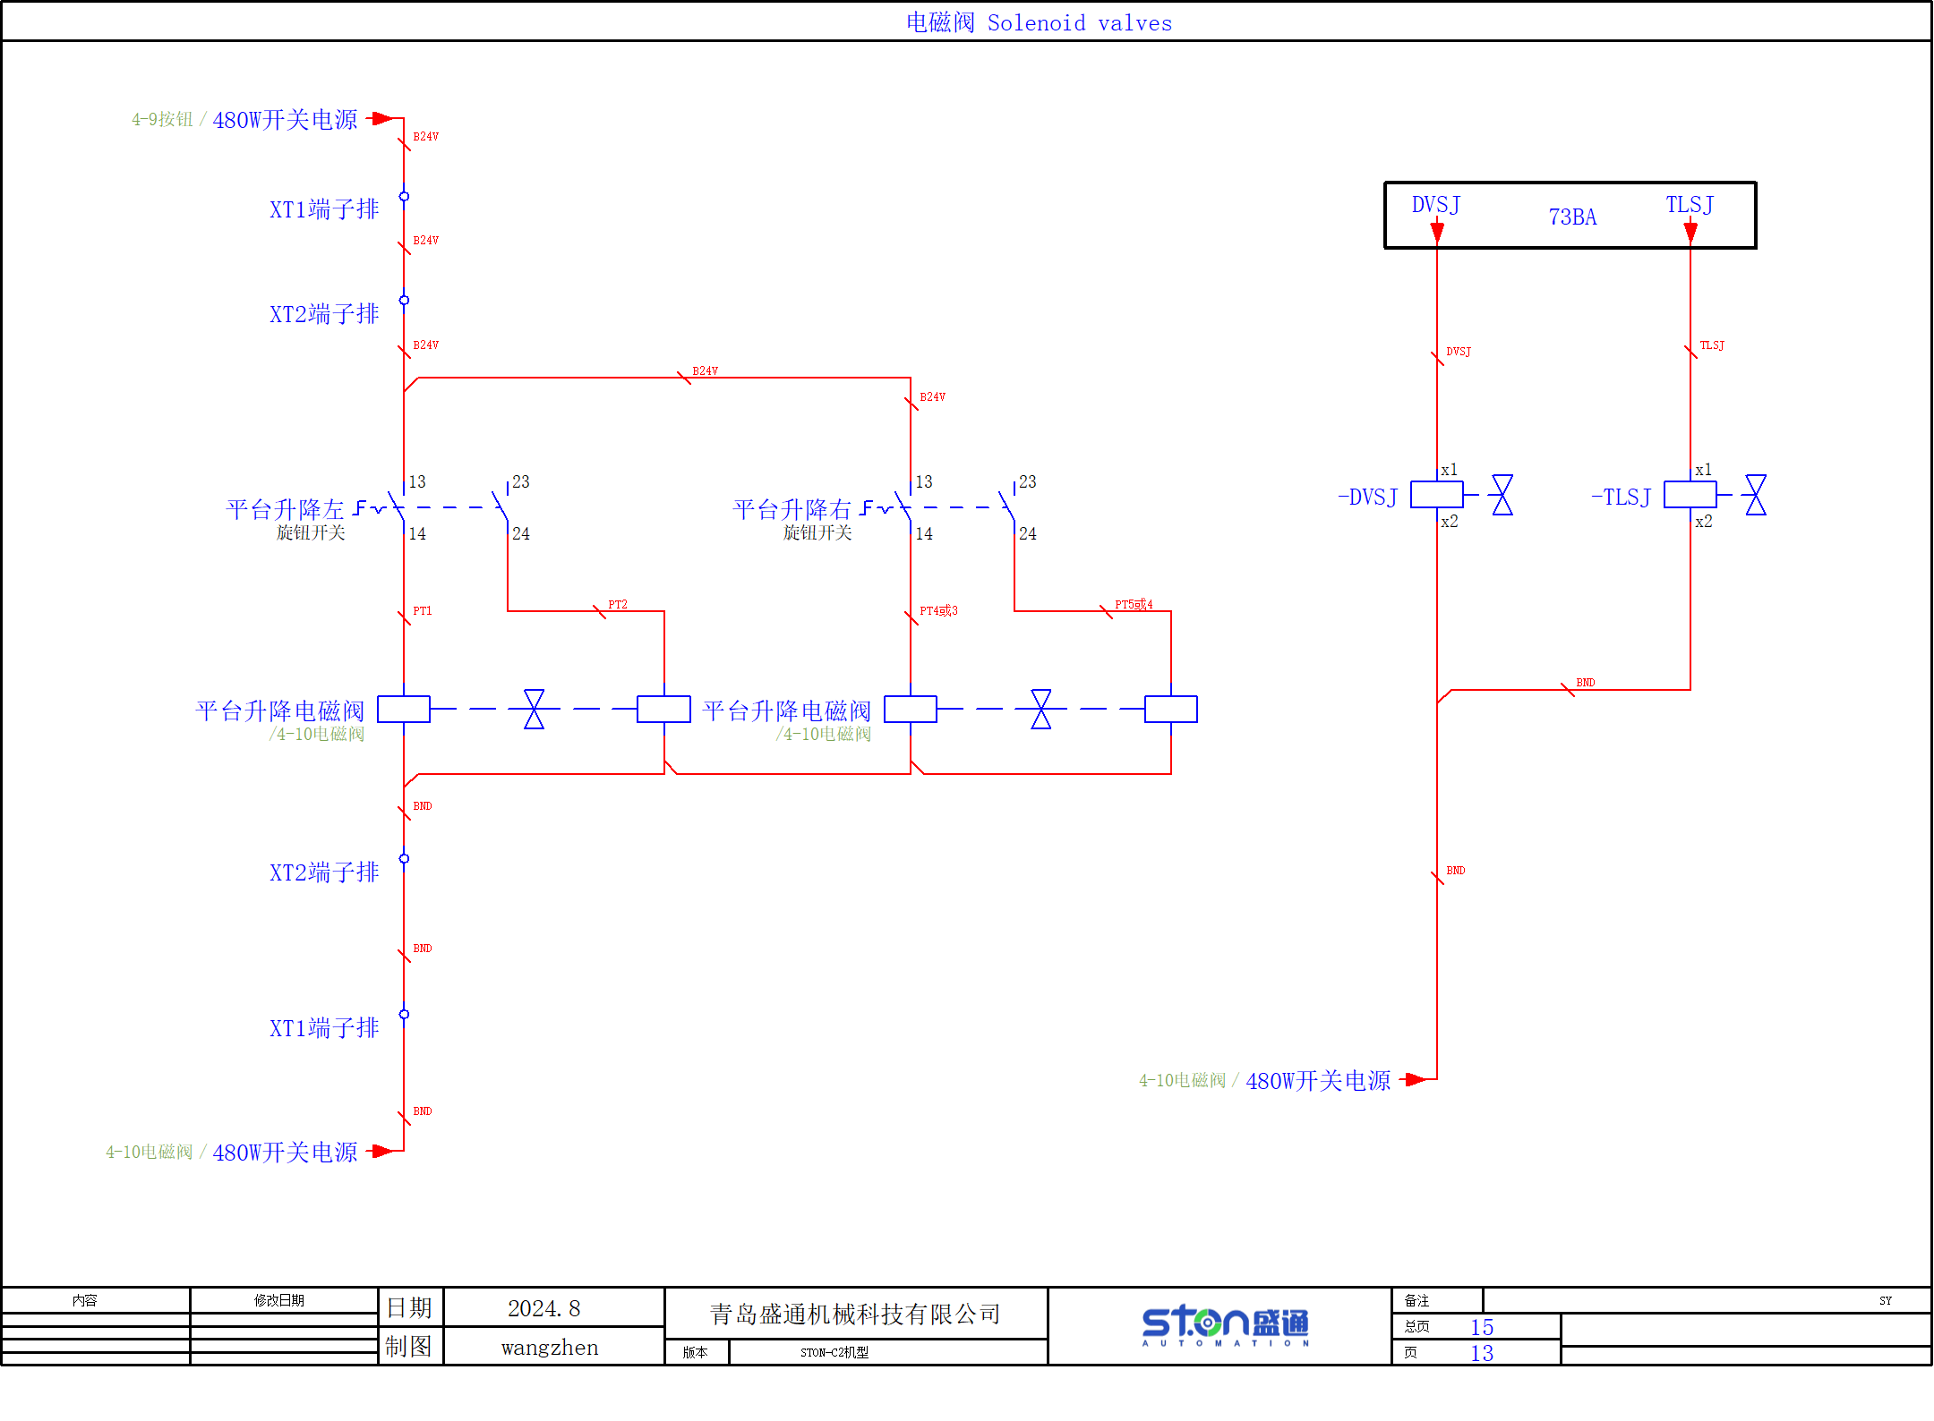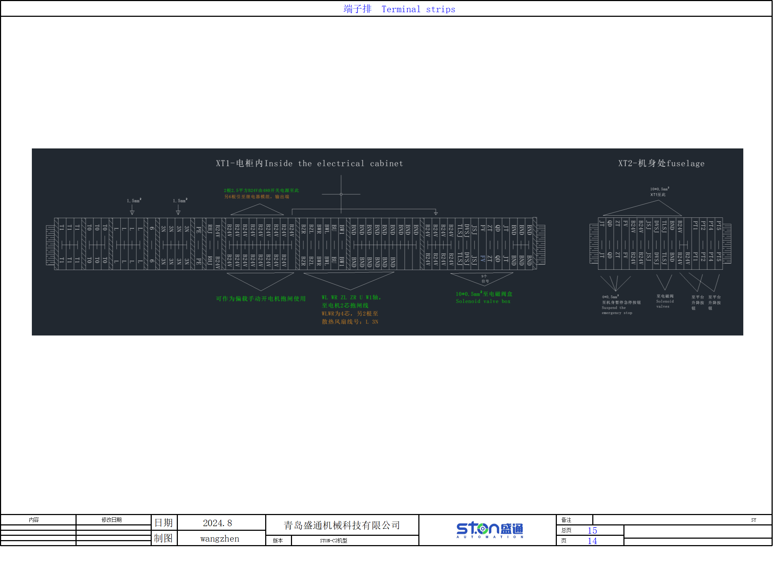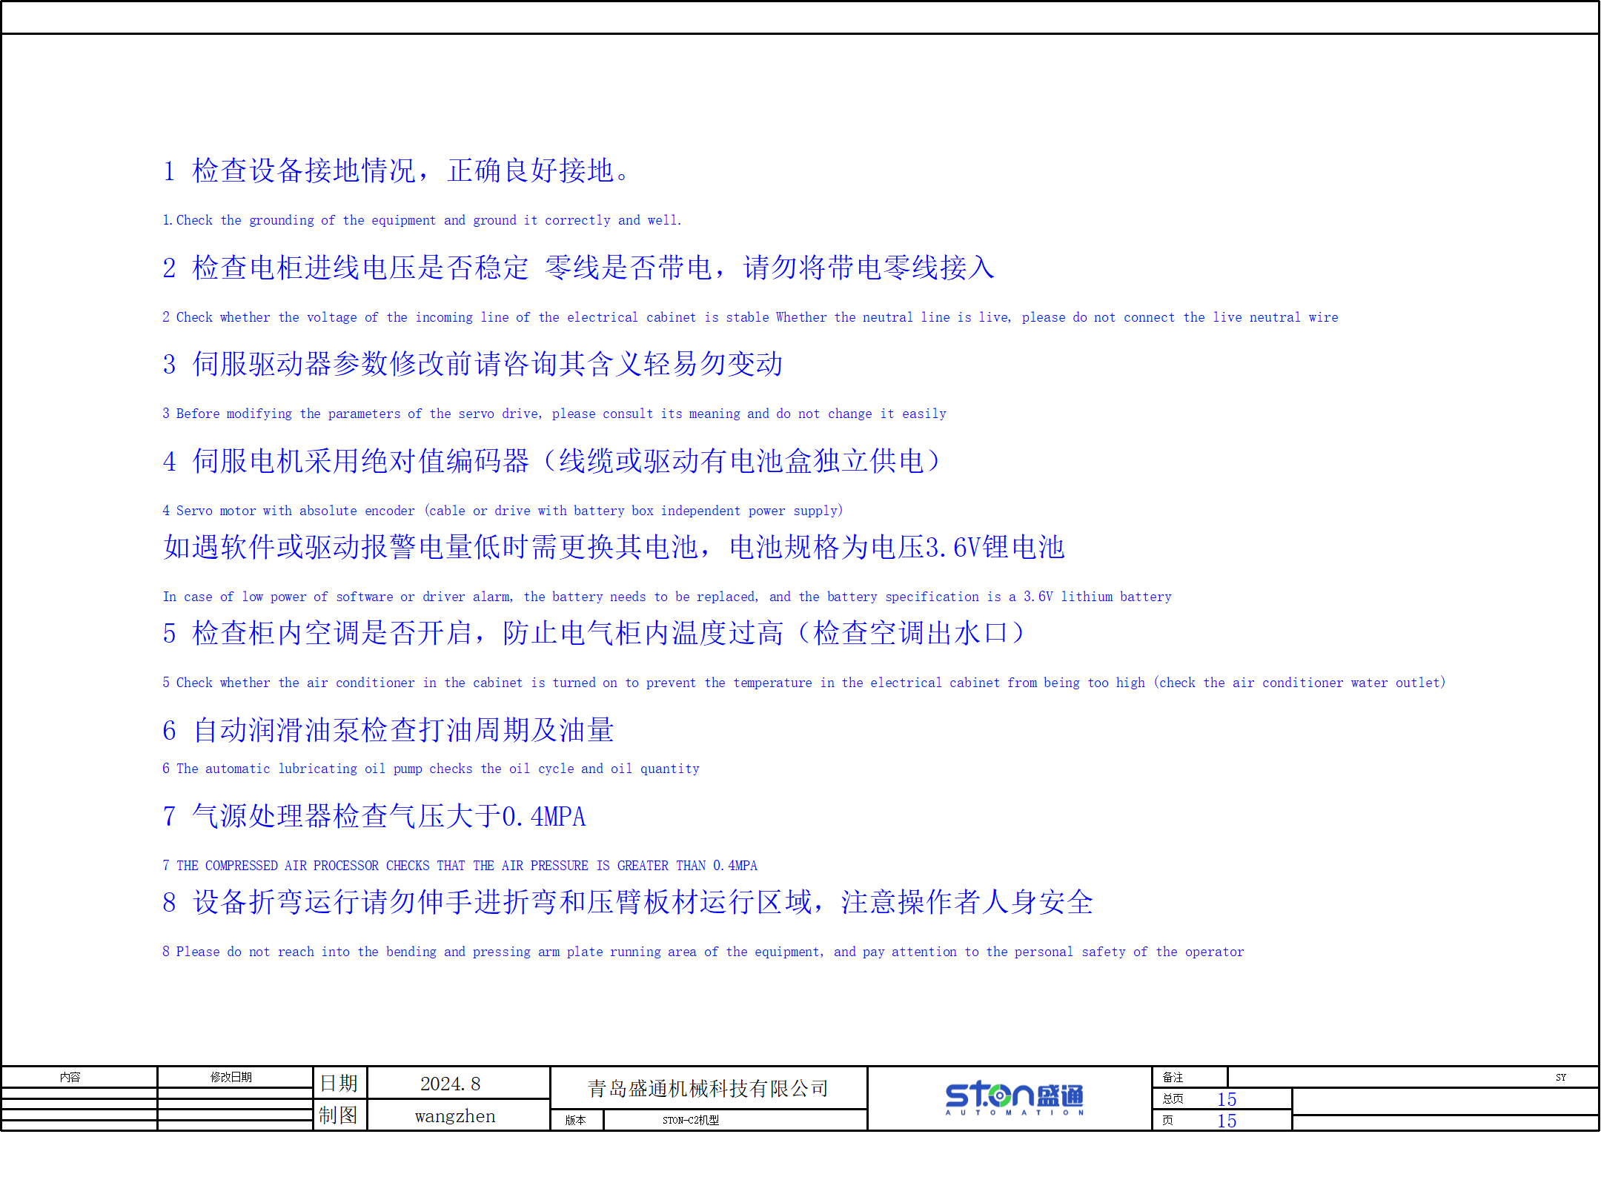


合 格 证
Certificate of Conformity

机床型号：Model
出厂编号：Factory No.:
经检验整机合格准予出厂
This equipment is qualified for the inspection and approved to be delivered.

检 验 员：Inspector:
检验部长：Inspection Director:
出厂日期： 年 月 日
Date of shipment: Month Day Year

青 岛 盛 通 机 械 科 技 有 限公 司
Qingdao Shengtong Mechanical Technology Co., Ltd.

